Appendix 2: Underlying assumptions for the pre-post analyses
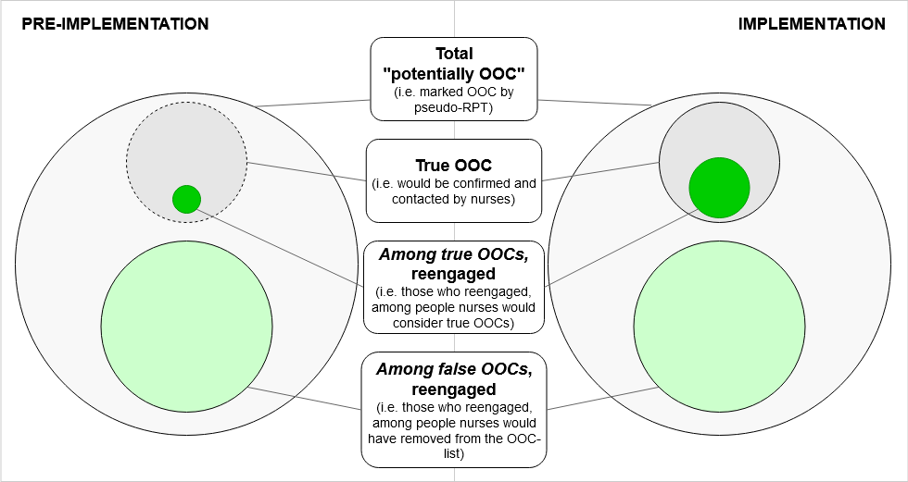
Figure 1: Pre-post analysis assumptions

Ideally, our analysis would be an assessment of reengagement among true OOCs only (within the darker grey circles). We would compare the number of people who were reengaged in the implementation phase (dark green circle on the right), who received the Lost & Found intervention, to the number of people reengaged in the pre-implementation phase (dark green circle on the left), who did not receive the intervention. Differences in reengagement between phases could be attributed to the Lost & Found intervention.

However, in order to determine which patients are truly OOC, we need nurses to validate patients on the OOC list. This was not possible in the pre-implementation phase, since Lost & Found had not yet been implemented. Thus, in the pre-implementation phase, we are unable to differentiate true OOC patients from patients falsely marked OOC (those not included within the boundary of the darker grey circle in Figure 1). This means that we cannot separate reengagement among true OOCs (dark green circles) from “reengagement” among people who are not actually OOC (light green circles). This latter group represents those marked OOC by the automated portion of the OOC-RPT who would have been removed from the OOC-list by nurses if they were in the implementation phase. Since they are in the pre-implementation phase, any visit they have after being marked potentially OOC is considered “reengagement,” even though they were never actually OOC to begin with.

In our analysis, the overall denominator for each phase is the total number of people marked potentially OOC, while the outcome is reengagement among all people marked potentially OOC, including among true and false OOCs. Reengagement among the false OOCs would be expected to be consistent between phases, since neither are contacted by nurses. However, any difference in reengagement among the true OOCs could be attributed to Lost & Found, since only true OOCs in the implementation phase received the Lost & Found intervention. Thus, since each phase has a larger denominator consisting of many additional non-differentially misclassified patients (i.e. the same number of additional false OOCs in each phase), as well as a larger numerator consisting of many additional non-differentially misclassified outcomes (i.e. the same number of additional reengagements among false OOCs in each phase), any intervention effect that may exist is diluted. Detecting any effect of the intervention would therefore be considered a conservative estimate of the true effect.

