Appendix 3: Detailed analysis plans and results

Independence in the pre-post analyses
A total of 740 and 804 patients were marked OOC by the pseudo-RPT in the pre-implementation and implementation phases, respectively. Just under half of patients included in this analysis (n = 350) were marked OOC by the pseudo-RPT in both phases (44% of patients in the implementation phase and 47% of those in the pre-implementation phase). In other words, they were marked OOC by the pseudo-RPT in the pre-implementation phase, reengaged, and marked again in the implementation phase. However, the robust Poisson model assumes that OOC events are independent. Other studies demonstrate that this is a false assumption – past OOC events are predictive of future ones¹. To our knowledge, there were no major changes in clinical care practice guidelines or how patients were followed in the years immediately prior to the implementation of Lost & Found. As such, we assume that HIV care histories for these patients are similar to others in each phase. This would mean that the effects of previous OOC events are similarly distributed across the implementation and pre-implementation phases, which would result in non-differential misclassification and further bias to no effect.

Pre-post analyses: Survival analysis

Cox proportional hazards model results
The results for the full model Cox proportional hazards model (controlled for Age, Canada, and Sex) are presented in Table A1, overall and stratified by risk category. Adjusted cumulative incidence curves are presented in Figure A1.
Table A1: Results from the Cox proportional hazards model, overall and by risk category
Variable | Estimate* (95% CI) | p-value
All risk categories (Implementation phase: n = 804; Pre-implementation phase: n = 740)
Imp† | 1.324 (1.147, 1.530) | < 0.001
Sex | 0.947 (0.807, 1.112) | 0.506
Age | 1.003 (0.998, 1.009) | 0.273
Canada | 0.661 (0.567, 0.772) | < 0.001
High risk category (Implementation phase: n = 199; Pre-implementation phase: n = 128)
Imp† | 1.301 (0.952, 1.777) | 0.099
Sex | 0.738 (0.540, 1.008) | 0.056
Age | 1.007 (0.997, 1.018) | 0.182
Canada | 0.507 (0.354, 0.726) | < 0.001
Intermediate risk category (Implementation phase: n = 481; Pre-implementation phase: n = 493)
Imp† | 1.196 (1.002, 1.428) | 0.048
Sex | 0.992 (0.810, 1.214) | 0.936
Age | 1.003 (0.996, 1.010) | 0.433
Canada | 0.800 (0.664, 0.964) | 0.019
Low risk category (Implementation phase: n = 124; Pre-implementation phase: n = 119)
Imp† | 2.384 (1.465, 3.881) | < 0.001
Sex | 0.971 (0.574, 1.642) | 0.912
Age | 0.992 (0.972, 1.012) | 0.441
Canada | 0.404 (0.244, 0.669) | < 0.001
*Hazard ratio
†‘Imp’ is a binary variable for being marked OOC in the implementation phase, compared to the pre-implementation phase.

Figure A1: Cumulative incidence curves of reengagement over time among OOC patients by risk category, adjusted for age, sex, and being born in Canada
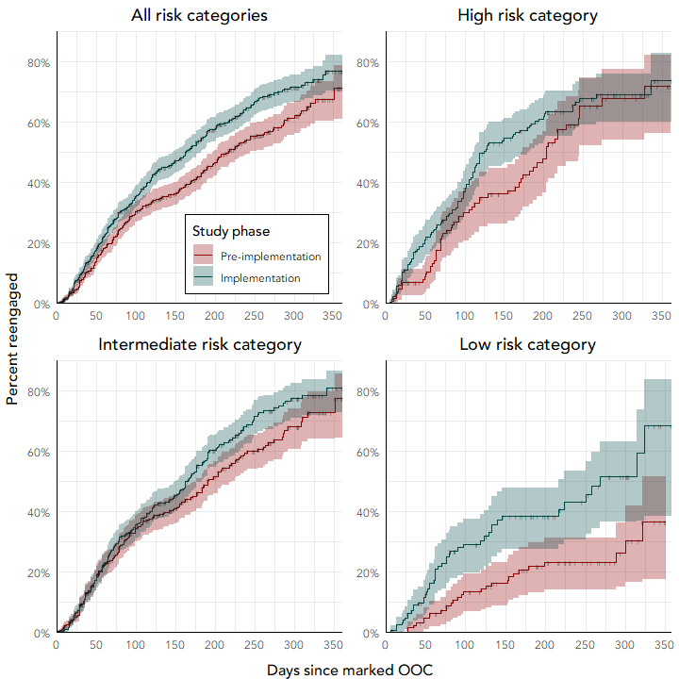

Testing model assumptions
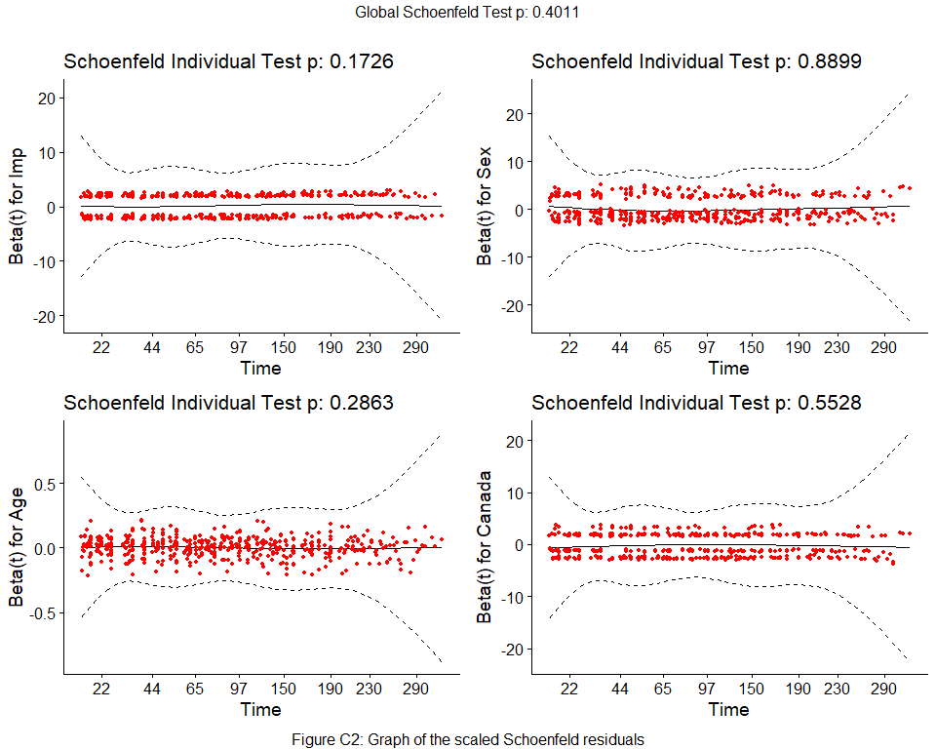
The tests of the proportional hazards assumption using scaled Schoenfeld residuals are summarised in Table A2 and Figure A2, and graphs of the deviance and dfbeta residuals in Figures A3 and A4.
Figure A2: Directed acyclic graph, only ‘Can’ as a confounder
Table A2: Tests of the proportional hazards assumption for Cox regression model fit, using scaled Schoenfeld residuals
Variable | chisq | df | p*
Imp | 1.86017523 | 1 | 0.173
Sex | 0.01914676 | 1 | 0.890
Age | 1.13715691 | 1 | 0.286
Canada | 0.35236210 | 1 | 0.553
GLOBAL | 4.03610758 | 4 | 0.401
*p value under 0.05 indicative of non-proportional hazards
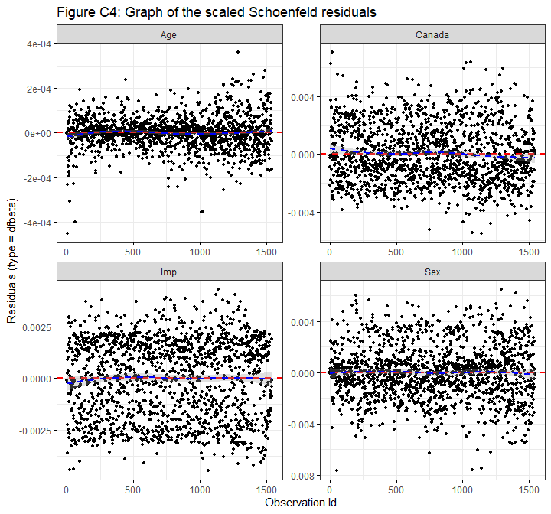
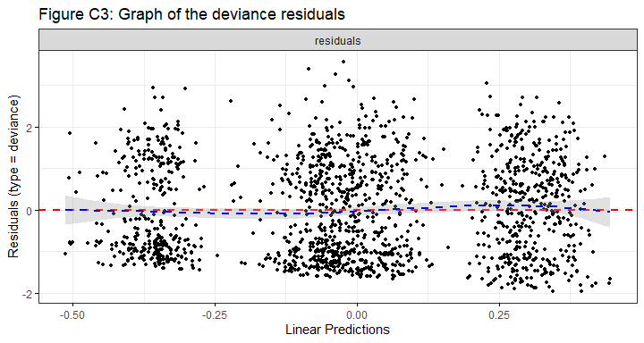
Figure A4: Graph of dfbeta residuals
Figure A3: Graph of the deviance residuals

Pre-post analysis: Propensity score analyses

Directed acyclic graphs (DAGs)
Among variables in the Lost & Found dataset, four were possible confounders in the relationship between being marked OOC in the implementation phase (Imp) and being reengaged (Re):
- Sex;
- Age;
- Being born in Canada (Can); and
- History of HCV (HCV), defined as any positive HCV RNA test.
Sex, Age, and Can were included in multivariable model outlined in the protocol. HCV was added here, since it is likely associated with reengagement (people with HCV include a large number of people who inject drugs, who are likely more difficult to reengage than the general clinical population) and may be associated with being OOC in the implementation phase (i.e. there may be more or fewer people with HCV infection histories in the pre-implementation phase compared to implementation.)
Two directed acyclic graphs (DAGs) are considered here. In the first, all covariates are considered confounders (Figure A5). In the second, Sex, Age, and HCV are treated only as ancestors of the outcome, while Can is considered a confounder and an ancestor of the other three variables (Figure A6). There was a change in the number and proportion of asylum seekers (thus, people born in Canada) in the implementation phase compared to the pre-implementation phase, many of whom likely became OOC. These asylum seekers were younger, more likely to be female, and less likely to have contracted HCV than the clinical population. It is unclear whether Sex, Age, or HCV vary by implementation phase, other than when mediated by Can. Thus, Sex, Age, and HCV may not be true confounders. Nonetheless, if they are not confounders, when controlling for Can, they become pure predictors of the outcome, and are thus worth including in the model².
Unmeasured confounding is included as the covariate $U$ in both DAGs. This unmeasured confounding might include some clinic-level events that would be associated with the exposure and outcome. For example, some people may have been more likely to become OOC and less likely to reengage due to certain doctors’ limited availabilities.
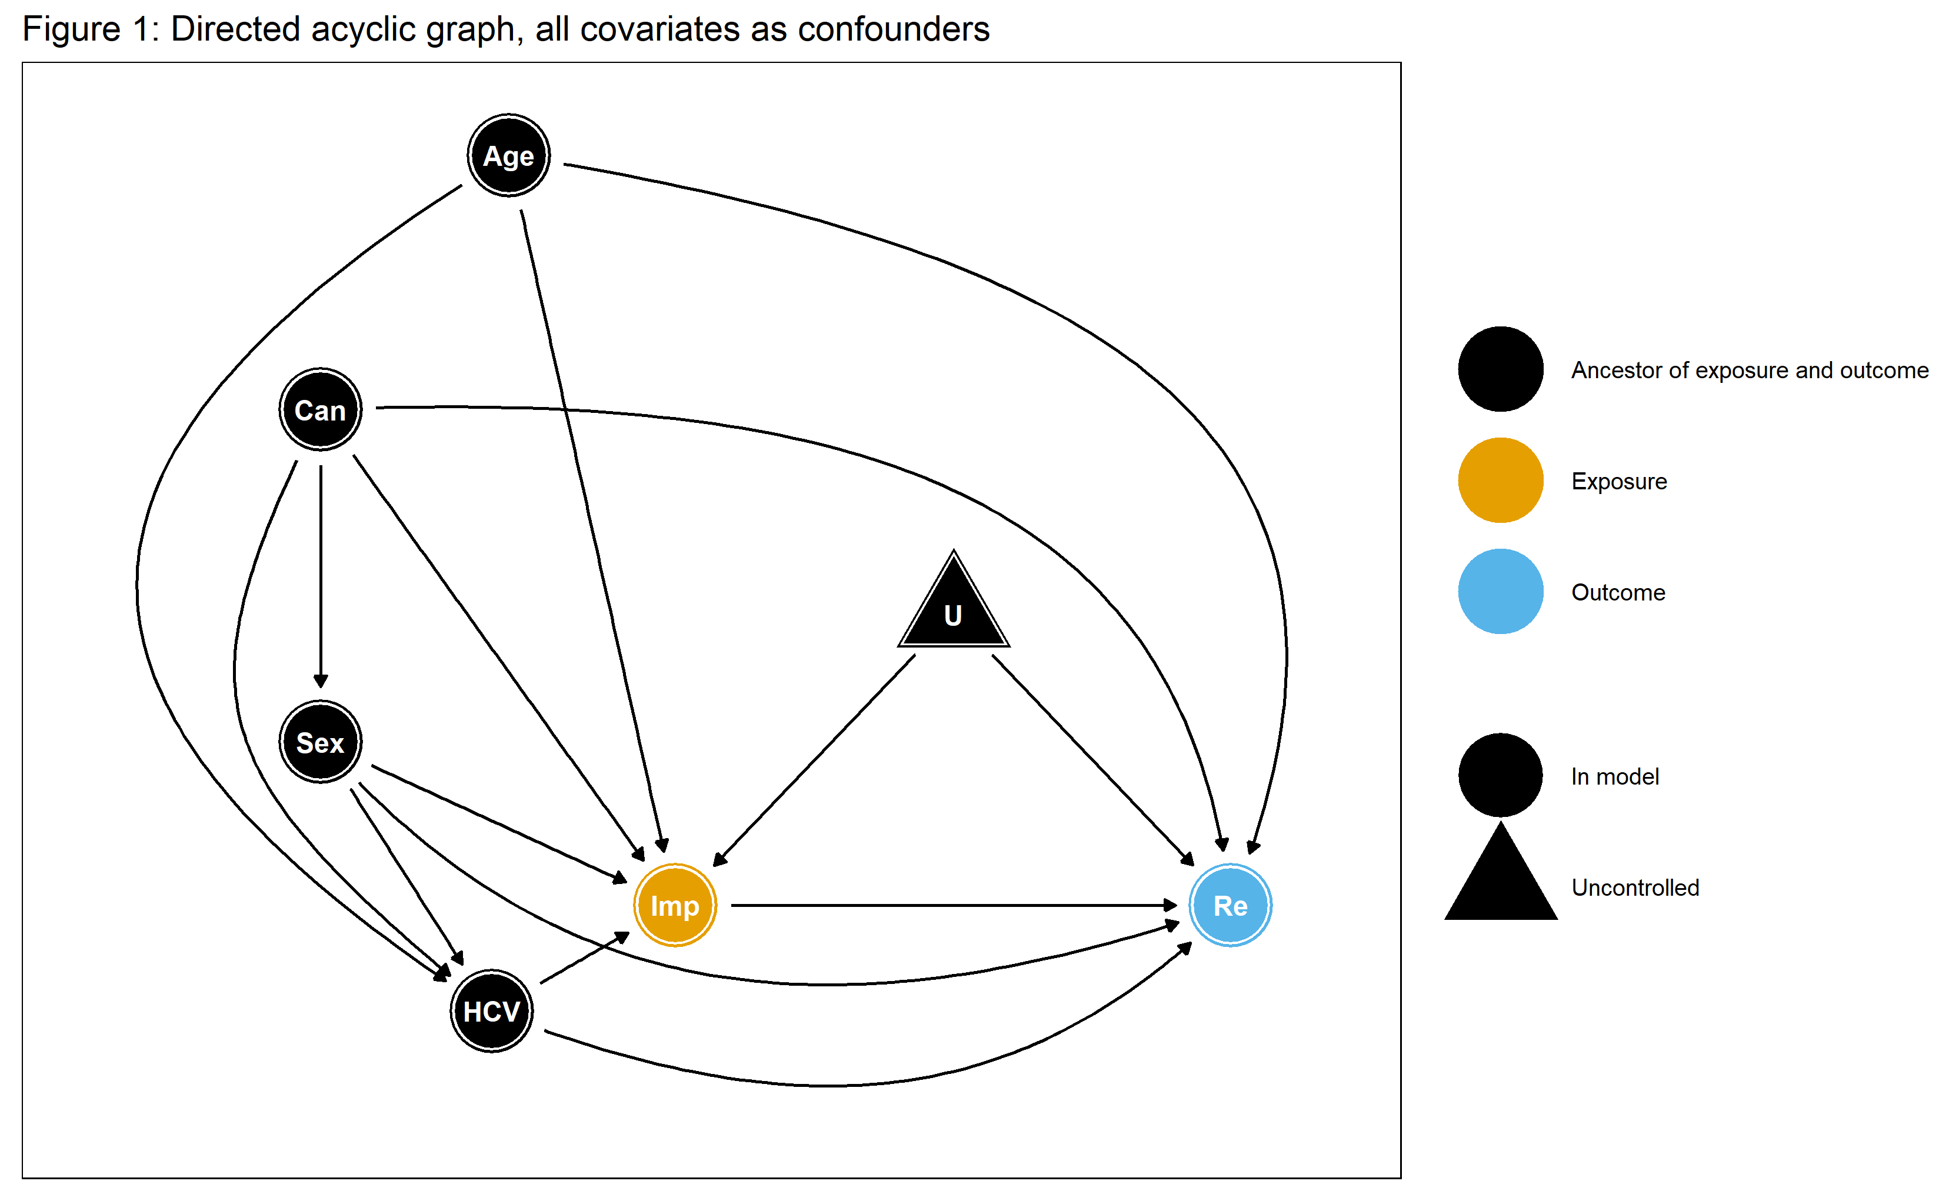
Figure A5: Directed acyclic graph, all covariates as confounders

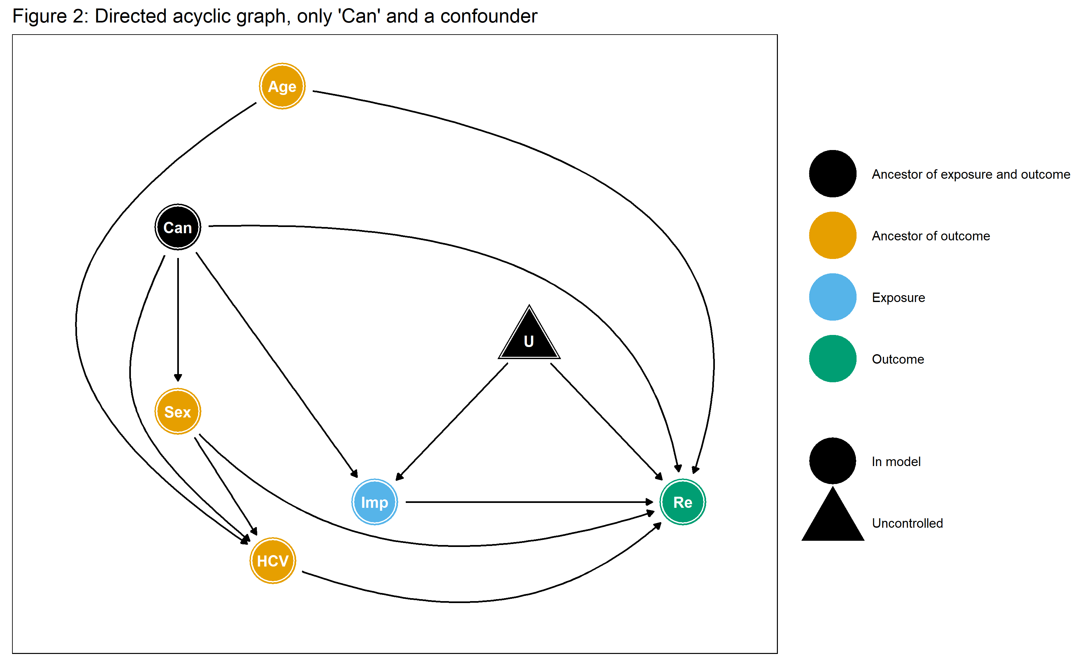
Figure A6: Directed acyclic graph, only ‘Can’ as a confounder

Propensity score model
A logistic regression model (Eq. 1), based on the DAGs in figures A5 and A6, were used to determine propensity scores for each participant:
Eq. 1: $logit(Imp)=β_{0}+β_{1}Age+β_{2}Can+β_{3}HCV+β_{4}Sex$
where $Imp$ is a dummy variable, in which $Imp=1$ indicates that the patient was OOC during the implementation phase and 0 for the pre-implementation phase, $Sex$ accounts for the possible differences in the proportion of men and women in the pre-implementation or implementation phases, $Age$ accounts for differences in the ages of patients between the two periods, $HCV$ accounts for differences in proportion of patients with histories of HCV between the two periods, and $Canada$ accounts for differences between the two periods for the proportion of patients born outside of Canada.
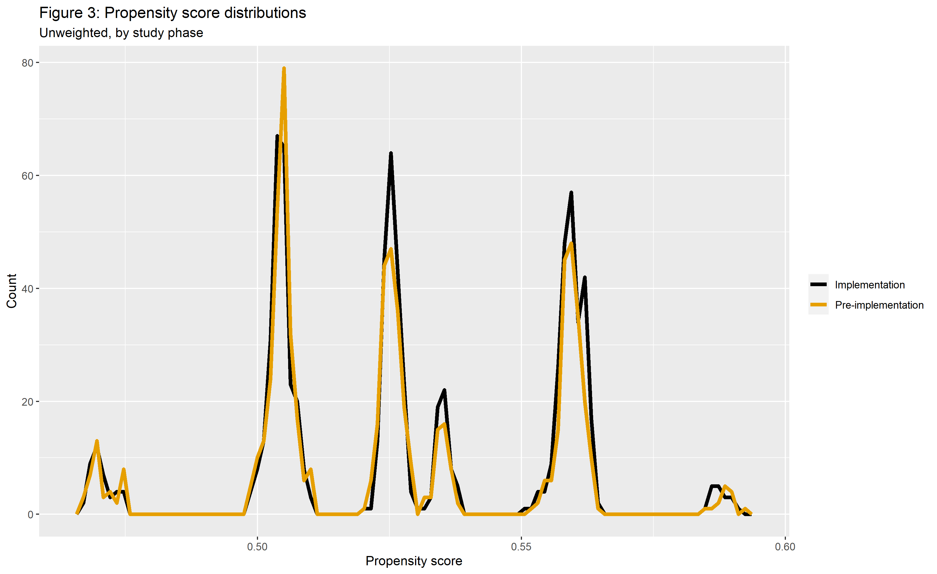
The results for this model are presented in Table A3, and the distribution of propensity scores in Figure A7.
Figure A7: Propensity score distributions, by study phase
Table A3: Propensity score model
Variable | Estimate* (95% CI) | p-value
(Intercept) | 1.224 (1.032, 1.453) | 0.020
Sex | 0.881 (0.702, 1.105) | 0.272
Age | 1.000 (0.992, 1.008) | 0.972
Canada | 0.809 (0.650, 1.007) | 0.058
HCV | 1.146 (0.838, 1.570) | 0.394
*Odds for '(Intercept)', odds ratio otherwise

Of note, the distributions of propensity scores between phases are relatively concordant, indicating that the participants in each phase are very similar.

Outcome models
The results of the unadjusted, multivariable adjusted, and propensity score adjusted models are presented in tables A4 to A6. Each model is a Poisson regression model with robust variance estimation.
Table A4: Unadjusted model
Variable | Estimate* (95% CI) | p-value
(Intercept) | 0.508 (0.457, 0.565) | < 0.001
Imp | 1.191 (1.033, 1.372) | 0.016
*Risk for '(Intercept)', risk ratio otherwise
Table A5: Multivariable adjusted model
Variable | Estimate* (95% CI) | p-value
(Intercept) | 0.576 (0.500, 0.664) | < 0.001
Imp | 1.179 (1.022, 1.359) | 0.023
Sex | 0.918 (0.783, 1.076) | 0.290
Age | 0.999 (0.993, 1.005) | 0.795
Canada | 0.799 (0.686, 0.931) | 0.004
*Risk for '(Intercept)', risk ratio otherwise
Table A6: Propensity score adjusted model
Variable | Estimate* (95% CI) | p-value
(Intercept) | 0.053 (0.013, 0.220) | < 0.001
Imp | 1.176 (1.020, 1.356) | 0.025
Propensity score | 76.702 (5.057, 1163.353) | 0.002
Propensity scores included as covariates in the model.
*Risk for '(Intercept)', risk ratio otherwise
The point estimates for the causal effect in each model are about even (ranging from 1.18 in the PS-adjusted model to 1.19 in the unadjusted model). These similar effect sizes can likely be attributed to the balance already achieved prior to adjustment. The unadjusted model had the largest standard errors, while the propensity score weighted model had the lowest (and thus, the thinnest CIs).

Pre-Post analyses: Robust poisson regression

Univariate models and contingency tables

I) Univariate models and contingency tables for reengagement by study phase
Table A7: Contingency table, reengagement by study phase, counts
 |  | ReEng
 |  | 0 | 1
Imp | 0 | 413 | 327 | 740
 | 1 | 374 | 430 | 804
 |  | 787 | 757 | 1544
Table A8: Contingency table, reengagement by study phase, proportions
 |  | ReEng
 |  | 0 | 1
Imp | 0 | 0.267 | 0.212 | 0.479
 | 1 | 0.242 | 0.278 | 0.521
 |  | 0.510 | 0.490 | 1.000

Table A9: Univariate model, reengagement as a function of study phase
Variable | Estimate* (95% CI) | p-value
(Intercept) | 0.508 (0.457, 0.565) | < 0.001
Imp | 1.191 (1.033, 1.372) | 0.016
*Risk for 'Intercept', risk ratio otherwise

II) Univariate models and contingency tables for reengagement by age
Table A10: Mean age by study phase
Imp | Mean age | Standard deviation
0 | 50.33539 | 12.39439
1 | 50.27421 | 12.52399

Table A11: Univariate model, reengagement as a function of age
Variable | Estimate* (95% CI) | p-value
(Intercept) | 0.560 (0.522, 0.600) | < 0.001
Age | 0.998 (0.993, 1.004) | 0.528
*Risk for 'Intercept', risk ratio otherwise

III) Univariate models and contingency tables for reengagement by sex
Table A12: Contingency table, study phase by sex, counts
 |  | Imp
 |  | 0 | 1
Sex | 0 | 488 | 252 | 740
 | 1 | 541 | 263 | 804
 |  | 1029 | 515 | 1544
Table A13: Contingency table, study phase by sex, proportions
 |  | Imp
 |  | 0 | 1
Sex | 0 | 0.316 | 0.163 | 0.479
 | 1 | 0.350 | 0.170 | 0.521
 |  | 0.666 | 0.334 | 1.000

Table A14: Univariate model, study phase as a function of sex
Variable | Estimate* (95% CI) | p-value
(Intercept) | 0.562 (0.516, 0.612) | < 0.001
Sex | 0.986 (0.850, 1.145) | 0.858
*Risk for 'Intercept', risk ratio otherwise

IV) Univariate models and contingency tables for reengagement by Canadian birth
Table A15: Contingency table, study phase by Canadian birth, counts
 |  | Imp
 |  | 0 | 1
Canada | 0 | 398 | 342 | 740
 | 1 | 463 | 341 | 804
 |  | 861 | 683 | 1544
Table A16: Contingency table, study phase by Canadian birth, proportions
 |  | Imp
 |  | 0 | 1
Canada | 0 | 0.258 | 0.222 | 0.479
 | 1 | 0.300 | 0.221 | 0.521
 |  | 0.558 | 0.442 | 1.000

Table A17: Univariate model, study phase as a function of Canadian birth
Variable | Estimate* (95% CI) | p-value
(Intercept) | 0.610 (0.557, 0.667) | < 0.001
Canada | 0.811 (0.702, 0.937) | 0.004
*Risk for 'Intercept', risk ratio otherwise

V) Univariate models and contingency tables for risk category by study phase

High risk category
Table A18: Contingency table, study phase by risk category (high risk or not), counts
 |  | Imp
 |  | 0 | 1
High risk cat. | 0 | 612 | 128 | 740
 | 1 | 605 | 199 | 804
 |  | 1217 | 327 | 1544
Table A19: Contingency table, study phase by risk category (high risk or not), proportions
 |  | Imp
 |  | 0 | 1
High risk cat. | 0 | 0.396 | 0.083 | 0.479
 | 1 | 0.392 | 0.129 | 0.521
 |  | 0.788 | 0.212 | 1.000

Table A20: Univariate model, study phase as a function of risk category (high risk or not)
Variable | Estimate* (95% CI) | p-value
(Intercept) | 0.540 (0.499, 0.585) | < 0.001
High risk category | 1.167 (0.990, 1.375) | 0.066
*Risk for 'Intercept', risk ratio otherwise

Table A22: Contingency table, study phase by risk category (intermediate risk or not), proportions
 |  | Imp
 |  | 0 | 1
Int. risk cat. | 0 | 0.160 | 0.319 | 0.479
 | 1 | 0.209 | 0.312 | 0.521
 |  | 0.369 | 0.631 | 1.000

Intermediate risk category
Table A21: Contingency table, study phase by risk category (intermediate risk or not), counts
 |  | Imp
 |  | 0 | 1
Int. risk cat. | 0 | 247 | 493 | 740
 | 1 | 323 | 481 | 804
 |  | 570 | 974 | 1544

Table A23: Univariate model, study phase as a function of risk category (intermediate risk or not)
Variable | Estimate* (95% CI) | p-value
(Intercept) | 0.518 (0.459, 0.584) | < 0.001
Intermediate risk category | 1.127 (0.971, 1.307) | 0.115
*Risk for 'Intercept', risk ratio otherwise

Table A25: Contingency table, study phase by risk category (low risk or not), proportions
 |  | Imp
 |  | 0 | 1
Low risk cat. | 0 | 0.402 | 0.077 | 0.479
 | 1 | 0.440 | 0.080 | 0.521
 |  | 0.843 | 0.157 | 1.000

Low risk category
Table A24: Contingency table, study phase by risk category (low risk or not), counts
 |  | Imp
 |  | 0 | 1
Low risk cat. | 0 | 621 | 119 | 740
 | 1 | 680 | 124 | 804
 |  | 1301 | 243 | 1544

Table A26: Univariate model, study phase as a function of risk category (low risk or not)
Variable | Estimate* (95% CI) | p-value
(Intercept) | 0.595 (0.553, 0.641) | < 0.001
Low risk category | 0.592 (0.466, 0.752) | < 0.001
*Risk for 'Intercept', risk ratio otherwise

References

1. Woodward B, Person A, Rebeiro P, Kheshti A, Raffanti S, Pettit A. Risk prediction tool for medical appointment attendance among HIV-infected persons with unsuppressed viremia. AIDS patient care and STDs. 2015;29(5):240-247.
2. Alam S, Moodie EE, Stephens DA. Should a propensity score model be super? The utility of ensemble procedures for causal adjustment. Statistics in medicine. 2019;38(9):1690-1702.

