Supplement

Supplementary Table 1 Comparison of surrogate scores of advanced fibrosis in PLWH with and without NAFLD
 | No Steatosis  (n = 182; 64.5%) | NAFLD  (n = 76; 27%)
Variable | n (%) | n (%) | p-value
Surrogate Scores of Advanced fibrosis
NFS n = 140
> -1.455 | 25 (26.6) | 23 (50) | 0.006
 |  |  | 0.019
< -1.455 | 69 (73.4) | 23 (50.0)
- 1.455 to 0.675 | 23 (24.5) | 20 (43.5)
> 0.675 | 2 (2.1) | 3 (6.5)
FIB-4 n = 262
> 1.3 | 62 (36.9) | 24 (33.3) | 0.597
 |  |  | 0.900
< 1.45 | 119 (96) | 53 (96.4)
> 3.25 | 5 (4.0) | 2 (3.6)
Data are expressed as numbers and percentage (%). NFS, NAFLD-Fibrosis score; FIB4, Fibrosis-4. A chi-square test was used to compare categorical values. Boldface indicates statistical significance. A p-value < 0.05 was considered statistically significant.

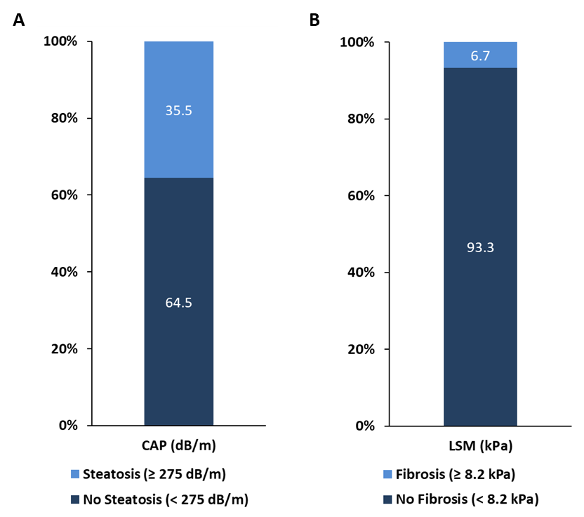
Supplementary Figure 1 Prevalence of hepatic steatosis and fibrosis in PLWH in Germany. Steatosis was present in 35.5% of PLWH (A). Significant fibrosis (LSM ≥ 8.2 kPa) was detected in 6.7% of PLWH (B). CAP, controlled attenuation parameter (dB/m); LSM, liver stiffness measurement (kPa).

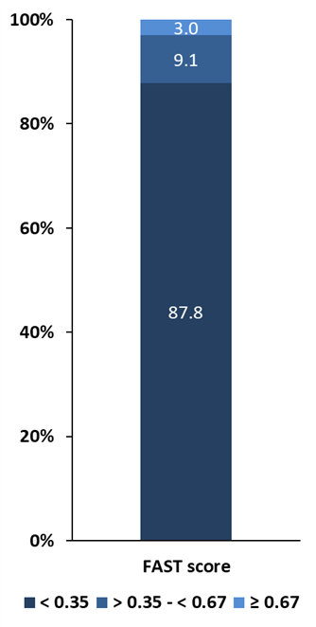
Supplementary Figure 2 Prevalence of steatohepatitis in PLWH in Germany. The FAST score ruled out steatohepatitis in 231 (87.8%) PLWH (cut-off < 0.35). A total of 32 (12.1%) PLWH had a cut-off of > 0.35, of whom 9.1% (n = 24) and 3.0% (n = 8) showed a cut-off > 0.35 - < 0.67 and ≥ 0.67, respectively.

