Figure S1. Study participant sample selection flowchart. Specific inclusion and exclusion criteria are listed for each selection step and for HIV reservoir measure analysis.
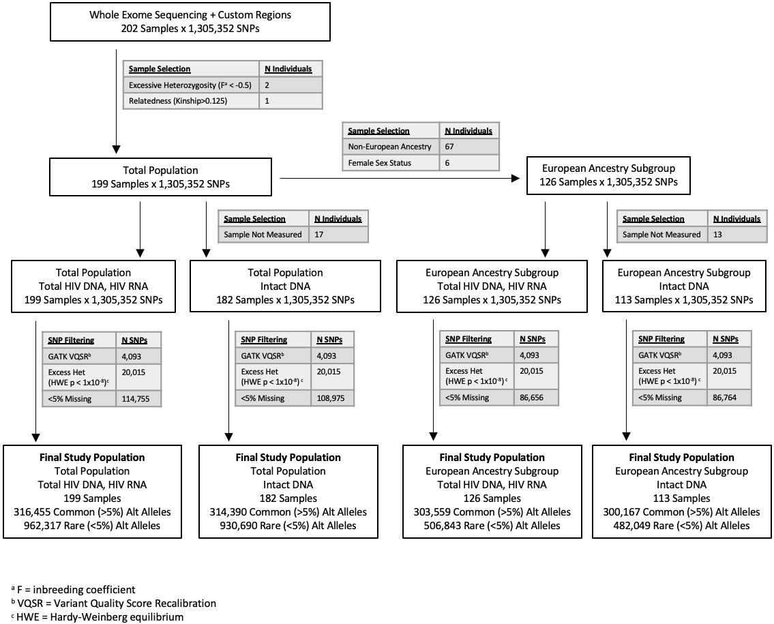

Table S1. Descriptive statistics for the study population of 202 HIV-infected ART-suppressed non-controllers. Median frequencies (with interquartile ranges) are shown below unless otherwise specified.
Descriptive Characteristic | Total  (N=202) | Early-Treatedª  (N=57) | Later-Treatedª  (N=145)
Male (%)^{b} | 192 (95%) | 57 (100%) | 135 (93%)
Age (years) | 46 (13) | 43 (12) | 47 (13)
Nadir CD4+ T cell count (cells/mm3) | 341 (259) (N=201) | 537 (333) | 300 (201) (N=144)
Maximum pre-ART HIV RNA (log₁₀copies/mL)^{c} | 5.1 (0.9) (N=197) | 5.6 (0.7) (N=54) | 5.0 (0.9) (N=143)
Duration of ART suppression (years)^{c} | 5.1 (4.1) (N=200) | 6.0 (4.3) (N=55) | 4.7 (4.0)
Timing of ART initiation (years)^{c} | 2.0 (4.5) (N=190) | 0.23 (0.19) | 3.4 (4.3) (N=133)
HIV intact DNA (log₁₀copies/10⁶ CD4+ T cells) | 1.2 (1.1) (N=182) | 1.9 (1.0) (N=46) | 1.2 (0.7) (N=136)
HIV total DNA (log₁₀copies/10⁶ CD4+ T cells) | 1.0 (1.3) | 0.4 (1.3) | 1.2 (1.2)
HIV unspliced RNA (log₁₀copies/10⁶ CD4+ T cells) | 3.2 (0.8) | 3.0 (0.8) | 3.3 (0.7)
HIV RNA/DNA | 2.3 (1.0) | 2.4 (1.0) | 2.2 (0.9)

ª Early-treated = Individuals who initiated ART within 6 months of the date of detected HIV infection; later-treated = Individuals who initiated ART after 6 months of date of detected HIV infection.
^{b} Absolute frequencies (with percent).
^{c} Adjudicated data from clinical records and patient history were available for a total of: 201 (nadir CD4+ T cell count), 197 (pre-ART HIV RNA), 200 (duration of ART suppression until date of specimen), and 190 (timing from estimate date of HIV infection to ART initiation) of the total 202 study participants.
Table S2. List of custom genes included in the whole exome sequencing. For each, custom sequencing included 50 kb upstream and 50 kb downstream of the gene start and end loci.

 | List of Genes
Immune Checkpoint Inhibitor Genes | PDCD1, CD274, PDCD1LG2, PTPN6, PTPN11, ZAP70, CD247, LCK, CSK, AKT1, AKT2, AKT3, PIK3R1, PIK3R2, PIK3R3, PIK3R4, PIK3R5, PIK3R6, FOXO3, MTOR, CCR5, HLA-A, HLA-B, HLA-C, KIR2DL1, KIR2DL2, KIR2DL3, KIR2DL4, KIR2DL5A, KIR2DL5B, KIR3DL1, KIR3DL2, KIR3DL3, KIR2DS1, KIR2DS2, KIR2DS3, KIR2DS4, KIR2DS5, KIR3DS1
Host Restriction Factor Genes | APOBEC3A, APOBEC3B, APOBEC3C, APOBEC3D, APOBEC3F, APOBEC3G, APOBEC3H, BST2, CD74, CDKN1A, CH25H, CNP, CTR9, EIF2AK2, HERC5, IFITM1, IFITM2, IFITM3, IRF1, IRF7, ISG15, LGALS3BP, MOV10, MX2, PAF1, RNASEL, RSAD2, RTF1, SAMHD1, SERINC3, SERINC5, SLFN11, SUN2, TNFRSF10A, TRIM5, TRIM11, TRIM14, PML, TRIM21, TRIM22, TRIM26, TRIM28, TRIM32, BRD4
HIV Integration Genes | BACH2, MKL2, STAT5B, CYTH1, RPTOR, TAOK1, TNRC6B, VPS45, PRKCB, MKL1, MAP4, PAK2, NSD1, KIAA0319L, SLC30A7, SHOC2, NUMA1, CDKN1B, ARID2, NFATC3, SMARCE1, EPS15L1, GATAD2A, HORMAD2, ALG12, BTBD9, OSBPL3, UBE2H, FNBP1
GO Cell Cycle Genes | ZNF503, AIF1, IFNG, IL12B, IL12A, PID1, TAL1, CDC27, CDK6, CDK4, BTG3, CDK14, CDK9, SLC9A3R1, CCPG1, RAD17, RGCC, LILRB1, LEF1, CENPF, TCF7L2, CDC7, FZR1, GATA3, CCNO, CENPE, CDKN2A, MCPH1, MAP2K1, GNB2L1, ESX1, GAS2L1, PES1, CIB1, NKX3-1, MADD, MX2, ING4, TIMELESS, THBS1, TP53, ADARB1, CDKN1B, XRCC2, PCBP4, DCLRE1B, ZNF703, YY1AP1, SOX2, TGFB2, ZW10, CDKN2D, CTBP1, ATM, DTL, MAD2L1, ZAK, TARDBP, MLF1, CENPC, MECOM, INTS3, RAB6C, ZWILCH, IRF1, CDKN3, PRR11, MASTL, CXCL8, INHA, NOTCH2, NABP1, KIF14, MAD2L1BP, KIAA0101, PNPT1, UHMK1, GADD45GIP1, ZBTB49, STK11, CENPW, SMC1A, PUM1, WDR6, KIF18B, RASSF1, PRDM5, KLLN, TGFB1, HRAS, MYC, NABP2, OVOL2, NBN, PHF13, UBE2L3, BIRC2, PRCC, CEP250, BAP1, CHFR, SMAD3, CENPT, FER, APC, SON, BOP1, GADD45A, USP3, FOXO4, DDIT3, GRK5, CDKN2C, CDKN2B, PTPRC, INHBA, NEK4, BCL2L1, ZWINT, WNT9A, IRF6, CALR, TIPIN, PML, TBRG1, CDKN1A, SIRT2, BEX2, KNTC1, USP17L2, RBM38, NEK11, BIN1, RB1, MEN1, HPGD, TCF3, ETS1, LRP6, GMNN, ANKRD17, BMP4, BMP2, ZNF143, TAF6, SOX9, DAPK3, RPS15A, TRIM32, RNF167, RARA, THAP5, C6orf89, RPS6KA2, PTPRK, FOXM1, RPRD1B, CYLD, THAP1, ASUN, PIM3, TXLNG, ZNF268, SLC25A33, GBF1, BRINP1, SIRT1, BMP7, TRIM21, TBX3, AFAP1L2, TP73, ALOX15B, SFRP1, PLK1, HMGA2, MCIDAS, E4F1, NLRP2P, BRCA1, KDM8, DUSP3, EIF4E, ASNS, ABCB1, LATS2, MIF, CCNK, USP2, USP22, CCNB1, TRIM35, TERF1, FBXL15, PLK3, RRP8, INSM1, FOXA1, MDM2, PLK2, XPC, TFAP4, ARPP19, NES, UHRF2, TPD52L1, DDB1, PKN2, POLE, PIM2, MED25, ACVR1, RCC1, HMGN5, MLXIPL, SETMAR, SCRIB, MYBBP1A, SPHK1, DLG1, FOXC1, DGKZ, PKD2, EIF4EBP1, FOXE3, USP37, CDCA5, NUDT16, NPPC, RPS6KB1, CDC25C, CDC25B, ERCC2, PTPN3, ERCC3, SPDYA, PRKCA, CCND1, ZNF16, USH1C, SOX11, GATA6, HINFP, PHF8, CACUL1, LATS1, FGF10, BIRC5, CHEK2, CCNY, TAF2, DAB2IP, CRLF3, BRSK2, ACVR1B, TFDP3, GAS1, DBF4B, PTEN, KCNH5, CDC73, ID2, PHB2, DDX3X, LCMT1, SUSD2, PPP1R1C, INO80, VPS4B, H2AFY, GEN1, TPR, RAC1, XRCC3, RAD51C, TP63, E2F1, RAB11A, DACT1, C10orf99, UBE2E2, USP47, ZC3H12D, SLFN11, RCC2, LSM11, STXBP4, NEK10, STOX1, BRD7, RAD51B, FHL1, BRD4, LSM10, ATP2B4, DYNC1LI1, JADE1, PCID2, PLK5, WIZ, C8orf4, PTPN6, ZNF655, KANK2, ANAPC15, MUC1, CRADD, PPP2R5C, SOX4, CASP2, PIDD1, MDM4, CYP27B1, FBXO31, FOXN3, RPA2, TAOK3, RPS27L, CDK5RAP3, RFWD3, BLM, ATF2, PRKDC, DUX4, RHNO1, RINT1, BRCC3, RBBP8, TAOK2, BABAM1, MAPKAPK2, BRE, UIMC1, BRSK1, WAC, CDC14B, FAM175A, TAOK1, CHEK1, NEK6, CLSPN

Definitions of the above custom gene set lists are included below:

Immune Checkpoint Inhibitor Genes. Previously reported immune checkpoint inhibitor genes associated with PD1-signaling in Ref (45).
Host Restriction Factor Genes. Previously reported host restriction factor genes in Ref. (46)
HIV Integration Genes. Previously reported genes into which HIV integrates 3 or more times among the 5 patients in Ref (47).
Gene Ontology (GO, Biologic Processes) Cell Cycle Genes. Genes with "cell cycle" annotation either directly or inferred, or inferred annotation of "virus", "virion", or "viral", in MSigDB (Ref (48)).

Figure S2. HIV total DNA, unspliced RNA, RNA/DNA, and intact DNA were associated with timing of ART initiation. Spearman correlation and p-values are shown in the inset boxes.
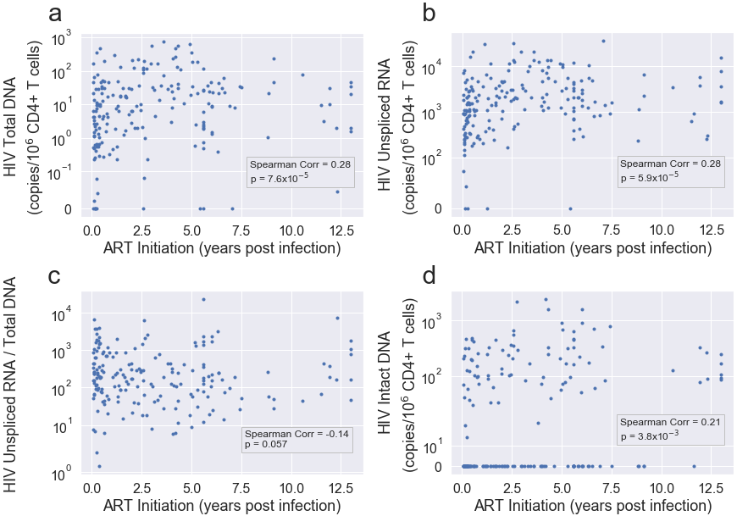
Figure S3. Nadir CD4+ T cell counts were associated with measures of the HIV reservoir: total DNA (a), unspliced RNA (b), RNA/DNA (c), and intact DNA (d). Spearman correlation and corresponding p-value are shown in the inset boxes.
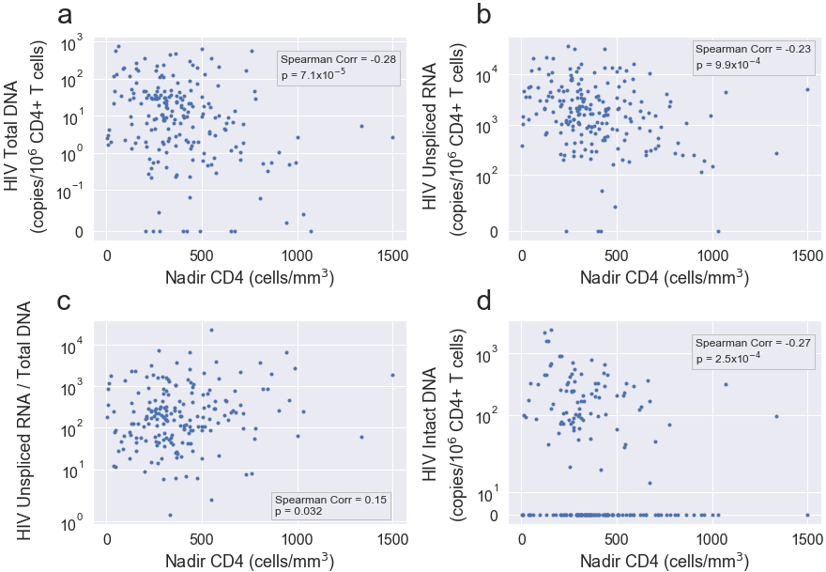

Figure S4. Maximum pre-ART viral loads prior ART initiation (and at least 1 year prior to specimen collection for these analyses) were not associated with measures of the HIV reservoir: total DNA (a), unspliced RNA (b), RNA/DNA (c), and intact DNA (d). Spearman correlation and corresponding p-value are shown in the inset boxes.
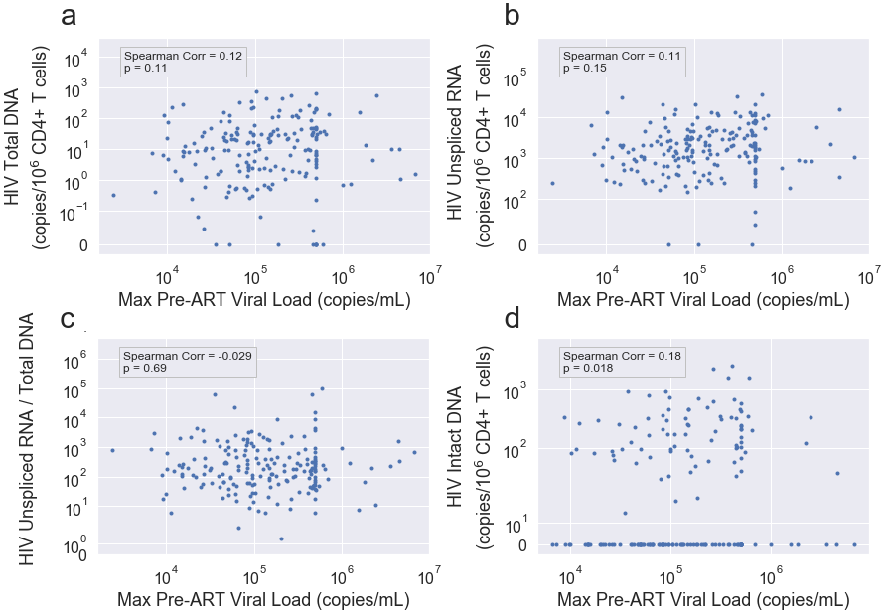

Figure S5. Duration of ART suppression at the time of specimen collection was not associated with measures of the HIV reservoir: total DNA (a), unspliced RNA (b), RNA/DNA (c), and intact DNA (d). Spearman correlation and corresponding p-value are shown in the inset boxes.
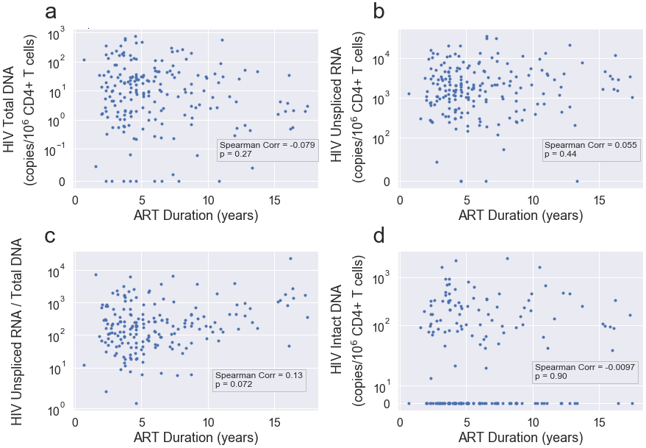

Figure S6. Measures of HIV total DNA (a) and HIV intact DNA (b) were statistically significantly correlated with HIV unspliced RNA, but HIV total DNA was not correlated with intact DNA (c). Spearman correlation and p-values are shown in the inset boxes.
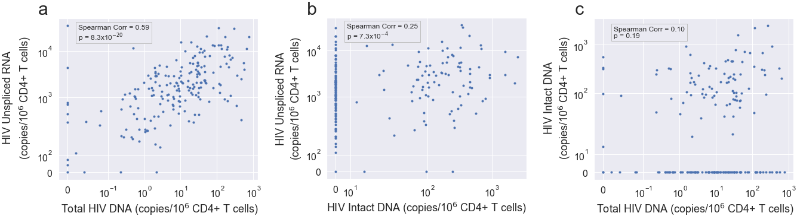

Figure S7. Distribution of the total number of host variants (a), as well as all exonic variants (b) sequenced in the study population.

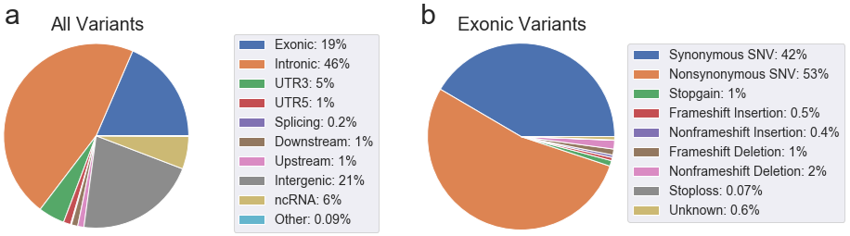
Table S3. HLA allele associations with HIV total DNA (copies/10⁶ CD4+ T cells).

HIV Total DNA
 |  | Full Cohort |  |  |  | European Subgroup
 | HLA Alleleª | MAC^{b} | Beta^{c} | p^{d} | q^{e} | MAC^{b} | Beta^{c} | p^{d} | q^{e}
1 | B*57:01 | 10 | -1.6 | *0.032 | 0.13 | 9 | -1.44 | *0.041 | 0.12
2 | B*27:05 | 11 | 0.79 | 0.26 | 0.36 | 4 | 0.37 | 0.73 | --
3 | B*14 | 24 | 0.41 | 0.36 | 0.41 | 19 | 0.083 | 0.86 | 0.86
4 | C*08:02 | 23 | 0.23 | 0.62 | 0.62 | 17 | -0.15 | 0.77 | 0.86
5 | B*52 | 3 | 1.7 | 0.2 | -- | 2 | 1.5 | 0.32 | --
6 | A*25 | 7 | 0.96 | 0.27 | 0.36 | 5 | 1.4 | 0.13 | --
7 | B*35 | 46 | -0.81 | *0.021 | 0.13 | 32 | -0.6 | 0.11 | 0.22
8 | C*07 | 107 | 0.4 | 0.14 | 0.28 | 74 | 0.76 | *0.012 | 0.072
9 | Composite Variable | N/A | 0.32 | 0.066 | 0.18 | N/A | 0.13 | 0.48 | 0.72

ª Alleles 1-6 were previously designated as “protective” alleles, while alleles 7-8 were defined as “risk” alleles, in the International HIV Controllers genomewide association study (16). The “Composite Variable” combines each of the above alleles, counting each protective allele as +1 and each risk allele as -1.
^{b} We list minor allele count (MAC), rather than MAF, due to the multiallelic nature of these variants. Alleles with MAC<=5 are greyed out to highlight low observed frequencies in our study population.
^{c} Beta estimate from multivariate linear mixed model adjusted for age, sex, nadir CD4+ T cell count, timing of ART initiation, and ancestry.
^{d} Two-sided p-values; p<0.05 are annotated with asterisks.
^{e} Two-sided false discovery rate (FDR)-adjusted Benjamini-Hochberg q-values.
Table S4. HLA allele associations with HIV unspliced RNA (copies/10⁶ CD4+ T cells).
HIV Unspliced RNA
 |  | Full Cohort |  |  |  | European Subgroup
 | HLA Alleleª | MAC^{b} | Beta^{c} | p^{d} | q^{e} | MAC^{b} | Beta^{c} | p^{d} | q^{e}
1 | B*57:01 | 10 | -1.5 | *4.2x10⁻⁴ | 0.0033 | 9 | -1.5 | *5.3x10⁻⁴ | 0.0032
2 | B*27:05 | 11 | 0.39 | 0.35 | 0.7 | 4 | 0.13 | 0.85 | --
3 | B*14 | 24 | 0.041 | 0.88 | 0.88 | 19 | -0.047 | 0.88 | 0.88
4 | C*08:02 | 23 | -0.078 | 0.77 | 0.88 | 17 | -0.14 | 0.67 | 0.8
5 | B*52 | 3 | 0.56 | 0.47 | -- | 2 | -0.21 | 0.83 | --
6 | A*25 | 7 | 0.15 | 0.77 | 0.88 | 5 | 0.43 | 0.48 | --
7 | B*35 | 46 | -0.44 | *0.032 | 0.13 | 32 | -0.24 | 0.31 | 0.62
8 | C*07 | 107 | 0.2 | 0.21 | 0.56 | 74 | 0.41 | *0.034 | 0.1
9 | Composite Variable | N/A | 0.058 | 0.57 | 0.88 | N/A | -0.056 | 0.64 | 0.8

ª Alleles 1-6 were previously designated as “protective” alleles, while alleles 7-8 were defined as “risk” alleles, in the International HIV Controllers genomewide association study (16). The “Composite Variable” combines each of the above alleles, counting each protective allele as +1 and each risk allele as -1.
^{b} We list minor allele count (MAC), rather than MAF, due to the multiallelic nature of these variants. Alleles with MAC<=5 are greyed out to highlight low observed frequencies in our study population.
^{c} Beta estimate from multivariate linear mixed model adjusted for age, sex, nadir CD4+ T cell count, timing of ART initiation, and ancestry.
^{d} Two-sided p-values; p<0.05 are annotated with asterisks.
^{e} Two-sided false discovery rate (FDR)-adjusted Benjamini-Hochberg q-values.
Table S5. HLA associations with HIV unspliced RNA/ total DNA.
HIV RNA/DNA
 |  | Full Cohort |  |  |  | European Subgroup
 | HLA Alleleª | MAC^{b} | Beta^{c} | p^{d} | q^{e} | MAC^{b} | Beta^{c} | p^{d} | q^{e}
1 | B*57:01 | 10 | 0.067 | 0.91 | 0.91 | 9 | -0.091 | 0.88 | 0.98
2 | B*27:05 | 11 | -0.41 | 0.48 | 0.55 | 4 | -0.23 | 0.8 | --
3 | B*14 | 24 | -0.37 | 0.31 | 0.55 | 19 | -0.13 | 0.76 | 0.98
4 | C*08:02 | 23 | -0.3 | 0.41 | 0.55 | 17 | 0.01 | 0.98 | 0.98
5 | B*52 | 3 | -1.1 | 0.3 | -- | 2 | -1.7 | 0.19 | --
6 | A*25 | 7 | -0.81 | 0.25 | 0.55 | 5 | -0.99 | 0.23 | --
7 | B*35 | 46 | 0.37 | 0.2 | 0.55 | 32 | 0.35 | 0.28 | 0.56
8 | C*07 | 107 | -0.2 | 0.35 | 0.55 | 74 | -0.35 | 0.19 | 0.56
9 | Composite Variable | N/A | -0.26 | 0.064 | 0.51 | N/A | -0.19 | 0.25 | 0.56

ª Alleles 1-6 were previously designated as “protective” alleles, while alleles 7-8 were defined as “risk” alleles, in the International HIV Controllers genomewide association study (16). The “Composite Variable” combines each of the above alleles, counting each protective allele as +1 and each risk allele as -1.
^{b} We list minor allele count (MAC), rather than MAF, due to the multiallelic nature of these variants. Alleles with MAC<=5 are greyed out to highlight low observed frequencies in our study population.
^{c} Beta estimate from multivariate linear mixed model adjusted for age, sex, nadir CD4+ T cell count, timing of ART initiation, and ancestry.
^{d} Two-sided p-values; p<0.05 are annotated with asterisks.
^{e} Two-sided false discovery rate (FDR)-adjusted Benjamini-Hochberg q-values.

Table S6. HLA associations with HIV intact DNA (copies/10⁶ CD4+ T cells).
HIV Intact DNA
 |  | Full Cohort |  |  |  | European Subgroup
 | HLA Alleleª | MAC^{b} | Beta^{c} | p^{d} | q^{e} | MAC^{b} | Beta^{c} | p^{d} | q^{e}
1 | B*57:01 | 9 | -0.59 | 0.24 | 0.77 | 8 | -0.42 | 0.43 | 0.76
2 | B*27:05 | 11 | -0.48 | 0.29 | 0.77 | 4 | -1.4 | 0.057 | --
3 | B*14 | 20 | 0.072 | 0.82 | 0.9 | 16 | -0.11 | 0.76 | 0.76
4 | C*08:02 | 19 | 0.039 | 0.9 | 0.9 | 15 | -0.15 | 0.67 | 0.76
5 | B*52 | 3 | -1.1 | 0.21 | -- | 2 | -1.2 | 0.25 | --
6 | A*25 | 6 | -1.2 | 0.054 | 0.43 | 4 | -1.5 | *0.044 | --
7 | B*35 | 43 | -0.069 | 0.78 | 0.9 | 29 | 0.21 | 0.46 | 0.76
8 | C*07 | 101 | -0.09 | 0.61 | 0.9 | 69 | 0.1 | 0.66 | 0.76
9 | Composite Variable | N/A | -0.1 | 0.4 | 0.8 | N/A | -0.25 | 0.079 | 0.47

ª Alleles 1-6 were previously designated as “protective” alleles, while alleles 7-8 were defined as “risk” alleles, in the International HIV Controllers genomewide association study (16). The “Composite Variable” combines each of the above alleles, counting each protective allele as +1 and each risk allele as -1.
^{b} We list minor allele count (MAC), rather than MAF, due to the multiallelic nature of these variants. Alleles with MAC<=5 are greyed out to highlight low observed frequencies in our study population.
^{c} Beta estimate from multivariate linear mixed model adjusted for age, sex, nadir CD4+ T cell count, timing of ART initiation, and ancestry.
^{d} Two-sided p-values; p<0.05 are annotated with asterisks.
^{e} Two-sided false discovery rate (FDR)-adjusted Benjamini-Hochberg q-values.

Table S7. Full list of single nucleotide polymorphisms (SNPs) from Table 1 that were associated with HIV total DNA (upper table) and unspliced RNA (lower table) in the total study population, ranked by p-value. Benjamini-Hochberg false discovery rate (FDR) adjusted q<0.05 shown in bold font.

SNP | Chrom | Position | Nearest Gene | Gene Location | MAFª | Beta^{b} | eQTL Effect^{c} | PVE^{d} | p^{e} | q^{f} | Description
HIV TOTAL DNA
Full Cohort
rs34814968 | chr21 | 41421873 | MX1 | 5’UTR^{g} | 0.45 | -1.2 | -0.26 | 0.15 | 1.3x10⁻⁷ | 0.02 | MX1 is an interferon stimulated gene and encodes for MX1 (MX Dynamin Like GTPase 1). It is upregulated in HIV+ vs. uninfected individuals^{[88]}, associated with higher viremia among HIV+ individuals^{[89]}, and linked to HIV-1 latency in cell lines and HIV+ PBMC samples^{[90]}. A closely related paralog gene (MX2), encodes for MX2, a potent antiviral host restriction factor which acts against HIV-1 virus^{[57, 58]}.
rs459482 | chr21 | 41421864 | MX1 | 5’UTR^{g} | 0.45 | -1.2 | -0.26 | 0.15 | 1.3x10⁻⁷ | 0.02
rs74867009 | chr12 | 25063777 | IRAG2; LRMP | 5’UTR^{g} | 0.06 | -2.5 |  | 0.15 | 1.5x10⁻⁷ | 0.02 | Inositol 1, 4,5-triphosphate receptor associated 2 gene (IRAG2), also known as lymphoid-restricted membrane protein (LRMP), delivers peptides to major MHC class I molecules^{[64]}, and is differentially expressed in lymphatic tissue and peripheral blood mononuclear cells (PBMCs) of HIV+ individuals^{[65]}, and in response to ART initiation and cessation during treatment interruption^{[66]}.
rs469073 | chr21 | 41444274 | MX1 | Intronic | 0.50 | 1.1 |  | 0.13 | 5.8x10⁻⁷ | 0.02
rs462687 | chr21 | 41425130 | MX1 | Intronic | 0.51 | -1.1 | -0.26 | 0.13 | 8.4x10⁻⁷ | 0.02
rs364105 | chr21 | 41446429 | MX1 | Intronic | 0.51 | 1.1 |  | 0.13 | 8.7x10⁻⁷ | 0.02
rs364203 | chr21 | 41446430 | MX1 | Intronic | 0.51 | 1.1 |  | 0.13 | 8.7x10⁻⁷ | 0.02
rs469483 | chr21 | 41446588 | MX1 | Intronic | 0.51 | 1.1 |  | 0.13 | 8.7x10⁻⁷ | 0.02
rs364199 | chr21 | 41446205 | MX1 | Intronic | 0.51 | 1.1 |  | 0.13 | 9.5x10⁻⁷ | 0.02
rs363882 | chr21 | 41446346 | MX1 | Intronic | 0.51 | 1.1 |  | 0.13 | 9.5x10⁻⁷ | 0.02
rs469390 | chr21 | 41446003 | MX1 | Exonic | 0.51 | 1.1 |  | 0.13 | 9.5x10⁻⁷ | 0.02
rs364143 | chr21 | 41447005 | MX1 | Intronic | 0.51 | 1.1 |  | 0.13 | 9.5x10⁻⁷ | 0.02
rs364043 | chr21 | 41447022 | MX1 | Intronic | 0.51 | 1.1 |  | 0.13 | 9.5x10⁻⁷ | 0.02
rs369454 | chr21 | 41447036 | MX1 | Intronic | 0.51 | 1.1 |  | 0.13 | 9.5x10⁻⁷ | 0.02
rs365628 | chr21 | 41447039 | MX1 | Intronic | 0.51 | 1.1 |  | 0.13 | 9.5x10⁻⁷ | 0.02
rs467773 | chr21 | 41446179 | MX1 | Intronic | 0.51 | 1.1 |  | 0.13 | 9.5x10⁻⁷ | 0.02
rs467960 | chr21 | 41440964 | MX1 | Exonic | 0.47 | 1.1 | 0.13 | 0.12 | 1.2x10⁻⁶ | 0.02
rs464138 | chr21 | 41426246 | MX1 | 5’UTR^{g} | 0.41 | -1.0 | -0.27 | 0.12 | 1.5x10⁻⁶ | 0.02
rs469383 | chr21 | 41445738 | MX1 | Intronic | 0.51 | 1.1 |  | 0.12 | 1.5x10⁻⁶ | 0.02
rs464783 | chr21 | 41424553 | MX1 | Intronic | 0.40 | -1.1 | -0.28 | 0.12 | 1.5x10⁻⁶ | 0.02
rs459498 | chr21 | 41423100 | MX1 | Intronic | 0.40 | -1.1 | -0.28 | 0.12 | 1.5x10⁻⁶ | 0.02
rs461981 | chr21 | 41422154 | MX1 | Intronic | 0.40 | -1.1 | -0.28 | 0.12 | 1.5x10⁻⁶ | 0.02
rs148214 | chr21 | 41442291 | MX1 | Intronic | 0.48 | 1.1 | 0.12 | 0.12 | 1.7x10⁻⁶ | 0.02
rs467987 | chr21 | 41442345 | MX1 | Intronic | 0.48 | 1.1 | 0.12 | 0.12 | 1.7x10⁻⁶ | 0.02
rs468704 | chr21 | 41442549 | MX1 | Intronic | 0.48 | 1.1 | 0.12 | 0.12 | 1.7x10⁻⁶ | 0.02
rs468440 | chr21 | 41442594 | MX1 | Intronic | 0.48 | 1.1 | 0.12 | 0.12 | 1.7x10⁻⁶ | 0.02
rs468747 | chr21 | 41442939 | MX1 | Intronic | 0.48 | 1.1 | 0.12 | 0.12 | 1.7x10⁻⁶ | 0.02
rs468414 | chr21 | 41443367 | MX1 | Intronic | 0.48 | 1.1 | 0.12 | 0.12 | 1.7x10⁻⁶ | 0.02
rs10670165 | chr21 | 41443170 | MX1 | Intronic | 0.48 | 1.1 | 0.12 | 0.12 | 1.7x10⁻⁶ | 0.02
rs364197 | chr21 | 41443442 | MX1 | Intronic | 0.48 | 1.1 | 0.12 | 0.12 | 1.7x10⁻⁶ | 0.02
rs468786 | chr21 | 41443293 | MX1 | Intronic | 0.48 | 1.1 | 0.12 | 0.12 | 1.8x10⁻⁶ | 0.02
rs1638369 | chr21 | 41444193 | MX1 | Intronic | 0.48 | 1.1 | 0.12 | 0.12 | 1.8x10⁻⁶ | 0.02
rs462698 | chr21 | 41444139 | MX1 | Intronic | 0.48 | 1.1 |  | 0.12 | 1.8x10⁻⁶ | 0.02
rs469012 | chr21 | 41443535 | MX1 | Intronic | 0.48 | 1.1 | 0.12 | 0.12 | 1.8x10⁻⁶ | 0.02
rs456018 | chr21 | 41421797 | MX1 | Intronic | 0.40 | -1.1 | -0.28 | 0.12 | 2.1x10⁻⁶ | 0.02
rs35477708 | chr21 | 41446620 | MX1 | Intronic | 0.48 | 1.0 |  | 0.12 | 2.8x10⁻⁶ | 0.02
rs469270 | chr21 | 41445250 | MX1 | Intronic | 0.48 | 1.0 | 0.12 | 0.12 | 2.8x10⁻⁶ | 0.02
rs467537 | chr21 | 41447082 | MX1 | Intronic | 0.48 | 1.1 |  | 0.11 | 3.1x10⁻⁶ | 0.03
rs469093 | chr21 | 41444578 | MX1 | Intronic | 0.48 | 1.1 | 0.12 | 0.11 | 3.1x10⁻⁶ | 0.03
rs457274 | chr21 | 41420558 | MX1 | 5’UTR^{g} | 0.41 | -1.0 | -0.27 | 0.11 | 3.2x10⁻⁶ | 0.03
rs467574 | chr21 | 41447278 | MX1 | Intronic | 0.41 | 1.1 | 0.12 | 0.11 | 3.7x10⁻⁶ | 0.03
rs751660317 | chr2 | 28786774 | PPP1CB | Intronic | 0.07 | -1.8 |  | 0.11 | 4.1x10⁻⁶ | 0.03 | PPP1CB encodes for protein phosphatase 1 catalytic subunit beta, which reduces the antiviral potency of MX2 against HIV^{[59]}. It encodes for a subunit of PP1; PP1 is involved in transcription of HIV-1; inhibition of PP1 inhibits HIV-1 transcription^{[63]}.
rs469288 | chr21 | 41445655 | MX1 |  | 0.52 | 1.0 |  | 0.11 | 7.2x10⁻⁶ | 0.05
rs776025235 | chr6 | 51638799 | PKHD1 | Intronic | 0.09 | -1.7 |  | 0.09 | 2.5x10⁻⁵ | 0.17 | Polycystic Kidney and Hepatic Disease 1 gene (PKHD1) is predicted to have a transmembrane-spanning domain and an immunoglobulin-like plexin-transcription-factor domain. No direct relationship with HIV found in the literature.
N/A | chrX | 41382082 | DDX3X; NYX | Intergenic | 0.18 | -1.4 |  | 0.09 | 2.5x10⁻⁵ | 0.17 | DDX3X regulates the production of type I interferons^{[67]} and encodes for DEAD-Box Helicase 3 X-Linked, a protein that shuttles HIV-1 RNA from the nucleus to the cytoplasm. DDX3X is upregulated in HIV-infected cells; knockdown of DDX3X suppresses HIV-1 replication^{[68]}, and plays a key role in innate antimicrobial immunity^{[67]}.
rs468259 | chr21 | 41453222 | MX1 | Intronic | 0.48 | 0.9 |  | 0.09 | 2.6x10⁻⁵ | 0.18
rs17506750 | chr14 | 32599402 | AKAP6 | Intronic | 0.07 | -1.8 |  | 0.09 | 3.0x10⁻⁵ | 0.20 | AKAP6 encodes for Protein Kinase A Anchoring Protein 6, which binds to regulatory subunits of protein kinase A (PKA) and anchors them to the nuclear membrane. PKA activation has been associated with HIV-1 infection, T cell proliferation, and dysfunction^{[69, 70]}.
rs469066 | chr21 | 41444089 | MX1 | Intronic | 0.64 | 1.0 | 0.24 | 0.09 | 3.3x10⁻⁵ | 0.22
rs463856 | chr21 | 41431931 | MX1 | Intronic | 0.64 | -1.0 |  | 0.09 | 3.6x10⁻⁵ | 0.23
European Ancestry Subgroup
rs469483 | chr21 | 41446588 | MX1 | Intron/Exon/  5’UTR^{g} | 0.55 | 1.3 |  | 0.20 | 9.2x10⁻⁷ | 0.02 | MX1 is an interferon stimulated gene and encodes for MX1 (MX Dynamin Like GTPase 1). It is upregulated in HIV+ vs. uninfected individuals^{[88]}, associated with higher viremia among HIV+ individuals^{[89]}, and linked to HIV-1 latency in cell lines and HIV+ PBMC samples^{[90]}. A closely related paralog gene (MX2), encodes for MX2, a potent antiviral host restriction factor which acts against HIV-1 virus^{[57, 58]}.
rs364203 | chr21 | 41446430 | MX1 | Intronic | 0.55 | 1.3 |  | 0.20 | 9.2x10⁻⁷ | 0.02
rs469288 | chr21 | 41445655 | MX1 | Intronic | 0.55 | 1.3 |  | 0.20 | 9.2x10⁻⁷ | 0.02
rs364105 | chr21 | 41446429 | MX1 | Intronic | 0.55 | 1.3 |  | 0.20 | 9.2x10⁻⁷ | 0.02
rs369454 | chr21 | 41447036 | MX1 | Intronic | 0.54 | 1.3 |  | 0.20 | 1.0x10⁻⁶ | 0.02
rs364043 | chr21 | 41447022 | MX1 | Intronic | 0.54 | 1.3 |  | 0.20 | 1.0x10⁻⁶ | 0.02
rs364143 | chr21 | 41447005 | MX1 | Intronic | 0.54 | 1.3 |  | 0.20 | 1.0x10⁻⁶ | 0.02
rs469073 | chr21 | 41444274 | MX1 | Intronic | 0.54 | 1.3 |  | 0.20 | 1.0x10⁻⁶ | 0.02
rs365628 | chr21 | 41447039 | MX1 | Intronic | 0.54 | 1.3 |  | 0.20 | 1.0x10⁻⁶ | 0.02
rs363882 | chr21 | 41446346 | MX1 | Intronic | 0.54 | 1.3 |  | 0.20 | 1.0x10⁻⁶ | 0.02
rs364199 | chr21 | 41446205 | MX1 | Intronic | 0.54 | 1.3 |  | 0.20 | 1.0x10⁻⁶ | 0.02
rs467773 | chr21 | 41446179 | MX1 | Intronic | 0.54 | 1.3 |  | 0.20 | 1.0x10⁻⁶ | 0.02
rs469390 | chr21 | 41446003 | MX1 | Exonic | 0.54 | 1.3 |  | 0.20 | 1.0x10⁻⁶ | 0.02
rs469383 | chr21 | 41445738 | MX1 | Intronic | 0.54 | 1.2 |  | 0.19 | 1.7x10⁻⁶ | 0.04
rs34814968 | chr21 | 41421873 | MX1 | 5’UTR^{g} | 0.46 | -1.2 | -0.26 | 0.18 | 5.0x10⁻⁶ | 0.08
rs459482 | chr21 | 41421864 | MX1 | 5’UTR^{g} | 0.46 | -1.2 | -0.26 | 0.18 | 5.0x10⁻⁶ | 0.08
. | chr21 | 41424232 | MX1 | Intronic | 0.39 | -1.2 |  | 0.18 | 5.4x10⁻⁶ | 0.08
rs464138 | chr21 | 41426246 | MX1 | 5’UTR^{g} | 0.44 | -1.1 | -0.27 | 0.17 | 5.9x10⁻⁶ | 0.08
rs457274 | chr21 | 41420558 | MX1 | 5’UTR^{g} | 0.44 | -1.1 | -0.27 | 0.17 | 7.8x10⁻⁶ | 0.08
rs468414 | chr21 | 41443367 | MX1 | Intronic | 0.53 | 1.1 | 0.12 | 0.17 | 7.9x10⁻⁶ | 0.08
rs35477708 | chr21 | 41446620 | MX1 | Intronic | 0.53 | 1.1 |  | 0.17 | 7.9x10⁻⁶ | 0.08
rs364197 | chr21 | 41443442 | MX1 | Intronic | 0.53 | 1.1 | 0.12 | 0.17 | 7.9x10⁻⁶ | 0.08
rs469270 | chr21 | 41445250 | MX1 | Intronic | 0.53 | 1.1 | 0.12 | 0.17 | 7.9x10⁻⁶ | 0.08
rs148214 | chr21 | 41442291 | MX1 | Intronic | 0.53 | 1.1 | 0.12 | 0.17 | 7.9x10⁻⁶ | 0.08
rs10670165 | chr21 | 41443170 | MX1 | Intronic | 0.53 | 1.1 | 0.12 | 0.17 | 7.9x10⁻⁶ | 0.08
rs468747 | chr21 | 41442939 | MX1 | Intronic | 0.53 | 1.1 | 0.12 | 0.17 | 7.9x10⁻⁶ | 0.08
rs468440 | chr21 | 41442594 | MX1 | Intronic | 0.53 | 1.1 | 0.12 | 0.17 | 7.9x10⁻⁶ | 0.08
rs467987 | chr21 | 41442345 | MX1 | Intronic | 0.53 | 1.1 | 0.12 | 0.17 | 7.9x10⁻⁶ | 0.08
rs468704 | chr21 | 41442549 | MX1 | Intronic | 0.53 | 1.1 | 0.12 | 0.17 | 7.9x10⁻⁶ | 0.08
rs468786 | chr21 | 41443293 | MX1 | Intronic | 0.52 | 1.1 | 0.12 | 0.17 | 9.0x10⁻⁶ | 0.08
rs467960 | chr21 | 41440964 | MX1 | Exonic | 0.52 | 1.1 | 0.13 | 0.17 | 9.0x10⁻⁶ | 0.08
rs469012 | chr21 | 41443535 | MX1 | Intronic | 0.52 | 1.1 | 0.12 | 0.17 | 9.0x10⁻⁶ | 0.08
rs462698 | chr21 | 41444139 | MX1 | Intronic | 0.52 | 1.1 |  | 0.17 | 9.0x10⁻⁶ | 0.08
rs467537 | chr21 | 41447082 | MX1 | Intronic | 0.52 | 1.1 |  | 0.17 | 9.0x10⁻⁶ | 0.08
rs1638369 | chr21 | 41444193 | MX1 | Intronic | 0.52 | 1.1 | 0.12 | 0.17 | 9.0x10⁻⁶ | 0.08
rs469093 | chr21 | 41444578 | MX1 | Intronic | 0.52 | 1.1 | 0.12 | 0.17 | 9.0x10⁻⁶ | 0.08
rs462687 | chr21 | 41425130 | MX1 | Intronic | 0.46 | -1.1 | -0.26 | 0.16 | 1.1x10⁻⁵ | 0.09
rs467574 | chr21 | 41447278 | MX1 | Intronic | 0.50 | 1.1 | 0.12 | 0.16 | 1.3x10⁻⁵ | 0.11
rs456018 | chr21 | 41421797 | MX1 | Intronic | 0.44 | -1.1 | -0.28 | 0.16 | 1.8x10⁻⁵ | 0.14
rs461981 | chr21 | 41422154 | MX1 | Intronic | 0.44 | -1.1 | -0.28 | 0.16 | 1.9x10⁻⁵ | 0.14
rs464783 | chr21 | 41424553 | MX1 | Intronic | 0.44 | -1.1 | -0.28 | 0.16 | 1.9x10⁻⁵ | 0.14
rs459498 | chr21 | 41423100 | MX1 | Intronic | 0.44 | -1.1 | -0.28 | 0.16 | 1.9x10⁻⁵ | 0.14
N/A | chr11 | 59574427 | OSBP | 3’UTR^{g} | 0.15 | -1.8 |  | 0.15 | 1.9x10⁻⁵ | 0.14 | OSBP encodes for oxysterol binding protein, which is involved in intracellular lipid transport. It is associated with in vitro HIV-1 infection of monocyte-derived macrophages (MDMs) from highly (HIV)-exposed seronegatives (HESNs)^{[72]}, and is required for the replication of several human viruses such as hepatitis C (HCV), encephalomyocarditis (EMCV), Zika, etc.^{[71]}.
HIV UNSPLICED RNA
Full Cohort
N/A | chr19 | 17374631 | PLVAP;  BST2 | Intronic | 0.10 | -1.2 |  | 0.14 | 6.9x10⁻⁷ | 0.21 | PLVAP encodes for Plasmalemma Vesicle Associated Protein, an endothelial membrane protein that controls the entry of lymphocytes and antigens into lymph nodes[74]. The gene is located within 30kb of BST2, an interferon stimulated gene encoding for the host restriction factor tetherin, which is known to inhibit HIV-1 release by directly tethering virions to cells^{[73]}.

ª MAF = minor allele frequency in the study population.
^{b} Beta = estimate from multivariate linear mixed model adjusted for age, sex, nadir CD4+ T cell count, timing of ART initiation, and ancestry.
^{c} eQTL effect = The normalized effect of the SNP on gene expression from previously reported human whole blood experimental data (57).
^{d} PVE = proportion of phenotype variance explained.
^{e} p = two sided p-value.
^{f} q = two-sided false discovery rate (FDR) Benjamini-Hochberg q-value.
^{g} UTR= untranslated region

Table S8. Host gene sets associated with HIV reservoir size using the Gene Ontology (GO) Biological Processes database from the multi-SNP rare variant gene-based analyses. Core enrichment genes contributing to q-values are shown in bold font.
Gene Set | NESª | q^{b} | List of Genes in Gene Set
HIV TOTAL DNA
Full Cohort
N Glycan Processing | 1.76 | 0.12 | MGAT4B, MAN2A1, PRKCSH, GNPTAB, ST8SIA3, MAN1A1, MAN1C1, MGAT4A, FUT8, GANAB, ST8SIA2, MAN1B1, MAN1A2, ST8SIA4, MAN2A2
HIV UNSPLICED RNA
Full Cohort
Single Stranded Viral RNA Replication VIA Double Stranded DNA Intermediate | 1.73 | 0.16 | APOBEC3D, APOBEC3C, TRIM28, APOBEC3F, TOP2B, APOBEC3H, APOBEC3G, HMGA2, TASOR, RESF1, INPP5K, CXCL8, TOP2A, MPHOSPH8, AICDA, SETDB1, MORC2
HIV INTACT DNA
Full Cohort
Linoleic Acid Metabolic Process | 1.71 | 0.22 | ALOX15B, ELOVL1, ALOX12B, ALOXE3, CYP2J2, GSTA1, ACSL1, ELOVL5, GSTM2, ALOX12, GSTP1, ABCD1, FADS2, ELOVL3, FADS1, PNPLA8, ELOVL2
Replacement Ossification | 1.69 | 0.18 | SMPD3, RUNX2, DLX5, MEF2C, BMP4, INPPL1, PHOSPHO1, PEX7, MMP16, FGF18, COL1A1, TEK, COL2A1, GNAS, FGFR3, NAB2, BMP6, ALPL, COL13A1, FOXC1, IMPAD1, SCX, MEF2D, MMP14, MMP13, CSGALNACT1, NAB1
Regulation of Peptidyl Serine Phosphorylation of STAT Protein | 1.67 | 0.19 | IFNA4, IFNA16, IFNA10, IFNA7, IFNA17, IFNA21, RET, IFNA14, IFNW1, LIF, IFNB1, ERCC6, IFNA5, IFNK, IFNA8, IFNG, IFNA13, IFNA6, IFNE, IFNA2, PWP1, IFNA1
Response to Lead Ion | 1.65 | 0.21 | PPP2CA, ATP7A, ANXA5, PPP5C, FECH, CDK4, PPP1CA, SLC6A1, BECN1, PPP2CB, PTH, SLC34A1, QDPR, ALAD, BACE1, STAR, SPARC, APP, MAP1LC3A, PTGS2, CLDN1, DNMT3A, CAT
Serine Phosphorylation of STAT Protein | 1.63 | 0.25 | IFNA4, IFNA16, IFNA10, IFNA7, IFNA17, IFNA21, RET, IFNA14, IFNW1, CDK5R1, LIF, IFNB1, IL24, ERCC6, IFNA5, IFNK, CDK5, IFNA8, IFNG, IFNA13, IFNA6, IFNE, IFNA2, PWP1, IFNA1, NLK
European Ancestry Subgroup
Negative Regulation of Viral Entry into Host Cell | 1.81 | 0.03 | IFITM1, IFITM3, APCS, IFITM2, FCN3, FCN1, GSN, TRIM59, SNX3, TRIM25, PTX3, TRIM11, TRIM8, MID2, TRIM5, IFNA2

ª NES = Normalized enrichment score = gene set enrichment score normalized based on the number of genes in the gene set.
^{b} q = two-sided false discovery rate (FDR) Benjamini-Hochberg q<0.05 shown in bold font.

Table S9. As an example of the lack of overlap in SNP associations by ancestral subgroups: the top ten SNPs associated with HIV total DNA are shown for the non-European (upper table) and the African-American (bottom table) ancestry subgroups. These results compare to the SNPs associated with HIV total DNA in the total population and European ancestry subgroup, as shown in Table 1.

SNP | Chrom | Position | Nearest Gene | Gene Location | MAFª | Beta^{b} | PVE^{c} | p^{d} | q^{e} | Rank^{f} Total | Rank^{f} EUR
HIV TOTAL DNA
Non-European Ancestry Subgroup
NA^{g} | chr17 | 29439869 | TAOK1 | Intron | 0.08 | -3.4 | 0.34 | 8.0x10⁻⁶ | 0.99 | 1393 | 180210
rs10770125 | chr11 | 2147784 | INS-IGF2 | Exon | 0.43 | -1.9 | 0.30 | 2.2x10⁻⁵ | 0.99 | 12114 | 149522
rs3743598 | chr16 | 75612787 | ADAT1 | Exon | 0.59 | 1.8 | 0.28 | 4.1x10⁻⁵ | 0.99 | 10296 | 168996
NA^{g} | chr19 | 15194957 | NOTCH3 | Intron | 0.38 | -2.5 | 0.28 | 4.3x10⁻⁵ | 0.99 | 1806 | 79122
rs1003483 | chr11 | 2146313 | IGF2-AS | Intron/Exon | 0.42 | -1.8 | 0.27 | 5.8x10⁻⁵ | 0.99 | 16656 | 149522
NA^{g} | chr17 | 29439872 | TAOK1 | Intron | 0.07 | -3.4 | 0.27 | 7.2x10⁻⁵ | 0.99 | 5082 | 69970
NA^{g} | chr17 | 29439873 | TAOK1 | Intron | 0.07 | -3.3 | 0.27 | 7.5x10⁻⁵ | 0.99 | 5130 | 73764
NA^{g} | chr17 | 29439871 | TAOK1 | Intron | 0.07 | -3.3 | 0.27 | 7.5x10⁻⁵ | 0.99 | 4723 | 61379
rs17659204 | chr2 | 6931128 | RNF144A | Intron | 0.14 | -2.4 | 0.26 | 8.7x10⁻⁵ | 0.99 | 5351 | 300439
rs751660317 | chr2 | 28786774 | PPP1CB | Intron | 0.10 | -2.2 | 0.25 | 1.1x10⁻⁴ | 0.99 | 42 | 565
African-American Ancestry Subgroup
rs6946155 | chr7 | 5299139 | SLC29A4 | Intron | 0.28 | -3.3 | 0.75 | 4.1x10⁻⁴ | 0.98 | 126566 | 28785
rs770098394 | chr15 | 43635425 | PPIP5K1P1-CATSPER2 | Intron | 0.10 | -4.0 | 0.75 | 4.4x10⁻⁴ | 0.98 | 43050 | NA
rs372669041 | chr17 | 45242067 | FMNL1 | Exon | 0.54 | -2.3 | 0.73 | 5.0x10⁻⁴ | 0.98 | NA | NA
rs7250831 | chr19 | 55388066 | RPL28 | Intron/Exon | 0.10 | -3.8 | 0.72 | 5.6x10⁻⁴ | 0.98 | NA | NA
rs780679191 | chrX | 156025084 | WASH6P | Exon | 0.16 | -3.3 | 0.70 | 6.3x10⁻⁴ | 0.98 | NA | NA
rs34551990 | chr7 | 5300371 | SLC29A4 | Intron | 0.26 | -3.4 | 0.70 | 6.9x10⁻⁴ | 0.98 | 67704 | 94946
rs62378453 | chr5 | 141408283 | PCDHGB6 | Intron/Exon | 0.20 | -3.3 | 0.69 | 7.0x10⁻⁴ | 0.98 | 14391 | 127130
rs7224464 | chr17 | 4449244 | SPNS3 | Exon | 0.48 | 2.4 | 0.69 | 7.2x10⁻⁴ | 0.98 | 177961 | 147106
rs1752435 | chr14 | 59479376 | L3HYPDH | Intron | 0.14 | -3.7 | 0.69 | 7.2x10⁻⁴ | 0.98 | 31937 | 215209
rs373114591 | chr9 | 39102618 | CNTNAP3 | Exon | 0.10 | -3.8 | 0.69 | 7.2x10⁻⁴ | 0.98 | NA | NA
ª MAF = minor allele frequency in the study population.
^{b} Beta = estimate from multivariate linear mixed model adjusted for age, sex, nadir CD4+ T cell count, timing of ART initiation, and ancestry.
^{c} PVE = proportion of phenotype variance explained.
^{d} p = two sided p-value.
^{e} q = two-sided false discovery rate (FDR) Benjamini-Hochberg q-value.
^{f} Rank = SNP “rank” (from lowest to highest two-sided q-value) for the total population (“Total”) or for the European ancestry subgroup (“EUR”). Bold font represents statistically significant SNP(s) for that subgroup at a two-sided q<0.05. “NA” stated if the MAF is below 5% in the reference population.
^{g} NA = novel variant; no rs number.

