Figure S1 Receive operating characteristic curves of urine tenofovir and dried blood spot tenofovir diphosphate concentrations to predict viraemia ≥50 copies/mL, by ART regimen
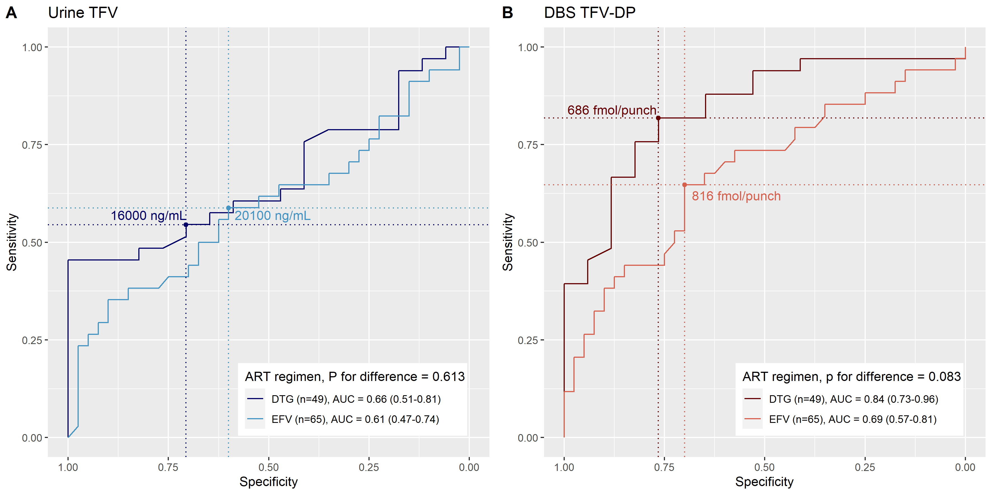
TFV = tenofovir, DBS TFV-DP = dried blood spot tenofovir di-phosphate, ART = antiretroviral therapy, EFV = efavirenz, DTG = dolutegravir, AUC = area under the curve

