Supplemental Digital Content
Table 1: Demographic characteristics of study participants
 | Study participants
HIV status  Median (IQR) | HCs  (n=35) | LTNPs  (n=32) | Progressors (n=40) | ART Naive (n=18) | On ART  (12 months) (n=18)
Age (years) | 33  (28-38) | 36  (34-40) | 35  (34-39) | 38  (33-41) | 39  (34-42)
Viral Load (log10) | ND | 3.4  (2.0-4.2) | 4.5  (3.0-6.2) | 4.8  (4.3-5.2) | ≤ 1.60
CD4T cell (cells/mm3) | 944  (756-1092) | 684  (546-865) | 319  (180-381) | 192  (129-293) | 372  (286-417)
% CD4 T cells | 62  (39-84) | 56  (30-80) | 38  (8-60) | 18  (8-35) | 27  (18-38)
% total NKT cells | 0.24  (0.16-0.46) | 0.12  (0.05-0.26) | 0.04  (0.02-0.08) | 0.03  (0.02-0.04) | 0.07  (0.03-0.11)
% CD4+ NKT cells | 0.12  (0.07-0.16) | 0.05  (0.02-0.09) | 0.01  (0.01-0.03) | 0.01  (0.004-0.03) | 0.02  (0.01-0.04)
% CD4- NKT cells | 0.09  (0.06-0.24) | 0.08  (0.03-0.15) | 0.01  (0.01-0.02) | 0.02  (0.01-0.03) | 0.04  (0.02-0.09)
% CD38+NKT cells | 3.98  (2.60-6.92) | 7.14  (4.12-9.45) | 13.6  (9.8-16.9) | 15.8  (11.4-24.9) | 12.8  (9.1-17.1)
% CD 69+ NKT cells | 11.4  (8.6-16.4) | 14.2  (11.5-19.1) | 25.6  (18.4-38.6) | 25.7  (17.4-33.4) | 24  (17.7-32.3)
%HLA-DR+NKT cells | 7.3  (4.8-10.4) | 10.7  (6.8-17.3) | 18.6  (15.6-24.1) | 25.4  (18.2-21.3) | 15.8  (11.4-22.7)
% CD 57+ NKT cells | 6.4  (4.2-6.4) | 8.4  (6.1-12.1) | 12.8  (9.6-18.9) | 11.8  (10.9-21.4) | 11.5  (7.4-14.2)
% PD1+ NKT cells | 4.5  (3.6-6.6) | 7.2  (5.3-10.8) | 14.9  (8.9-25.3) | 16.8  (8.1-27.4) | 13.3  (10.5-20.5)
Abbreviation: HIV, Human immunodeficiency virus; NKT, natural killer T; ND, not done; IQR, Inter Quartiles rang; HCs healthy controls; LTNPs, Long Term non Progressors.

Supplemental Digital Content Fig. 1: Assessment of markers of immune activation on CD4+ and CD4- NKT cells. (a) The association between the frequencies of CD4+CD38+, CD4+CD69+ and CD4+HLA-DR+ NKT cells (Y axis) with corresponding CD4 T cell counts (X axis). (b) Correlation between percent of CD4-CD38+, CD4-CD69+ and CD4-HLA-DR+ NKT cells with corresponding CD4 T cell counts (X axis) and (c) Correlation between percent of CD4-CD38+, CD4-CD69+ and CD4-HLA-DR+ NKT cells with corresponding plasma viral loads (X axis).

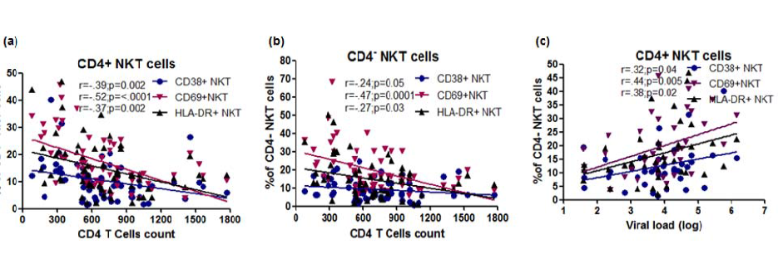
Supplemental Digital Content Fig. 2: Expression of immune exhaustion and senescence markers on CD4+ and CD4- NKT cells. (a) The association between the frequencies of CD4+CD57+ and CD4+PD1+ NKT cells (Y axis) with corresponding CD4 T cell counts (X axis). (b) Correlation between percent of CD4-CD57+ and CD4-PD1+ NKT cells with corresponding CD4 T cell counts (X axis) and (c) plasma viral loads (X axis).

