SUPPLEMENTAL DIGITAL CONTENT
Digital content S1. Interview guide
The Day of the Visit

Introducing question: Please tell me a little about the day of the CHW visit.
Probes:
What happened when the CHW visited?
What do you remember about the visit from the CHW?

Introducing question: How did you feel about the visit?
Probes:
What were your expectations for the visit?
What did you like most about the visit?
What did you find most challenging about the visit?
What questions did you want to ask the CHW?
Did you have any worries while the community health worker was visiting? What were they?
What are your feelings toward community health workers?

Household Context

Introducing question: What did your family say about the visit before the community health workers arrived?
Probes:
What were the good things that family members thought could happen from the visit?
Were there any worries family members had about the visit before it happened? What were they?

Introducing question: First, can you tell me a little about your family?
Probes:
How long have you lived in the same household?
Before the visit, were there any new household members?
How would you describe each of the household members? {Member by member.}

Home-based HIV Counseling and Testing

Introducing question: Were you asked to take a test for HIV in your home? Please tell me about that.

Specifying question: How did the CHW ask you?
Probe:
Who in your family went first? Why?
Was there anything the CHW said or did that made you want to take the test?
Was there anything the CHW said or did that made you not want to take the test?

Introducing question: How did you feel about CHWs giving HIV counseling and testing inside the home instead of going to a clinic?

Specifying question: Did you decide to take the test? [Pause.] Why?
Probe:
What were your thoughts when you decided?
What about the other members of your family?
Do you think they also took the test / did not take the test? Why?

Introducing question: What other things do you want to tell me about home-based HIV testing?
Probe:
If you were me and you were trying to understand people’s feelings about home-based HIV testing, what questions would you ask?

Home-based Sputum Collection for TB Testing

Introducing question: Were you asked to give a sputum sample for TB testing during the CHW visit? [Pause.] Please tell me a little about that.

Specifying question: How did the CHW ask you?
Probes:
Who in your family went first? Why?
Was there anything the CHW said or did that made you want to take the test? (What was it?)
Was there anything the CHW said or did that made you not want to take the test?

Introducing question: In general, how did you feel about collecting a sputum specimen at home to check for TB instead of going to a clinic?

Specifying question: Did you decide to give a sputum specimen at home to check for TB?
Probes:
What were your thoughts when you decided?
What about the other members of your family?
Do you think they also took the test / did not take the test? Why?

Introducing question: What other things you want to tell me about home-based TB testing?
Probes:
If you were me and you were trying to understand people’s feelings about home-based sputum collection for TB testing, what questions would you ask?

Making Room for New Questions

That’s all the questions I have. Is there anything that we haven’t talked about that you think is important?

Is there anything you want to ask me? {The interviewer should use their own discretion in answering any questions asked. Do not answer any questions that make you uncomfortable or that you are not qualified to answer. The purpose of this question is to further probe any unaddressed concerns, worries, or even ideas that the respondent may have.}

Digital content S2. Data Collection
A bilingual, native Luganda-speaking researcher conducted all interviews. He used a semi-structured interview guide (Supplemental Digital Content S1) to inquire about the events of the day of the visit, the household context, and the decision to accept or decline testing. Responses were recorded on a digital recorder, translated into English, transcribed, and entered into Dedoose 2.0 (Manhattan Beach, CA), an application for analysis of qualitative and mixed-methods data. Two researchers, a Ugandan (J.G.) and a non-Ugandan (M.A.H.), coded all transcripts. We continued collecting new interviews until both coders agreed that the study had reached thematic saturation, which we operationally defined as the point at which no new themes directly relevant to the study purpose emerged during a round of three interviews. After qualitative data collection and coding was completed, interview data were linked to individual- and household-level data.

Digital content S3. COM-B model and BCW framework
The COM-B model organizes determinants of behavior into three major domains. Capability, which refers to the capacity to perform a behavior, consists of physical and psychological sub-domains. Opportunity, which refers to the environmental context of a behavior, consists of physical and social sub-domains. Motivation, which refers to the internal influences that drive individuals to act on opportunities and capabilities, consists of automatic and reflective sub-domains. Motivation is automatic if it derives from emotion, desire, impulses, habits, or reflexes. It is reflective if it is formed by beliefs, plans, intentions, or a process of evaluation. Each of these sub-domains is linked in turn to intervention functions: theoretically informed strategies for changing behaviors by changing the underlying determinants of those behaviors. COM-B is a tool for classifying behavioral determinants. The BCW, in turn, links determinants classified through the COM-B model to intervention functions that specifically address those barriers.

Figure S1. Flow diagram describing selection of interviewees
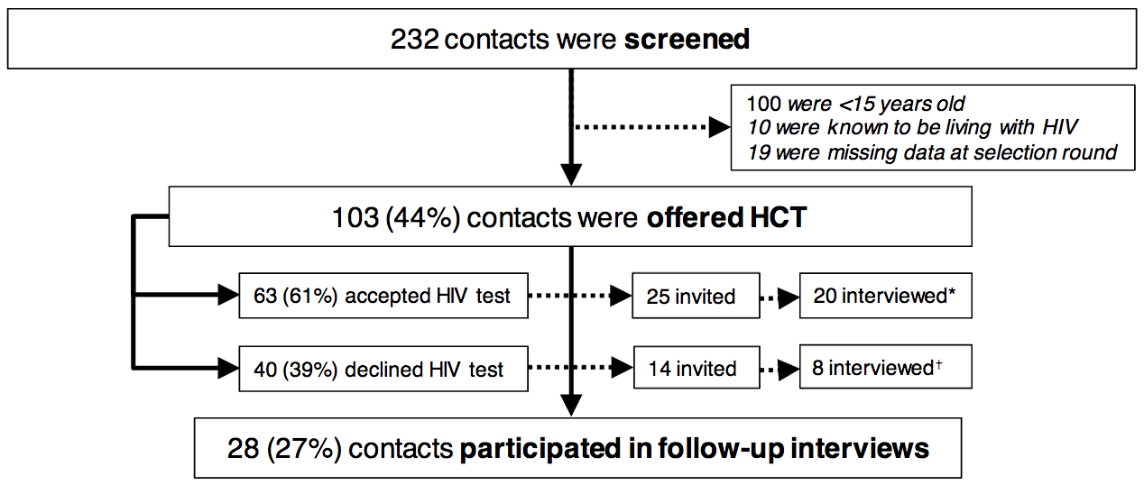

Abbreviations: HCT, HIV Counseling and Testing
Legend: Of 103 household contacts offered HCT, 63 (61%) chose to test and 40 (39%) declined testing. Twenty-eight contacts, including 20 testers and 8 non-testers, from 28 households participated in the interview. Nine contacts were not reachable, and two contacts declined to participate. *One tester declined the interview and four had temporarily or permanently left the household. †One non-tester declined the interview and five were not reachable because they had temporarily or permanently left the household.
Supplemental Digital Content Table S1 contains a detailed table describing reasons for not participating in the interview.

Table S1. Reasons for failure to complete follow-up interview
No. | Sex | Age | HCT Acceptance | Reasons for failure to complete the interview
1 | Female | 27 | Declined | The index patient died and the family left Kampala.
2 | Female | 60 | Declined | Declined interview.
3 | Male | 28 | Declined | The contact is a long distance truck driver and unreachable.
4 | Female | 17 | Accepted | Away at school.
5 | Female | 21 | Declined | Away at school.
6 | Female | 17 | Accepted | Left Kampala to return to village.
7 | Female | 25 | Accepted | She was an employee to the household head and resigned.
8 | Female | 50 | Accepted | Declined interview (“too busy”).
9 | Male | 23 | Declined | Left the household.
10 | Female | 20 | Declined | Away at school.
11 | Female | 22 | Accepted | Left to complete her studies at a university in another region.
Abbreviations: HCT, HIV Counseling and Testing

Table S2. Characteristics of household contacts sampled, by interview completion status
 | Interviewed (n=28) | Not interviewed (n=11)
Individual characteristics
Women | 20 (69%) | 9 (81%)
Declined HCT | 8 (28%) | 6 (55%)
Age (median, range) | 27 (16-61) | 24 (17-60)
Previous HIV testing | 21 (75%) | 5 (46%)
Household characteristics
Index patient HIV-positive | 6 (21%) | 5 (46%)
Household size (median, range) | 5 (2-11) | 5 (2-7)
Household income  (median, range) | UGX 100,000* (30,000 – 1,000,000) | UGX 50,000 (30,000-200,000)
Abbreviations: HCT, HIV Counseling and Testing; UGX, Uganda Shillings
Legend: One US dollar is equivalent to approximately 3,600 UGX. The 28 interviewees were drawn from 28 different households.

Table S3. Interview sample
Sex | Age | Previous HIV testing | Index HIV status | Relationship to Index Patient
Participants who accepted testing
Female | 16 | At least once | Negative | Sibling of index patient
Male | 16 | Never | Positive | Child of index patient
Male | 18 | Never | Negative | Nephew of index patient
Male | 18 | At least once | Negative | Sibling of index patient
Female | 21 | Never | Negative | Sibling of index patient
Male | 21 | At least once | Negative | Sibling of index patient
Female | 22 | Never | Positive | Spouse of index patient
Male | 22 | At least once | Negative | Non-relative household member
Male | 24 | At least once | Negative | Sibling of index patient
Female | 25 | Within past 3 months | Positive | Sibling of index patient
Female | 26 | At least once | Negative | Spouse of index patient
Female | 27 | At least once | Negative | Spouse of index patient
Female | 27 | At least once | Unknown | Sibling of index patient
Female | 28 | Within past 3 months | Negative | Niece of index patient
Female | 30 | At least once | Positive | Sibling of index patient
Female | 33 | Within past 3 months | Negative | Cousin of index patient
Female | 33 | Within past 3 months | Negative | Non-relative household member
Female | 50 | Never | Negative | Parent of index patient
Female | 52 | Within past 3 months | Negative | Grandmother of index patient
Female | 61 | At least once | Negative | Parent of index patient
Participants who declined testing
Female | 17 | Never | Negative | Sibling of index patient
Female | 20 | Never | Negative | Sibling of index patient
Female | 28 | At least once | Positive | Spouse of index patient
Male | 32 | At least once | Positive | Non-relative household member
Female | 36 | Within past 3 months | Negative | Spouse of index patient
Male | 43 | At least once | Negative | Parent of index patient
Male | 51 | At least once | Negative | Spouse of index patient
Female | 55 | Within past 3 months | Negative | Parent of index patient

Table S4. Summary of facilitators within the COM-B model and BCW framework

Behavioral determinants and themes |  |  | Intervention functions
CAPABILITY | Psychological | Normalizing knowledge of HIV and TB | Education
 | Physical
OPPORTUNITY | Physical | Home delivery of counseling and testing services | Re-structuring of the physical environment
 |  | Immediate availability | Re-structuring of the physical environment
 | Social | Home encounter allows for questions | Re-structuring of the social environment
 |  | Rapport, positive perception of lay health workers | Re-structuring of the social environment
MOTIVATION | Reflective | Previously developed intention to test  Desire to support index patient* | Education  Persuasion
 | Automatic | Desire to support index patient* | Modeling
Abbreviations: COM-B, Capability, Opportunity, Motivation, and Behavior
*Desire to support index patient has both automatic and reflective components because it reflects both emotion and social roles.

We located each of the facilitator themes within the COM-B model to identify the intervention functions associated with facilitators to testing. The previously developed intention to test falls into the motivation domain and is reflective in nature. In the COM-B framework, the intervention functions associated with this facilitator are education and persuasion. The factors related to convenience fall under the opportunity domain: the home delivery and immediate availability of HCT are physical in nature, while the greater opportunity for questions in the home environment compared to the clinic is social in nature. The positive perception and easy rapport with lay health workers also falls under the opportunity domain and is social in nature. In the COM-B framework, these facilitators are associated with the structure of the physical and social environments. The desire to support the index patient falls under the motivation domain, but is automatic rather than reflective in nature. The intervention function associated with this facilitator is modeling.

Table S5. Summary of barriers within the COM-B model and BCW framework
Behavioral determinants and themes |  |  | Intervention functions
CAPABILITY | Psychological | Feeling unprepared to face own results* | Educating  Training  Modeling  Enabling contact to prepare to test
 | Physical
OPPORTUNITY | Physical | Lay health worker does not offer service* | N/A
 | Social | Privacy concerns within household | Restriction  Restructuring home testing environment  Modeling  Enabling
 |  | Social influence of other household members | Restructuring social environment  Modeling  Enabling
 |  | HIV and/or TB stigma | Restructuring environment  Modeling with normalizing language  Enabling
MOTIVATION | Reflective | Lack of confidence in health care system | Educating  Persuading  Modeling  Enabling
 | Automatic | Fear of positive results* | Persuading  Incentivizing  Modeling normalizing language  Enabling
*Bold indicates major emergent themes in interviews and recommended intervention functions. Further emergent themes identified in interviews and intervention functions are included for reference.

