Supplement
Figure (Supplement-A). Number of clinics that integrated per month across the study period (n=131)

Figure Supplement-B. Number of HIV patients on antiretroviral therapy (ART) in primary health care clinics (2009-13)
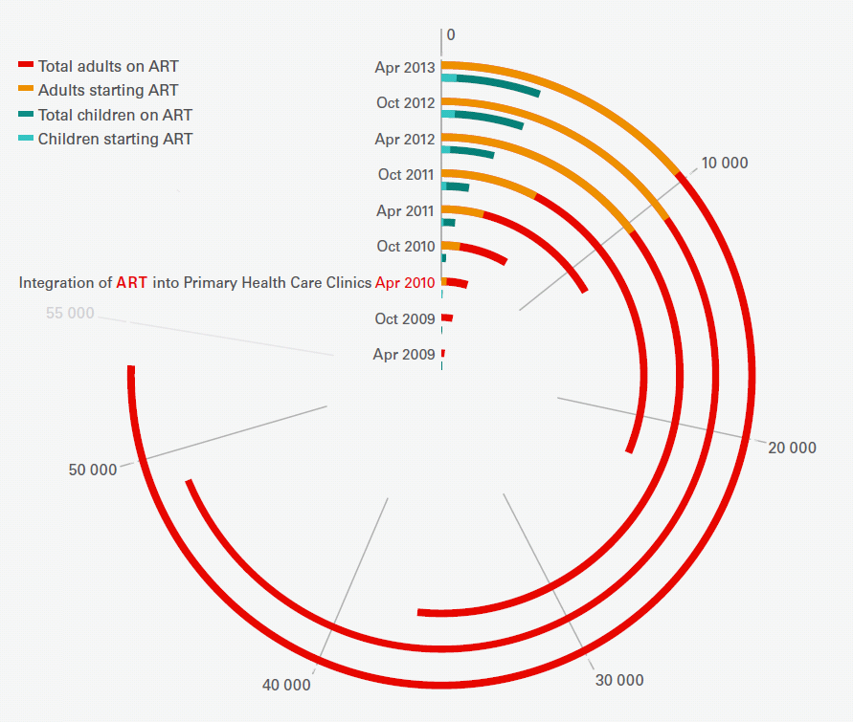

Details of Data Sources, Management and Models Employed for Interrupted Time Series Analysis and Linear Mixed Effects Regressions
Data Sources
“Population estimates were analysed from elements found in District Health Information Software and are based on demographic data collected by Statistics South Africa. This is the number of people aged 30 years and older who the government has designated to fall within the clinic catchment population at mid-year. Mid-year estimates are calculated using a cohort based population projection accounting for annual changes in fertility, mortality and migration. For our study, the mid-level population estimate was divided by 12 months and used for a denominator of a calendar year. Therefore this reflects yearly changes in the population 30 years old and older. Detailed methodology on how mid-year population estimates are derived can be found at http://www.statssa.gov.za/publications/P0302/P03022017.pdf.
The clinic level denominators were calculated by a variable in the DHIS dataset called “PHC Headcount”. It is defined in the DHIS system as “All individual patients attending the facility during the reporting period (usually month) for Primary Health Care. Each patient is counted once for each day they appear at the facility, regardless of the number of services”. This data was available for those over 5 years old and those under 5 years old. Because we were interested in Diabetes Mellitus and Hypertension for this study which typically manifest in adulthood, we chose to examine the indicator over 5 years old.”
Data Management
Outlier detection was done using inter quartile range (IQR) where the difference of the 3rd quartile and the 1st quartile of data was measured. In cases that IQR = 0, we set IQR = 0.1. Values that are larger than the 3rd quartile plus 3*IQR or smaller than the 1st quartile minus 3*IQR are considered as outliers for clinic level indicators. For New Diabetics on treatment per PHC headcount under 5 years old (clinic level), 79/4585 (1.7%) data points were identified as outliers. For New hypertension patients on treatment per PHC headcount under 5 years old (clinic level), 112/6288 (1.8%) outliers were detected. For population level indicators, New Diabetic on treatment (population level), values larger than 0.03 are marked as outliers. A total of 19/4585 (0.4%) values were identified as outliers for this variable. For New hypertensive patients on treatment (population level), values larger than 0.1 are marked as outliers which resulted in 19/6288 (0.3%) values were identified as outliers. Identified outliers were removed prior to analysis.
Models
For each clinic the month and year of integration was coded as 0, with months leading up to the integration coded sequentially negative for each month before integration (i.e. -1 for the month preceding integration, -2 for 2 month preceding integration, etc.) and months post-integration were coded sequentially in the positive direction (i.e. 1 for the month directly after integration, 2 for 2 months after integration, etc.). We identified first level-autocorrelation using the Durbin-Watson test. Where auto-correlation was identified, the Prais-Winsten method was used as a generalised least squares estimator to estimate the regression.
Trends for each non-communicable disease indicator of each facility were fitted to a trend using the following equation:
${ Y}_{it}= β_{o}*{time}_{t}+β_{2}*{integration}_{t}+β_{3}*{postslope}_{t}+Facility+{Month}_{ij}+ε_{it}$
The second model that measured the effect of HIV patients initiated on ART on PHC indicators is as follows:
${\begin{aligned} \\ Y\end{aligned}}_{it}= β_{o}*{time}_{t}+β_{2}*{integration}_{t}+β_{3}*{postslope}_{t}+β_{4}*{ART new initiations}_{t}+Facility+{Month}_{ij}+ε_{it}$.
The third model that measured for the effect of ART patients remaining in care on PHC indicators is as follows:
${ Y}_{it}= β_{o}*{time}_{t}+β_{2}*{integration}_{t}+β_{3}*{postslope}_{t}+β_{4}*{ART patients remaining in care}_{t}+Facility+{Month}_{ij}+ε_{it}$.

Supplement Table 1. Summary of characteristics of primary health care clinics included in the study (n=131)

 | Year of Integration
 | 2010 | 2011 | 2012 | Total
Former Homeland | 1 | 7 | 22 | 30
Large | 1 | 5 | 4 | 10
Medium |  | 2 | 8 | 10
Small |  |  | 10 | 10
Rural | 16 | 32 | 16 | 64
Large | 2 | 3 |  | 5
Medium | 5 | 15 | 6 | 26
Small | 9 | 14 | 10 | 33
Urban | 9 | 18 | 10 | 37
Large | 5 | 4 | 3 | 12
Medium | 2 | 12 | 4 | 18
Small | 2 | 2 | 3 | 7
Total | 26 | 57 | 48 | 131

