Development and calibration of a mathematical model of anal carcinogenesis for high-risk HIV-infected men
Web appendix

This web appendix provides supplementary details on the methods and results presented in the main manuscript.

Primary data from empirical studies

HIPVIRG
Initiated in 2002, the HIPVIRG cohort (Human Immunodeficiency and Papilloma Virus Research Group) (n=247) study involved repeated measurements (i.e., questionnaires, chart reviews, and anal examinations) every 6 months for 3 years (7 total visits; 30.8 months mean follow-up time) without intervention unless invasive cancer was discovered (1). We estimated monthly progression and regression probabilities from the HIPVIRG cohort study, which performed anal cytology and high-resolution anoscopy (HRA) annually or bi-annually on all study participants (HIV-infected mend who have sex with men (MSM). As p16 staining was not performed on anal intraepithelial neoplasia (AIN) grade 2 biopsies, we could not classify anal precancerous lesions based on the histopathologic terminology for human papillomavirus (HPV)-associated squamous intraepithelial lesions outlined by the Lower Anogenital Squamous Terminology Standardization (LAST) guidelines (2).

NA-ACCORD
Age and CD4⁺ nadir-specific anal cancer incidence rates were derived from the Multi-cohort collaboration North American AIDS Cohort Collaboration on Research and Design (NA-ACCORD; https://statepiaps7.jhsph.edu/NAaccord/). The analytic dataset (P2010) included HIV-infected MSM who had their HAART initiation date after 1995 and had an available nadir CD4⁺ measurement, resulting in 13,146 individuals (71,261 person-years) and 75 cases of invasive anal canal cancer (97.4% were squamous cell carcinomas). CD4⁺ nadir was defined as CD4⁺ count measurement closest to ART initiation within the window of 6 months prior to ART initiation; if no measurement was available in the window 6 months prior, then a CD4⁺ measurement within 3 months after ART initiation was used. Men were censored at anal diagnosis date, date of death, or on December 31, 2010, whichever came first.

Model assumptions

Health states at model start
Upon entering the model, individuals are randomly assigned a nadir CD4⁺ count following a gamma distribution and categorized into one of four CD4⁺ categories. We selected a mean of 315 and standard deviation of 240 to reflect the nadir CD4⁺ counts observed among HIV-infected MSM enrolled in the HIPVIRG cohort study, resulting in nadir CD4+ frequencies of 38.5%, 26.8%, 16.3%, and 18.3% for nadir CD4⁺ categories of <200, 200-349, 350-500 and >500, respectively. Following CD4⁺ category assignment, each individual is stochastically allocated to one or more initial non-cancer anal health states (i.e., no/latent HPV, HPV, AIN1, and AIN2/3) for each independent HPV category, if relevant (i.e., HPV-16; HPV-18; HPV hi-5; other oncogenic types; low-risk types; and HPV-negative) (primary data from HIPVIRG; lower panel Web Appendix Table 1). Starting distributions reflect genotype-specific lesion prevalence derived from the baseline data from the HIPVIRG cohort (1, 3) (upper panel Web Appendix Table 1). Due to sample size limitations and the stability of disease burden by age within the study, we did not restrict starting distributions by age.

General assumptions
Based on the currently-available evidence, we made the following model assumptions: 1) initiating ART implicitly increases CD4⁺ count, resulting in lower HIV-related mortality; however, all anal health state-related transitions remain a function of their pre-ART (nadir) CD4⁺ count and are independent of time-spent at nadir CD4⁺ count; 2) HPV type-specific infections, HPV type-specific precancerous lesions, and HPV type-specific cancers are independent and can occur simultaneously; 3) individuals face an independent probability of developing non-HPV-related precancer and cancer; 4) individuals with a higher CD4⁺ nadir have an equal or higher (lower) probability of HPV clearance or regression (progression) of precancerous lesions compared to individuals with lower CD4⁺ nadir (3, 4); 5) regression of AIN2/3 returns individuals to the no HPV/latent HPV health state; and 6) upon anal cancer detection, other non-cancer anal health states can no longer transition to cancer, while individuals with undetected CA continue to develop/progress among all other health states while their existing cancer remains undetected.

While our model structure allows men to have an HPV infection without an anal lesion, the HIPVIRG study captured clearance rates among all men irrespective of lesion status; therefore, we assumed that the mean HPV infection clearance rates reported among men from the HIPVIRG study (with and without lesions) reflected the lower bound (i.e., slowest clearance probabilities) of the plausible range from the empirical data.

For any specific HPV, the model only tracks the worst associated lesion. For example, if an individual has HPV-16 associated AIN2/3, he may not also have HPV-16 associated AIN1 at the same time. In addition, we assumed regression from AIN2/3 signals an immune response that would also allow the individual to clear (or force into latency) the specific HPV type associated with AIN2/3, as well as any AIN1 associated with the specific HPV type; therefore, we collapsed the regression probabilities from AIN2/3 to AIN1, and AIN2/3 to no HPV/latent HPV, into a single regression probability, i.e., returning all individuals to the no HPV/latent HPV health state.

Calibration
Following a similar calibration approach used for a natural history model of cervical carcinogenesis (5, 6), we identified plausible ranges around baseline input parameter values and repeated model simulations by drawing uniformly across the predefined parameter search space for each model run, resulting in unique combinations of natural history parameters. For specific parameters, we constrained the search space to preserve well-understood relationships between HPV genotypes (Main Manuscript Table 2). For example, we required the monthly progression probability from AIN2/3 to invasive anal cancer to be greater for HPV-16- compared to non-HPV-16-related AIN2/3s. The calibration target data (Web Appendix Table 4) included data formats not directly used as model inputs. For example, to guide transition probabilities as individuals age, we used genotype-specific prevalence of HPV infection by age, and prevalence of AIN1 and AIN2/3 precursors by age from the HIPVIRG cohort study. In order to mimic cross-sectional detection methods applied in the HIPVIRG study, we evaluated model-projected output at 6-month intervals. To inform HPV genotype-specific transition probabilities, we identified the proportion of AIN1 and AIN2/3s that tested positive for any HPV, HPV-16, non-HPV-16 and no HPV from the HIPVIRG study (3), which were consistent with estimates from a stratified meta-analysis of high-grade precancerous lesions among HIV-infected individuals (7). Similarly, we used data from the most recent meta-analysis evaluating HPV type distribution in anal cancer tissues among HIV-infected men (8), which showed a lower contribution of HPV-16 to anal cancers among HIV-infected men compared with HPV-uninfected men (i.e., 57% vs. 77%, respectively). We used type distributions among male anal cancers and calculated binomial-distributed confidence intervals to capture uncertainty in the empirical data.

Age and CD4⁺ nadir-specific anal cancer incidence rates were derived from NA-ACCORD. For calibration, we restricted the analytic cohort to cancers diagnosed among men aged 30 and older between 2000 and 2007 (n=57 cases and 47,366 person-years) in order to correspond with the HIPVIRG longitudinal trial period. Upper and lower bounds for the incidence rates were calculated using Poisson-distributed exact confidence intervals (Web Appendix Table 4).

In order to identify the parameter sets that maximized correspondence between model-projected outcomes and empirical data (i.e., calibration targets), we employed a likelihood-based approach that involved calculating the likelihood score for each unique parameter set using a likelihood ratio test (distributed chi-squared with degrees of freedom equal to the number of calibration targets (i.e., 58)) to identify ‘good-fitting’ parameter sets.

We used a panel of experts from Harvard-affiliated teaching hospitals to inform baseline estimates of the duration between Stage I, Stages II/III and Stage IV anal cancers, and calibrated these baseline inputs to fit stage distribution observed in SEER among the general population (Web Appendix Table 4). We surveyed 5 clinicians at Harvard-affiliated hospitals to identify upper and lower bounds for dwell times between cancer states. For monthly cancer detection the mean dwell times were: Stage I to Stages II/III: 1 year (calibration search range: 0.5 years-3 years), and Stages II/III to Stage IV: 3 years (calibration search range: 1.5 years-5 years). The monthly detection probability of Stage I was: 6.2%, Stages II/III was: 24.8%, and Stage IV was: 58.8%.

HIV sub-model
HIV-infected individuals face a monthly probability of initiating ART that increases as nadir CD4+ count declines (Web Appendix Table 3). In 2002 at the baseline of the HIPVIRG cohort, 93% of individuals had initiated ARTs. In the absence of ART initiation, individuals may progress to lower CD4 counts over time (9) and face elevated CD4⁺-specific risks of dying from HIV-related causes (Web Appendix Table 3) (10). Upon initiating ART (to ensure the model simulated cohort corresponds to that of the HIPVIRG cohort), individuals stay within their CD4+ nadir category for their remaining lifetime, but face a lower HIV-related mortality (remains slightly elevated compared with the general population (11)). Average dwell times in the model for each CD4⁺ category was 2.7 years, 2.7 years and 1.4 years for CD4⁺ of >500, 350-500, and 200-349 categories based on empirical data (12), respectively.

Web Appendix Table 1. Starting Distributions

AIN starting distributions
 | No AIN | AIN1 | AIN2/3
Proportion | 0.22 | 0.40 | 0.38
HPV infection starting distributions (allowing HPV co-infection)
 | Negative | HPV-16 | HPV-18 | HPV-Hi5 | HPV-HO | HPV-LR
No/latent HPV | 0.99 | 0.62 | 0.76 | 0.4 | 0.35 | 0.48
HPV | 0 | 0.08 | 0.06 | 0.2 | 0.35 | 0.17
AIN1 | 0.0075 | 0.2 | 0.14 | 0.3 | 0.25 | 0.3
AIN2/3 | 0.0025 | 0.1 | 0.04 | 0.1 | 0.05 | 0.05
HPV: Human papillomavirus; AIN: anal intraepithelial lesion; AIN2/3: High-grade anal intraepithelial lesion; AIN1: Low-grade anal intraepithelial lesion; HPV-Hi5: high-risk HPV types include HPV-31, -33, -45, -52, -58; HPV-HO: high-risk other HPV types (including HPV-35, -39, -51, -56, -59, -66, -68, -82) ; HPV-LR: low-risk HPV types 6 and 11; NL: normal/no lesion.

Web Appendix Table2. Monthly Probability of Dying from Anal Cancer from the National Cancer Institute’s (NCI) Surveillance, Epidemiology, and End Results (SEER) program for cancer registries
Invasive cancer mortality | Parameter value | Age-specific multipliers¹  (30-49, 50-69, 70+ years)
Stage I
Year 1 | 0.0037 | 0.738, 0.733, 1.320
Years 2-3 | 0.0033
Years 4-20 | 0.0030
Stages II/III
Year 1 | 0.0125 | 0.746, 0.874, 1.568
Years 2-3 | 0.0094
Years 4-20 | 0.0052
Stage IV
Year 1 | 0.0351 | 0.900, 0.888, 1.236
Years 2-3 | 0.0230
Years 4-20 | 0.0074
¹Age-specific cancer mortality was captured by applying age-specific multipliers to the baseline probabilities. For undetected cancer, individuals face year 1 probability of dying from cancer until diagnosis through symptoms.

Web Appendix Table 3. HIV Sub-model Transition Parameters

Parameter | Parameter value | Source
Excess mortality multiplier for HIVª
CD4 nadir >500, no ART | 4.0 | Menzies 2012 (10)
CD4 nadir 350-500, no ART | 16.0 | Menzies 2012 (10)
CD4 nadir 200-349, no ART | 16.0 | Menzies 2012 (10)
CD4 nadir <200, no ART | 50.0 | Menzies 2012 (10)
CD4 nadir >500, ART-initiated | 1.5 | McManus 2012 (11)
CD4 nadir 350-500, ART-initiated | 2.1 | McManus 2012 (11)
CD4 nadir 200-349, ART-initiated | 8.6 | McManus 2012 (11)
CD4 nadir <200, ART-initiated | 8.6 | McManus 2012 (11)
HIV monthly progression probabilities in absence of ART
From nadir CD4+ >500 to CD4+ 350-500 | 0.013 | Lodi 2011 (12)
From nadir CD4+ 350-500 CD4+ 200-349 | 0.029 | Lodi 2011 (12)
From nadir CD4+ 200-349 to CD4+ <200 | 0.023 | Lodi 2011 (12)
ART monthly initiation probabilities
CD4 nadir >500 | 0.30 | Assumed to  fit distribution during  period of study in  HIPVIRG cohort
CD4 nadir 350-500 | 0.50
CD4 nadir 200-349 | 0.95
CD4 nadir <200 | 0.95
ART: Anti-retroviral therapies; HIPVIRG: Human Immunodeficiency and Papilloma Virus Research Group cohort study. ªMultiplier value adjusted age-specific U.S. background lifetables for a male cohort born in 1970.

Web Appendix Table 4. Model Calibration Target Data
Calibration target endpoint | 95% Confidence Interval | Source
Prevalence of HPV infection, by ageª
HPV-16 |  | de Pokomandy 2009 (1)
<40 years | 0.284—0.509
40-49 | 0.294—0.483
50-69 | 0.231—0.502
HPV-18 |  | de Pokomandy 2009 (1)
<40 years | 0.194—0.404
40-49 | 0.178—0.349
50-69 | 0.067—0.276
HPV hi-5 (HPV-31, -33, -45, -52, -58) |  | de Pokomandy 2009 (1)
<40 years | 0.441—0.669
40-49 | 0.583—0.765
50-69 | 0.351—0.632
Other high-risk HPV (HPV-35, -39, -51, -56, -59, -66, -68, -82) |  | de Pokomandy 2009 (1)
<40 years | 0.569—0.784
40-49 | 0.554—0.74
50-69 | 0.441—0.719
Low-risk (HPV-6, -11) |  | de Pokomandy 2009 (1)
<40 years | 0.428—0.657
40-49 | 0.48—0.672
50-69 | 0.231—0.502
Prevalence of precancer lesion, by age
Low-grade squamous intraepithelial lesion (AIN1) |  | de Pokomandy 2011 (3)
30-39 | 0.422—0.652
40-49 | 0.258—0.44
50-69 | 0.187—0.451
High-grade squamous intraepithelial lesion (AIN2/3) |  | de Pokomandy 2011 (3)
30-39 | 0.219—0.436
40-49 | 0.316—0.504
50-69 | 0.287—0.568
HPV genotype frequencies of HPV in precancer and cancer
Anal intraepithelial neoplasia grade 1 (AIN1) |  | de Pokomandy 2011 (3)
Any HPV | 0.927—0.997
HPV-16 | 0.174—0.357
Non-HPV-16 | 0.621—0.808
No HPV | 0.003—0.073
Anal intraepithelial neoplasia grades 2/3 (AIN2/3) |  | de Pokomandy 2011 (3)
Any HPV | 0.959—1.00
HPV-16 | 0.458—0.673
Non-HPV-16 | 0.274—0.485
No HPV | 0.00—0.041
Invasive anal cancer |  | Clifford 2017 (8)
Any HPV | 0.94-0.99
HPV-16 | 0.49-0.67
HPV-18 | 0.08-0.19
Incidence rate of anal cancer per 100,000, by age and nadir CD4 category^{b}
CD4 nadir >500 |  | NA-ACCORD 2000-2007
30-39 | 1.28—281.55
40-49 | 6.66—198.69
50-59 | 0.00—183.33
60-69 | 0.00—895.36
70-79 | 0.00—8931.91
CD4 nadir 350-500 |  | NA-ACCORD 2000-2007
30-39 | 0.00—159.81
40-49 | 16.39—232.22
50-59 | 13.47—401.91
60-69 | 0.00—962.9
70-79 | 0.00—5606.2
CD4 nadir 200-349 |  | NA-ACCORD 2000-2007
30-39 | 19.21—272.26
40-49 | 62.02—283.05
50-59 | 41.98—394.48
60-69 | 38.66—1153.18
70-79 | 0—28463.6
CD4 nadir <200 |  | NA-ACCORD 2000-2007
30-39 | 61.44—314.84
40-49 | 88.11—270.4
50-59 | 112.75—432.41
60-69 | 23.3—513.52
70-79 | 0.00—2277.09
Cancer stage distribution
Stage I | 0.22—0.25 | SEER-18 2004-2013
Stages II/III | 0.66—0.69 | SEER-18 2004-2013
Stage IV | 0.076—0.095 | SEER-18 2004-2013
Abbreviations: HPV: Human papillomavirus; NA-ACCORD: North American AIDS Cohort Collaboration on Research and Design; ªIrrespective of prevalent low- or high-grade anal intraepithelial neoplasia, ^{b}Confidence interval ranges reflect small sample sizes when stratified by both CD4 nadir and age, which is particularly evident for the oldest age groups.

Web Appendix Figure 1. Calibration targets (solid black bars) and model outputs (grey dots) from the good-fitting parameter sets for the age-specific prevalence of low-grade anal intraepithelial neoplasia (AIN1) and high-grade anal intraepithelial neoplasia (AIN2/3)

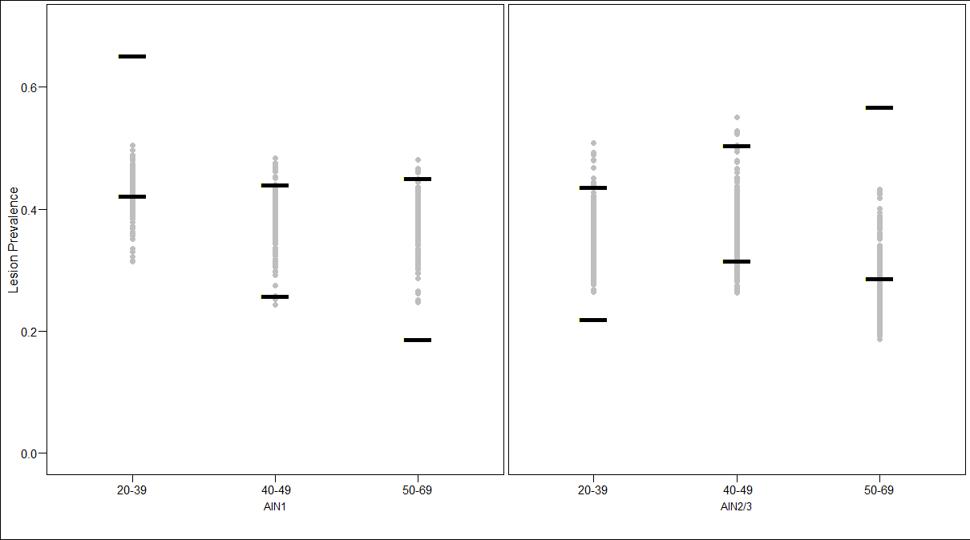

Web Appendix Figure 2. Calibration targets (solid black bars) and model outputs (grey dots) from the good-fitting parameter sets for the stage distribution of detected anal cancer

Web Appendix Figure 3. Posterior distribution (model output) of the monthly probability of progressing from a high-grade anal intraepithelial neoplasia (AIN2/3) to invasive anal cancer by HPV genotype status and CD4+ nadir <200 (red shaded) and >500 (blue shaded)

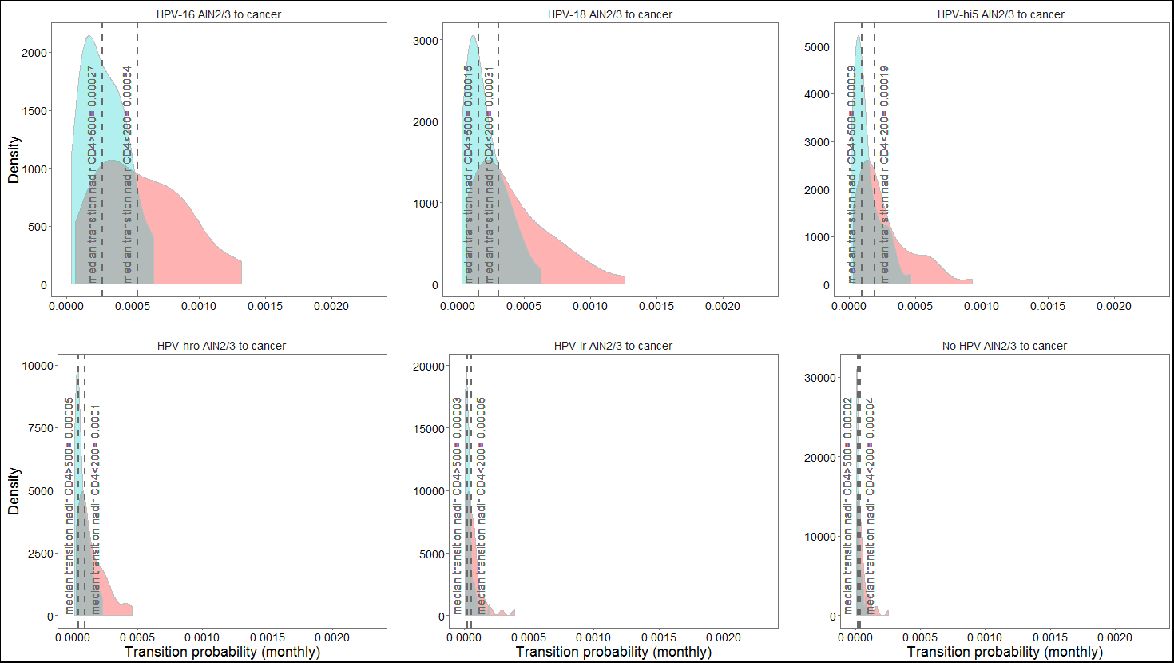

Web Appendix Figure 4. Model-projected anal cancer mortality rates per 100,000 HIV-infected men who have sex with men (MSM) by age. Grey dots reflect model-projected output among the top 50 ‘good-fitting’ parameter sets identified following likelihood-based calibration.

References

1. de Pokomandy A, Rouleau D, Ghattas G, et al. Prevalence, Clearance, and Incidence of Anal Human Papillomavirus Infection in HIV-Infected Men: The HIPVIRG Cohort Study. Journal of Infectious Diseases 2009;199(7):965-73.
2. Darragh TM, Colgan TJ, Cox JT, et al. The Lower Anogenital Squamous Terminology Standardization Project for HPV-Associated Lesions: Background and Consensus Recommendations from the College of American Pathologists and the American Society for Colposcopy and Cervical Pathology. Archives of Pathology & Laboratory Medicine 2012;136(10):1266-97.
3. de Pokomandy A, Rouleau D, Ghattas G, et al. HAART and Progression to High-Grade Anal Intraepithelial Neoplasia in Men Who Have Sex with Men and Are Infected with HIV. Clinical Infectious Diseases 2011;52(9):1174-81.
4. Palefsky J, Holly E, Ralston M, et al. Anal squamous intraepithelial lesions in HIV-positive and HIV-negative homosexual and bisexual men: prevalence and risk factors. Acquir Immune Defic Syndr Hum Retrovirol 1998;17(4):6.
5. Campos NG, Burger EA, Sy S, et al. An Updated Natural History Model of Cervical Cancer: Derivation of Model Parameters. American Journal of Epidemiology 2014;180(5):545-55.
6. Kim JJ, Kuntz KM, Stout NK, et al. Multiparameter Calibration of a Natural History Model of Cervical Cancer. American Journal of Epidemiology 2007;166(2):137-50.
7. De Vuyst H, Clifford GM, Nascimento MC, et al. Prevalence and type distribution of human papillomavirus in carcinoma and intraepithelial neoplasia of the vulva, vagina and anus: A meta-analysis. International Journal of Cancer 2009;124(7):1626-36.
8. Clifford GM, Lin C, Franceschi S. A meta-analysis of HPV type distribution across the full spectrum of anal disease, by HIV status. Presented at International Papillomavirus Cape Town, South Africa2017.
9. Lodi S, Phillips A, Touloumi G, et al. Time From Human Immunodeficiency Virus Seroconversion to Reaching CD4+ Cell Count Thresholds <200, <350, and <500 Cells/mm3: Assessment of Need Following Changes in Treatment Guidelines. Clinical Infectious Diseases 2011;53(8):817-25.
10. Menzies NA, Cohen T, Lin H-H, et al. Population Health Impact and Cost-Effectiveness of Tuberculosis Diagnosis with Xpert MTB/RIF: A Dynamic Simulation and Economic Evaluation. PLOS Medicine 2012;9(11):e1001347.
11. McManus H, O'Connor CC, Boyd M, et al. Long-Term Survival in HIV Positive Patients with up to 15 Years of Antiretroviral Therapy. PloS one 2012;7(11):e48839.
12. Lodi S, Phillips A, Touloumi G, et al. Time from human immunodeficiency virus seroconversion to reaching CD4+ cell count thresholds <200, <350, and <500 Cells/mm(3): assessment of need following changes in treatment guidelines. Clinical infectious diseases : an official publication of the Infectious Diseases Society of America 2011;53(8):817-25.

