Supplemental Figure. Adjusted* Association between Change in AUDIT-C and Change in VACS Index 2.0* in a National Sample of Patients with HIV: Stratified by Baseline AUDIT-C Risk Group (n = 76,202 observations)

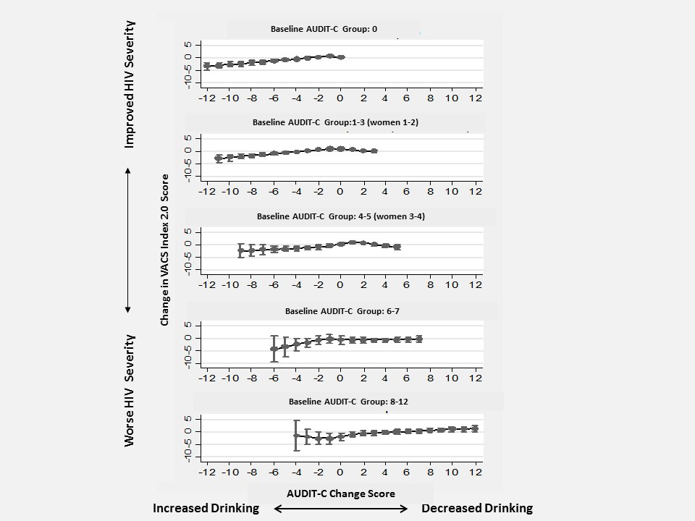

* adjusted for demographics (age, gender, and race),initial VACS Index 2.0 score, and time between VACS Index 2.0 measures.

