**Supplemental figure 1**: Flow diagram of the fourteen Cohort II participants of whom 9 completed 24 weeks of EFV therapy. Two Cohort I, Step 2 participants who developed TB and received ATT are also included in the PK analysis.



**Supplemental Figure 2**: Efavirenz CL/F by age and CYP 2B6 genotype. Participants 3-<24 months are represented by circles (EM red / PM blue), >24-36 months by pink squares (Cohort II) and pink “+” (Cohort I, Step 2).



**Supplemental Figure 3A:** Observed AUC among EM and PM participants receiving the Cohort II EFV dose.

**Supplemental Figure 3B**: Predicted AUCs if Cohort II participants had received the lower EFV dose used in Cohort I (for those not receiving rifampin co-therapy).

Participants 3-<24 months are represented by circles (EM red/PM blue), >24-36 months by pink squares (Cohort II) and pink “+” (Cohort I, Step 2).



**Supplemental Figure 4**. Virologic Response to EFV in Extensive Metabolizer (EM) Participants. Log10 change in HIV-RNA from baseline in as treated analysis. Participants with early discontinuations due to early toxicities or non-adherence are not represented in the figure. VS = virologic success

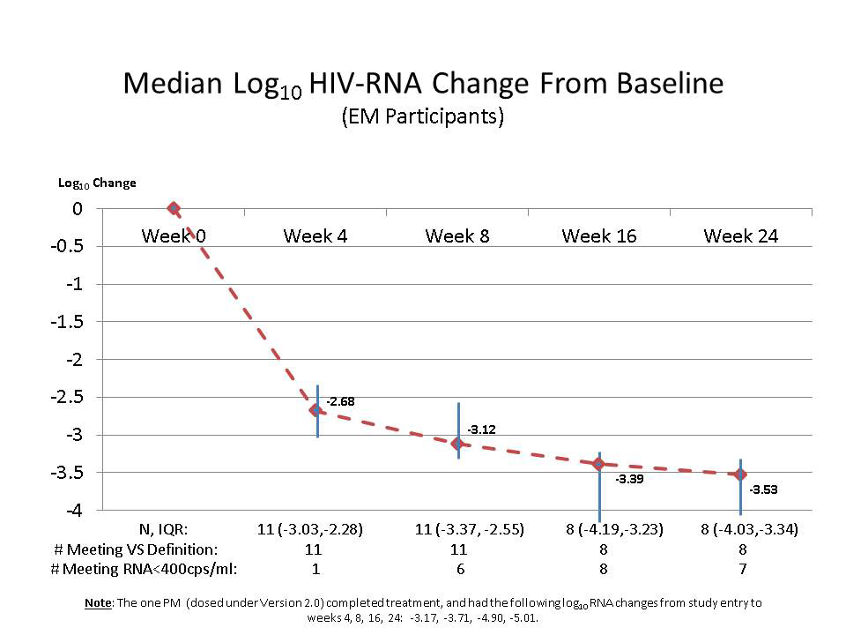

**Supplemental figure 5**: Efavirenz clearance by CYP2B6 Genotype.

