Supplemental Digital Content (SDC)

SDC 1. Detailed Description of Measures and Coding

SDC 2. Supplementary Eligibility Analyses

SDC 3. Summary of State-Level PrEP Eligibility Criteria for Women

SDC 1

Detailed Description of Measures and Coding:

PrEP Eligibility and Indicators of HIV Risk and PrEP Motivation

PREP ELIGIBILITY
PrEP eligibility was conceptualized as a dichotomous variable, coded as (1) eligible vs. (0) ineligible. Eligibility was determined separately for each set of CDC guideline criteria (guidance summary criteria and recommended indications criteria) for all participants who identified as women (“woman” or “transgender woman”), reported no prior HIV diagnosis, and responded to all relevant survey items used to determine eligibility for both sets of criteria. Specific operationalization of each criterion (wording of associated survey item[s]) is detailed in Table 1 of the main text.
Based on the current (2017) CDC guideline criteria,¹ participants were considered eligible because of heterosexual activity by guidance summary criteria if they reported one or more of the following: HIV-positive sex partner, recent bacterial STI (gonorrhea or syphilis), high number of sexual partners, history of inconsistent or no condom use, or commercial sex work. All other participants in the analytic sample were considered ineligible because of heterosexual activity by guidance summary criteria. (Note: For all participants, high area/network HIV prevalence, a CDC guidance summary criterion, was not directly measured and assumed not to apply.) Participants were considered eligible because of injection drug-related activity by guidance summary criteria if they reported an HIV-positive injecting partner, sharing injection equipment, or both; otherwise, they were considered ineligible.
Based on the current (2017) CDC guideline criteria,¹ participants were considered eligible because of heterosexual activity by recommended indications criteria if they reported any sex with men in the past 6 months, not being in a monogamous partnership with a recently tested HIV-negative partner, and one or more of the following: infrequent condom use with one or more partners of unknown HIV status who are known to be at substantial risk for HIV, being in an ongoing sexual relationship with an HIV-positive partner, or a recent bacterial STI (gonorrhea or syphilis.) All other participants in the analytic sample were considered ineligible because of heterosexual activity by recommended indications criteria. Participants were considered eligible because of injection drug-related activity by recommended indications criteria if they reported any injection of drugs in the past 6 months and any sharing of injection drug or preparation equipment in the past 6 months; otherwise, they were considered ineligible.
For primary analyses, eligibility due to heterosexual activity and drug activity were considered together, such that a woman was considered eligible by a given set of criteria (guidance summary or recommended indications) if she met the subset of criteria pertaining to heterosexual activity, the subset pertaining to injection drug-related activity, or both; she was considered ineligible by a given set of criteria if she did not meet the subset of eligibility criteria pertaining to heterosexual activity and she did not meet the subset of criteria pertaining to injection drug-related activity. In supplemental analyses, eligibility due to heterosexual activity and injection drug-related activity were examined separately (see eTables 1-2, SDC 2).
For analyses comparing eligibility by current (2017) criteria to original (2014) criteria, eligibility determination based on the original (2014) CDC guideline criteria was coded as described above for the current (2017) criteria, substituting the original criteria outlined in the 2014 CDC guidelines² (see eTables 3-4, SDC 2).

HIV RISK INDICATORS
HIV risk indicators encompassed sexual health history, sexual behavior, and relationship circumstances. All risk indicators were coded as dichotomous variables with values of 1 denoting the presence or occurrence of the indicator and 0 denoting the absence or nonoccurrence of the indicator.

Sexual Health Risk Indicators
Sexually transmitted infection (STI) was examined for two timeframes: lifetime and past six months. Lifetime STI was assessed with the survey matrix item “Has a healthcare provider EVER in your life told you that you have…” followed by a list that included “Chlamydia,” “Gonorrhea,” “Syphilis,” “Genital Herpes,” “Trichomoniasis,” “Human Papilloma Virus (HPV) or Genital Warts,” and “Other type of sexually transmitted infection (STI/STD).” Response options were “Yes, “No,” or “I don’t know” for each. “Other” STIs had follow-up text entry and responses were recoded if participants reported a condition that was not an STI (e.g., “Yeast Infection”) or could be reclassified as one of the preceding STIs. A “Yes” response to any of the STIs or the recoded “Other” STI variable was coded as (1) STI in lifetime whereas “No” or “I don’t know” responses to all were coded as (0) no known STI in lifetime. Past 6 months STI was assessed with the item “Do you think you have had a sexually transmitted infection (STI or STD) over the past 6 months? This can include symptoms that you believe to be an STI even if you haven’t seen a provider about it and gotten an official diagnosis.” Response options were “Yes, “No,” or “I don’t know.” A “Yes” response was coded as (1) STI in past six months, whereas “No” and “I don’t know” responses were coded as (0) no known STI in past six months.
PrEP use was assessed for two timeframes: lifetime and current. Participants were first asked, “Before participating in this survey, had you ever HEARD OF a daily pill that an HIV­negative person can take to prevent HIV BEFORE being exposed to the HIV virus (for example, before having sex with someone who is HIV­positive)? This pill is also called HIV pre­exposure prophylaxis, PrEP, and Truvada®.” Response options were “Yes,” “No,” and “I don’t know.” Participants who responded “No” or “I don’t know” were not asked about PrEP use and assigned the value (0) no known PrEP use for both lifetime and current timeframes. Those who answered “Yes” to the item assessing whether they had heard of PrEP were asked the follow-up question, “Have you ever TAKEN a daily pill to prevent HIV before being exposed to the HIV virus? In other words, have you ever taken PrEP?,” with “Yes,” “No,” and “I don’t know” response options. “Yes” responses were coded as (1) PrEP use for the lifetime timeframe. “No” and “I don’t know” responses were coded as (0) no known PrEP use for both lifetime and current timeframes. Those who answered “Yes” to the item assessing whether they had ever taken PrEP were asked the follow-up question, “Are you currently taking PrEP?,” with “Yes,” “No,” and “I don’t know” response options. “Yes” responses were coded as (1) PrEP use for the current timeframe. “No” and “I don’t know” responses were coded as (0) no known PrEP use for the current timeframe.
Post-exposure prophylaxis (PEP) use was assessed over the lifetime. Participants were first asked, “Before participating in this survey, had you ever HEARD OF emergency anti-HIV medication that an HIV-negative person can take for 28 days to prevent HIV AFTER being exposed to the HIV virus (for example, after having sex with someone who is HIV-positive and not using a condom)? These emergency anti-HIV pills are also called HIV post-exposure prophylaxis or ‘PEP,’ which is different from PrEP.” Response options were “Yes,” “No,” and “I don’t know.” Participants who responded “No” or “I don’t know” were not asked about PEP use and assigned the value (0) no known PEP use in lifetime. Those who responded “Yes” to having heard of PEP were asked the follow-up question, “Have you ever taken pills to prevent HIV after being exposed to HIV? In other words, have you ever taken PEP?,” with “Yes,” “No,” and “I don’t know” response options. “Yes” responses were coded as (1) PEP use in lifetime. “No” and “I don’t know” response options were coded as (0) no known PEP use in lifetime.
Emergency contraception use was assessed over the lifetime among the subset of women who indicated they have sex with men only or both men and women (n = 667 out of 679) in response to the item “Do you have sex with men, women, or both?,” with response options “I have sex with men only,” “I have sex with women only,” “I have sex with BOTH men and women,” “Other,” and “I prefer not to say.” This subset of participants was asked, “Which of the following methods of birth control have you used over the course of your LIFETIME? Check all that apply,” with “Morning after pill (emergency contraception)” listed among the response options. Endorsement of this option (box checked) was coded as (1) emergency contraception use in lifetime and non-endorsement (box unchecked) was coded as (0) no emergency contraception use in lifetime.
Unwanted pregnancy was assessed over the lifetime among the subset of women who indicated they have sex with men only or both men and women (n = 667 out of 679) in response to the item “Do you have sex with men, women, or both?,” with response options “I have sex with men only,” “I have sex with women only,” “I have sex with BOTH men and women,” “Other,” and “I prefer not to say.” This subset of participants was first asked, “How many times have you been pregnant over the course of your lifetime?,” followed by a response box with numeric text entry. Those who reported zero pregnancies were not asked about unwanted pregnancy and assigned the value (0) no unwanted pregnancy in lifetime. Those who reported one or more pregnancies were asked the follow-up question, “How many times have you been pregnant when you didn’t want to be?,” followed by a response box with numeric text entry. Values of one or more were coded as (1) unwanted pregnancy in lifetime and zero was coded as (0) no unwanted pregnancy in lifetime.
Pregnancy was assessed at the current time among the subset of women who indicated they have sex with men only or both men and women (n = 667 out of 679). Participants were asked, “Are you currently pregnant?,” with “Yes,” “No,” and “I don’t know” response options. “Yes” responses were coded as (1) current pregnancy. “No” and “I don’t know” responses were coded as (0) no known current pregnancy.

Behavioral Risk Indicators
Vaginal or anal sex with multiple male partners was assessed over a past six-month timeframe. Participants were first asked, “Over the past 6 months, have you had any vaginal or anal sex with a man? In other words, over the past 6 months, has a man inserted his penis into your vagina or anus?” Response options were “Yes,” “No,” and “I don’t know.” Participants who responded “No” or “I don’t know” were not asked about number of male sex partners and assigned the value of (0) no known vaginal or anal sex with multiple male partners. Participants who said “Yes” were asked the follow-up question, “Over the past 6 months, with about how many DIFFERENT MEN did you have vaginal or anal sex?,” followed by a response box with numeric text entry. Values of two or more were coded as (1) vaginal or anal sex with multiple male partners. Values of zero or one were coded as (0) no known vaginal or anal sex with multiple male partners.
Condomless vaginal or anal sex with male partner(s) was assessed in general over a past six-month timeframe. (See below for condomless vaginal or anal sex specific to HIV-positive or status-unknown male partners.) Participants were first asked, “Over the past 6 months, have you had any vaginal or anal sex with a man? In other words, over the past 6 months, has a man inserted his penis into your vagina or anus?,” Response options were “Yes,” “No,” and “I don’t know.” Participants who responded “No” or “I don’t know” were not asked about condomless sex and assigned the value (0) no known condomless vaginal or anal sex with male partner(s). Those who said “Yes,” were asked follow-up questions about vaginal and anal sex separately. With respect to vaginal sex, they were asked, “Over the past 6 months, with about how many DIFFERENT MEN have you had vaginal sex? In other words, over the past 6 months, how many men inserted their penis into your vagina?,” followed by a response box with numeric text entry. Those who reported one or more men were asked, “Over the past 6 months, how consistently did you use condoms when having vaginal sex with a man?,” with the following response options: Always (100% of the time), Mostly (75% of the time), Sometimes (50% of the time), Rarely (25% of the time), Never (0% of the time). They were subsequently asked the same set of questions with respect to anal sex. The questions were identical except that “vaginal” was replaced with “anal.” Participants who reported using condoms less consistently than “Always” for either behavior were assigned the value (1) condomless vaginal or anal sex with male partner(s). Participants who reported for both activities either “Always” using condoms or having zero partners were assigned the value (0) no known condomless vaginal or anal sex with male partner(s).
Condomless vaginal or anal sex with HIV-positive or status-unknown male partner(s) was assessed over a past six-month timeframe with two questions. Participants were first asked, “Over the past 6 months, have you had any vaginal or anal sex with a man? In other words, over the past 6 months, has a man inserted his penis into your vagina or anus?” Response options were “Yes,” “No,” and “I don’t know.” Participants who responded “No” or “I don’t know” were not asked about condomless sex with an HIV-positive or status-unknown partner and assigned the value of (0) no known condomless vaginal or anal sex with HIV-positive or status-unknown male partner. Those who said “Yes,” were asked the follow-up question, “Over the past 6 months, did you have any vaginal or anal sex WITHOUT a condom with a man who might be HIV­positive?,” with “Yes,” “No,” and “I don’t know” response options. Participants who responded “Yes” were assigned the value of (1) condomless vaginal or anal sex with HIV-positive or status-unknown male partner. Those who answered “No” or “I don’t know” were assigned the value of (0) no known condomless sex with HIV-positive or status-unknown male partner.
Anticipated increase in number of sex partners was assessed over a future six-month timeframe. Participants first received the following instructions: “These next couple of questions ask about what you expect your sexual behavior will be like over the next 6 months. Think about both male and female partners in answering these questions.” They were then asked, “Which of the following statements is true?,” followed by theses response options: “Over the next 6 months, I will probably have the SAME NUMBER of sexual partners as I did over the past 6 months,” “Over the next 6 months, I will probably have MORE sexual partners than I did over the past 6 months,” and “Over the next 6 months, I will probably have FEWER sexual partners than I did over the past 6 months.” Those who reported they would probably have more sexual partners were assigned the value of (1) anticipated increase in number of partners, whereas those who reported they would have the same or fewer partners were assigned the value (0) no anticipated increase in number of partners.
Anticipated decrease in condom use was assessed over a future six-month timeframe. Participants first received the following instructions: “These next couple of questions ask about what you expect your sexual behavior will be like over the next 6 months. Think about both male and female partners in answering these questions.” They were subsequently asked, “Which of the following statements is true?,” followed by these response options: “Over the next 6 months, I will probably use condoms JUST AS consistently as I did over the past 6 months,” “Over the next 6 months, I will probably use condoms MORE consistently than I did over the past 6 months,” and “Over the next 6 months, I will probably use condoms LESS consistently than I did over the past 6 months.” Those who reported they would probably use condoms less were assigned the value of (1) anticipated decrease in condom use, whereas those who reported they would use condoms the same or more were assigned the value of (0) no anticipated decrease in condom use.
Sex in exchange for money, drugs, or other goods was assessed over the lifetime. Participants were asked, have you ever had sex in exchange for money, drugs, or other goods?,” with response options “Yes,” “No,” “I don’t know or don’t recall,” and “I prefer not to say.” “Yes” responses were coded as (1) exchange sex. “No” and “I don’t know or don’t recall” responses were coded as (0) no known exchange sex. Participants who endorsed “I prefer not to say” were excluded from the analytic sample.
Injection drug use was assessed over a past six-month timeframe. Participants were asked, “Over the past 6 months, have you injected drugs?,” with response options “Yes,” “No,” “I don’t know or don’t recall,” and “I prefer not to say.” “Yes” responses were coded as (1) injection drug use. “No” and “I don’t know or don’t recall” responses were coded as (0) no known injection drug use. Participants who endorsed “I prefer not to say” were excluded from the analytic sample.

Relationship Risk Indicators
Intimate partner violence (IPV) was examined over a past one-year timeframe among the subset of women (n = 357 out of 679) who reported (a) they have sex with men only or both men and women in response to the item “Do you have sex with men, women, or both?,” with response options “I have sex with men only,” “I have sex with women only,” “I have sex with BOTH men and women,” “Other,” and “I prefer not to say” and (b) they have a main sexual or romantic partner with whom they have been in a relationship for at least 1 year. The latter was established by asking, “Do you have a sexual or romantic partner with whom you have been in a relationship for at least 1 month” with “Yes” and “No” response options and, for those who responded affirmatively, a follow-up question: “How long have you been in a sexual or romantic relationship with your main partner?,” with response options of “Less than 3 months,” “Between 4 and 6 months,” “Between 7 and 12 months,” “1-5 years,” and “More than 5 years.” Gating by main partner status was applied because established response options in the measure used, the short form of the revised Conflict Tactics Scale (CTS2S),³ referred to relationship experiences with a partner over the past year. The measure assesses the frequency with which various forms of violence occurred. An IPV index value was created from four forms of violence involving physical assault or sexual coercion: the partner pushed, shoved, or slapped the participant; the partner punched, kicked, or beat up the participant; the partner physically forced the participant to have sex; or the partner insisted on sex or sex without a condom when it was unwanted by the participant. Participants who reported any of the four forms of violence happening at least once in the past year with their main partner were assigned the value of (1) experienced IPV. Participants who reported experiencing none of them in the past year within their current relationship were assigned the value of (0) IPV not experienced.
Reproductive coercion was examined over the lifetime among the subset of women who indicated they have sex with men only or both men and women (n = 667 out of 679) in response to the item “Do you have sex with men, women, or both?,” with response options “I have sex with men only,” “I have sex with women only,” “I have sex with BOTH men and women,” “Other,” and “I prefer not to say.” A 5-item measure of birth control sabotage was used.⁴ Participants reported whether someone they dated had ever interfered with their contraception strategy (taken off, put holes in, broken, or refused to use a condom so they would get pregnant, or obstructed their use of birth control). Response options were “Yes,” “No,” and “I don’t know.” Participants who responded “Yes” to any of the items (i.e., reported 1+ forms of interference) were assigned the value of (1) experienced reproductive coercion. Those who responded “No” or “I don’t know” to all items were assigned the value of (0) reproductive coercion not experienced.
Presently being in a relationship with a potentially viremic HIV-positive male partner was assessed with four items. Participants were asked, “Are you currently in a monogamous sexual relationship with a partner who has recently tested HIV­negative? ‘Monogamous’ means that you only have sex with each other and no one else.” Participants who answered “Yes” were assigned the value of (0) not in a relationship with a potentially viremic HIV-positive male partner. Those who answered “No” or “I don’t know” about being in a monogamous relationship with an HIV-negative partner were asked, “Are you in an ongoing sexual relationship with an HIV­positive partner?,” with response options “Yes,” “No,” and “I don’t know.” Participants who answered “No” or “I don’t know” were assigned the value of (0) not in a relationship with a potentially viremic HIV-positive male partner. Those who answered “Yes” about whether they were in a sexual relationship with an HIV-positive partner were asked the follow-up question, “Is your HIV­positive sexual partner virally suppressed? ‘Virally suppressed’ means that he/she has an undetectable level of HIV in his/her blood,’” with response options “Yes,” “No,” and “I don’t know.” They were also asked, “How would you describe the gender of the HIV­positive partner with whom you are in an ongoing sexual relationship?,” with response options “my partner is a woman,” “my partner is a man,” “my partner is a transgender woman (biologically assigned male but identifies as a woman),” “my partner is a transgender man (biologically assigned female, but identifies as a man),” “my partner is gender queer,” and “I would describe my partner’s gender in another way.” Participants who reported their partner’s viral status to be unsuppressed or unknown and described their HIV-positive partner’s gender as “man” or “transgender man” were assigned the value of (1) in a relationship with a potentially viremic HIV-positive male partner. Participants who reported their partner’s viral status to be suppressed and/or their partner’s gender to be something other than “man” or “transgender man” were coded as (0) not in a relationship with a potentially viremic HIV-positive male partner.
Presently being in a relationship with a male partner of unknown HIV status was assessed with four items. Participants were asked, “Do you currently have a sexual or romantic partner with whom you have been in a relationship for at least 1 month?,” with response options “Yes” and “No.” Participants who answered “No” were coded as (0) not in a relationship with a male partner of unknown HIV status. Participants were asked, “Are you currently in a monogamous sexual relationship with a partner who has recently tested HIV­negative? ‘Monogamous’ means that you only have sex with each other and no one else.” Participants who answered “Yes” were assigned the value of (0) not in a relationship with a male partner of unknown HIV status. Those who answered “No” or “I don’t know” about being in a monogamous relationship with an HIV-negative partner were asked, “Are you in an ongoing sexual relationship with an HIV­positive partner?,” with response options “Yes,” “No,” and “I don’t know.” They were also asked, “How would you describe the gender of your main partner?,” with response options “my partner is a woman,” “my partner is a man,” “my partner is a transgender woman (biologically assigned male but identifies as a woman,” “my partner is a transgender man (biologically assigned female, but identifies as a man),” “my partner is gender queer,” and “I would describe my partner’s gender in another way.” Participants who responded “I don’t know” about being in a relationship with an HIV-positive partner and described their partner’s gender as “man” or “transgender man” were coded as (1) in a relationship with a male partner of unknown HIV status. Participants who responded “Yes” or “No” about being in a relationship with an HIV-positive partner and/or reported their partner’s gender to be something other than “man” or “transgender man” were assigned the value of (0) not in a relationship with a with a male partner of unknown HIV status.

PREP MOTIVATION INDICATORS
PrEP motivation indicators included self-perceived HIV risk, PrEP interest, and PrEP intention. All motivation indicators were coded as dichotomous variables with values of 1 denoting presence or high levels of the indicator and 0 denoting absence or low levels of the indicator.
Self-perceived HIV risk was measured with a single item asking, “What do you think the chances are that you will ever get HIV in your lifetime?” Participants responded according to a 5-point scale ranging from “Not at all likely” to “Extremely likely.” “Very likely” and “Extremely likely” responses were coded as (1) self-perceived HIV risk, and “Not at all likely,” “A little bit likely,” and “Somewhat likely” responses were coded as (0) no/low self-perceived HIV risk.
Prior to viewing the two PrEP-related motivation indicator items, participants were provided with the following background information about PrEP:
Now we would like you to read some background information about PrEP, which will be important for you to think about when you answer the next set of questions:
- PrEP is a daily pill that can be prescribed to HIV-negative individuals to help prevent them from becoming infected with HIV.
- If they take PrEP once a day before they are exposed to HIV (such as through having sex with someone who is HIV-positive), PrEP can be over 90% effective in preventing them from getting HIV.
- In July of 2012, the U.S. Food and Drug Administration (FDA) approved a medication called Truvada® as the first PrEP medication, stating, "Truvada is approved for use as part of a comprehensive HIV prevention strategy that includes other prevention methods, such as safe sex practices, risk reduction counseling, and regular HIV testing."
- Providers can now prescribe Truvada as a once-a-day pill to individuals who are at risk for getting HIV.
- People taking PrEP will need to take an HIV test and follow up with their medical provider every 3 months.
- Most insurance companies cover the cost of PrEP and there are PrEP financial assistance programs for people who are uninsured.
- Side effects can include upset stomach and dizziness when first starting PrEP. However, they typically go away after the first few weeks, and most people who take PrEP do not notice any side effects at all.
PrEP interest was measured with a single item asking, “How interested are you in learning more about PrEP (daily HIV prevention pill)?” Participants responded according to a 5-point scale ranging from “Not at all interested” to “Extremely interested.” “Very interested” and “Extremely interested” responses were coded as (1) PrEP interest, and “Not at all interested,” “A little bit interested,” and “Somewhat interested” responses were coded as (0) no/low PrEP interest.
PrEP intention (i.e., intention to use PrEP) was measure with a single item asking, “How likely would you be to take PrEP (daily HIV prevention pill) if it were available for free?”⁵ Participants responded according to a 5-point scale ranging from “Definitely would not take PrEP” to “Definitely would take PrEP.” “Probably would take PrEP” and “Definitely would take PrEP” were coded as (1) PrEP intention, and “Definitely would not take PrEP” “Probably would not take PrEP,” and “Might take PrEP” were coded as (0) low/no PrEP intention.

SDC 1 References

1. US Centers for Disease Control and Prevention, US Public Health Service. Preexposure prophylaxis for the prevention of HIV infection in the United States - 2017 update: A clinical practice guideline. https://www.cdc.gov/hiv/pdf/risk/prep/cdc-hiv-prep-guidelines-2017.pdf. Accessed August 19, 2018.

2. US Centers for Disease Control and Prevention, US Public Health Service. Preexposure prophylaxis for the prevention of HIV infection in the United States - 2014: A clinical practice guideline. https://www.cdc.gov/hiv/pdf/guidelines/PrEPguidelines2014.pdf. Accessed August 19, 2018.

3. Straus MA, Douglas EM. A short form of the Revised Conflict Tactics Scales, and typologies for severity and mutuality. Violence Vict. 2004;19(5):507-520.

4. Miller E, Decker MR, McCauley HL, et al. Pregnancy coercion, intimate partner violence and unintended pregnancy. Contraception. 2010;81(4):316-322.

5. Gamarel KE, Golub SA. Intimacy motivations and pre-exposure prophylaxis (PrEP) adoption intentions among HIV-negative men who have sex with men (MSM) in romantic relationships. Ann Behav Med. 2015;49(2):177-186.

SDC 2

Supplementary Eligibility Analyses

eTable 1. PrEP Eligibility by Risk Indicator Based on 2017 Recommended Indications Criteria for Heterosexual Activity vs. Injection Drug-Related Activity vs. Both Combined
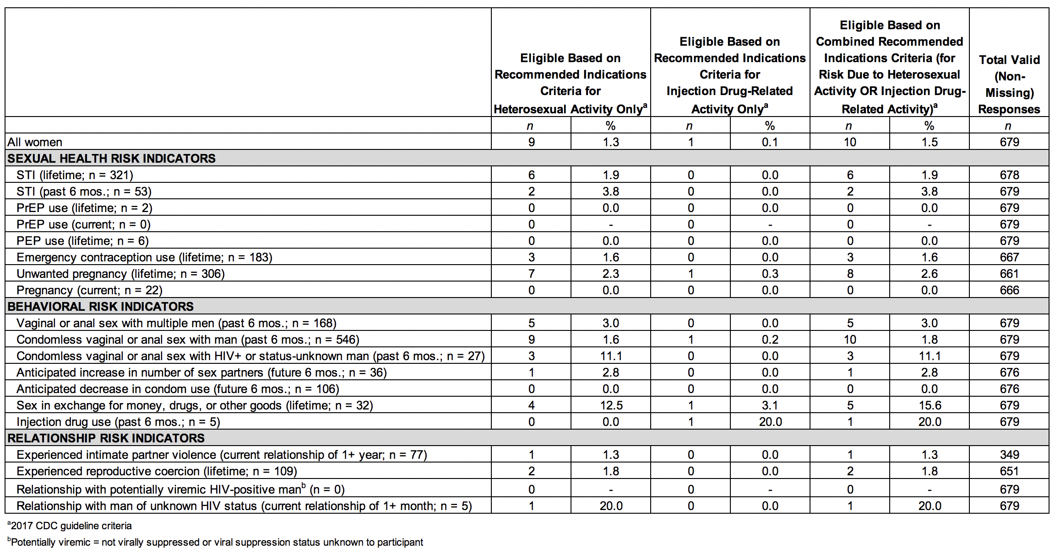

eTable 2. PrEP Eligibility by Risk Indicator Based on 2017 Guidance Summary Criteria for Heterosexual Activity vs. Injection Drug-Related Activity vs. Both Combined
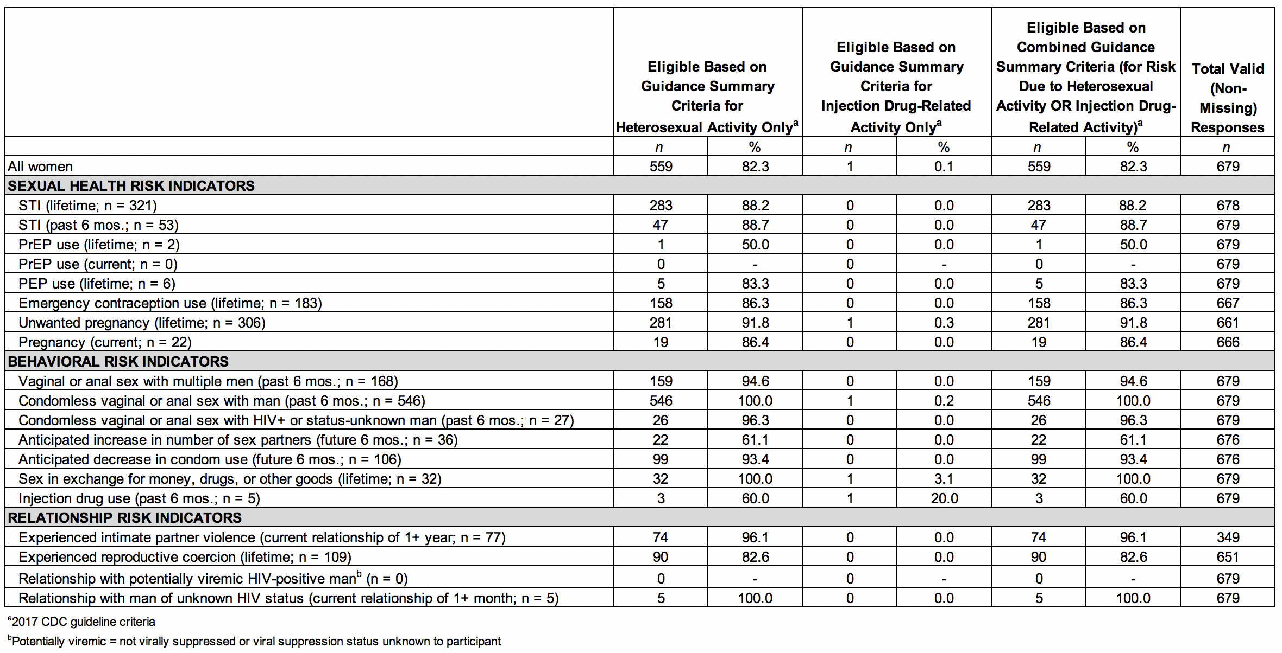

eTable 3. PrEP Eligibility by Risk Indicator Based on Current (2017) CDC Criteria vs. Original (2014) CDC Criteria
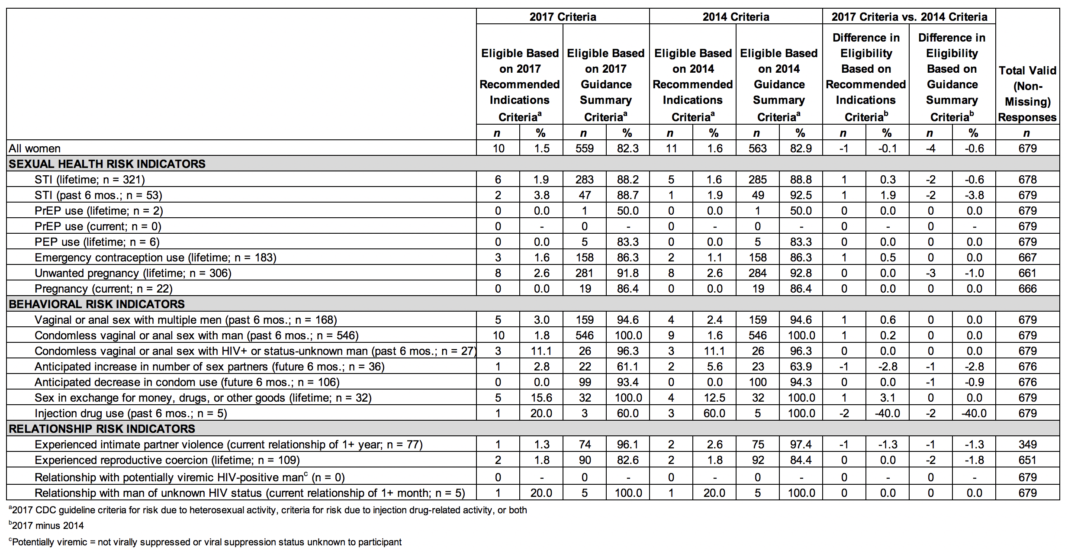

eTable 4. PrEP Eligibility by PrEP Motivation Indicator Based on 2017 CDC Criteria
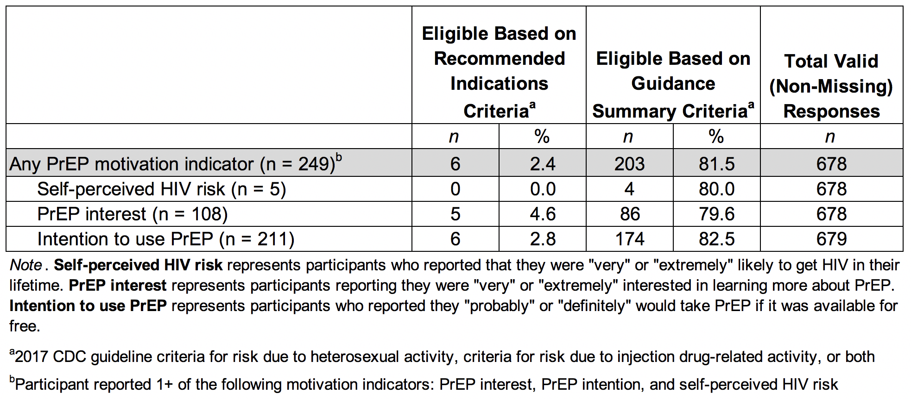

SDC 3

Summary of State-Level PrEP Eligibility Criteria for Women

eTable 5 is accessible through the following link:
https://docs.google.com/spreadsheets/d/18cjsBxxg1z7N5jxJ13GSVs-hI3v89eiDXmMazUad7Go

