Supplementary data

Table S1: Comparison of transmission chains identified by Sanger and UDS

Clusters identified by Sanger | HCV sub-type | Patient | HIV  co-infection | HCV  reinfection | Date of 1st positive HCV viral load or anti-HCV | UDS at 3% of maximum genetic distance |  | UDS at 4.5% of maximum genetic distance
1 | GT3a | 1 | Yes | No | 13/08/2015
 |  | 2 | Yes | No | 18/09/2015
 |  | 3 | Yes | Yes | 13/05/2015
 |  | 4 | Yes | Yes | 27/04/2015
 |  | 5 | Yes | No | 19/03/2015
 |  | 6 | No | No | 17/05/2016
2 | GT1a | 7 | Yes | No | 16/10/2014
 |  | 8 | No | No | 04/08/2015
3 | GT1a | 9 | Yes | No | 09/10/2015
 |  | 10 | Yes | Yes | 14/08/2015
 |  | 11 | Yes | No | 20/06/2014
 |  | 12 | Yes | No | 15/05/2015
 |  | 13 | Yes | No | 19/05/2015
 |  | 14 | No | No | 18/03/2014 |  |  | G
4 | GT1a | 15 | Yes | No | 07/08/2014
 |  | 16 | Yes | No | 02/04/2015
 |  | 17 | Yes | Yes | 27/07/2015
 |  | 18 | No | No | 24/04/2014
 |  | 19 | No | No | 03/02/2014
5 | GT1a | 20 | Yes | No | 23/07/2014
 |  | 21 | Yes | No | 27/06/2015
 |  | 22 | No | No | 15/09/2014
6 | GT1a | 23 | Yes | Yes | 02/04/2015
 |  | 24 | Yes | No | 21/09/2015
 |  | 25 | Yes | Yes | 07/05/2015
* | GT1a | 26 | Yes | No | 27/12/2014 |  |  |  | K
* | GT4d | 27 | Yes | No | 08/04/2015
7 | GT4d | 28 | Yes | Yes | 29/12/2014
 |  | 29 | No | No | 15/05/2015
 |  | 30 | Yes | Yes | 13/04/2015
* | GT4d | 31 | Yes | No | 18/09/2014
8 | GT4d | 32 | Yes | No | 12/12/2014
 |  | 33 | Yes | Yes | 22/01/2016
 |  | 34 | Yes | No | 16/09/2015
 |  | 27 | Yes | No | 08/04/2015
 |  | 35 | No | No | 06/08/2012
* | GT4d | 36 | Yes | No | 07/01/2016
9 | GT4d | 37 | Yes | No | 14/03/2014
 |  | 38 | No | No | 20/11/2014
10 | GT4d | 39 | Yes | No | 04/05/2015
 |  | 40 | Yes | Yes | 07/11/2014
 |  | 41 | Yes | No | 25/02/2015
The table presents ten clusters identified by Sanger sequencing and numerated from 1 to 10 (first column).
The same coloured boxes in the two last columns represent individuals involved in the same chain of transmission detected by UDS at 3% and 4.5% of maximum genetic distance (MGD).
*: Individuals additionally detected by UDS in a transmission chain.
Additional transmission chains detected by UDS at 4.5% of MGD compared to the 3% threshold are presented in grey boxes.
UDS at both thresholds of MGD did not detect the transmission chain number 5 found by Sanger sequencing.
Trans-  mission chains | Sub-type | Patient | HIV  co-infection | HCV re-infection | Date of 1st positive HCV viral load or anti-HCV | UDS at 3% of maximum genetic distance |  | UDS at 4.5% of maximum genetic distance
1 | GT4d | 42 | No | No | 23/09/2015
 |  | 43 | Yes | No | 09/01/2015
2 | GT4d | 44 | Yes | No | 01/02/2016
 |  | 45 | No | No | 05/10/2015
3 | GT1a | 46 | Yes | Yes | 21/09/2015
 |  | 47 | Yes | No | 11/06/2015
 |  | 48 | Yes | No | 05/12/2014
Table S2: Hidden transmission chains additionally detected by UDS

The same coloured boxes in the two last columns represent individuals involved in the same chain of transmission detected by UDS at 3% and 4.5% of maximum genetic distance, respectively.

,

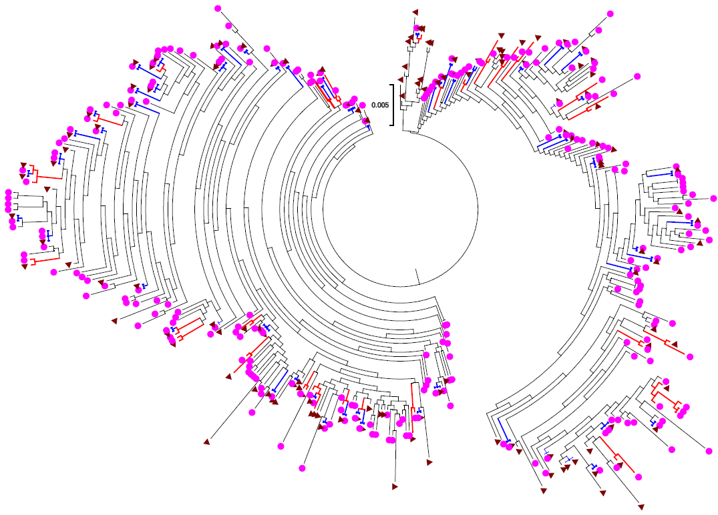

Figure S1: Phylogenetic tree constructed from UDS viral sequences of two individuals, individual 9 (pink circle) and 10 (brown triangle), which were considered as closely related transmission.
Red clades represent sequences with maximum genetic distance (MGD) < 0.5% between the 2 individuals. Blue clades represent identical sequences between the 2 individuals (MGD = 0%)

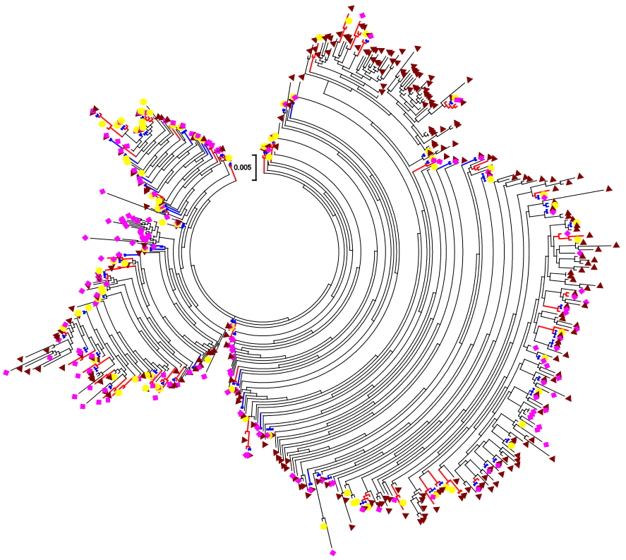

Figure S2: Phylogenetic tree constructed from three individuals, individual 27 (yellow circle), 28 (pink diamond), and 29 (brown triangle) which were considered to belong to closely related transmission events. Blue clades represent identical sequences among the three individuals. Red clades represent sequences with MGD < 0.5% among the three individuals.

