|  |  |
| --- | --- |
| **Supplementary Table 1. Databases used and exact search terms** | |
| **Database** | **Search terms** |
| Pubmed  (includes Medline) | ("HIV-1"[Mesh] OR "HIV Infections"[Mesh] OR "HIV Seropositivity"[Mesh] OR HIV-exposed[Text Word] ) Filters: Child: birth-18 years; Infant: birth-23 months; Child: 6-12 years; Newborn: birth-1 month; Infant: 1-23 months; Preschool Child: 2-5 years AND uninfected[Text Word] AND “humans” [Mesh] |
| Web of Science  (Science Citation Index and Social Science Citation Index) Includes Medline | TS=HIV Infect* OR TS=Infect* HIV OR TS=HIV Seropositiv* OR TS=Seropositiv*, HIV OR TS=AIDS Seropositiv* OR TS=Seropositiv*, AIDS OR TS=Anti-HIV Positiv* OR TS=Positiv*, Anti-HIV OR TS=HIV Seroconver* OR TS=Seroconver*, HIV OR TS=AIDS Seroconver* OR TS=Seroconver*, AIDS OR TS=HIV Antibody Positiv* OR TS=Antibody Positiv*, HIV OR TS=Positiv*, HIV Antibody OR TS=HIV-1 OR HIV-expose* AND TS=infan* OR TS=child* AND TS=uninfect* |
| Excerpta Medica Abstract Journals  (EMBASE) | ‘human immunodeficiency virus infection’/exp AND ‘uninfected’: ab,ti AND ([newborn]/limOR[infant]/limOR[preschool]/limOR[child]/lim)AND[humans]/lim |
| ProQuest Dissertation & Thesis Outline | ((HIV infection) AND uninfected AND (child OR children)) AND if (“Highly active antiretroviral therapy”) |
| International AIDS Society (IAS) abstract archives | (HIV exposed uninfected) AND (child* OR infant*) site:.iasociety.org  (HIV exposed uninfected) AND (child* OR infant*) site:.ias2013.org |
| AIDS Conference abstract archives | (HIV exposed uninfected) AND (child* OR infant*) site:.www.aids2008.org  (HIV exposed uninfected) AND (child* OR infant*) site:.www.aids2010.org  (HIV exposed uninfected) AND (child* OR infant*) site:.www.aids2012.org(HIV exposed uninfected) AND (child* OR infant*) site:.www.aids2014.org  (HIV exposed uninfected) AND (child* OR infant*) site:.www.aids2016.org  (HIV exposed uninfected) AND (child* OR infant*) site:.www.aids2018.org |

**Supplement Figure 1. Forest plot of risk ratios for diarrhea overall comparing HIV-exposed uninfected children to HIV-unexposed uninfected children stratified by pre 2002 vs. post 2002 after PMTCT guidelines were implemented.**



**Supplement Figure 2. Forest plot of risk ratios for pneumonia comparing HIV-exposed uninfected children to HIV-unexposed uninfected children stratified by pre 2002 vs. post 2002 after PMTCT guidelines were 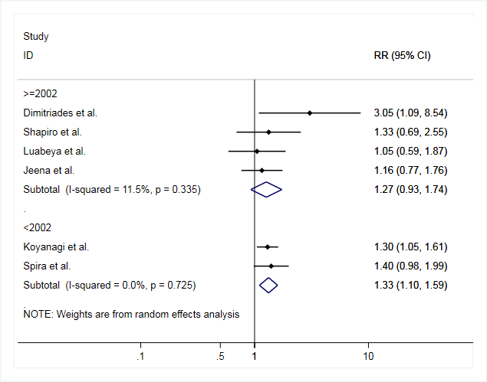implemented.**

*x

**Supplement Figure 2. Funnel plot assessing publication bias for a) diarrhea [10-19] and b) pneumonia [9,12-14, 16, 20]**

a)



b)

*funnel plot assesses the hypothesis that the relationship between log(RR) and standard error of the log(RR) are independent

**Egger’s test for a) pneumonia p=0.746 and b) diarrhea p=0.366

**Supplemental Table 2. Assessment of study quality using the Newcastle-Ottawa Scale [25]**

|  |  |  |  |  |  |  |  |  |  |  |  |
| --- | --- | --- | --- | --- | --- | --- | --- | --- | --- | --- | --- |
|  |  | **Selection** | | | | **Comparability** | **Exposure** | | | **Score** | **Categorization** |
|  | **Study** | **1** | **2** | **3** | **4** | **1** | **1** | **2** | **3** |  |  |
| **1** | **Dimitriades et al.[9]** | c) | a) | a) | a) | a) | b) | a) | d) | 6 | Moderate |
| **2** | **O'Reilly et al.[10]** | a) | a) | a) | a) | a) b) | a) | a) | b) | 9 | High |
| **3** | **Landes et al.[11]** | a) | a) | a) | b) | a) b) | c) | a) | c) | 7 | High |
| **4** | **Koyanagi et al.[12]** | a) | a) | a) | a) | a) b) | b) | a) | a) | 9 | High |
| **5** | **Shapiro et al.[13]** | a) | a) | a) | a) | a) b) | b) | a) | a) | 9 | High |
| **6** | **Spira et al.[14]** | a) | a) | a) | a) | a) b) | b) | a) | b) | 9 | High |
| **7** | **Thea et al.[15]** | a) | a) | a) | a) | a) | c) | a) | b) | 7 | High |
| **8** | **Luabeya et al.[16]** | a) | a) | a) | a) | a) b) | c) | a) | c) | 7 | High |
| **9** | **Pavlinac et al.[17]** | a) | a) | b) | b) | a) b) | a) | a) | b) | 9 | High |
| **10** | **Rollins et al.[18]** | a) | a) | a) | a) | a) b) | c) | a) | b) | 8 | High |
| **11** | **Marguez et al.[19]** | a) | a) | a) | a) | a) b) | b) | a) | b) | 9 | High |
| **12** | **Jeena et al.[20]** | a) | a) | a) | a) | a) | b) | a) | b) | 8 | High |