Supplementary Materials

Title:
Clinical consequences of using an indeterminate range for early infant diagnosis of HIV: a decision model

Authors:

Phillip Salvatore*†, PhD, SM
Karl Johnson‡, BS
Lara Vojnov§, PhD
Meg Doherty§, MD, PhD, MPH
David Dowdy*‖, MD, PhD, ScM

* Department of Epidemiology, Johns Hopkins Bloomberg School of Public Health, Baltimore, Maryland, USA
† Department of Molecular Microbiology & Immunology, Johns Hopkins Bloomberg School of Public Health, Baltimore, Maryland, USA
‡ Krieger School of Arts and Sciences, Johns Hopkins University, Baltimore, Maryland, USA
§ Department of HIV and Global Hepatitis Programme, World Health Organization, Geneva, Switzerland
‖ Department of International Health, Johns Hopkins Bloomberg School of Public Health, Baltimore, Maryland, USA

Supplementary Methods

The Probability of an Indeterminate Result
The model described in this study estimates the number of HIV-infected and HIV-uninfected infants that may be correctly (and incorrectly) identified through the use of an “indeterminate” classification produced by semi-quantitative HIV PCR testing. This analysis requires estimation of the proportion of infants in each group (infected and uninfected) that receive an indeterminate result from the first NAAT test, among all infants that receive non-negative results. Although the accuracy of NAAT testing is reduced at birth (Mallampati et al., JAIDS 2017), we assume for simplicity that initial HIV testing occurs at 6 weeks of age and parameterize assay characteristics based on the available empirical data. First, the proportion of infants who receive a non-negative result (above the instrument’s limit-of-detection) is estimated based on empiric data on instrument sensitivity (for HIV-infected infants) and specificity (for HIV-uninfected infants). Then, a conditional probability of that non-negative result being indeterminate is used to calculate the proportion of infected or non-infected infants receiving a result in the indeterminate range. This proportion varies with different Ct values used as the cutoff to define the indeterminate range. For example, a higher proportion of HIV-infected infants are likely to fall in an indeterminate range defined by a cutoff of 30 (any result with a Ct greater than 30 and less than the limit of detection) than would fall in an indeterminate range defined by a cutoff of 35.
To generate estimates of these proportions, we constructed probability distributions for the Ct value of an initial non-negative NAAT test in each (HIV-infected and HIV-uninfected) population of infants. These distributions were derived from a meta-analysis of confirmatory test results for 14,753 infants with initial non-negative NAAT results (of whom 2,077 had confirmatory results available), drawn from published and unpublished data collected across Botswana, Namibia, South Africa, and Uganda (see Luo et al., “Use of an indeterminate range in HIV early infant diagnosis: a systematic review and meta-analysis” submitted with this manuscript). Data from across these settings were aggregated using a random effects regression model, and the proportion of infected or uninfected infants falling above each reported Ct value (30 through 36) was estimated. These empirically based probability distributions are illustrated in Figure S1. The proportion of indeterminate results expected at a given Ct value can be interpreted as the cumulative distribution of results falling between the limit of detection and the selected Ct cutoff value. For example, at a Ct cutoff value of 33, 93.4% (4.4% + 18.1% + 22.2% + 48.7%) of HIV-uninfected and 8.5% (4.5% + 2.1% + 1.4% + 0.5%) of HIV-infected infants would be classified as indeterminate.
The probability distributions constructed through the random effects model were used to calculate conditional probabilities of an indeterminate result at each potential Ct cutoff, using a nested resampling strategy. For example, 24.3% of HIV-infected infants (with non-negative NAAT results) were estimated to have a Ct value ≥30 and 18.5% of HIV-infected infants have a Ct value ≥31. Therefore, the conditional probability of a Ct result being ≥31, given that the result is ≥30, is estimated to be 18.5/24.3 = 76.4%.
For each simulation, the proportion of results in an indeterminate range with a cutoff of 30 was sampled from a uniform distribution (defined by ±10% the value estimated from the random effects model). Then, for each subsequent Ct cutoff (from 31 to 36), a conditional probability value was sampled from a uniform distribution (defined by ±10% the conditional probability estimated in the mixed effects model at the same cutoff). For example, among HIV-infected infants, conditional probability values of a Ct value ≥31, given that the result is ≥30, were sampled uniformly across the range 68.7-84.0% (i.e., 76.4% +/- 7.6%). In this way, a distribution of Ct values – based on empiric data – was generated for each population in each simulation, and the proportions of indeterminate results are calculated as the cumulative distributions from these simulated distributions.

Disability-Adjusted Life Years (DALYs)
The total DALYs accumulated in each scenario modeled were calculated as the estimated number of years of life lost (YLL) plus the estimated number of years of life lived with disability (YLD). All YLL and YLD were discounted at 3% per year from the time of birth. Mortality was estimated at 2 years of age according to HIV and treatment status; all HIV-infected children—regardless of initial test result—who survived past 2 years of age were assumed to receive an appropriate HIV diagnosis (and ART indication) at their second birthday and experience mortality in accordance with the general experience of HIV-positive individuals in later years (HIV-infected life expectancy sampling range: 25-31 years). Total YLL due to early mortality were calculated by subtracting the age at death (2 years for those who died before HIV diagnosis, otherwise according to the HIV-positive life expectancy above) from the life expectancy of a healthy, HIV-uninfected individual (sampling range: 57-69 years) in the population.
Disability weights were assigned to years of life lived with untreated HIV among HIV-infected infants (sampling range: 0.53-0.64) and treated HIV among HIV-infected infants (sampling range: 0.07-0.09). To estimate the disability weight of unnecessary ART among HIV-uninfected infants, we searched the Global Burden of Disease Study for health states comparable to common side effects of ART, including: aches, weakness, moderate fatigue, diarrhea, worry associated with a chronic disease but minimal interference with daily activities, daily medication, and some difficulty with daily activities. This description was best matched by “Generic uncomplicated disease: worry and daily medication” (weight=0.049). Given the emotional burden and social stigmatization which accompanies a diagnosis of HIV (compared with a generic uncomplicated disease), we took this to represent a lower bound on the disutility associated with a false-positive HIV diagnosis and sampled disability weights in the range 0.05-0.06. In each scenario, misdiagnosed HIV-infected infants (false negatives) were assumed to accumulate six disability-weighted months (if confirmatory testing were performed, subsequently resulting in a positive result) or two disability-weighted years (if missed in confirmatory testing, or if confirmatory testing were not performed) of life without treatment; those who survive beyond two years of age were assumed to accumulate disability-weighted years of life with treated HIV equal to the HIV-infected life expectancy (25-31 years) minus two. False-positive, HIV-uninfected individuals who survive beyond two years of age were assumed to remain on ART for the duration of their natural lives and accumulate an amount of disability-weighted years of life equal to the life expectancy of a healthy, HIV-uninfected individual. For example, an HIV-infected infant who is missed originally but survives past age two and receives treatment might incur the following amount of DALYs:
$$DALYs=YLL+YLD=\left(57-25\right)+\left[\left(0.07\right)\left(25-2\right)+\left(0.53\right)\left(2\right)\right]=34.67$$
where 57 is the minimum life expectancy of the population, 25 is the minimum life expectancy with HIV, 0.07 is the disability weight for treated HIV, (25 – 2) is the number of years of treated HIV, 0.53 is the disability weight for untreated HIV, and 2 is the number of years spent with untreated HIV.
Similarly, using the same assumptions, an HIV-uninfected infant who is a false-positive (thus unnecessarily receiving treatment) and survives past age 2 was assumed to receive the following amount of DALYs:
$$DALYs=YLL+YLD=\left(57-57\right)+\left(0.05\right)\left(57-0\right)=2.85$$

Nonparametric Multivariate Sensitivity Analysis
We evaluated the influence of each input parameter value on the primary outcome. In addition to the 10,000 simulations described in the Methods, 100,000 simulations were performed for the purpose of sensitivity analyses with parameter inputs randomly sampled from a range of possible values. We performed a nonparametric, multivariate sensitivity analysis by calculating partial rank correlation coefficients (PRCCs) between input parameter values and our primary outcome. Similarly, we evaluated the nonparametric correlations between input parameter values and the incremental cost-effectiveness ratio of the Indeterminate Range algorithm (relative to SoC). Cost and disability weight sampling ranges were varied across ranges defined in Table 1. For the purposes of this sensitivity analysis, the proportion of initial positive tests falling in the indeterminate range was sampled uniformly across 0-25% for HIV-infected infants and across 45-100% for HIV-uninfected infants. The independent probability of receiving a confirmatory test was sampled uniformly across 0-100%. The prevalence of HIV among tested infants was sampled uniformly from 0-15%.

False-Positive Patients Lost to Care
We investigated the potential impact of relaxing the assumption that an infant who receives a false-positive diagnosis will receive lifelong ART. In this analysis, we introduce a new parameter p to represent the annual probability of permanently leaving ART among infants diagnosed as false-positive, such that, by age t, only ${(1-p)}^{t}$ false-positive patients remain on treatment. For each simulation of this modified model, we calculate the total number of person-years of ART contributed by each false-positive patient as $Y=\int_{0}^{LE}{{(1-p)}^{x}dx}$ (where LE is the life expectancy of uninfected infants). Lifetime costs of HIV care for these patients are therefore reduced by a factor of Y/LE, and a false-positive patient contributes only Y years (before discounting) of disutility due to unnecessary treatment. For this analysis, we allow p to range uniformly from 0-3% per year (in this range, half of all false-positive patients are modeled to end ART within 22 years). With this modified model, we evaluate the incremental cost-effectiveness of the Indeterminate Range algorithm (relative to the SoC) at all possible Ct cutoffs at a prevalence of 2.5% and with 15% confirmatory testing.

Figure S1: Empiric Cycle Threshold Distributions from Random Effects Model. The probability distributions of cycle threshold (Ct) values among HIV-infected (left panel) and HIV-uninfected infants (right panel) with initial non-negative test results, based on estimates from a random effects model of 2,077 infants tested twice. For example, 4% (0.5% + 1.4% + 2.1%) of HIV-infected infants with an initial non-negative test result had Ct values of 34 or higher, while 89% (48.7% + 22.2% + 18.1%) of HIV-uninfected infants with an initial non-negative test result had Ct values of 34 or higher. These distributions were used to model the probability of an infant receiving an indeterminate result at each possible Ct value cutoff, conditional on HIV status.

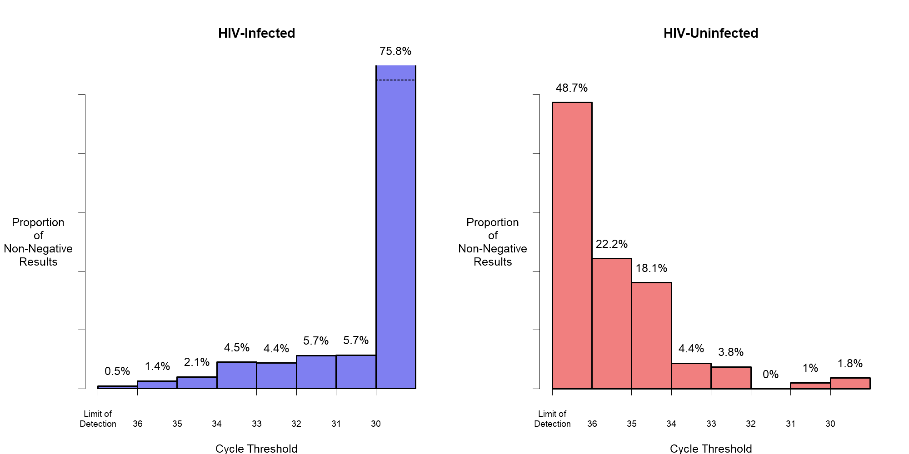

Supplementary Results
Nonparametric Sensitivity Analysis
The most significant determinants of the primary outcome were the prevalence of HIV among tested infants, the probabilities of receiving an indeterminate result (related to the Ct cutoff chosen), and the specificity of the assay. The most influential determinants of ICERs were similar to the determinants of our primary outcome, namely the prevalence of HIV among tested infants and the probability of receiving an indeterminate result. Additionally, ICERs were moderately influenced by the lifetime cost of HIV care and the life expectancy of an HIV-infected infant on treatment (Figure S2B). These parameters influence calculations of costs and DALYs but not the clinical outcomes of infants in either algorithm, and therefore have no correlation with our primary outcome. PRCC values for all parameters are illustrated in Figure S2.

Figure S2: Partial Rank Correlation Coefficients Describing the Correlation between Model Parameters on the Ratio of Unnecessary ART Averted to Excess Deaths. Coefficients represent the nonparametric correlations between each model parameter and the selected outcome, controlling for all other parameters across 100,000 simulations. Panel A represents the correlation between parameter values and the primary outcome (the ratio of ART regimens averted to additional HIV-related deaths), and Panel B represents the correlation between parameter values and the incremental cost-effectiveness ratio. Parameters which only impact costs and disability have been excluded from Panel A. All parameters are shown in Panel B. Values near -1 indicate a strong correlation between increases in parameter value and decreases in the value of the primary outcome; values near +1 indicate a strong correlation between increases in parameter value and increases in the value of the primary outcome. Bracketed values indicate the minimum/maximum values sampled from each parameter on the uniform distributions or the 2.5th/97.5th percentile values from parameters sampled from continuous distributions. (Parameters related to cost and DALY calculations, which do not influence the primary outcome, are excluded.)
Panel S2A
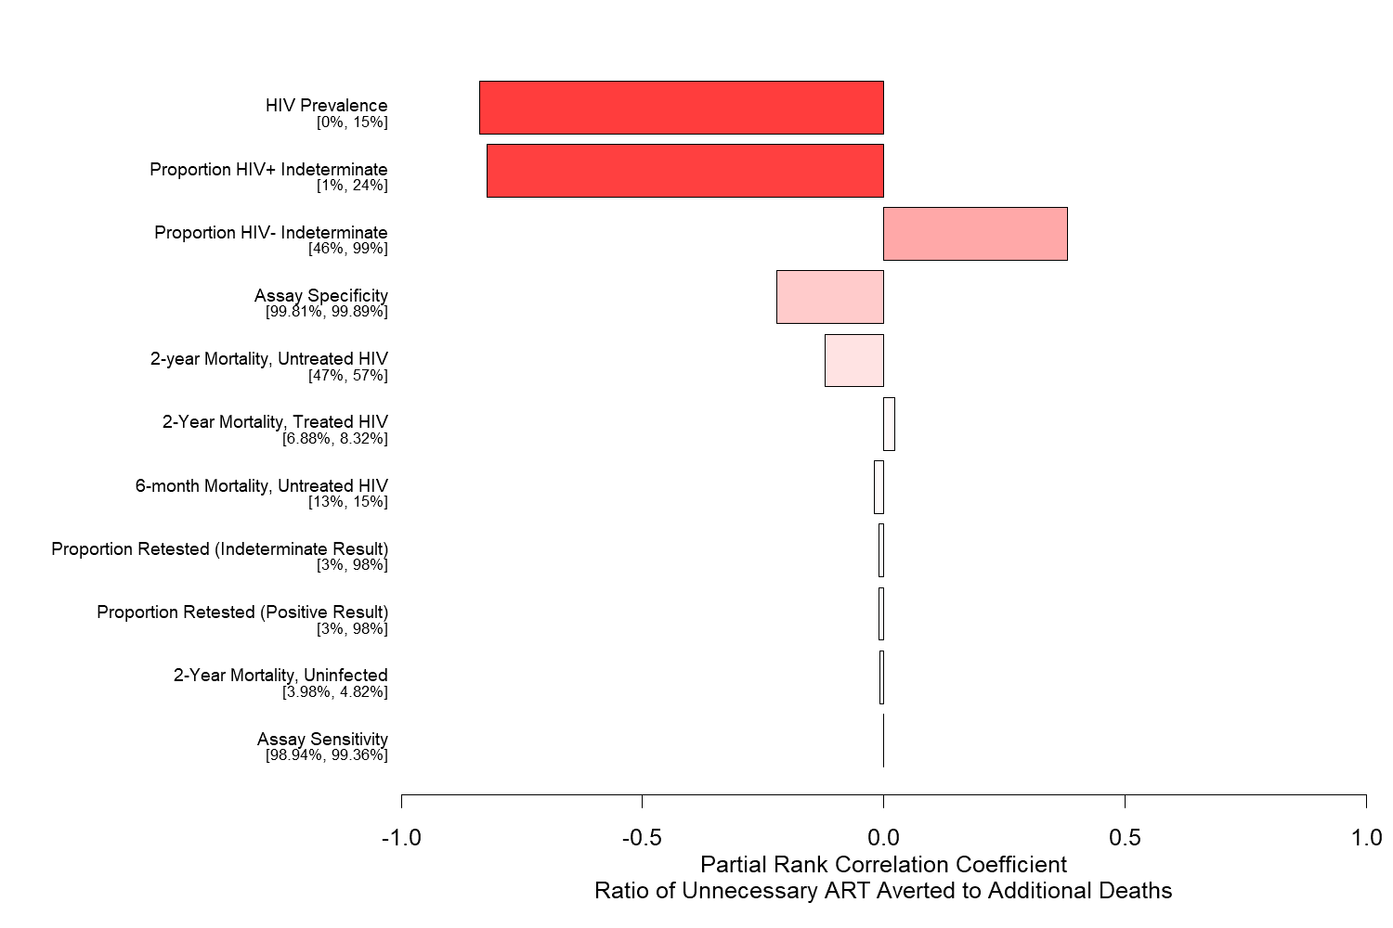

Panel S2B
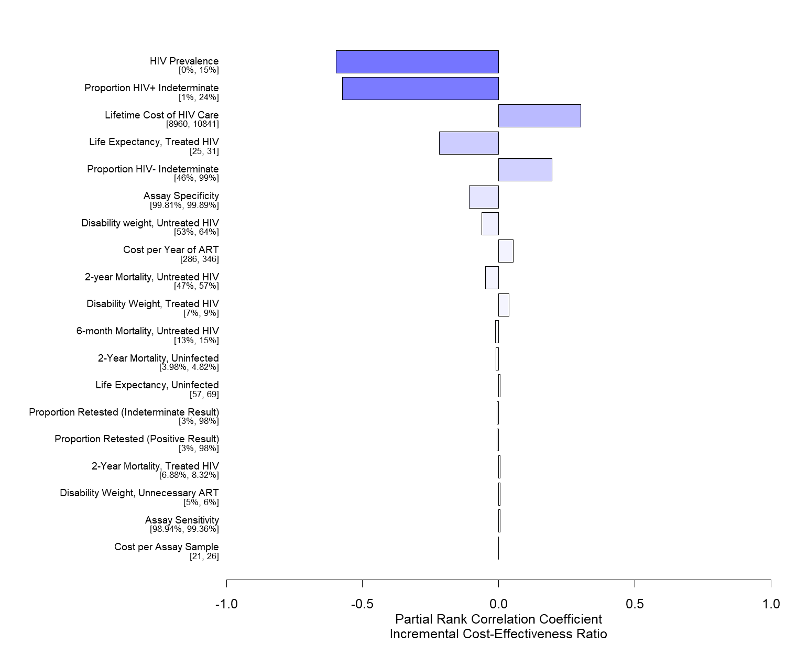

HIV Prevalence
In our model, we defined prevalence as the number of HIV-infected infants among all infants test by 6 weeks of age. This is dependent upon the transmission risks of HIV in utero, during labor and delivery, and in the first weeks of life, but it is also conditional among those seeking care. (For example, infants of mothers receiving PMTCT, and therefore at lower risk of transmission, are more likely to be tested than infants of mothers who do not receive PMTCT. Among a number of sub-Saharan African settings, the average prevalence by 6 weeks of age is estimated at 4%, but this ranges from 1% to more than 10% (UNAIDS, “Start Free Stay Free AIDS Free”, 2017). As the prevalence of HIV was determined to be the most significant determinant of the primary outcome, we further investigated the possible range of outcomes at several discrete HIV prevalence values (specifically, 10%, 7.5%, 5%, 2.5%, and 1%), presented in Figure S3. In simulations with a high HIV prevalence, a policy switch to an indeterminate range is least favorable: at a prevalence of 10%, 0.11 unnecessary ART regimens were averted for each additional HIV-related death (95% UR: 0.09-0.15) at a Ct cutoff ≥30, increasing to a ratio of 2.15 (95% UR: 1.4-3.3) at a Ct cutoff ≥36. This tradeoff becomes more favorable for the Indeterminate Range algorithm as the prevalence of HIV declines; for example, a Ct cutoff ≥36 scenario would be expected to avert 23.7 (95% UR: 15.5-36.8) unnecessary ART indications for each additional death incurred at 1% prevalence. These data illustrate that maintaining the SoC (presumptively treating all infants with a positive NAAT result, even in the absence of confirmatory testing) becomes increasingly inefficient as the prevalence of HIV declines. This illustrates that switching to an Intermediate Range policy becomes increasingly favorable with the continued global success of programs to prevent mother-to-child transmission of HIV (PMTCT).

Figure S3: Effectiveness of an Indeterminate Range, by HIV Prevalence. Bars represent the median primary outcome (and 95% uncertainty ranges) for simulations at each level of HIV prevalence among tested infants (holding other parameter distributions constant across prevalence levels). Switching from the SoC to an Indeterminate Range policy becomes increasingly favorable as the Ct cutoff increases at each level of prevalence, and as prevalence decreases overall.
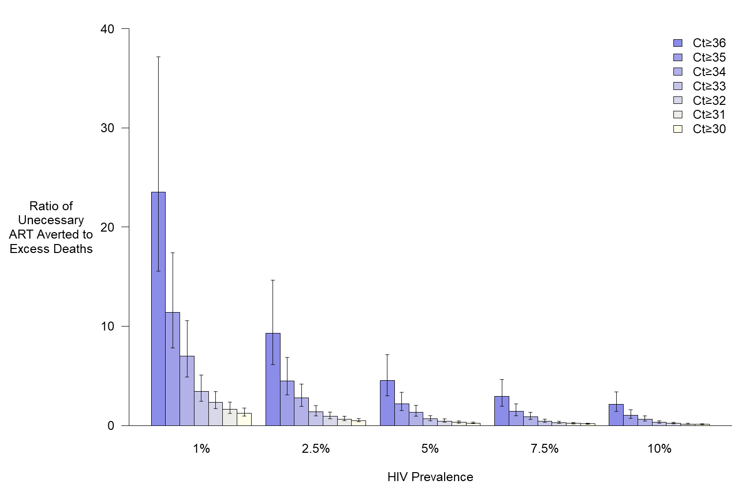

The Probability of Confirmatory Testing
As determined in our sensitivity analysis, the probability of confirmatory testing was weakly associated with the primary outcome (|PRCC|<0.01). While the primary outcome (the ratio of unnecessary ART averted to excess deaths) was not dependent on this probability, absolute clinical outcomes under all algorithms were substantially influenced by this probability. Figure S4 illustrates at a that, as the probability of confirmatory testing increases, the SoC results in fewer infants with unnecessary indications for ART. When the probability of confirmatory testing reaches 90%, fewer than 0.51 (95% UR: 0.39-0.69) additional infants are expected to receive ART unnecessarily under the SoC than with a Ct cutoff ≥36.
Figure S5 similarly illustrates that, as the probability of confirmatory testing increases, the number of excess deaths that would result from a switch to any Indeterminate Range policy also decreases. When the probability of confirmatory testing reaches 90%, fewer than 0.05 (95% UR: 0.03-0.07) excess HIV-related deaths are expected to occur following adoption of an Indeterminate Range policy defined by a Ct cutoff ≥36. This occurs because the classification of “Indeterminate” is modeled to only be used for making clinical decisions in the absence of a confirmatory result. Therefore, as confirmatory testing increases, SoC and Indeterminate Range algorithms converge to the same result (with optimal clinical outcomes).
Our primary outcome of interest represents a ratio of these incremental clinical outcomes. Both the SoC and Indeterminate Range algorithms perform better in absolute numbers as the probability of confirmatory testing increases: as this probability increases from 10% to 90%, the SoC scenario experiences a 95% reduction in excess unnecessary ART (relative to an Indeterminate Range Ct cutoff ≥36), and the Indeterminate Range scenario (with a Ct cutoff ≥36) experiences a 75% reduction in excess HIV-related deaths (relative to SoC). However, the ratio of these values remains relatively stable. Figure S6 illustrates that this ratio varies only slightly as confirmatory testing reaches 50%. At the 90% level, this ratio decreases to a reasonable degree, as the absolute number of infants on excess unnecessary ART in the SoC scenario declines by 95% whereas the absolute number of excess deaths in the indeterminate range scenario declines by a slightly more modest 75%.

Figure S4: Excess Unnecessary ART with Increasing Confirmatory Testing. Under the SoC, falsely-positive infants initiate ART unless corrected through confirmatory testing. As confirmatory testing increases, more false-positive results are corrected and fewer infants initiate ART unnecessarily. Bars represent the median (and 95% uncertainty ranges) absolute number of excess ART initiations that occur under the SoC (relative to each possible Indeterminate Range Ct cutoff) for simulations at each level of confirmatory testing among infants with initial non-negative results. All simulations were performed with an HIV prevalence of 1%.
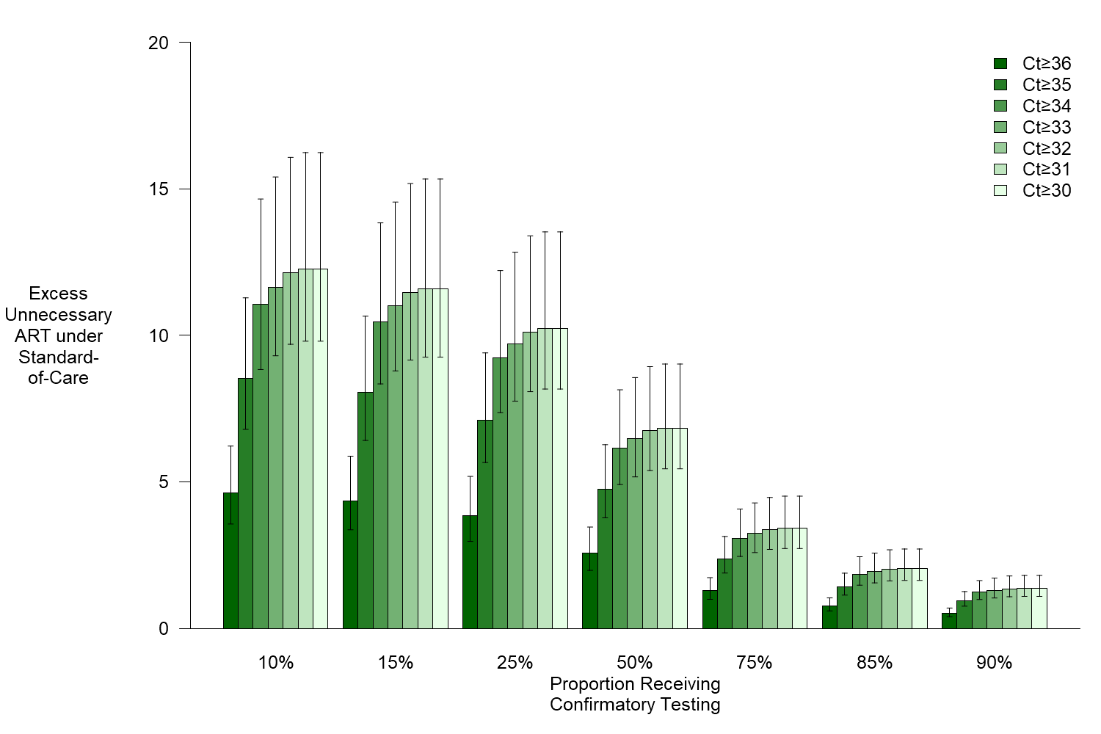

Figure S5: Excess Deaths with Increasing Confirmatory Testing. In the Indeterminate Range algorithm, the classification of “indeterminate” is only used for clinical decisions for infants who do not receive a confirmatory test. As confirmatory testing increases, fewer HIV-infected infants are subject to the “indeterminate” classification and thus fewer cases are missed. Bars represent the median (and 95% uncertainty ranges) absolute number of excess HIV-related deaths that occur under each Indeterminate Range Ct cutoff (relative to the SoC) for simulations at each level of confirmatory testing among infants with initial non-negative results. All simulations were performed with an HIV prevalence of 1%.
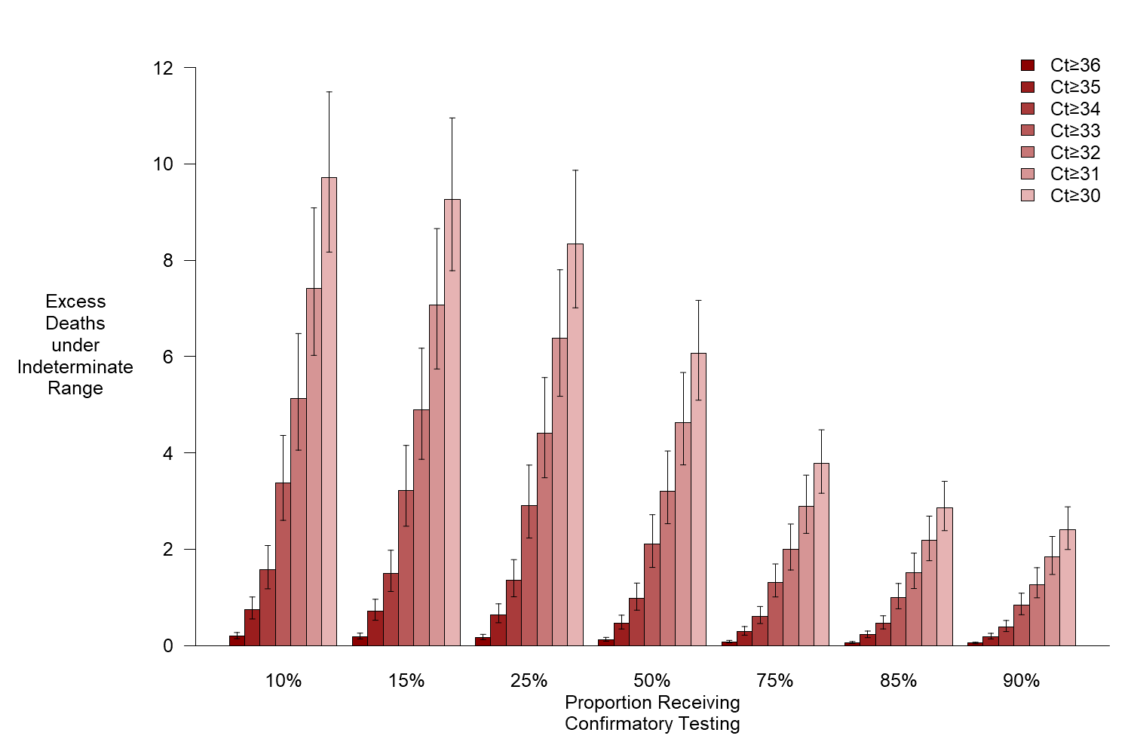

Figure S6: Effectiveness of an Indeterminate Range with Increased Confirmatory Testing. Bars represent the median primary outcomes for simulations at each level of confirmatory testing among infants with initial non-negative results. As ratios with small denominators (small numbers of excess deaths relative to SoC) create large quotients, only median ratio values are displayed. All simulations were performed with an HIV prevalence of 1%.

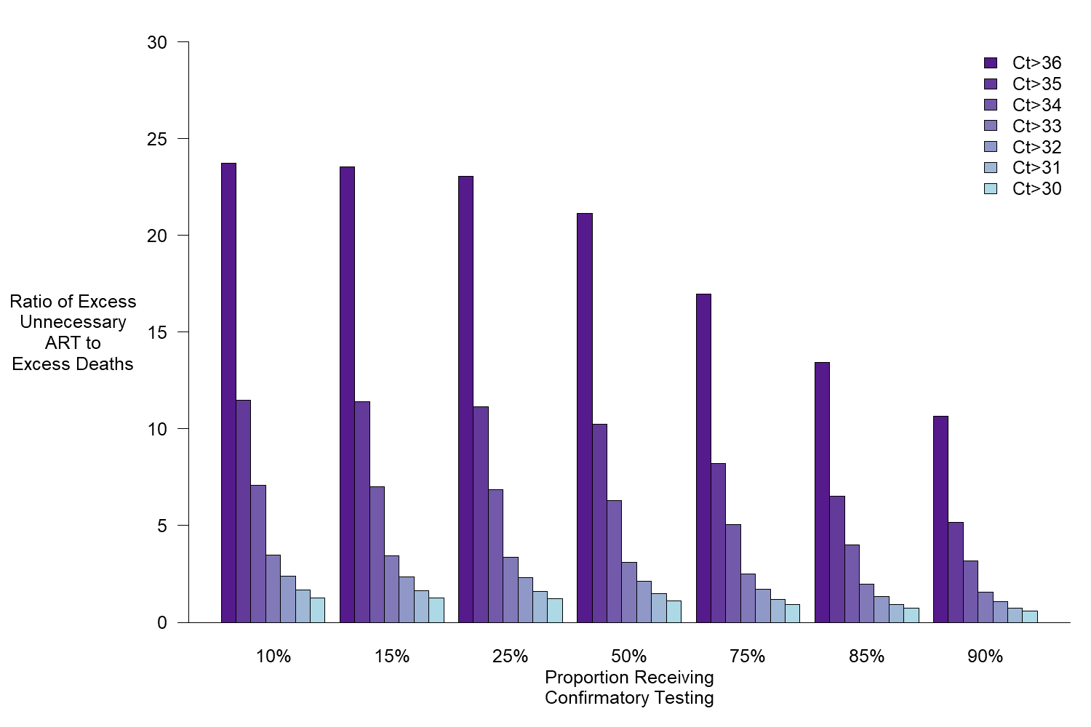

False-Positive Patients Lost to Care
When we relax the assumption that false-positive diagnoses result in lifelong ART, we find that the incremental value of an Indeterminate Range (relative to SoC) decreases somewhat but that trends largely mirror the findings in our primary analysis. Figure S7 presents the ICERs of adopting an Indeterminate Range at a prevalence of 2.5% before and after we relax this assumption. Relaxing this assumption reduces the incremental value of an Indeterminate Range defined by Ct≥33 by 20% (from a median of $1525 to $1233 gained per additional DALY), though this ranges from a 10% reduction at Ct≥30 to a 45% reduction at Ct≥36. Simultaneously, at cutoffs where relaxing this assumption had the largest relative impact on reducing the savings of an Indeterminate Range (i.e., Ct≥34, 35, and 36), the incremental cost-effectiveness of adopting an Indeterminate Range did not change so much as to move across likely decision thresholds of willingness to pay (new median values of $2003, $3213, and $9612 saved per additional DALY, respectively). At all Ct cutoffs, the median ICER with the relaxed assumption fell within the uncertainty bounds of the ICER in our main analysis.

Lifetime Costs of ART
Because lifetime costs of HIV care are difficult to estimate and may vary substantially across settings, we used for our primary analysis values previously used in the cost-effectiveness literature. However, as treatment and care costs are heterogeneous from country to country and over time, we also evaluated a wide range of possible costs of lifetime HIV care. Table S1 presents the cost and ICER estimates of adopting an indeterminate range defined by Ct≥33 at a prevalence of 2.5% and with 15% confirmatory testing under different assumptions about this lifetime cost. All other parameters were varied according to ranges defined in Table 1.These results demonstrate that the incremental savings of an Indeterminate Range and, consequently, ICER values track predictably with reductions in lifetime costs of care: if per-patient costs are reduced by 25% to $7500, the projected ICER value is reduced 23%; if costs are reduced 75% to $2500, the projected ICER is reduced 68%

Figure S7: Incremental Cost Effectiveness with False-Positive Loss to Care. The ratio of incremental costs to incremental DALYs (with both values being measured to SoC). Compared are ICER values at 2.5% Prevalence before and after allowing for misdiagnosed uninfected patients to drop out of HIV care over time. Lower limits for 2.5% Prevalence at Ct 36 are not displayed: Indeterminate Range simulations dominated at these values (they were less costly and resulted in fewer DALYs than SoC). Data labels represent median ICER values.
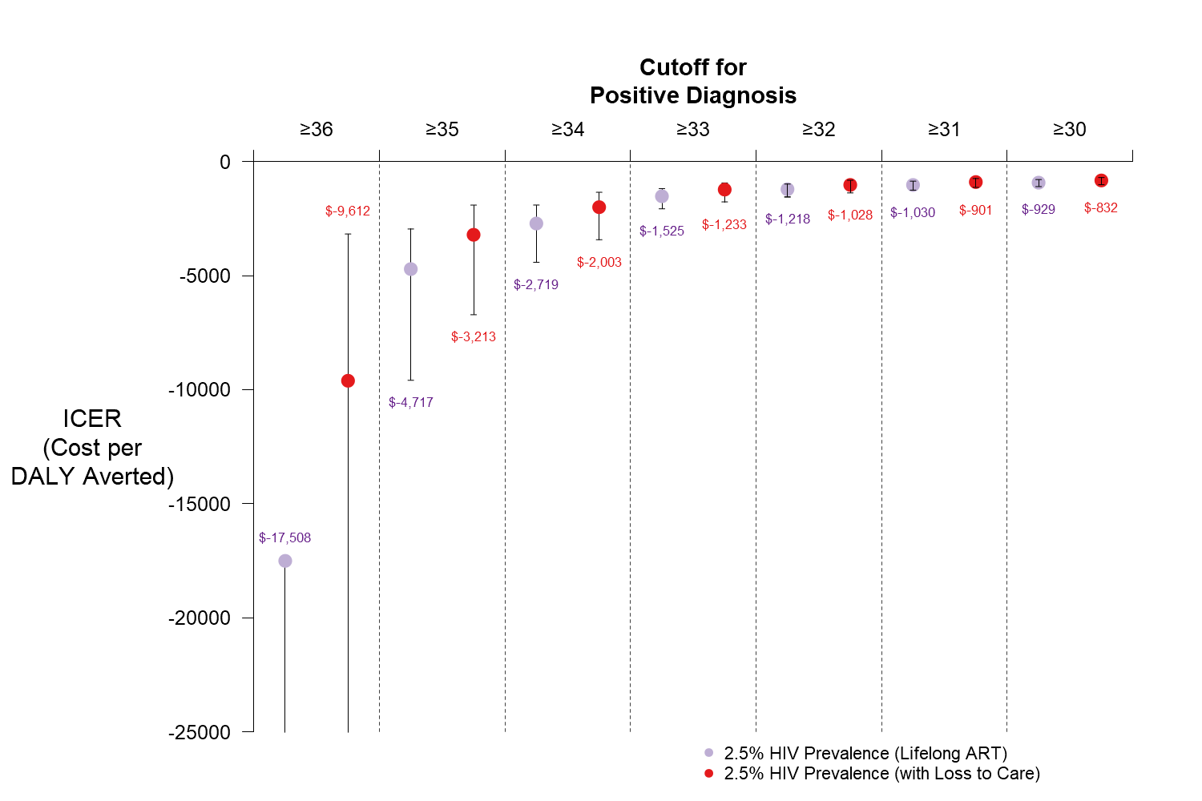

Table S1: Indeterminate Range Cost-Effectiveness with Lower Lifetime Costs of HIV Care
Lifetime Costs of HIV Care* | Total Costs† of SoC | Total Costs† of Indeterminate Range | Incremental Cost† of Indeterminate Range | ICER‡  (incremental cost per incremental DALY)
$10000 | $2810  (2760, 2860) | $2610  (2560, 2650) | $-204  (-247, -172) | $-1540  (-2080, -1230)
$7500 | $2210  (2170, 2250) | $2050  (2010, 2090) | $-158  (-191, -133) | $-1190  (-1610, -950)
$5000 | $1600  (1570, 1640) | $1490  (1460, 1530) | $-112  (-135, -94) | $-840  (-1130, -680)
$2500 | $1000  (970, 1030) | $940  (910, 970) | $-65  (-79, -55) | $-490  (-660, -400)
$1000 | $640  (610, 670) | $600  (570, 630) | $-38  (-45, -32) | $-280  (-380, -230)
SoC, Standard of Care; ICER, Incremental Cost-Effectiveness Ratio
*The lifetime costs of HIV care were fixed at specific values, while all other model parameters were varied according to the ranges defined in Table 1. Values represent simulations of an indeterminate range defined by Ct≥33 at a prevalence of 2.5% and with 15% confirmatory testing. Lifetime costs of HIV care are presented in 2017 USD.

Ideal Performance of the Standard of Care
An important reason for evaluating the potential performance of an Indeterminate Range policy is the reality that, in some settings, recommended confirmatory testing of infants with an initial non-negative EID result is not performed or performed only after long delays. To contextualize the results in our primary analysis, we present the results of an “ideal” SoC scenario in which all infants with an initial non-negative result receive confirmatory testing. At a prevalence of 2.5%, such a scenario would result in 0.019 infants unnecessarily receiving ART (Supplementary Table S2), compared with 11.6 infants in our reference scenario (in which only 15% of infants receive confirmatory testing, Table 2).

Cost-Effectiveness Outcomes
Estimates of the total costs and DALYs under each algorithm in the primary analysis (2.5% HIV prevalence, 15% probability of confirmatory testing) and priority confirmatory testing analysis are presented in Table 3. Incremental total costs were calculated for each potential Ct cutoff (used to define the indeterminate range), relative to the cost of the standard-of-care (SoC) algorithm. Incremental DALYs for each potential cutoff were calculated relative to the total DALYs accrued under the SoC. Incremental cost-effectiveness ratio (ICER) values for scenarios of 1%, 2.5%, and 5% HIV prevalence are presented in Figure S8. Parentheses show 95% uncertainty ranges. As the cutoff value increases from 36 to 30 (that is, the indeterminate range moves further from the SoC cutoff, such that more infants will receive indeterminate results), the incremental cost of the SoC increases as relatively more individuals are put on unnecessary ART, but the incremental DALYs of the Indeterminate Range algorithm also increase as fewer HIV-infected infants receive treatment.

Table S2. Ideal Performance of SoC with 100% Confirmatory Testing
Prevalence | Confirmatory Tests Performed | HIV-Infected Infants Potentially Missed | Total HIV-Related Deaths | Total DALYs | HIV-Uninfected Infants on ART | Total Costs*
1% | 113  (110, 118) | 1.6  ( 1.3, 2.1) | 8.3  (7.6, 9.1) | 12963  (11629, 14335) | 0.019  (0.012, 0.035) | $1210  (1110, 1300)
2.5% | 262  (259, 266) | 4.0  (3.2, 5.3) | 20.8  (18.9, 22.7) | 14641  (13181, 16125) | 0.019  (0.012, 0.034) | $2670  (2440, 2890)
5% | 509  (506, 514) | 7.9  (6.4, 10.5) | 41.6  (37.8, 45.3) | 17449  (15720, 19151) | 0.019  (0.012, 0.033) | $5100  (4660, 5540)
7.5% | 757  (754, 761) | 11.9  (9.6, 15.8) | 62.3  (56.7, 68.0) | 20265  (18256, 22215) | 0.018  (0.012, 0.033) | $7530  (6870, 8190)
10% | 1005  (1001, 1009) | 15.9  (12.8, 21.0) | 83.1  (75.6, 90.7) | 23071  (20758, 25317) | 0.018  (0.011, 0.032) | $9960  (9080, 10840)
DALYs, disability-adjusted life years; ART, Antiretroviral Therapy
*Total costs are presented in 2017 USD (in thousands)

Figure S8: Incremental Cost Effectiveness Ratios following Adoption of an Indeterminate Range. The ratio of incremental costs to incremental DALYs (with both values being measured to SoC). Negative values indicate that the Indeterminate Range algorithm are cost-saving (due to fewer unnecessary ART regimens) but incur additional (positive) DALYs over SoC. More negative ICERs represent greater savings for each additional DALY incurred. Median values and 95% confidence intervals are not displayed for Ct 36 at 1% prevalence: Indeterminate Range simulations dominated at these values (they were less costly and resulted in fewer DALYs than SoC). Lower limits for 2.5% Prevalence at Ct 36, and for 1% and 2.5% prevalence at Ct 35 were removed for the same reason.
