Supplementary table 1. Characteristics of MCH-ART trial participants who were eligible for LACE comparing A) those not enrolled versus enrolled in the LACE study and B) differences by trial arm (MCH-ART intervention versus standard of care [SOC]) among women enrolled in the LACE study; presented as n (%) unless specified as median (interquartile range [IQR]) or mead (standard deviation [SD]).
 | A) Women eligible to be traced for the LACE study (n=463) |  |  | B) Women enrolled in the LACE study (n=353)
 | Not enrolled (n=110) | Enrolled (n=353) | p-value | MCH-ART (n=172) | SOC (n=181) | p-value
Allocation in the MCH-ART trial
MCH-ART intervention | 57 (52) | 172 (49) | 0.571
Standard of care | 53 (48) | 181 (51)
Characteristics at first antenatal clinic visit
Mean age (SD) | 28.2 (5.5) | 28.6 (5.4) | 0.324 | 28.7 (5.5) | 28.6 (5.4) | 0.708
Nulliparous | 27 (25) | 59 (17) | 0.065 | 29 (17) | 30 (17) | 0.943
Median gestation at first ANC visit (IQR) | 21 [17,27] | 21 [16, 26] | 0.485 | 20.5 [15.5, 26] | 21 [16, 27] | 0.471
Completed secondary/any tertiary education | 29 (26) | 86 (24) | 0.671 | 38 (22) | 48 (27) | 0.333
Currently employed | 39 (35) | 141 (40) | 0.399 | 72 (42) | 69 (38) | 0.473
Married/cohabiting | 54 (49) | 136 (39) | 0.049 | 66 (38) | 70 (39) | 0.954
Newly diagnosed with HIV | 69 (63) | 194 (55) | 0.151 | 93 (54) | 101 (56) | 0.744
Initiated ART on day of first antenatal clinic visit | 77 (70) | 254 (72) | 0.692 | 121 (70) | 133 (73) | 0.513
Previous TB diagnosis | 13 (12) | 39 (11) | 0.823 | 17 (10) | 22 (12) | 0.496
Median CD4 (IQR); n=459 | 345 [227, 522] | 355 [255, 516] | 0.948 | 328 [236, 482] | 376 [264, 532] | 0.150
Characteristics at randomization
Median weeks on ART (IQR) | 19 [12, 22] | 18 [12, 23] | 0.667 | 18.5 [11.9,22.8] | 17.7 [12.3,23] | 0.947
Median days postpartum (IQR) | 6 [4, 9] | 5 [4, 7] | 0.040 | 5 [4,7] | 5 [4,7] | 0.943
Missed ART dose reported in previous 30 days | 13 (12) | 54 (14) | 0.840 | 24 (14) | 27 (15) | 0.797
Viral load <50 copies/mL at randomization  (n=462 overall, n=352 in LACE) | 80 (73) | 268 (76) | 0.524 | 121 (76) | 130 (78) | 0.655
Characteristics at 12 months postpartum
Retained in the MCH-ART study | 85 (77) | 326 (92) | <0.001 | 159 (92) | 167 (92) | 0.950
Retained in HIV care at 12 months postpartum | 76 (69) | 278 (79) | 0.037 | 145 (84) | 133 (73) | 0.013
Viral load <50 copies/mL at 12 months postpartum (n=410 overall, n=325 in LACE) | 54 (64) | 217 (67) | 0.574 | 121 (76) | 96 (58) | <0.001
Viral load <1000 copies/mL at 12 months postpartum (n=410 overall, n=325 in LACE) | 59 (69) | 244 (75) | 0.290 | 128 (81) | 116 (70) | 0.027
Characteristics at the LACE visit
Mean age (SD) |  | 32.6 (5.4) |  | 32.7 (5.5) | 32.6 (5.4) | 0.708
Median Parity (IQR) |  | 2 [2,3] |  | 2 [2,3] | 2 [2,3] | 0.673
Completed secondary school |  | 93 (26) |  | 39 (23) | 54 (30) | 0.127
Currently employed |  | 170 (48) |  | 81 (47) | 89 (49) | 0.696
Months between delivery and LACE visit |  | 44 [42,46] |  | 44 [42,46] | 44 [41,47] | 0.530

Supplementary table 2. Comparison of secondary outcomes between trial arms (MCH-ART intervention and standard of care [SOC]) among 353 women who completed the LACE visit; presented a n (%).
 | MCH-ART | SOC | Total
Number of women | 172 | 181 | 353
Reproductive health
Reported using family planning at the LACE visit | 121 (70) | 138 (76) | 259 (73)
Reported number of pregnancies after MCH-ART
No pregnancies | 141 (82) | 144 (80) | 285 (81)
One pregnancy | 29 (17) | 36 (20) | 65 (18)
Two pregnancies | 2 (1) | 1 (1) | 3 (1)
Maternal health status
Reported maternal hospitalization events in the 12 months prior to the LACE visit
No hospitalization | 168 (98) | 178 (98) | 346 (98)
One hospitalization | 3 (2) | 3 (2) | 6 (2)
Two hospitalizations | 1 (1) | 0 (0) | 1 (<1)
Reported TB diagnosis in the 12 months prior to the LACE visit | 6 (3) | 4 (2) | 10 (3)

Supplementary figure 1. Kaplan Meier of time to first 180-day gap without evidence of accessing routine HIV care from the time of the last attended visit in the integrated MCH clinic by trial arm (n=450 who had not withdrawn and were not known to have died, log rank p=0.068).

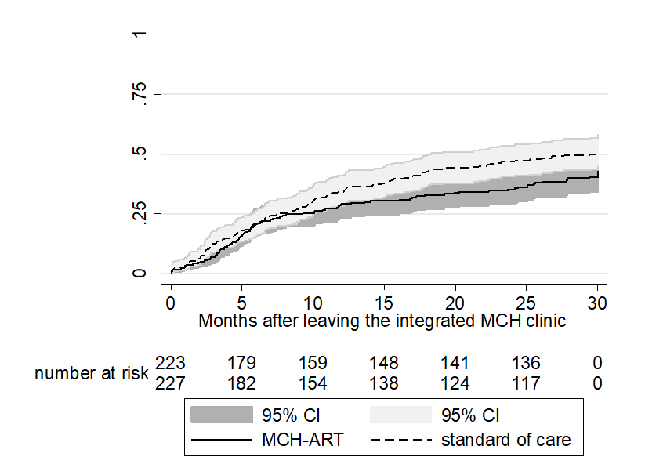
Supplementary table 3. Predictors of non-retention in HIV care (among all women who had not died or withdrawn, n=450) in the 12 months preceding the LACE study visit (36-60 months postpartum); presented as risk ratios (RR) and risk differences (RD) with 95% confidence intervals (CI).
 | Crude RR  (95% CI) | Adjusted RR  (95% CI) | Adjusted RD  (95% CI)
At presentation for ANC in the MCH-ART trial
Increasing maternal age (years) | 0.99 (0.97 to 1.01) | 0.99 (0.97 to 1.02) | -0.003 (-0.011 to 0.005)
Married/cohabiting | 0.86 (0.67 to 1.11)
Completed high school | 0.92 (0.68 to 1.23)
Currently employed | 0.88 (0.69 to 1.15)
Nadir CD4 cell count
CD4 ≤200 cells/µL | Ref
CD4 201-350 cells/µL | 1.05 (0.66 to 1.64)
CD4 >350 cells/µL | 1.45 (0.97 to 2.15)
Presented for antenatal care after 20 weeks gestation | 1.40 (1.09 to 1.80) | 1.36 (1.05 to 1.75) | 0.119 (0.031 to 0.208)
Newly diagnosed HIV+ in this pregnancy | 1.29 (1.00 to 1.67) | 1.22 (0.94 to 1.58) | 0.078 (-0.011 to 0.168)
At randomization in the MCH-ART trial
HIV viral load >50 copies/mL at randomization | 1.04 (0.78 to 1.37)
MCH-ART intervention (compared to SOC) | 1.02 (0.80 to 1.30) | 1.02 (0.81 to 1.30) | 0.020 (-0.068 to 0.108)

Supplementary table 4. Predictors of viremia (≥ 50 copies/mL) among all women with viral loads available (n=349) and following multiple imputation of missing viral loads (n=450) at the LACE study visit 36-60 months postpartum; presented as risk ratios (RR) and risk differences (RD) with 95% confidence intervals (CI).
 | Viral load ≥ 50 copies/mL  (All women in LACE, n=349) |  |  | Viral load ≥ 50 copies/mL (after imputation of missing viral loads, n=450)
 | Crude RR  (95% CI) | Adjusted RR  (95% CI) | Adjusted RD  (95% CI) | Adjusted RR  (95% CI) | Adjusted RD  (95% CI)
At presentation for ANC in the MCH-ART trial
Increasing maternal age (years) | 0.98 (0.95 to 1.00) | 0.98 (0.95 to 1.00) | -0.008 (-0.017 to 0.002) | 0.97 (0.95 to 1.00) | -0.011 (-0.020 to -0.002)
Married/cohabiting | 0.77 (0.59 to 1.00) | 0.85 (0.65 to 1.12) | -0.071 (-0.180 to 0.039) | 0.87 (0.69 to 1.09) | -0.064 (-0.165 to 0.036)
Completed high school | 0.96 (0.72 to 1.27)
Currently employed | 0.94 (0.73 to 1.20)
Nadir CD4 cell count
CD4 ≤200 cells/µL | Ref
CD4 201-350 cells/µL | 0.87 (0.61 to 1.23)
CD4 >350 cells/µL | 0.86 (0.63 to 1.19)
Presented for antenatal care after 20 weeks gestation | 1.42 (1.11 to 1.82) | 1.32 (1.02 to 1.71) | 0.120 (0.013 to 0.226) | 1.26 (1.02 to 1.56) | 0.104 (0.009 to 0.200)
Newly diagnosed HIV+ in this pregnancy | 0.98 (0.77 to 1.25)
At randomization in the MCH-ART trial
HIV viral load ≥ 50 copies/mL at randomization | 1.39 (1.09 to 1.77) | 1.19 (0.92 to 1.55) | 0.104 (-0.021 to 0.228) | 1.22 (0.95 to 1.58) | 0.101 (-0.030 to 0.223)
MCH-ART intervention (compared to SOC) | 1.04 (0.82 to 1.32) | 1.00 (0.79 to 1.27) | 0.023 (-0.078 to 0.125) | 1.04 (0.84 to 1.30) | 0.022 (-0.079 to 0.123)

