Supplementary Material

Figure S1 Flow chart showing inclusion/exclusion process
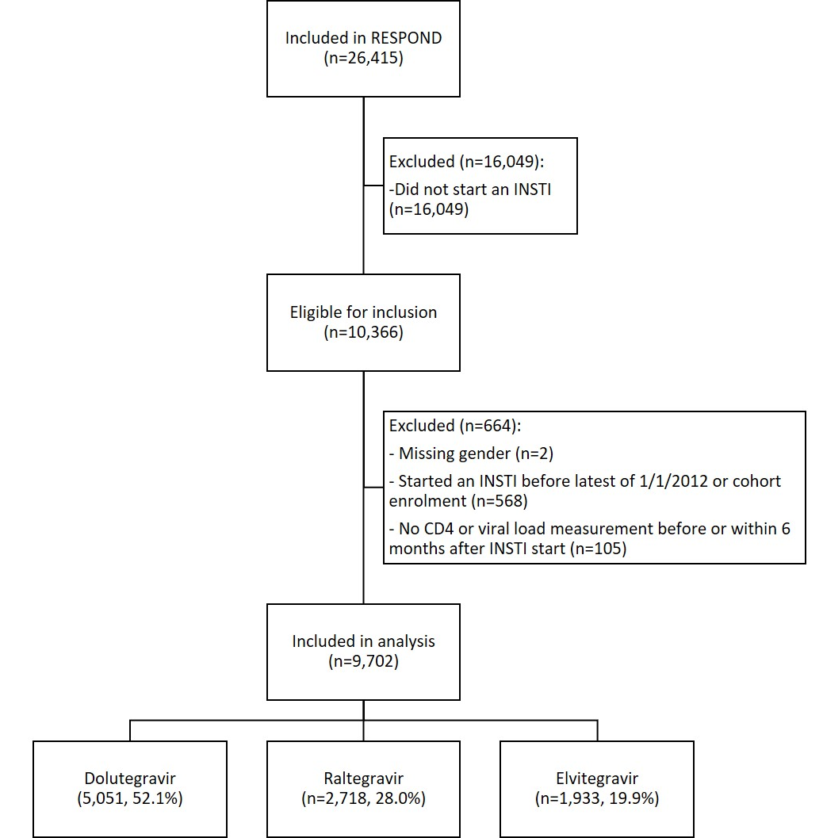

Table S1 Associations between baseline characteristics and choice of INSTIs – univariable analysis
 |  |  | Raltegravir vs Dolutegravir |  |  | Elvitegravir vs Dolutegravir
Variable | Reference | Group | RR* | (95% CI) | p-value | RR* | (95% CI) | p-value
INSTI start, per 1-year increase |  |  | 0.30 | (0.28, 0.31) | <0.001 | 0.81 | (0.77, 0.85) | <0.001
Geographical region¹ | Western Europe/Australia | Southern Europe | 1.60 | (1.42, 1.79) | <0.001 | 1.35 | (1.20, 1.52) | <0.001
 |  | Northern Europe | 4.45 | (3.88, 5.11) |  | 0.78 | (0.69, 0.96)
 |  | Eastern Europe | 2.80 | (2.32, 3.38) |  | 1.10 | (0.87, 1.41)
Age, per 10-year increase |  |  | 1.05 | (1.01, 1.09) | 0.03 | 0.83 | (0.80, 0.87) | <0.001
Gender | Male | Female | 1.06 | (0.95, 1.17) | 0.32 | 0.70 | (0.61, 0.80) | <0.001
Ethnic origin† | White | Black | 1.33 | (1.14, 1.54) | <0.001 | 1.30 | (1.10, 1.55) | <0.001
Smoking status† | Never | Current | 1.04 | (0.91, 1.20) | 0.08 | 1.00 | (0.87, 1.15) | 0.96
 |  | Previous | 1.23 | (1.03, 1.48) |  | 0.98 | (0.80, 1.19)
ART experience | Experienced, VL<400 cps/mL | Naive | 0.92 | (0.82, 1.04) | <0.001 | 1.44 | (1.28, 1.62) | <0.001
 |  | Experienced, VL≥400 cps/mL | 2.11 | (1.80 ,2.48) |  | 1.13 | (0.91, 1.40)
HIV risk† | MSM | IDU | 1.25 | (1.09, 1.44) | <0.001 | 0.62 | (0.52, 0.74) | <0.001
 |  | Heterosexual | 1.09 | (0.98, 1.22) |  | 0.79 | (0.70, 0.89)
CD4 nadir, cells/mm³ | <200 | 200-349 | 0.76 | (0.68, 0.85) | <0.001 | 1.41 | (1.24, 1.60) | <0.001
 |  | 350-499 | 0.67 | (0.58, 0.79) |  | 1.68 | (1.44, 1.96)
 |  | ≥500 | 0.70 | (0.59, 0.83) |  | 1.67 | (1.42, 1.98)
CD4 at  INSTI start, cells/mm³ | <200 | 200-349 | 0.87 | (0.73, 1.04) | <0.001 | 1.79 | (1.41, 2.26) | <0.001
 |  | 350-499 | 0.71 | (0.60 ,0.83) |  | 1.85 | (1.49, 2.30)
 |  | ≥500 | 0.60 | (0.52 ,0.69) |  | 1.55 | (1.28, 1.89)
Hepatitis C† | No | Yes | 1.29 | (1.16, 1.45) | <0.001 | 0.69 | (0.59, 0.79) | <0.001
Hepatitis B† | No | Yes | 1.60 | (1.28, 2.00) | <0.001 | 1.59 | (1.24, 2.04) | <0.001
Hypertension† | No | Yes | 0.92 | (0.82, 1.04) | 0.20 | 0.80 | (0.70, 0.92) | 0.002
Diabetes† | No | Yes | 1.16 | (0.98, 1.37) | 0.09 | 0.87 | (0.70, 1.07) | 0.18
Prior AIDS† | No | Yes | 1.40 | (1.25, 1.56) | <0.001 | 0.65 | (0.56, 0.76) | <0.001
Prior NADM† | No | Yes | 1.14 | (0.91, 1.43) | 0.24 | 0.56 | (0.39, 0.79) | 0.001
Prior ESLD† | No | Yes | 1.22 | (0.78, 1.93) | 0.38 | 0.52 | (0.22, 1.24) | 0.14
Prior CVD† | No | Yes | 1.90 | (1.50, 2.40) | <0.001 | 0.84 | (0.59, 1.18) | 0.31
Prior fracture† | No | Yes | 0.84 | (0.68, 1.05) | 0.13 | 0.92 | (0.70, 1.21) | 0.56
Prior CKD† | No | Yes | 1.17 | (0.93, 1.47) | 0.18 | 0.60 | (0.42, 0.85) | 0.004
Abbreviations: RR-risk ratio; CI-confidence interval; INSTI-integrase inhibitor; ART-antiretroviral treatment; VL-viral load; MSM-men who have sex with men; IDU-intravenous drug user; NADM-non-AIDS defining malignancies; ESLD-end stage liver disease; CVD-cardiovascular disease; CKD-chronic kidney disease
*Results from a univariable, multinomial logistic regression
¹Due to low counts, Australia is grouped with Northern Europe and Eastern Central Europe is grouped with Eastern Europe.
†Missing data fitted as an unknown category (data not shown)

Figure S2 Association between gender and INSTI uptake, by age
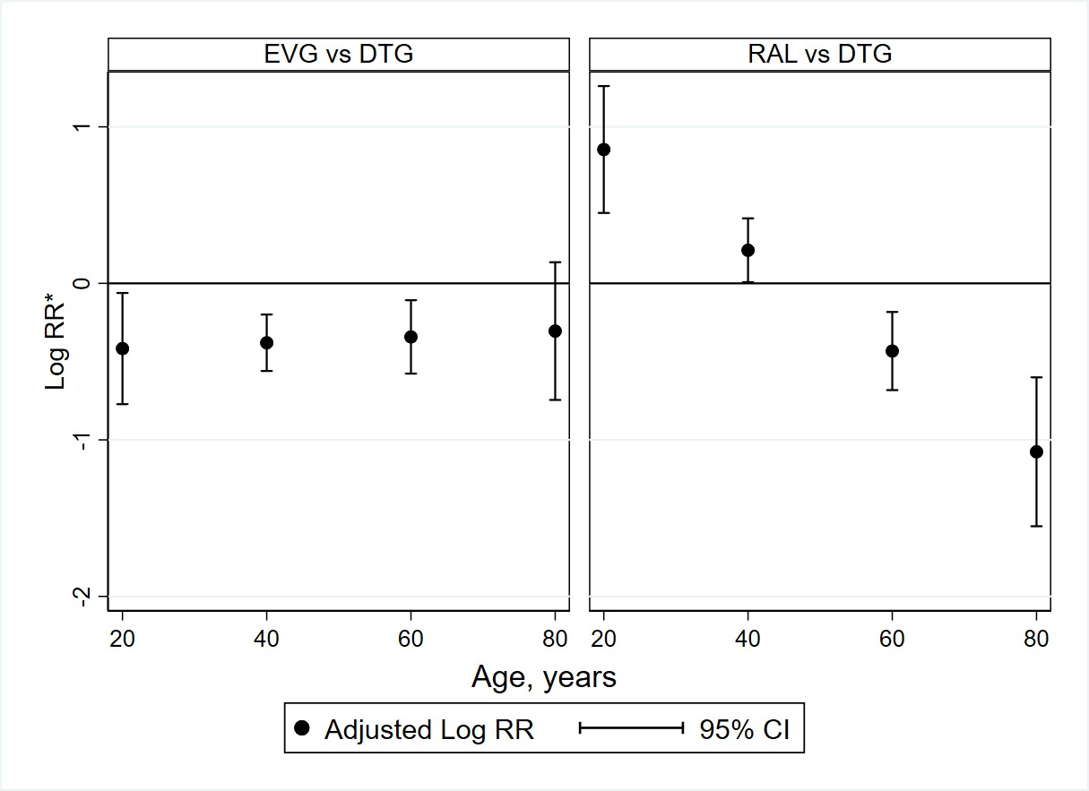
Abbreviations: EVG-elvitegravir; DTG-dolutegravir; RAL-raltegravir; RR-risk ratio; CI-confidence interval
*Log RR comparing females to males estimated from a multinomial logistic regression model including an interaction between age and gender, adjusted for year of starting INSTI, geographical region, ethnicity, smoking status, HIV risk group, antiretroviral treatment experience, CD4 nadir, CD4 at INSTI start, hepatitis B, hepatitis C, hypertension, diabetes, prior AIDS, non-AIDS malignancies, end stage liver disease, cardiovascular disease, fracture, chronic kidney disease

Table S2 Associations between baseline characteristics and INSTI discontinuation in the first 6 months after INSTI start
 |  |  | Univariable model* |  |  | Multivariable model*
Variable | Reference | Group | HR | (95% CI) | p-value | HR | (95% CI) | p-value
INSTI type | Dolutegravir | Raltegravir | 2.27 | (1.94, 2.64) | <0.001 | 3.03 | (2.47, 3.71) | <0.001
 |  | Elvitegravir | 1.17 | (0.95, 1.44) |  | 1.37 | (1.10, 1.70)
INSTI start, per 1 year later |  |  | 0.89 | (0.85, 0.94) | <0.001 | 1.11 | (1.04, 1.18) | 0.001
Geographical region¹ | Western Europe/Australia | Southern Europe | 0.83 | (0.70, 0.98) | <0.001 | 0.58 | (0.43, 0.78) | <0.001
 |  | Northern Europe | 1.03 | (0.84, 1.27) |  | 0.89 | (0.64, 1.25)
 |  | Eastern Europe | 0.43 | (0.28, 0.66) |  | 0.31 | (0.20, 0.50)
Age category | <30 | 30-39 | 1.07 | (0.81, 1.41) | 0.32 | 1.04 | (0.78, 1.39) | 0.19
 |  | 40-49 | 0.88 | (0.67, 1.16) |  | 0.84 | (0.63, 1.12)
 |  | ≥50 | 0.98 | (0.75, 1.27) |  | 0.95 | (0.70, 1.28)
Gender | Male | Female | 1.34 | (1.15, 1.56) | <0.001 | 1.28 | (1.06, 1.56) | 0.01
Ethnic origin† | White | Black | 1.14 | (0.92, 1.42) | 0.36 | 0.96 | (0.74, 1.25) | 0.47
 |  | Other | 0.88 | (0.60, 1.27) |  | 0.79 | (0.54, 1.15)
HIV risk† | MSM | IDU | 1.18 | (0.96, 1.46) | 0.06 | 0.89 | (0.67, 1.19) | 0.65
 |  | Heterosexual | 1.24 | (1.06, 1.45) |  | 1.01 | (0.82, 1.25)
 |  | Other | 1.05 | (0.66, 1.67) |  | 0.75 | (0.46, 1.22)
Smoking status† | Never | Current | 1.04 | (0.85, 1.27) | 0.79 | 0.96 | (0.77, 1.19) | 0.49
 |  | Previous | 1.10 | (0.84, 1.44) |  | 1.13 | (0.86, 1.50)
ART experience | Experienced, VL<400 cps/mL | Naive | 1.15 | (0.98, 1.36) | <0.001 | 1.10 | (0.87, 1.39) | 0.046
 |  | Experienced, VL≥400 cps/mL | 1.68 | (1.36, 2.08) |  | 1.36 | (1.07, 1.73)
CD4 nadir, cells/mm³ | <200 | 200-349 | 0.87 | (0.74, 1.03) | 0.41 | 1.05 | (0.86, 1.28) | 0.68
 |  | 350-499 | 0.91 | (0.73, 1.13) |  | 1.13 | (0.86, 1.47)
 |  | ≥500 | 1.00 | (0.80, 1.25) |  | 1.20 | (0.88, 1.64)
CD4 at  INSTI start, cells/mm³ | <200 | 200-349 | 0.70 | (0.54, 0.91) | <0.001 | 0.76 | (0.58, 1.01) | 0.06
 |  | 350-499 | 0.63 | (0.50, 0.80) |  | 0.69 | (0.51, 0.91)
 |  | ≥500 | 0.63 | (0.52, 0.77) |  | 0.71 | (0.54, 0.95)
Hepatitis C† | No | Yes | 1.18 | (1.00, 1.36) | 0.005 | 1.32 | (1.06, 1.66) | 0.01
Hepatitis B† | No | Yes | 0.96 | (0.68, 1.36) | 0.83 | 0.93 | (0.66, 1.33) | 0.70
Hypertension† | No | Yes | 0.87 | (0.73, 1.05) | 0.14 | 0.92 | (0.75, 1.11) | 0.37
Diabetes† | No | Yes | 0.82 | (0.62, 1.08) | 0.15 | 0.82 | (0.62, 1.10) | 0.19
Prior AIDS† | No | Yes | 1.08 | (0.92, 1.28) | 0.35 | 1.01 | (0.84, 1.21) | 0.90
Prior NADM† | No | Yes | 1.47 | (1.08, 1.99) | 0.01 | 1.55 | (1.13, 2.12) | 0.006
Prior ESLD† | No | Yes | 1.11 | (0.53, 2.36) | 0.78 | 0.99 | (0.46, 2.11) | 0.97
Prior CVD† | No | Yes | 1.16 | (0.82, 1.66) | 0.40 | 1.15 | (0.79, 1.68) | 0.46
Prior fracture† | No | Yes | 0.84 | (0.59, 1.20) | 0.35 | 0.85 | (0.59, 1.22) | 0.38
Prior CKD† | No | Yes | 0.83 | (0.56, 1.24) | 0.36 | 0.79 | (0.52, 1.19) | 0.26
Abbreviations: HR-hazard ratio; CI-confidence interval; INSTI-integrase inhibitor; ART-antiretroviral treatment; VL-viral load; MSM-men who have sex with men; IDU-intravenous drug user; NADM-non-AIDS defining malignancies; ESLD-end stage liver disease; CVD-cardiovascular disease; CKD-chronic kidney disease
*Results from a Cox proportional hazards model; all variables were fitted simultaneously in the multivariable model
¹Due to low counts, Australia is grouped with Northern Europe and Eastern Central Europe is grouped with Eastern Europe.
†Missing data fitted as an unknown category (data not shown)

Figure S3 Risk of INSTI discontinuation, by age category
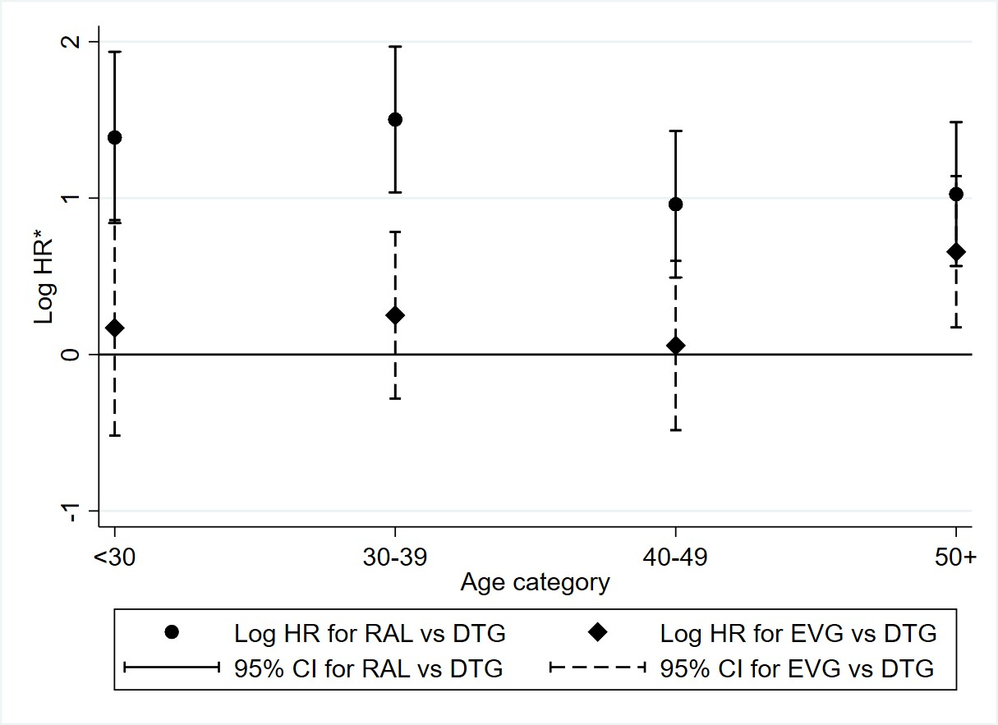
Abbreviations: EVG-elvitegravir; DTG-dolutegravir; RAL-raltegravir; HR-hazard ratio; CI-confidence interval
*Log HR comparing INSTI types estimated from a Cox proportional hazards model including an interaction between INSTI type and age category, adjusted for year of starting INSTI, geographical region, gender, ethnicity, smoking status, HIV risk group, antiretroviral treatment experience, CD4 nadir, CD4 at INSTI start, hepatitis B, hepatitis C, hypertension, diabetes, prior AIDS, non-AIDS malignancies, end stage liver disease, cardiovascular disease, fracture, chronic kidney disease

