Supplementary Tables

Supplementary Table 1: Randomly selected Hub Sites, Kenya
County | Sub County | Facility Name and Type
Kakamega | Lugari | Lumakanda District Hospital
 | Mumias | Mumias Dispensary
Bungoma | Kimilili | Kimilili District Hospital
Vihiga | Luanda | Emuhaya District Hospital
Homabay | Mbita | Mbita Sub-District Hospital
 | Suba | Suba District Hospital
 | Rangwe | Nyagoro Health Centre
 | Rangwe | Rangwe Sub-District Hospital
Nyamira | Nyamira | Nyamira District Hospital
 | Masaba North | Keroka District Hospital
Migori | Nyatike | Macalder Sub-District Hospital
 | Rongo | Rongo District Hospital
 | Awendo | Awendo Sub district Hospital
 | Kuria | Uriri Health Centre
Turkana | Turkana West | Kakuma Mission Hospital
 | Turkana South | Katilu District Hospital
Busia | Samia | Sio Port Hospital
Siaya | Gem | Yala Sub-District Hospital

Supplementary Table 2: Randomly selected Hub Sites, Zimbabwe

Region | District | Facility Name and Type
Matabeleland South | Matobo | Maphisa District Hospital
 | Insiza | Filabusi District Hospital
 | Mangwe | Plumtree District Hospital
Midlands | Shurugwi | Shurugwi District Hospital
 | Zvishavane | Zvishavane District Hospital
 | Mberengwa | Musume Mission Hospital
Masvingo | Mwenezi | Neshuro District Hospital
 | Bikita | Nyika Regional Health Center
 | Chivi | Chivi District Hospital
Mashonaland West | Zvimba | Banket District Hospital
 | Zvimba | Father O’Hea Hospital
Matabeleland North | Mupane | St Luke’s Mission Hospital
 | Tsholotsho | Tsholotsho District Hospital
Mashonaland East | Seke | Beatrice Hospital
 | Marondera | Marondera Provincial Hospital
 | Hwedza | Hwedza Rural Hospital
Mashonaland Central | Shamva | Shamva District Hospital
 | Mt Darwin | Mt Darwin District Hospital
Supplemental Figure 1.

Lab-based and POC results by facility (n=28), Zimbabwe

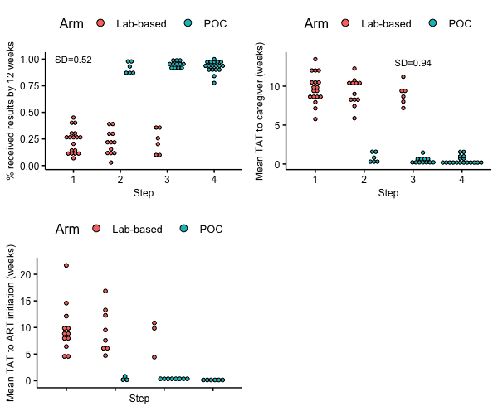

Supplemental Figure 2.

Lab-based and POC results by facility (n=18), Kenya

