Supplemental Appendices
An evaluation of 6-month versus continuous isoniazid preventive therapy for M. tuberculosis in adults living with HIV/AIDS in Malawi: A modelling study.
Yuli L HSIEH¹, Andreas JAHN^{2,3}, Nicolas A MENZIES^{4,5}, Reza YAESOUBI¹, Joshua A SALOMON^{4,6}, Belaineh GIRMA⁷, Laurence GUNDE⁸, Jeffrey W EATON⁹, Andrew AULD⁸, Michael ODO³, Caroline N KIYIIKA^{2,3}, Thokozani KALUA³, Brown CHIWANDIRA³, James U MPUNGA⁷, Kuzani MBENDRA⁷, Liz CORBETT^{3,11}, Mina C HOSSEINIPOUR^{12,13}, Ted COHEN^{1*}, Amber KUNKEL^{14*}
*denotes co-senior authors
- Department of Epidemiology of Microbial Diseases, Yale School of Public Health, New Haven, CT, USA
- Department of Global Health, University of Washington, Seattle, WA, USA
- Department for HIV and AIDS, Ministry of Health and Population, Lilongwe, Malawi
- Department of Global Health and Population, Harvard T.H. Chan School of Public Health, Boston, MA, USA
- Center for Health Decision Science, Harvard T.H. Chan School of Public Health, Boston, MA, USA
- Department of Medicine, Stanford University, Stanford, CA, USA
- National Tuberculosis Control Program, Ministry of Health and Population, Lilongwe, Malawi
- Division of Global HIV and TB, Center for Global Health, US Centers for Disease Control and Prevention, Lilongwe, Malawi
- MRC Centre for Global Infectious Disease Analysis, School of Public Health, Imperial College London, London, UK
- Faculty of Infectious and Tropical Diseases, London School of Hygiene and Tropical Medicine, London, UK
- Department of Clinical Research, London School of Hygiene and Tropical Medicine, London, UK
- Department of Medicine, University of North Carolina-Chapel Hill, NC, USA
- UNC-Project Malawi, Lilongwe, Malawi
- Emerging Diseases Epidemiology Unit, Institut Pasteur, Paris, France
Contents Overview
- Algorithm for district selection for IPT intervention
- Model overview
- Model parameters
- Model calibration
- District level estimates
- Effeciency of 6-month versus continuous IPT
- Sensitivity analysis on HIV decline rate since IPT program initiation
- Model equations (as R code)
- Supplemental references

Appendix 1. Algorithm for district selection for IPT intervenion
- Districts were ranked in descending order by our model estimates of TB incidence rates at the beginning of 2018.

- Districts with the highest estimated TB incidence rates in 2018 were prioritized for intervention until we ran out of the total number of person-year of IPT available (1,003,423 person-years) in the first budget cycle (2018-2020). Each district was treated as an indivisible intervention unit, so a district was enrolled only if there was enough person-time of IPT left for all eligible patients in that district to initiate and complete the treatment course. As we moved down the list, if the demand of person-years of IPT in the next district on the list was higher than the amount of IPT available, we skipped the district and considered the next on the list until we either ran out of IPT or after all districts had been considered for intervention.

- Only the budget and spending conditions in the first three years was relevant to our decision on which districts could receive the intervention. The rate of spending within this three-year budget envelope was flexible. We assumed sufficient funding would be available for the IPT program to continue after Year 3. The maximum number of person-years of IPT available was calculated based on the combined cost (per day) of a single tablet of isoniazid (300 mg) plus a single tablet of pyridoxine (25 mg).

Calculation:

Budget for IPT: $10,800,000 USD
Cost for one tablet of isoniazid (300 mg): $12.76 USD/ 672 tablets
Cost for one tablet of pyridoxine (25 mg): $1.05 USD/ 100 tablets
Cost for once daily IPT: 12.76/ 672 + 1.05/ 100
Person-year of IPT available in the current budget cycle (3 years):

$$\frac{10,800,000}{\left(\frac{12.76}{672}+\frac{1.05}{100}\right)×365}≈ 1,003,423$$

- For both the 6-month IPT scenario and the continuous IPT scenario, the list of districts selected for intervention was kept constant for the entire 12-year simulation period, reflecting a static intervention policy.

Appendix 2. Model overview
Demographics
The modeled population was divided into the child population (< 15 y.o.) and the adult population. The total population in each of the 27 districts was informed by data on district-level adult population size in 2016, with the assumption that children represented half of the total population ^{[1]}. We set the birth rate to be equal to the overall mortality rate so that the size of the modeled population was stable over the simulation period. Children were all HIV negative and susceptible to or latently infected by TB, and hence not contributing to TB or HIV transmission in our model. They entered the adult and adolescent population at 15 years old via either the state susceptible to TB and HIV or via the state with latent TB infection but susceptible to HIV.
HIV related health states
With respect to HIV infection among the adult population, individuals could be susceptible to infection; infected but undiagnosed; diagnosed and receiving ART but not IPT; receiving both ART and IPT; or receiving ART post-IPT. The index cases for HIV in our model were introduced in 1976 ^{[2]}. The annual HIV incidence thereafter for each district was informed by the UNAIDS estimates of annual national-level HIV incidence rate from 1990-2017 ^{[3]}, adjusted by a scaling factor which was estimated from model calibration (Appendix 3, Table 2). We assumed the HIV incidence rate had a linear decrease after 2017 and would be halved by the end of 2030. The rate at which HIV infected individuals were diagnosed and initiated on ART (hereinafter, HIV case detection rate) was estimated by fitting a logistic growth curve to the UNAIDS estimates of national level data on ART coverage (all ages) from 2010-2017 (28% - 71%) (Appendix 3, Table 3) ^{[4]}. The curve levels of at around 80-83% after 2021. We assumed the HIV case detection rate was uniform across districts.
TB related health states
In terms of TB related health states, adults in the model could be susceptible; latently infected; having developed active TB; or undergoing treatment for active TB. Upon primary infection, susceptible individuals could either become latently infected (slow progression) or develop active TB disease (fast progression). Latent TB cases may progress to the active TB state through reactivation or reinfection. Individuals with active TB disease may undergo spontaneous self-cure, the rate of which was dependent on HIV infection and ART treatment status. Latent and active infections in the model included drug susceptible and resistant strains of any phenotypes.
The district-specific TB incidence rates were estimated by the transmission dynamic element of our model. The annual TB case detection rate was assumed to be 30% for all districts. Patients who completed the full treatment course, with or without biological confirmation, were considered as treatment successes and returned to the latent infection state. In cases of treatment failure, early treatment termination, and loss to follow up, patients returned to the active TB state. The disease durations for active TB in patients with untreated TB infection, untreated TB/HIV co-infection, and TB/HIV co-infection on ART were 1.43, 0.69, and 1.46 years in our model, respectively.
Model initialization
For each of the 27 districts, we initiated the model by introducing 10 infectious TB source cases to a pool of susceptibles, and the model was simulated until the TB epidemic reached equilibrium. The conditions in 1818 were assumed to be the starting conditions of the model that was set up to estimate the TB prevalence and incidence in Malawi in 1818 onwards. This model was then used to reproduce the historical time trends of TB and HIV epidemics from 1818 to 2018, prior to the start of IPT-era in 2018. The model was estimated based on the parameter values shown in Appendix 3.

Appendix 3. Model parameters

Table 1. Prior distributions on variable parameters for the first stage of calibration
Parameter | Description | Distribution | Lower  (2.5th percentile) | Upper  (97.5th percentile) | Median | Reference
beta_t1 | District-specific TB transmission parameter for active TB cases living with HIV | lognormal (1.83, 0.69) | 1.61 | 24.10 | 6.23 | --
p_h | progression rate from latent TB to active TB  (HIV+, not on ARV) | lognormal (-2.07, 0.23) | 0.08 | 0.20 | 0.13 | ^{[5]}
x_h | proportion of fast TB progressor (HIV+, not on ARV) | lognormal (-0.19, 0.05) | 0.75 | 0.91 | 0.83 | ^{[6]}
mu_tb_hiv_add | excess HIV TB mortality rate (no ARV, untreated TB) | lognormal (-0.26, 0.25) | 0.47 | 1.26 | 0.77 | ^{[7-9]}

Table 2. Prior distributions on variable parameters for the second stage of calibration
Parameter | Description | Distribution | Lower  (2.5th percentile) | Upper  (97.5th percentile) | Median | Reference
beta_t1 | District-specific TB transmission parameter for active TB cases living with HIV | lognormal (1.83, 0.69) | 1.61 | 24.10 | 6.23 | --
hivinc_s | Scaling factor for district-specific HIV incidence | lognormal (-0.02, 0.30) | 0.54 | 1.76 | 0.98 | --

Table 3. Fixed and derived parameters
Parameter | Description ª | Value or Explanation | Reference
Transmission Parameters
beta_t2 | TB transmission parameter for active TB cases not living with HIV | beta_t2=beta_t1*rr_tb | --
lambda_hiv | HIV force of infection, regardless of ART status | Time-varying, see Appendix 6 | ^{[3]}
rr_tb | relative infectiousness of TB among people with/without HIV, regardless of ART status | 0.65 | ^{[10]}
m | immunity to reinfection | 0.35 | ^{[11]}
TB Related Parameters
x | proportion of fast TB progressor (HIV-) | 0.115 | ^{[12]}
x_h | proportion of fast TB progressor (HIV+, not on ART) | 0.8443 | ^{[6]} and numerical experiment
x_a | proportion of fast TB progressor (HIV+, on ART) | 0.1565 | ^{[13]}
p | progression rate from latent TB to active TB  (HIV-) | 0.001 | ^{[14, 15]}
p_h | progression rate from latent TB to active TB  (HIV+, not on ART) | 0.1371 | ^{[5]} and numerical experiment
p_a | progression rate from latent TB to active TB  (HIV+, on ART) | 0.00272 | ^{[13]}
p_ai | progression rate from latent TB to active TB  (HIV+, on ART and IPT) | p_a*f_i | ^{[16-18]}
Parameter | Description ª | Value or Explanation | Reference
TB Related Parameters -- continued
sigma | spontaneous self-cure from active TB (HIV-) | 0.2 | ^{[19]}
sigma_h | spontaneous self-cure from active TB  (HIV+, not on ART) | 0 | Assume no immunological capacity for spontaneous self-cure
sigma_a | spontaneous self-cure from active TB  (HIV+, on ART) | 0.1 | Between treated and untreated HIV
sigma_ai | spontaneous self-cure from active TB  (HIV+, on ART and IPT) | sigma_a | Assume no curative effect from active TB with IPT
IPT Related Parameters
kappa_6 | rate of stopping 6-month IPT | -log(perc_adhr)*2 + 2 | ^{[20-22]}  Conversion from proportion to rate using risk = 1 – e^{-rate}  Also informed by local inputs
kappa_c | rate of stopping continuous IPT | -log(perc_adhr)*2 | ^{[20-22]}  Conversion from proportion to rate using risk = 1 – e^{-rate}  Also informed by local inputs
s_ipt | rate at which IPT cure latent infection | perc_cure*(mu_arv + 12/6 + p_ai)/(1-perc_cure) | Conversion from proportion to rate
ipt_add_mu | Excess mortality rate associated with IPT | -log(1-0.0004) | ^{[23]}
TB and HIV Treatment Related Parameters
tb_cdr | TB case detection rate | 0.3 | Assumption and manual tuning and WHO TB country profile
tau | rate of starting TB treatment  (HIV-) | tb_cdr*(mu_tb + sigma)/(1- tb_cdr) | Conversion from proportion to rate
Parameter | Description ª | Value or Explanation | Reference
TB and HIV Treatment Related Parameters -- continued
tau_h | rate of starting TB treatment  (untreated HIV) | tb_cdr *(mu_tb_hiv + sigma_h)/(1- tb_cdr) | Conversion from proportion to rate
tau_a | rate of starting TB treatment  (on ART) | tb_cdr *(mu_tb_arv + sigma_a)/(1- tb_cdr) | Conversion from proportion to rate
tau_ai | rate of starting TB treatment  (from active TB state on ART+IPT) | tb_cdr *(mu_tb_arv + sigma_ai)/(1- tb_cdr) | Conversion from proportion to rate
e | 1- proportion of active TB on ART starting IPT instead of starting TB treatment (clinical error) | 0.84 | ^{[24, 25]}
phi | rate of TB treatment completion | 1/(6/12) | ^{[24]}
rho | proportion of treatment success | 0.84 | ^{[26]}
hiv_cdr | HIV case detection rate | 0.8321/(1 + exp(-(-653.1621 + 0.3427*year) | Logistic growth curve fitted to UNAIDS data on ART coverage ^{[4]}
gamma | rate of starting ART | hiv_cdr*mu_hiv/(1-hiv_cdr) | Conversion from proportion to rate
Demographic Related Parameters
b | birth rate | (set to total mortality rate to maintain a stable population size) | --
mu | background mortality rate among adults and adolescents ≥ 15 y.o. | 0.01 | ^{[27]}
mu_peds | background mortality rate among individuals < 15 y.o. | 0.20 | --
mu_tb | TB mortality rate (untreated TB, HIV-) | mu + 0.28 | ^{[19]}
mu_tr | TB mortality rate (treated TB, HIV-) | 0.097*phi/(1-0.097) | Estimated based on outcome data:  9.7% died during treatment ^{[26]}
Parameter | Description ª | Value or Explanation | Reference
Demographic Related Parameters -- continued
mu_hiv | HIV mortality rate (no ART, TB-) | mu + 0.068 | ^{[28-30]}
mu_tb_hiv | HIV TB mortality rate (no ART, untreated TB) | mu + 1.006 | ^{[7-9]} and numerical experiment
mu_arv | HIV mortality rate (on ART, TB-) | mu + 0.005 | ^{[31]}
mu_tb_arv | HIV TB mortality rate (on ART, untreated TB) | mu + 0.37 | ^{[32]}
mu_tr_arv | HIV TB mortality rate (on ART, treated TB) | 0.097*(phi)/(1-0.097) | Estimated based on outcome data:  9.7% died during treatment; TB/HIV ≈ 53% of TB cases and TB/HIV mortality rate ≈ 2* TB mortality rate ^{[26]}
mu_ai | HIV mortality rate (on ART+IPT, TB-) | mu_arv + ipt_add_mu | ^{[23]}
mu_tb_ai | HIV TB mortality rate (on ART+IPT, untreated TB) | mu_tb_arv + ipt_add_mu | ^{[23]}
^{a.} Unit for all rates are per year

Table 4. Sampling distribution for probabilistic sensitivity analysis for IPT related parameters
Parameter | Description ª | Distribution | Lower (bound if uniform, else 2.5th percentile) | Upper (bound if uniform, else 97.5th percentile) | Median | Reference
IPT related parameters
iota | rate of starting IPT | uniform (1,3) | 1.05 | 2.95 | 2.00 | Informed by local inputs
z | proportion of treatment followed by secondary IPT | uniform (0.65, 0.99) | 0.65 | 0.999 | 0.83 | Informed by local inputs
q | proportion refuse to start IPT | uniform (0.05, 0.40) | 0.05 | 0.40 | 0.23 | Informed by local inputs
perc_adhr | percent of patients completing the full course of 6-month IPT | beta (167251, 31265) | 0.8441 | 0.8409 | 0.8425 | Malawi electronic medical record (unpublished data)
perc_cure | percent cured of latent TB infection by the end of 6 months of IPT | logitnormal (-0.60, 1.24) | 0.02 | 0.76 | 0.35 | ^{[33]}
f_i | effectiveness of IPT in preventing TB infection and re-infection and TB disease progression | lognormal (-0.39, 0.18) | 0.47 | 0.96 | 0.67 | ^{[34, 35]}
ª Unit for all rates are per year

Appendix 4. Model Calibration
A two-stage calibration was performed. In the first stage, the model was calibrated to national level service and surveillance data using the Nelder-Mead algorithm:
- The parameters estimated through this stage of model calibration were (a) the transmission parameter for TB infection, (b) the TB reactivation rate for those with undetected HIV, (c) the probability of TB fast progression among those with undetected HIV, and (d) the excess mortality rate for TB/HIV co-infection. Prior distributions for each of these parameters were described in Appendix 3 Table 1.
- Five likelihood functions were constructed to calibrate the model using national level service and surveillance data provided by the MOH Malawi for the following targets: (a) the number of TB cases notified each year (2008 – 2016), (b) the number of TB cases notified each year that were confirmed to be HIV infected (2009 – 2016), (c) the number of patients retained on ART in mid-year (2008, 2017), and (d) the HIV prevalence among individuals ≥ 15 years old (2008, 2017). Additionally, (e) the expected percentage (30%) of HIV deaths from TB cases was included as the fifth calibration target.
- The confidence intervals of these data points were not available to us, so we set the uncertainty intervals to be ± 20% of the observed values. For each target, the average of these uncertainty intervals was then set to be the standard deviation of the normal distributions in the likelihood functions. The rationale behind taking the mean is to allow each data point to weight equally in the likelihood functions. These five likelihood functions were assumed to be independent, and hence multiplied to create the joint likelihood function.
- After obtaining the parameter set that produced the model with the best fit to the calibration targets, the estimated excess mortality rate for TB/HIV co-infection, the TB reactivation rate, and probability of fast progression among undetected HIV individuals were extracted and used as fixed parameters in the second stage of the calibration, where models were calibrated at the district level.
In the second stage of the calibration, following Raftery and Bao (2010) ^{[36]}, our model was calibrated using the incremental mixture importance sampling (IMIS) algorithm:
- The parameters estimated through model calibration were (a) the transmission parameter for TB infection and (b) the scale factor of the HIV incidence input vector. Both parameters were estimated at the district level, using the same prior distributions, which are presented in Table 2 in Appendix 3. In other words, the TB transmission parameter and HIV incidence were allowed to vary between districts to fit to the district-level TB and HIV sercie and surveillance data.
- For each district, four likelihood funtions were used to calibrate the model to the first four calibration targets as in stage one, but with district-level data. The uncertainty intervals of these data points were also set to be ± 20% and the five likelihood functions were assuemd to be independent.
- A total of 800 parameter sets were sampled in the first iteration in IMIS. To improve the efficiency of the algorithm, the first of the 800 initial parameter sets was estimated using optimizer Nelder-Mead with the same likelihood functions defined above. A maximum of 40 IMIS iterations were performed to obtain 300 re-sampled parameter sets, which were subequenclty used to simulate the model.
- This procedure was performed for each of the 27 districts, assuming all districts were independent of one another. Note that Likoma was excluded due to a lack of data. Figures below show the district level comparison of calibration targets and model estimates for TB notifications, number of patients retained on ART in mid-year, HIV prevlanece (%), and the percentage of notified TB cases that were confirmed to be HIV positive. The solid lines represent the arithmetic mean of the joint posterior distribution based on the resampled parameter sets. The dashed lines the 2.5th and 97.5th quantile of the joint posterior distributions.
- 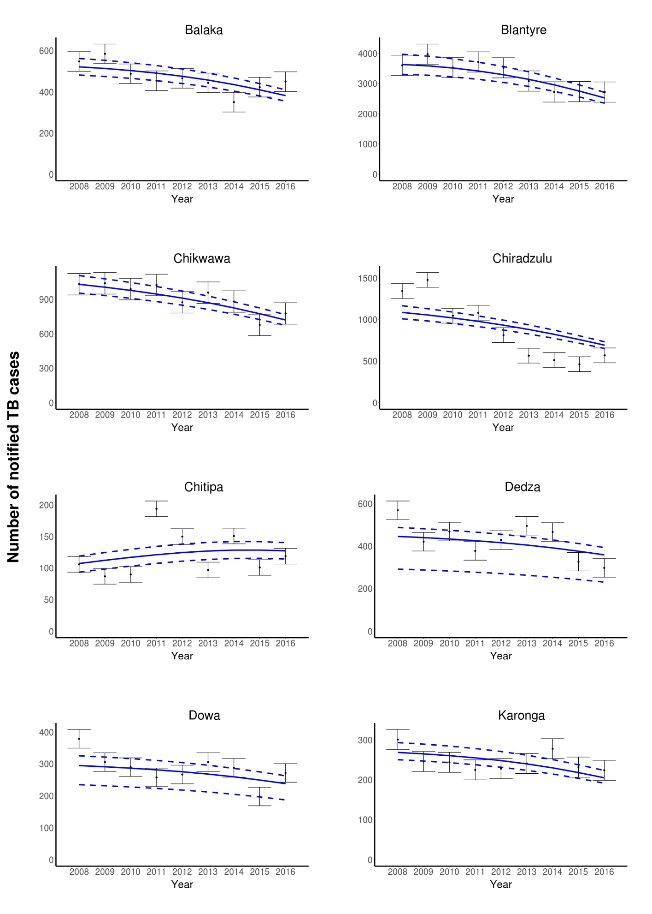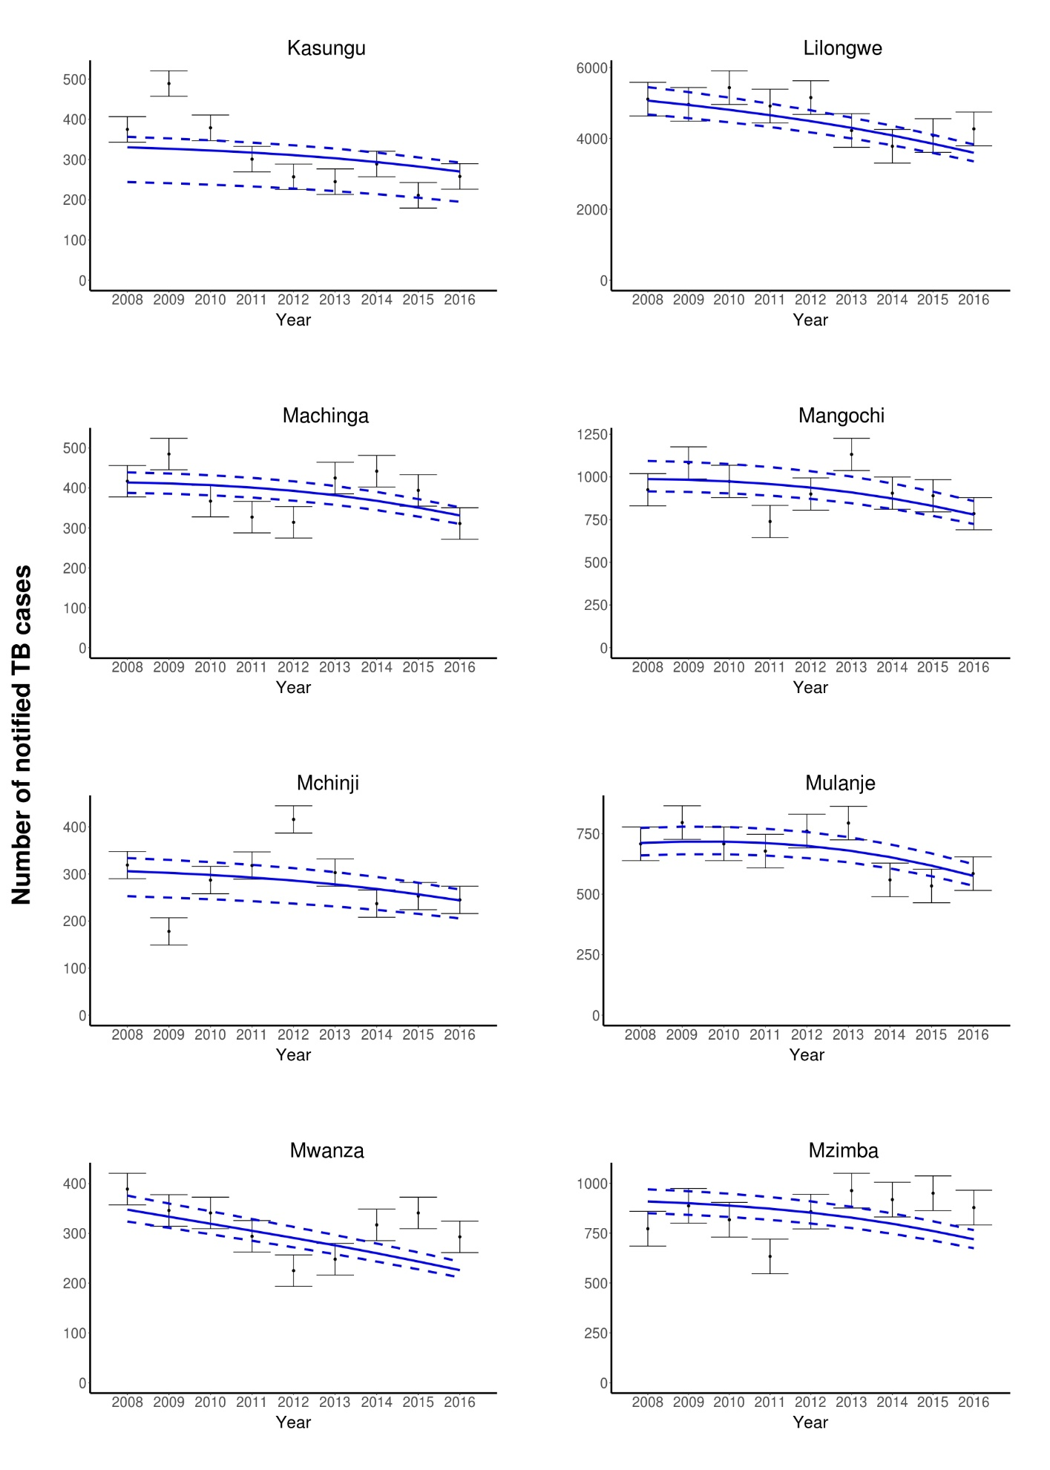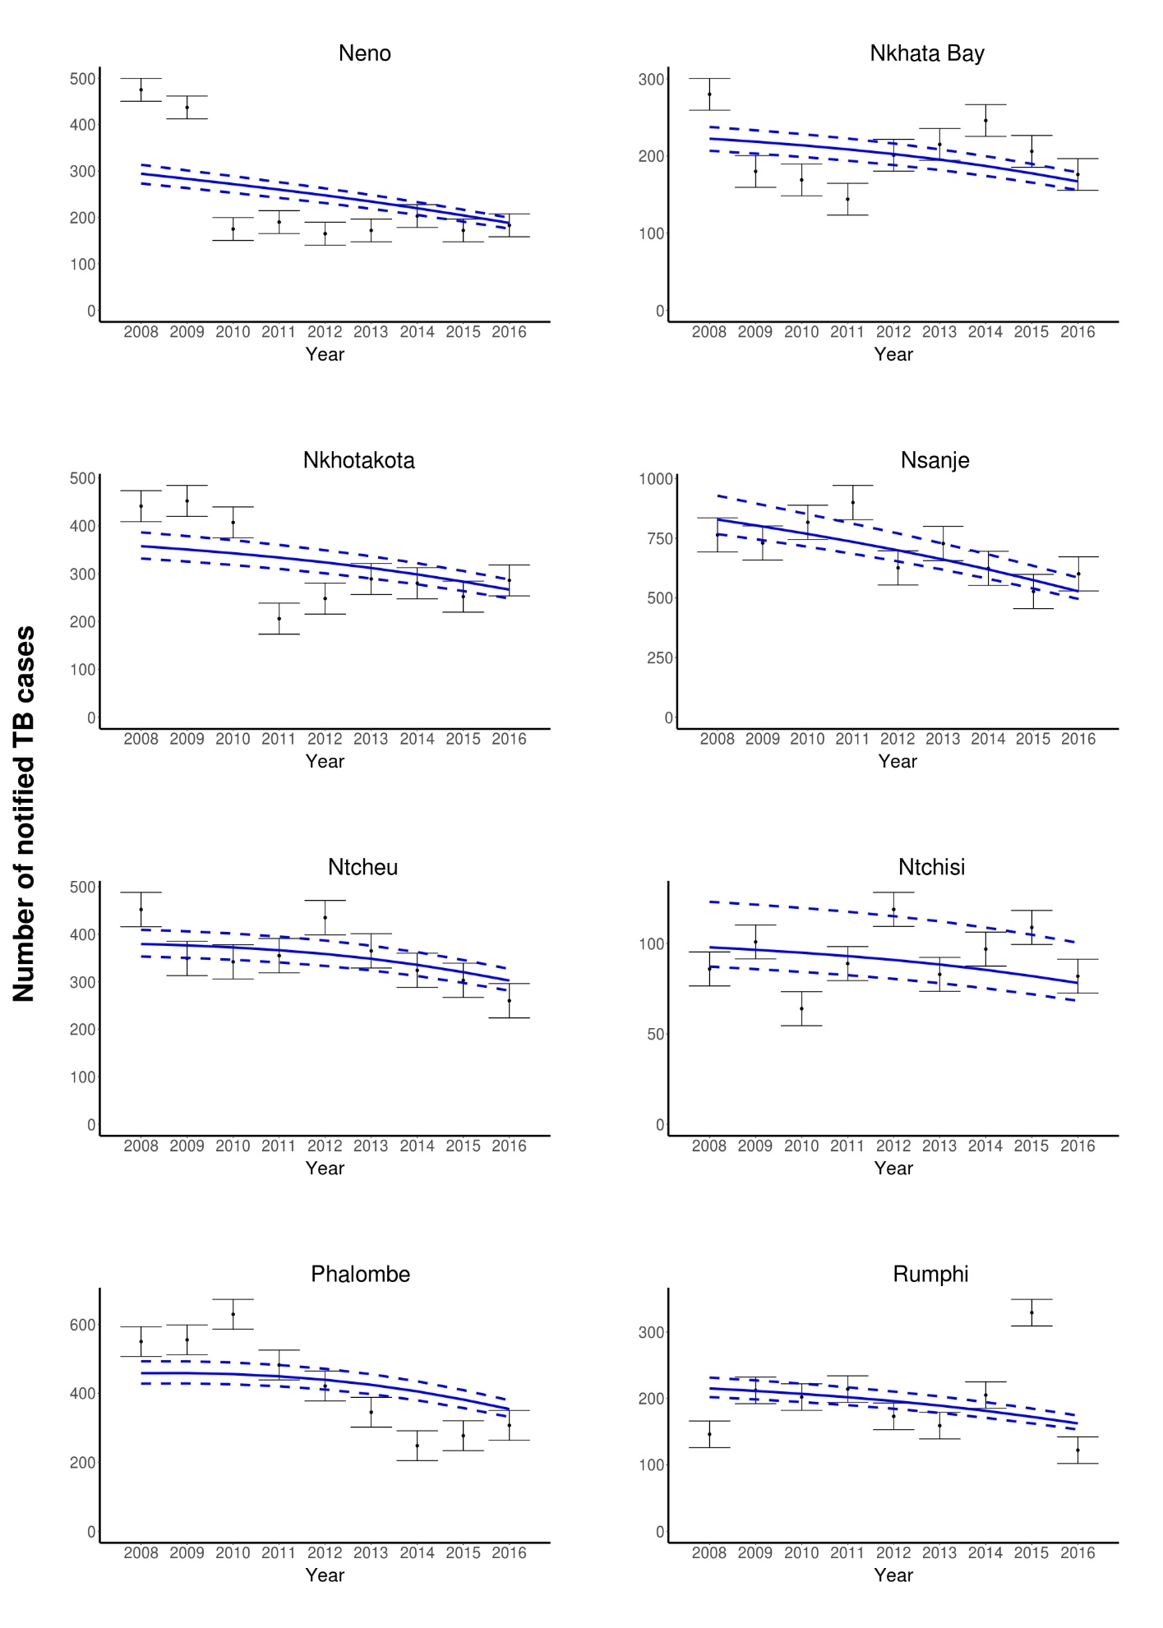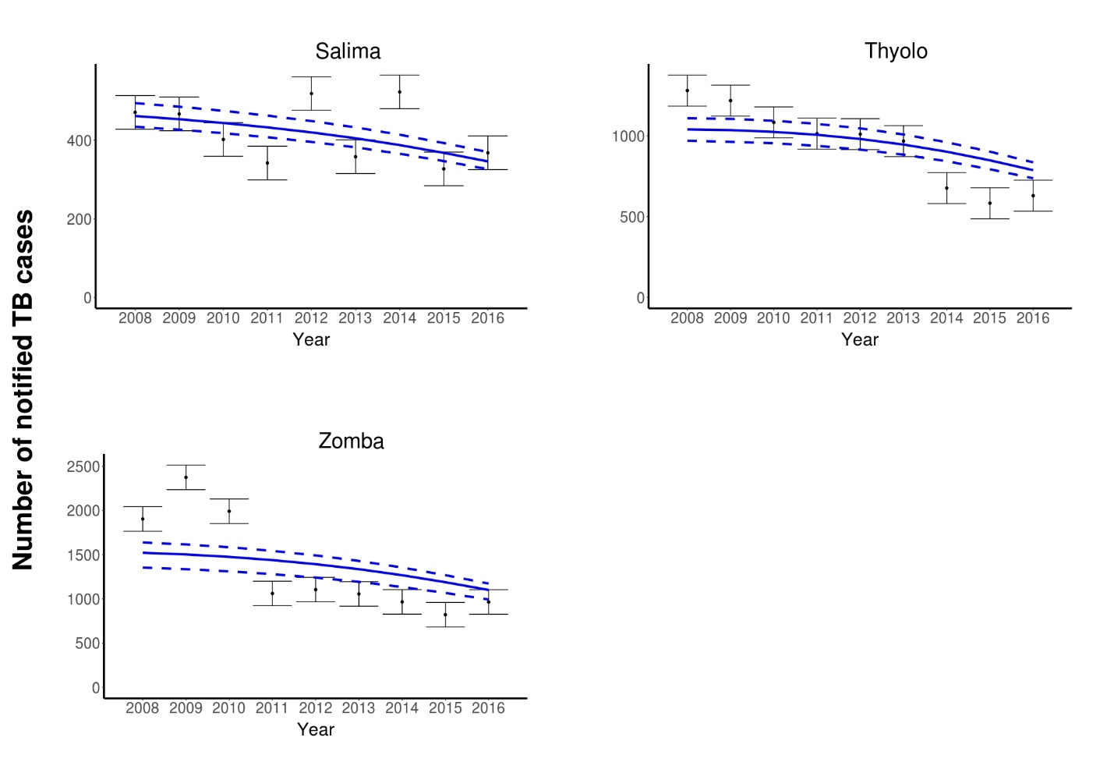
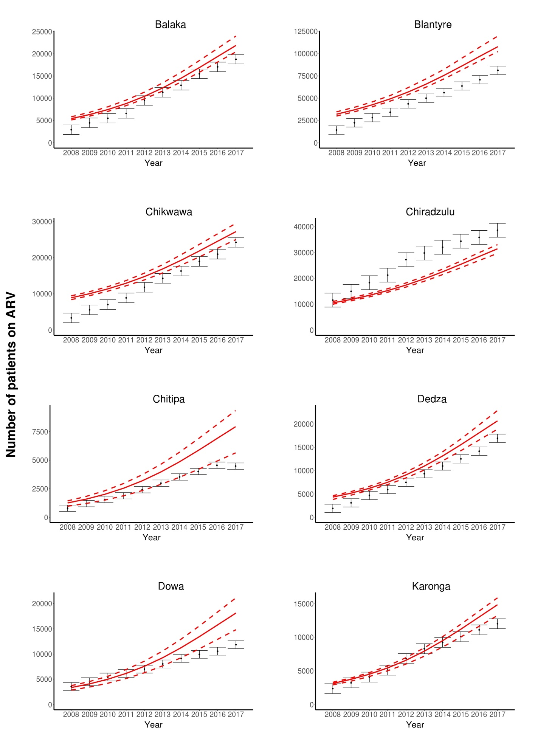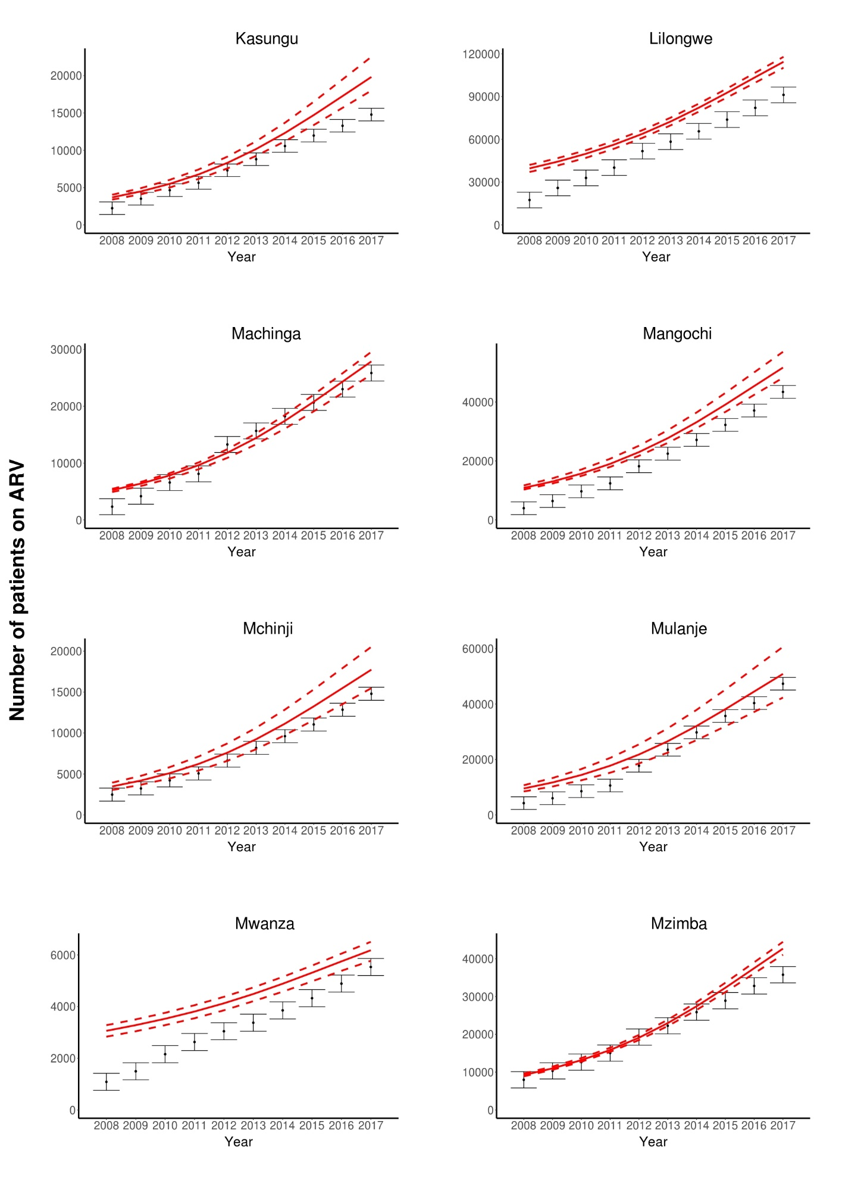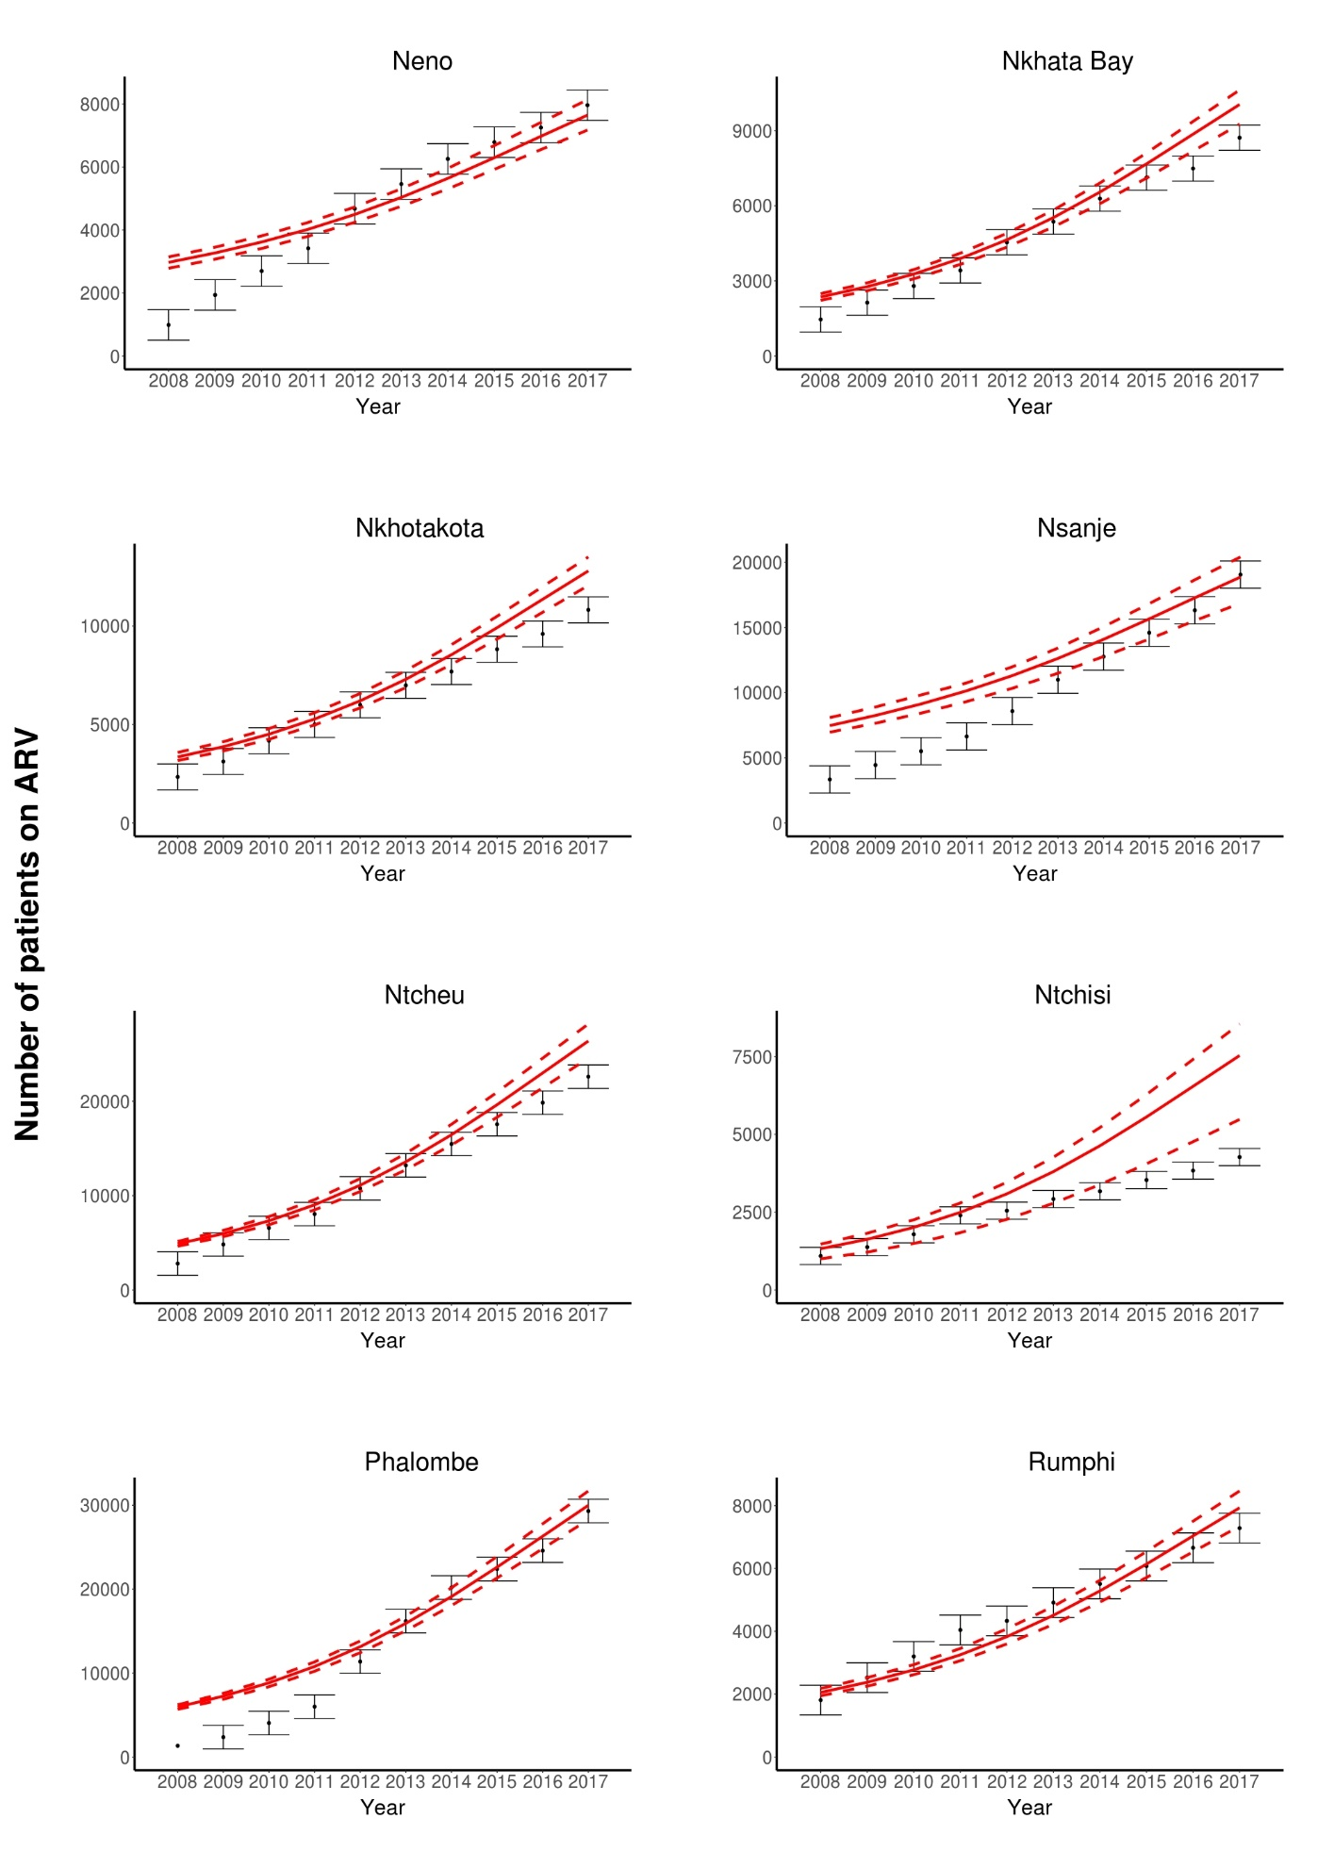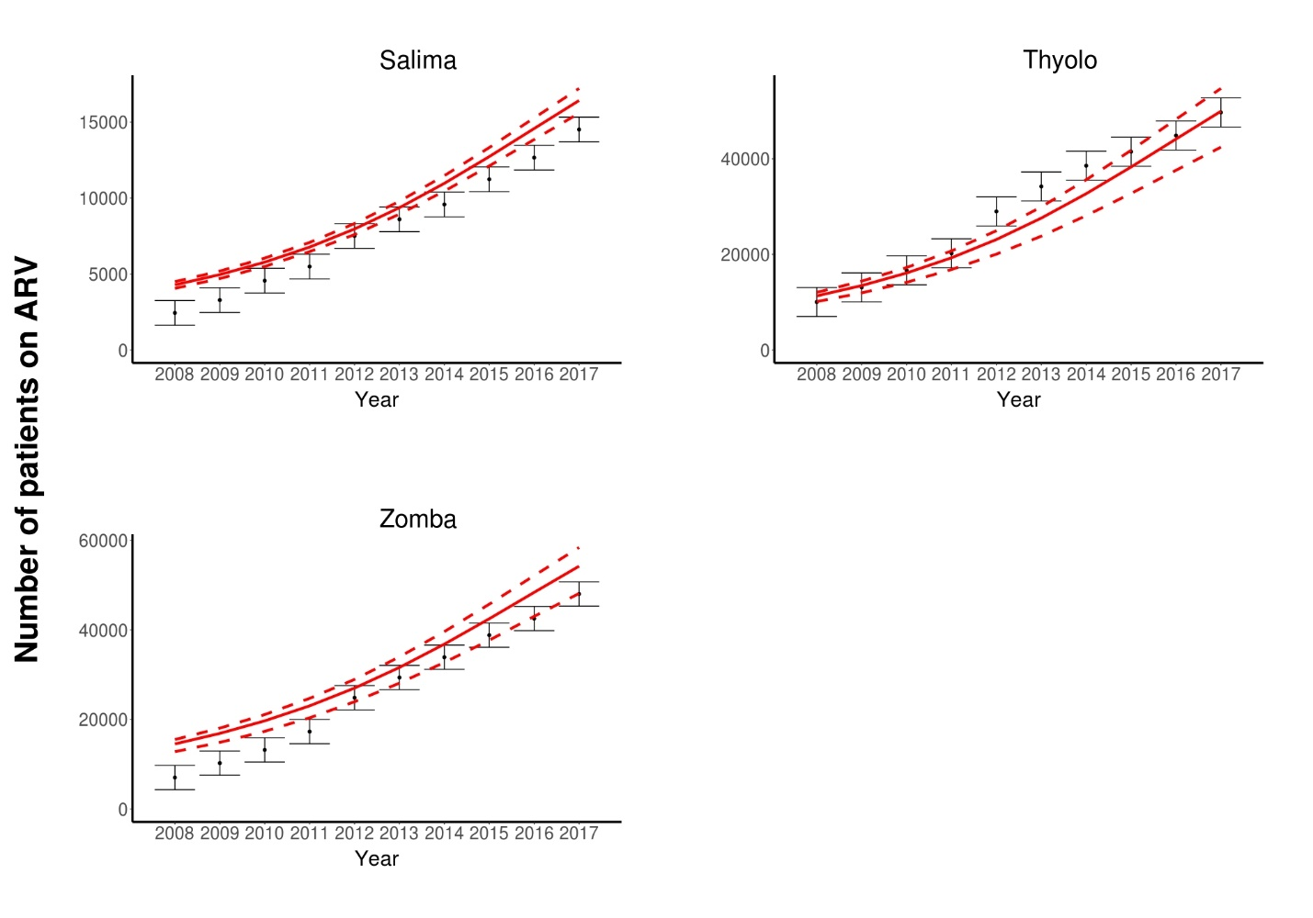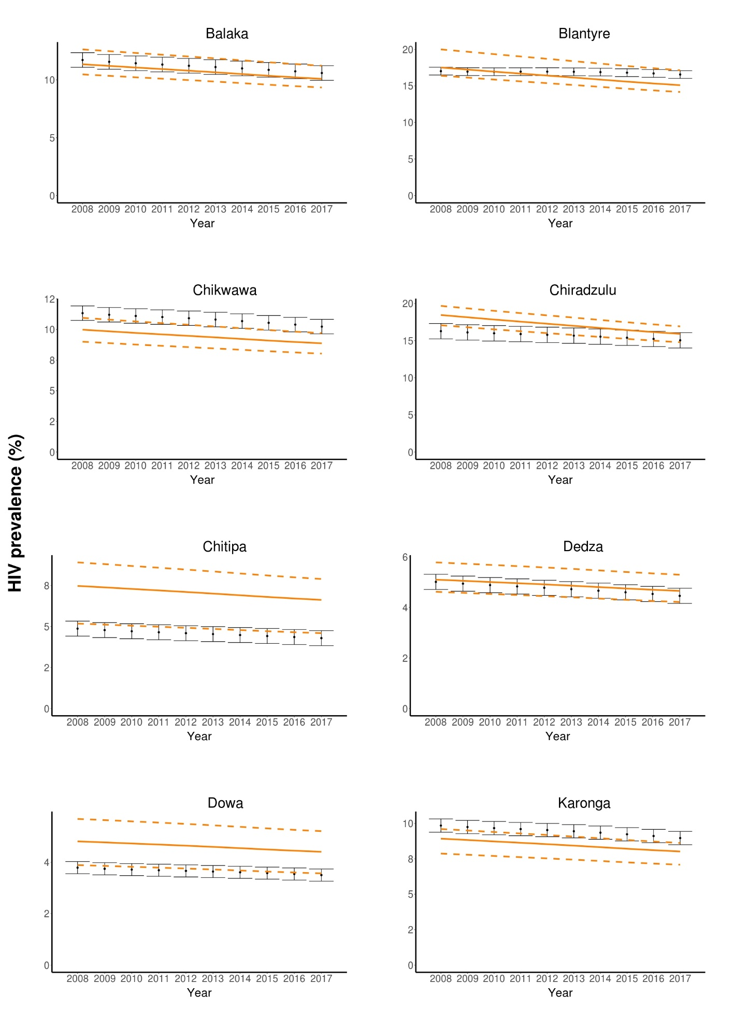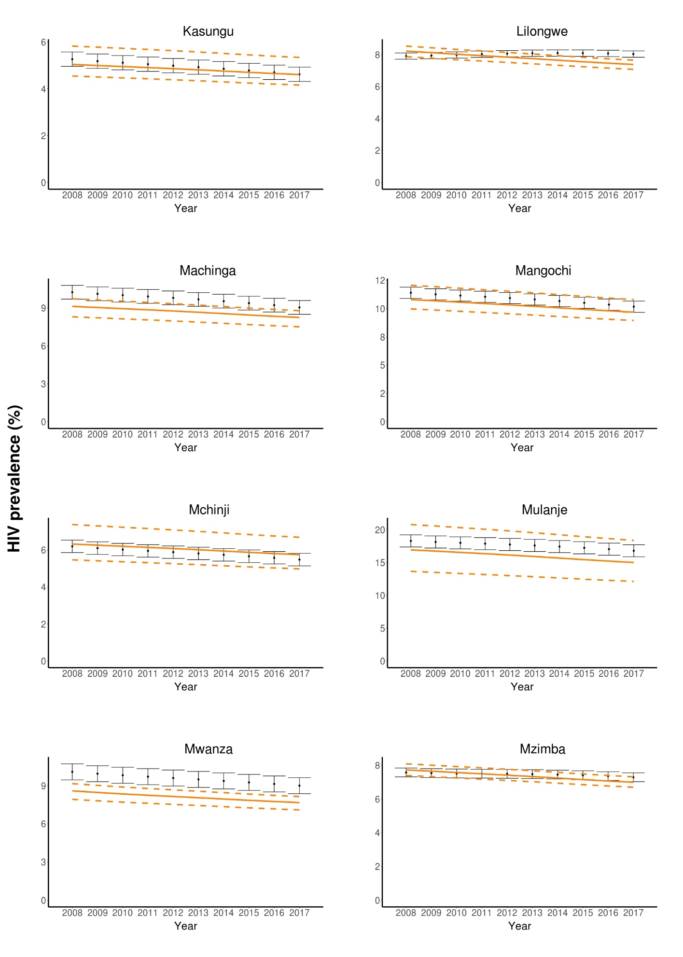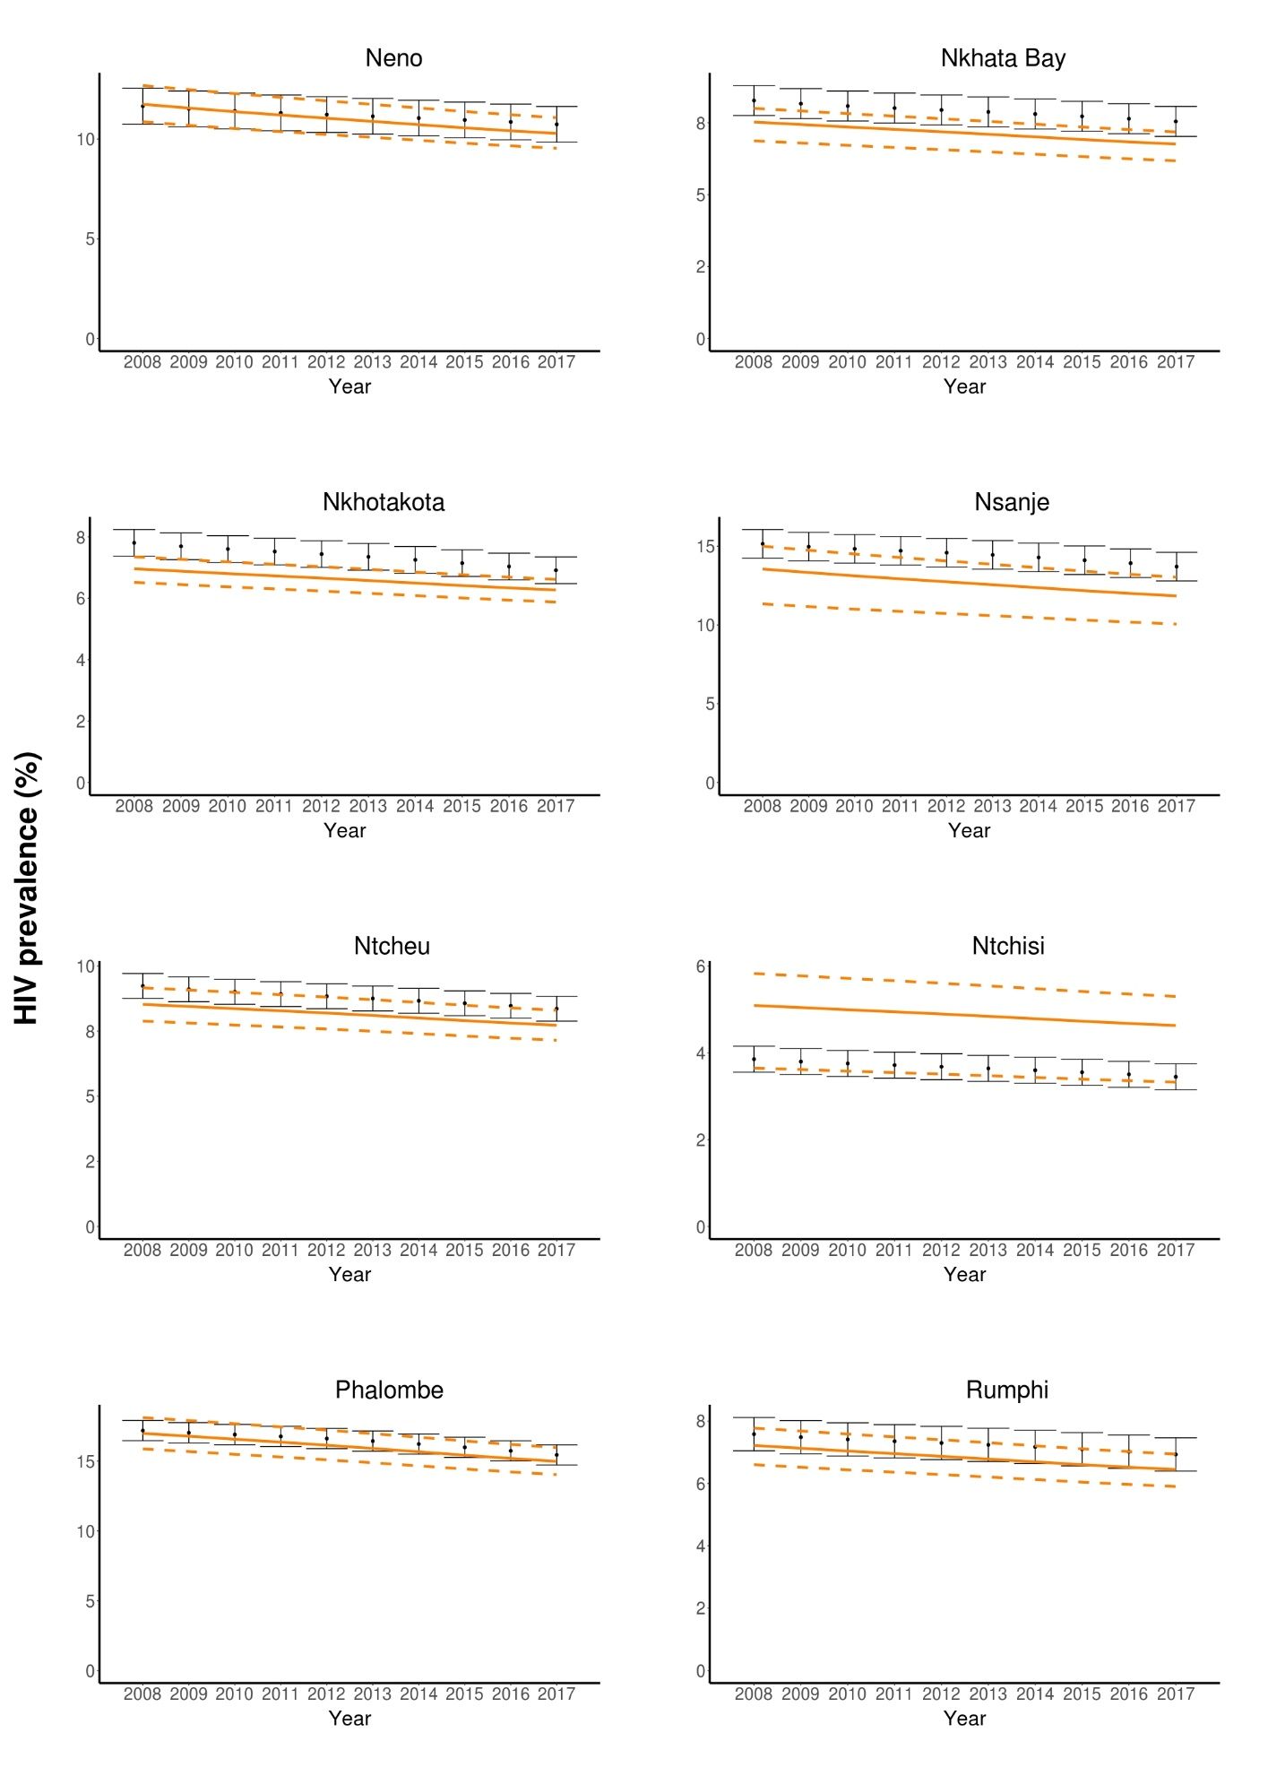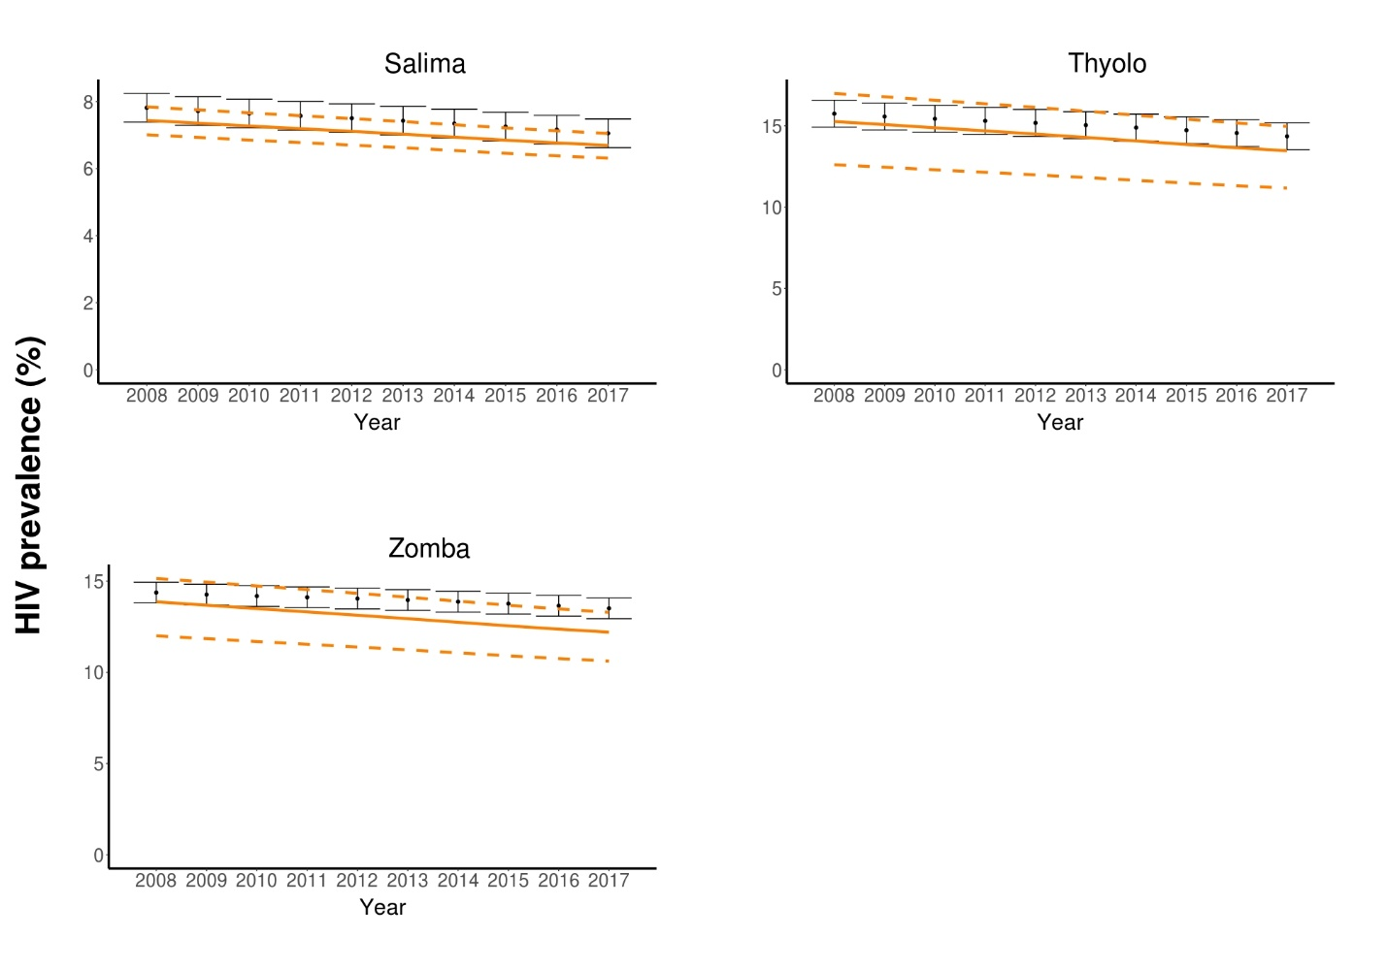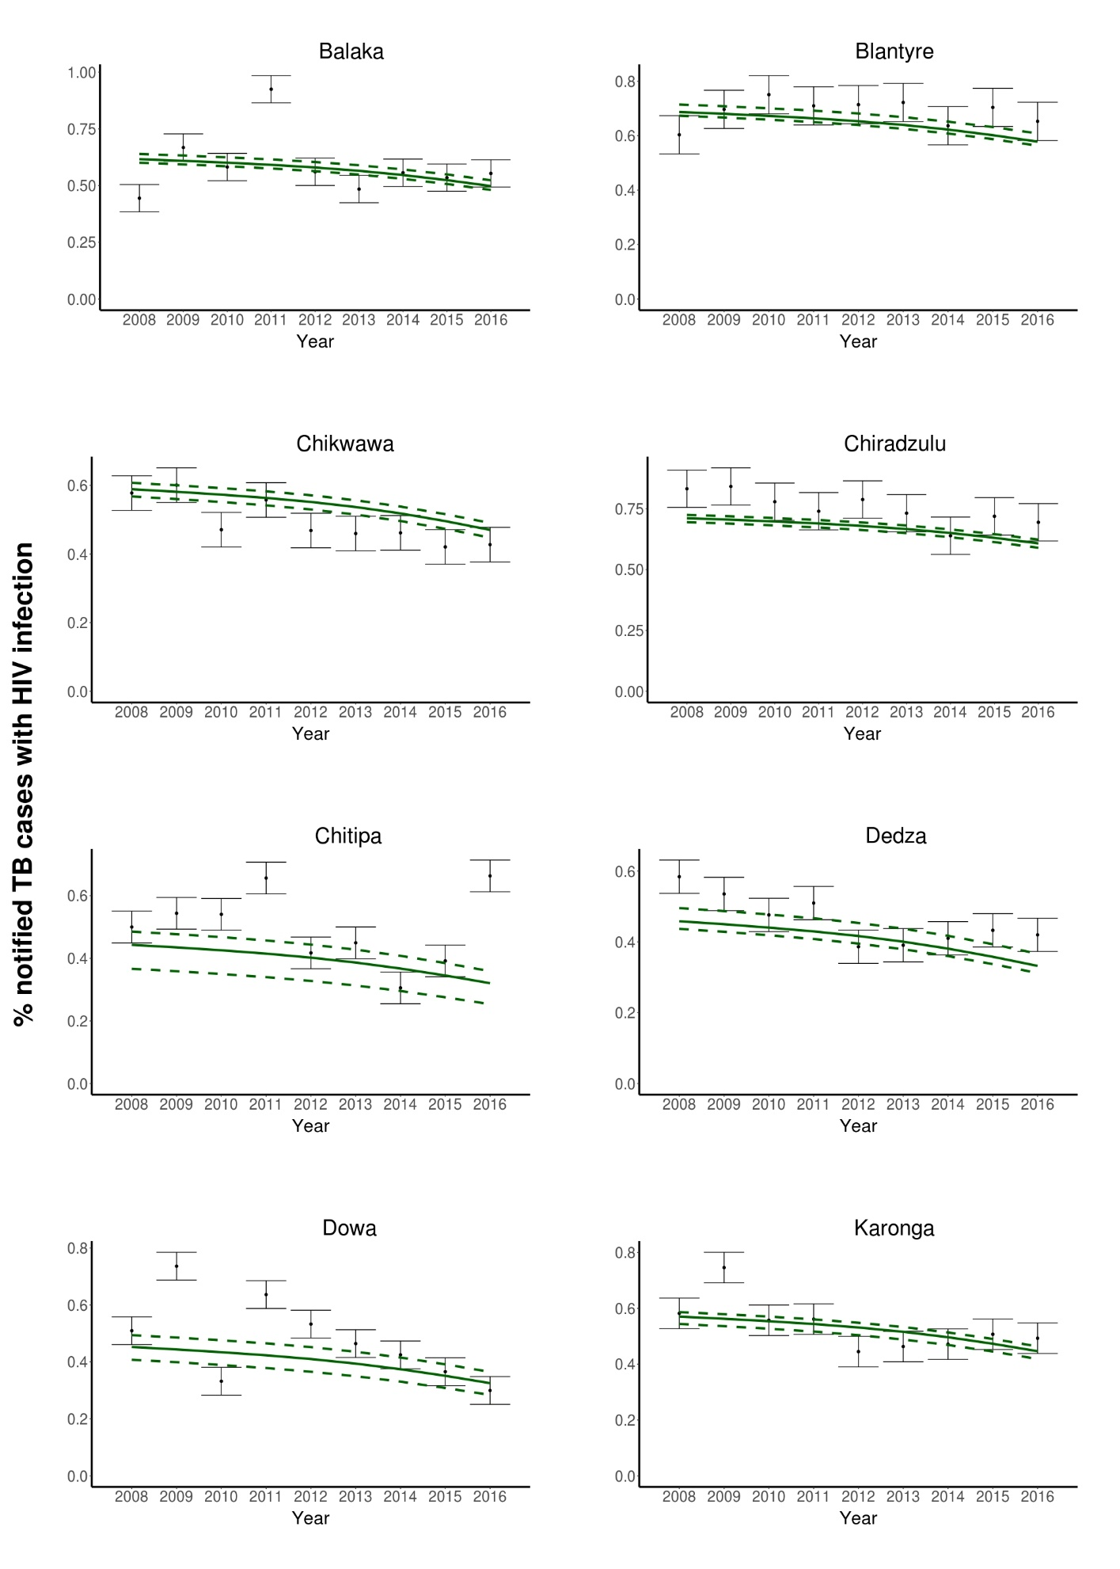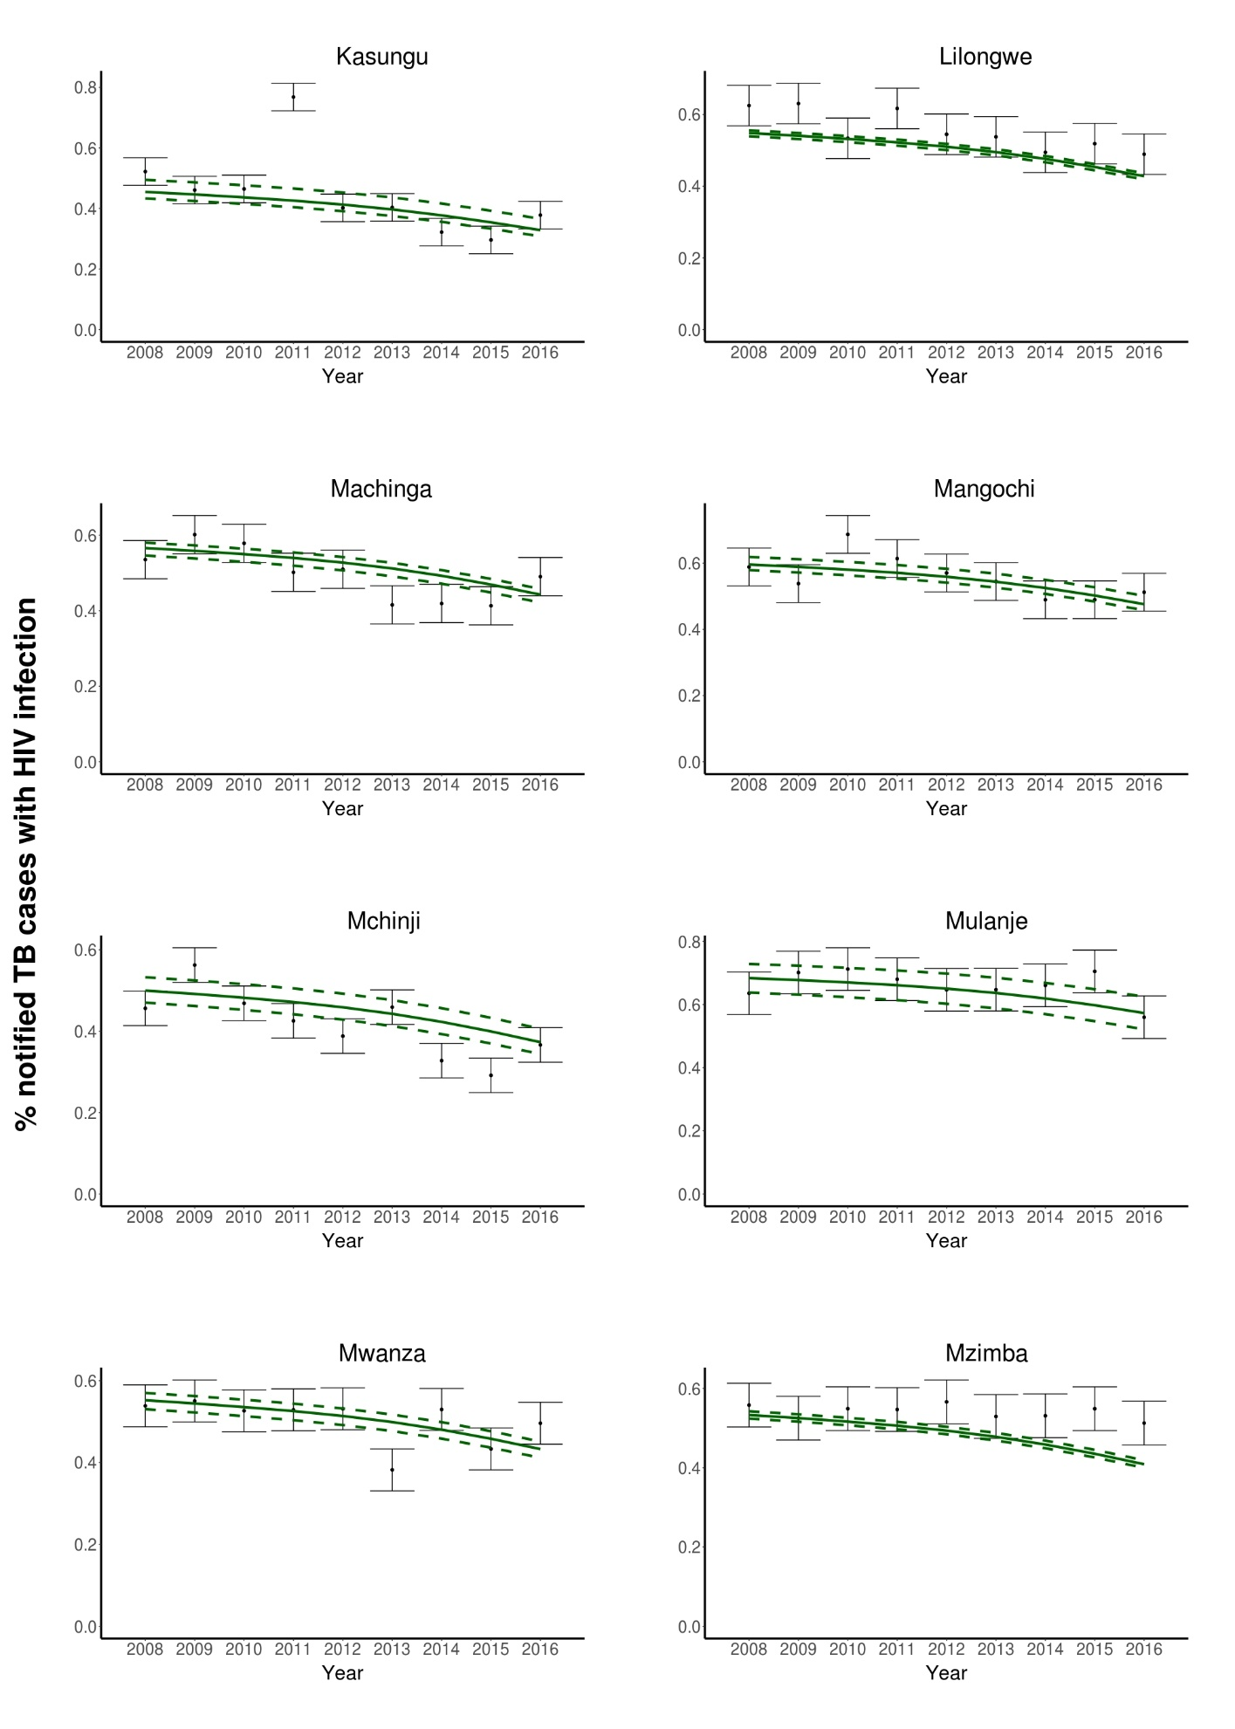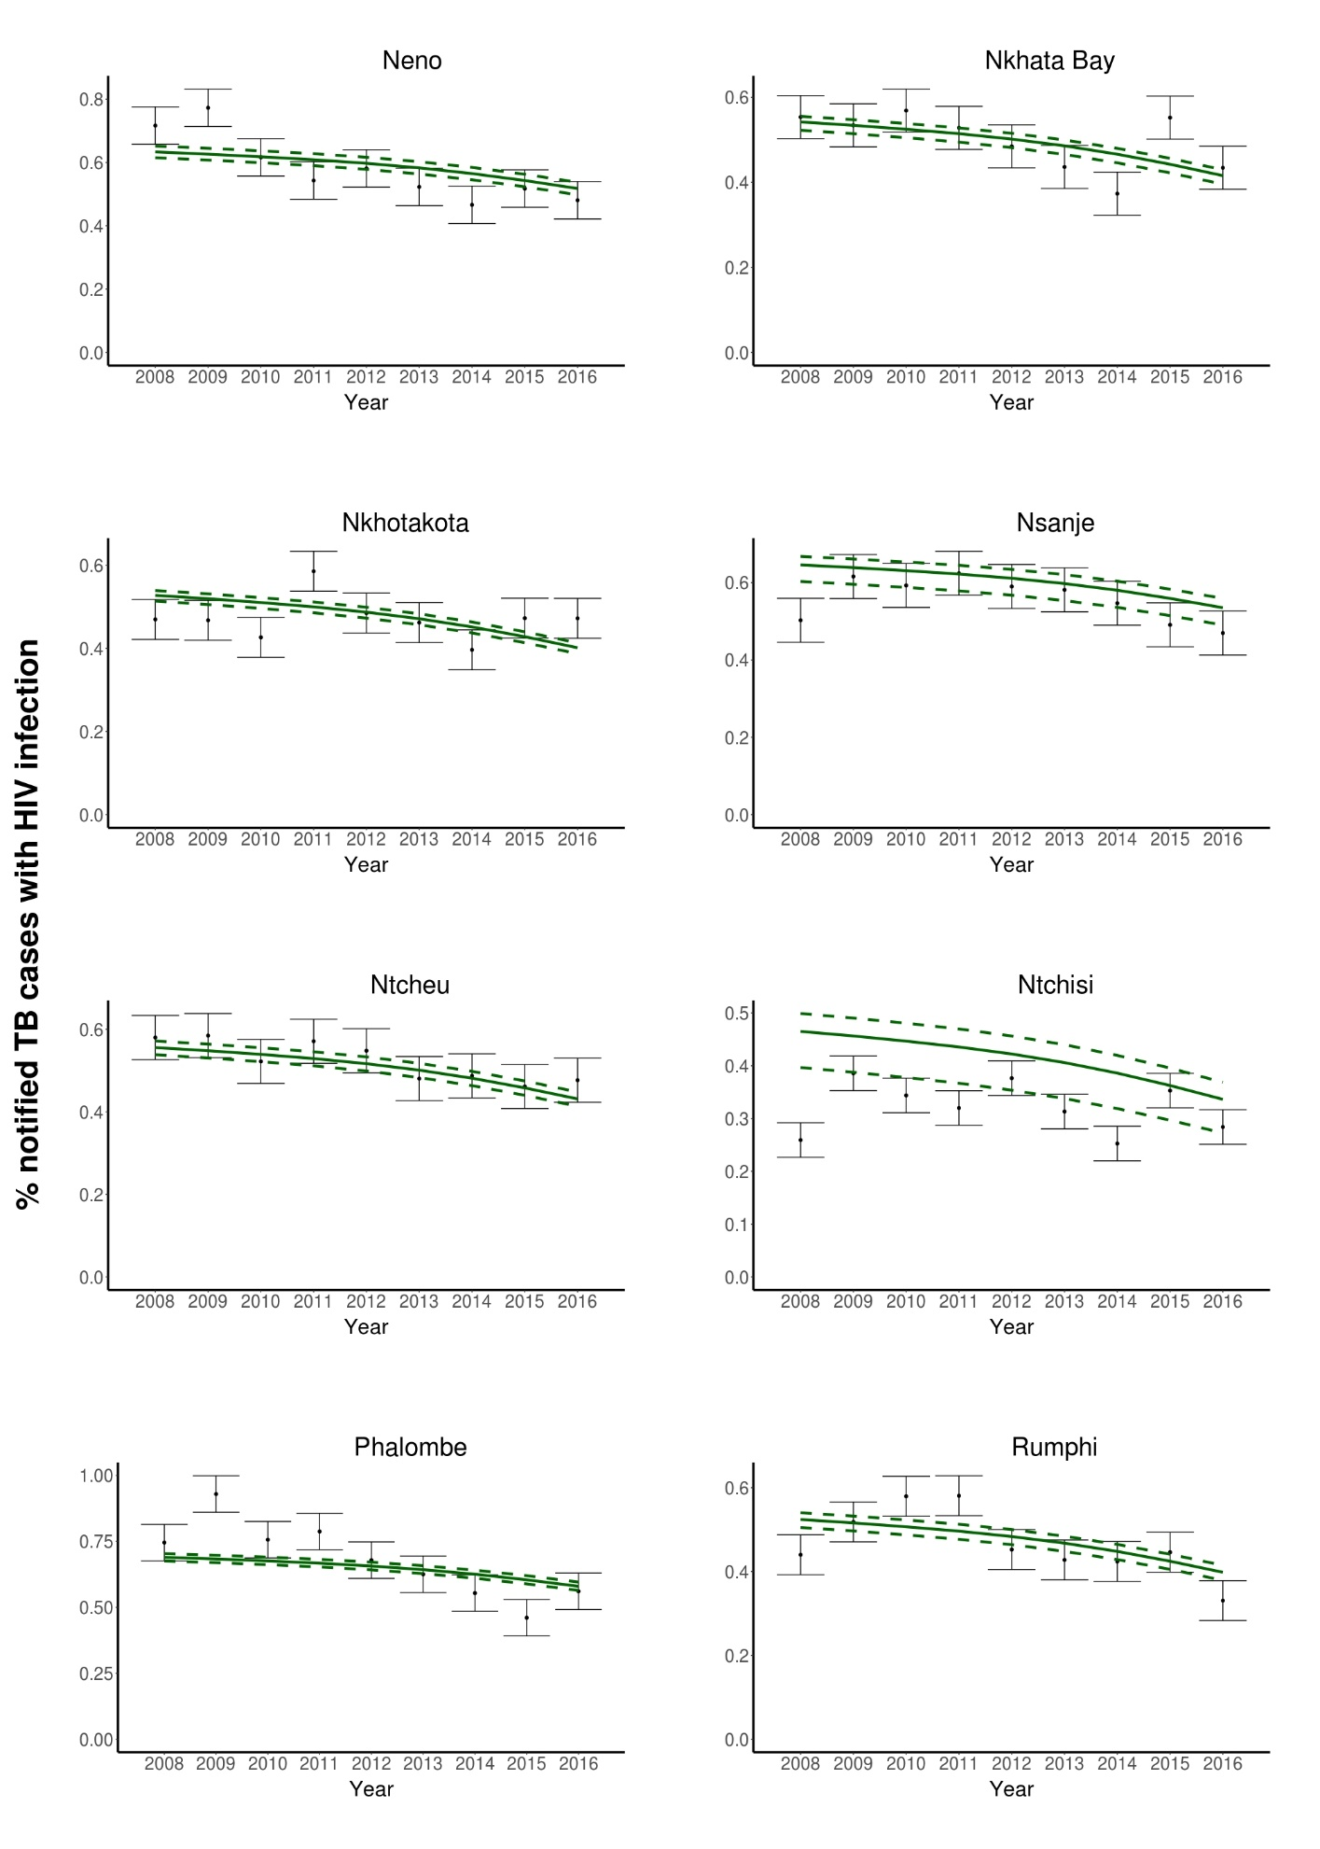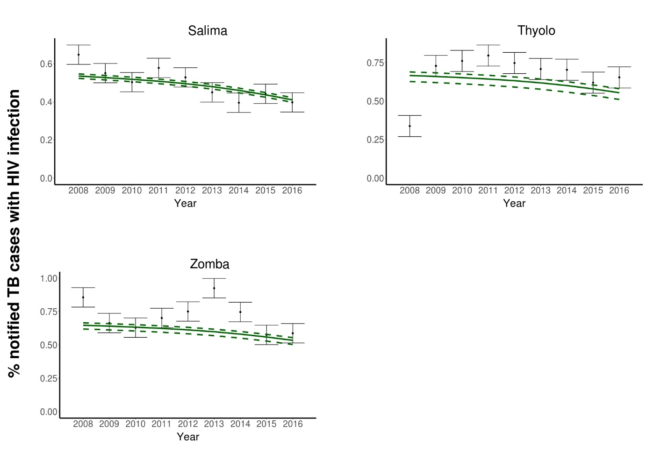
Appendix 5. District level estimates
Table 1. Model estimates of HIV/TB epidemiological characteristics of the 27 districts in 2018
ª Districts were ranked by TB incidence rates in 2018. Districts highlighted in blue, namely Lilongwe, Blantyre, Thyolo, Chiradzulu, and Zomba are the districts where Malawi had planned to start continuous IPT. The model was calibrated to TB and HIV service data provided by the MOH Malawi. Model estimates represent the arithmetic means of the distribution generated by the resampled parameter sets. More details can be found in Appendix 3.
District | Name ª | TB incidence (per 100k) | TB prevalence  (per 100k) | No. of notified TB cases | HIV incidence (per 1k) | HIV prevalence (%) | No. retained on ART in mid-year | Total pop. size  (≥15 y.o.)
1 | Blantyre | 494.68 | 665.14 | 1,484 | 3.04 | 14.89 | 117,746 | 1,129,734
2 | Nsanje | 493.86 | 673.89 | 322 | 2.51 | 11.70 | 20,356 | 239,747
3 | Chiradzulu | 485.84 | 648.39 | 396 | 3.21 | 15.69 | 34,166 | 307,779
4 | Mwanza | 466.79 | 654.41 | 151 | 1.67 | 7.59 | 6,584 | 115,016
5 | Neno | 377.98 | 516.32 | 118 | 2.06 | 10.16 | 8,277 | 113,325
6 | Lilongwe | 360.37 | 502.32 | 2,436 | 1.56 | 7.30 | 124,453 | 2,404,516
7 | Chikwawa | 352.43 | 485.86 | 471 | 1.81 | 8.78 | 29,678 | 481,665
8 | Zomba | 349.60 | 472.43 | 685 | 2.37 | 12.05 | 59,703 | 723,140
9 | Thyolo | 291.73 | 390.17 | 488 | 2.50 | 13.29 | 55,434 | 621,537
10 | Balaka | 250.37 | 340.35 | 248 | 1.90 | 9.97 | 24,228 | 359,847
11 | Phalombe | 236.95 | 313.53 | 216 | 2.67 | 14.79 | 33,464 | 342,217
12 | Mulanje | 228.87 | 302.43 | 357 | 2.67 | 14.82 | 56,898 | 584,105
13 | Salima | 211.72 | 293.92 | 243 | 1.28 | 6.63 | 18,168 | 404,971
14 | Mangochi | 208.46 | 283.32 | 525 | 1.78 | 9.58 | 57,623 | 907,760
15 | Rumphi | 199.46 | 277.66 | 116 | 1.20 | 6.38 | 8,776 | 203,418
16 | Nkhotakota | 196.82 | 273.80 | 189 | 1.19 | 6.21 | 14,165 | 337,210
17 | Chitipa | 180.23 | 244.54 | 111 | 1.15 | 6.54 | 8,923 | 210,164
18 | Mzimba | 174.37 | 240.95 | 514 | 1.30 | 6.92 | 47,595 | 1,037,403
19 | Nkhata Bay | 165.73 | 229.32 | 118 | 1.24 | 6.69 | 11,167 | 250,044
20 | Karonga | 159.35 | 218.40 | 141 | 1.45 | 7.94 | 16,566 | 315,920
21 | Machinga | 140.52 | 191.98 | 232 | 1.48 | 8.16 | 31,260 | 586,743
22 | Ntcheu | 127.49 | 174.67 | 214 | 1.38 | 7.65 | 29,606 | 593,895
23 | Dedza | 123.89 | 174.06 | 275 | 0.85 | 4.61 | 23,123 | 762,256
24 | Mchinji | 117.66 | 163.63 | 181 | 1.04 | 5.70 | 19,879 | 533,558
25 | Kasungu | 95.51 | 133.99 | 209 | 0.83 | 4.57 | 22,256 | 749,638
26 | Dowa | 87.93 | 123.52 | 185 | 0.79 | 4.37 | 20,367 | 718,048
27 | Ntchisi | 72.01 | 100.92 | 60 | 0.81 | 4.59 | 8,476 | 285,852
 | National | 246.32 | 336.66 | 10,683 | 1.53 | 8.80 | 908,935 | 15,319,509

A  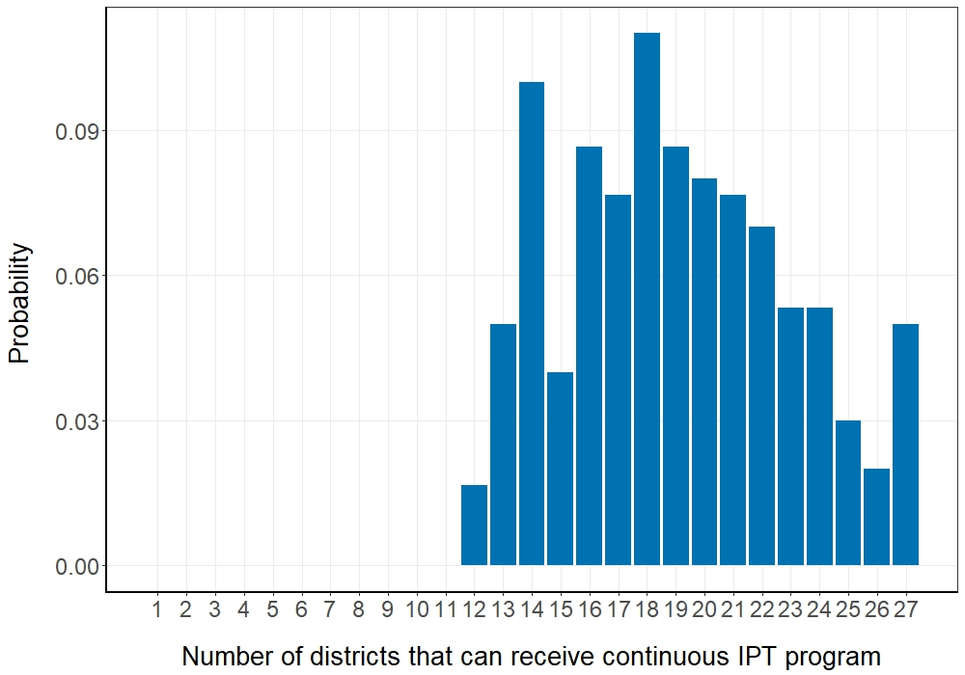 | B  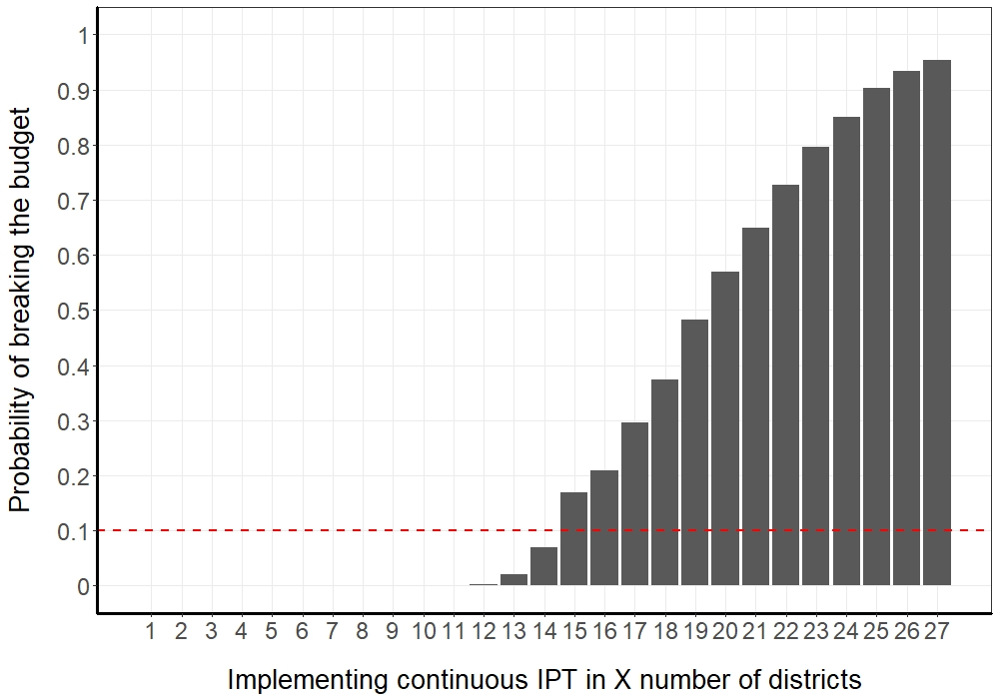 | C  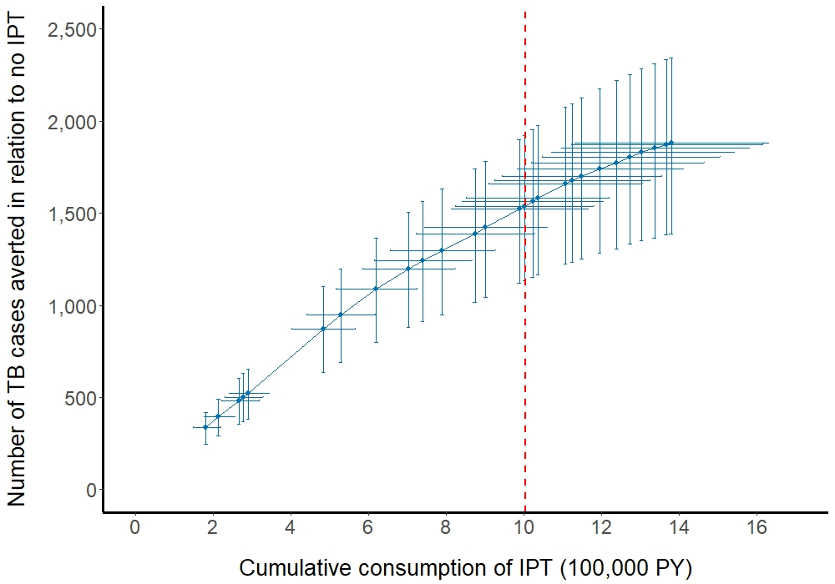
Figure 1. Allocation of continuous IPT program across districts, based on our model simulations (n=300) from resampled parameter sets. A, the probability we could implement continuous IPT in a given number of districts without exceeding the budget limit and based on the district selection algorithm defined in our study. This is an estimated probability mass function (pmf) of selecting X districts to receive IPT. B, the probability of exceeding the budget when the continuous IPT program is implemented in a given number of districts. Under the decision rule that the policy makers are willing to accept a 10% probability of exceeding the budget, we would then implement the continuous IPT program in 14 districts. C, the number of TB cases averted as a function of IPT consumption under a continuous IPT program in 1 to 27 districts. Each blue circle point to the right of the x-axis represents the introduction of the program to one additional district. Red dashed line (- - -), the budget line or the maximum person-years of IPT (1,003,423 PY) available for allocation in 2018-2020.

Table 2. Enrolment of districts in IPT intervention programs under the 6-month or continuous IPT scenario.
District | Name | Mean PY of IPT required in 2018-2020 for 6mo IPT | Mean PY of IPT required in 2018-2020 for cont. IPT | no IPT | 6mo. IPT | cont. IPT
1 | Blantyre | 44,499 | 164,371 | No | Yes | Yes
2 | Nsanje | 7,571 | 28,056 | No | Yes | Yes
3 | Chiradzulu | 12,847 | 47,502 | No | Yes | Yes
4 | Mwanza | 2,408 | 8,955 | No | Yes | Yes
5 | Neno | 3,090 | 11,447 | No | Yes | Yes
6 | Lilongwe | 46,818 | 173,101 | No | Yes | Yes
7 | Chikwawa | 11,203 | 41,398 | No | Yes | Yes
8 | Zomba | 22,802 | 84,073 | No | Yes | Yes
9 | Thyolo | 21,348 | 78,586 | No | Yes | Yes
10 | Balaka | 9,308 | 34,293 | No | Yes | Yes
11 | Phalombe | 12,971 | 47,703 | No | Yes | Yes
12 | Mulanje | 22,115 | 81,263 | No | Yes | Yes
13 | Salima | 6,973 | 25,693 | No | Yes | Yes
14 | Mangochi | 22,317 | 82,069 | No | Yes | Yes
15 | Rumphi | 3,368 | 12,410 | No | Yes | No
16 | Nkhotakota | 5,438 | 20,036 | No | Yes | No
17 | Chitipa | 3,491 | 12,812 | No | Yes | No
18 | Mzimba | 18,449 | 67,843 | No | Yes | No
19 | Nkhata Bay | 4,312 | 15,875 | No | Yes | No
20 | Karonga | 6,427 | 23,633 | No | Yes | No
21 | Machinga | 12,192 | 44,781 | No | Yes | No
22 | Ntcheu | 11,563 | 42,469 | No | Yes | No
23 | Dedza | 8,997 | 33,063 | No | Yes | No
24 | Mchinji | 7,753 | 28,484 | No | Yes | No
25 | Kasungu | 8,695 | 31,924 | No | Yes | No
26 | Dowa | 7,966 | 29,246 | No | Yes | No
27 | Ntchisi | 3,326 | 12,204 | No | Yes | No
PY IPT required | National | 348,245 | 1,283,291 | 0 | 348,245 | 908,510
Note: Intervention assignments were determined based on the district selection algorithm presented in Appendix 1 and with a willingness to accept 10% probability of exceeding the budget with implementation of the continuous IPT program. PY, person-years.
Appendix 6 Efficiency of 6-month verseus continuout IPT

Table 1. Cost-effectiveness of IPT among adults
Number of person-year of IPT needed to avert one case of (mean, 95% PI): | 6-month IPT | continuous IPT
TB incidence
In the first 3 years | 67 (48, 88) | 171 (133, 222)
By the end of year 12 | 25 (16, 36) | 96 (72, 134)
TB death
In the first 3 years | 86 (65, 111) | 251 (195, 315)
By the end of year 12 | 33 (23, 45) | 140 (108, 184)
All-cause mortality
In the first 3 years | 91 (69, 117) | 264 (206, 330)
By the end of year 12 | 37 (26, 51) | 157 (121, 206)
Number needed to treat to avert one case of (mean, 95% PI): | 6-month IPT | continuous IPT
TB incidence
In the first 3 years | 161 (114, 217) | 113 (84, 151)
By the end of year 12 | 58 (37, 82) | 36 (27, 51)
TB death
In the first 3 years | 208 (154, 272) | 165 (124, 214)
By the end of year 12 | 76 (54, 104) | 53 (41, 70)
All-cause mortality
In the first 3 years | 219 (164, 288) | 173 (131, 225)
By the end of year 12 | 86 (61, 118) | 59 (46, 78)
US dollars needed to avert one case of (mean, 95% PI): | 6-month IPT | continuous IPT
TB incidence
In the first 3 years | 716 (512, 952) | 1848 (1429, 2387)
By the end of year 12 | 270 (175, 382) | 1029 (778, 1446)
TB death
In the first 3 years | 923 (695, 1194) | 2703 (2103, 3387)
By the end of year 12 | 354 (253, 482) | 1506 (1158, 1977)
All-cause mortality
In the first 3 years | 978 (738, 1264) | 2846 (2221, 3556)
By the end of year 12 | 400 (285, 544) | 1688 (1300, 2215)

Appendix 7. Sensitivity analysis on HIV decline rate since IPT program initiaion
To assess how the assumption of HIV decline rate in Malawi would affect the outcome comparison between 6-month IPT program and the continuous IPT program, we explored a pessimistic scenario where the HIV decline rate remained zero throughout 2017-3030 since IPT program initiation in 2018. It appeared that both the TB incidence and TB prevalence decreased for several years following program initiation but rebounded in the longer term. However, the relative effectiveness of 6-month and continuous strategies on the number of TB cases averted in adult and the number of TB-related deaths and all-cause deaths averted among PLHIV remained the same as the scenario (with 50% reduction in HIV incidence by 2030) presented in the main text.
A  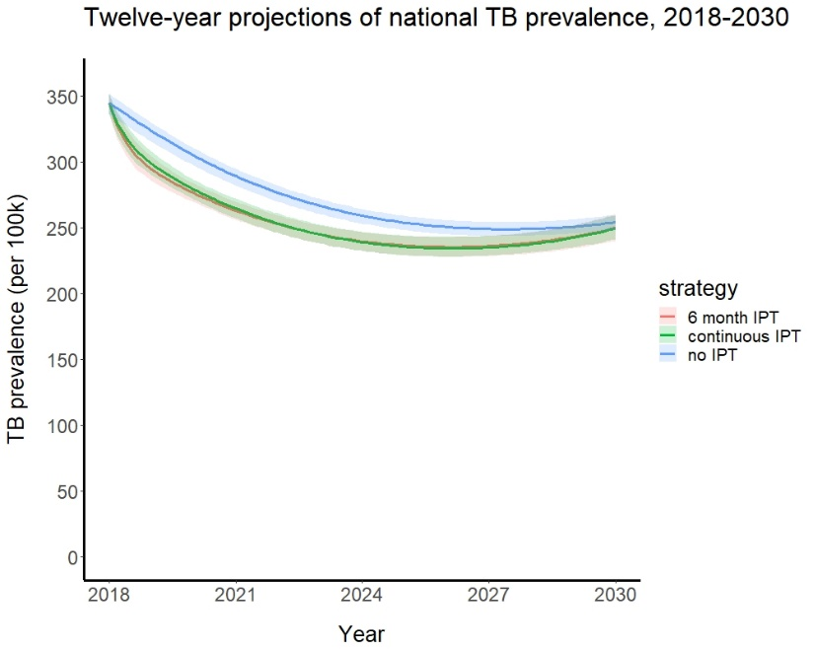 | B  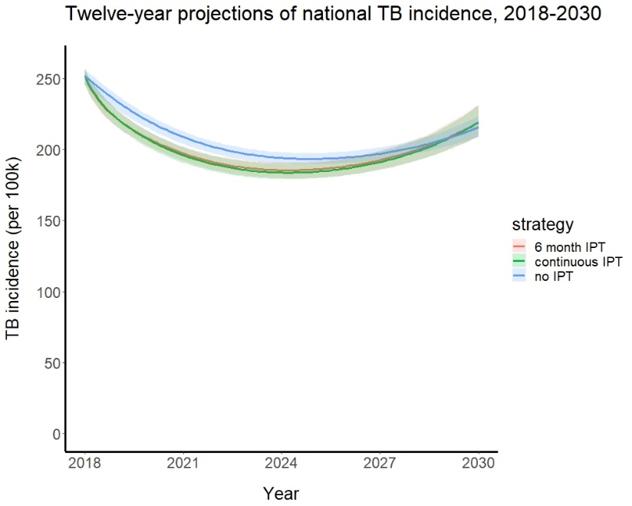
Figure 1. Twelve-year projection of TB burden among adults under the three IPT policy alternatives, assuming the HIV incidence rate remained the same throughout the entire simulation period (2017-2030). A. National TB prevalence (per 100,000). B. National TB incidence (per 100,000). The 6-month IPT program was introduced nationwide and the continuous IPT program was implemented in 14 districts with the highest estimated TB incidence rates in 2018. The number of districts intervened over the simulation period was fixed in either intervention scenario, reflecting a static intervention policy. Solid lines, arithmetic means of the distributions of resampled parameter sets; the ribbons, 95% projection intervals.

A  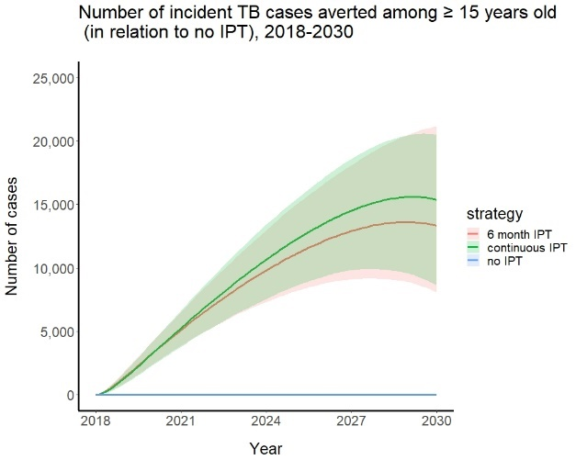 | B  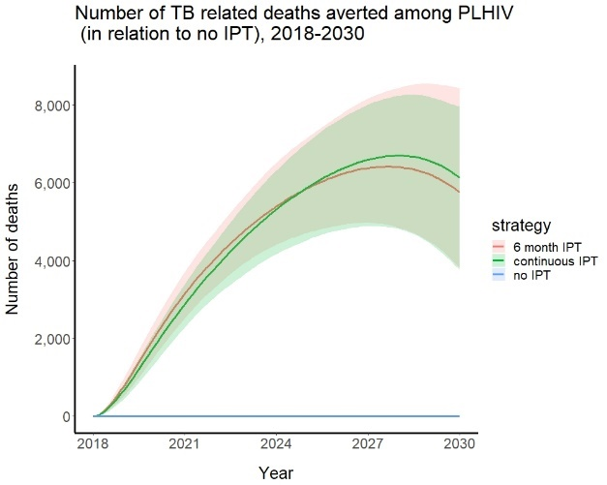 | C  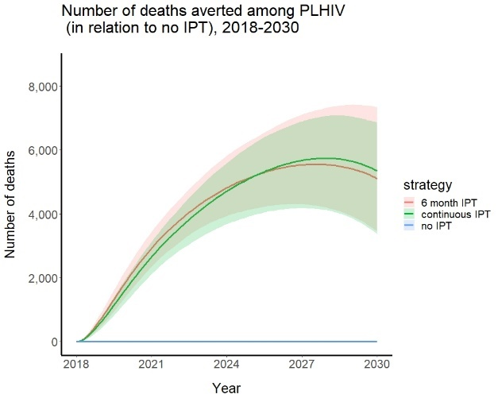
Figure 2. Comparisons of the health impacts of IPT between policy alternatives, assuming the HIV incidence rate remained the same throughout the entire simulation period (2017-2030). A, cumulative number of TB cases averted among adults, in relation to the base case. B, cumulative number of TB-related deaths averted among PLHIV, in relation to the base case. This includes the deaths averted among active TB cases that are being treated. C, cumulative number of all-cause deaths averted among PLHIV, in relation to the base case. For A-C: Solid lines, arithmetic means of the distributions of resampled parameter sets; the ribbons, 95% projection intervals.

Appendix 8. Model equations (as R code)
# R code containing the ordinary differential equations for the TB/HIV compartmental model
# Equation symbols correspond to the Parameter Table in Appendix 4.
# Can be run by using the R function ‘ode’ in the deSolve package

HIVTB_states_model <- function(times, yinit, pars, strategy) {

with(as.list(c(yinit,pars)),{

# TOTAL POPULATION SIZE
N_tot = S_p + E_p + S_N + E_N + I_N + T_N + S_H + E_H + I_H + S_AIpre + E_AIpre + I_AIpre + T_A + S_AIon +
E_AIon + I_AIon + S_AIpost + E_AIpost + I_AIpost + C_AIon + C_AIpost

N = S_N + E_N + I_N + T_N + S_H + E_H + I_H + S_AIpre + E_AIpre + I_AIpre + T_A + S_AIon + E_AIon +
I_AIon + S_AIpost + E_AIpost + I_AIpost + C_AIon + C_AIpost

# IPT STRATEGIES
# base case
if (init==T | strategy == 0){
kappa = 0
iota = 0
z = 0}

# 6-month IPT
if (strategy == 1) {
kappa = pars$kappa_6
iota = pars$iota
z = pars$z}

# continuous IPT
if (strategy == 2) {
kappa = pars$kappa_c
iota = pars$iota
z = pars$z}

# TB TRANSMISSION
beta_t2 = beta_t1*rr_tb
lambda_tb = beta_t1*I_N/N + beta_t2*(I_H + I_AIpre + I_AIon + I_AIpost)/N

# HIV TRANSMISSION

if (times < 1976){ # No HIV transmission in and prior to 1975
tau_h = 0
mu_hiv = 0
mu_tb_hiv = 0
} else {
tau_h = pars$tau_h
mu_hiv = pars$mu_hiv
mu_tb_hiv = pars$mu_tb_hiv
}

if (times < 1976){
lambda_hiv = 0
# No HIV transmission in and prior to 1975
} else if (times < 1991 & times >= 1976){
lambda_hiv = (10*(exp(log(2759.922*hivinc_s)/15*(times-1975))-1))/(S_N+E_N+I_N+T_N)/(times-1975) # HIV transmission in 1976-1990 is the same as 1990
} else if (times < 2018 & times >= 1991){
lambda_hiv = hivinc_s*inc[floor(times-1989)]*N/1000/(S_N + E_N + I_N + T_N)
# UNAIDS estimates of HIV incidence rates
} else {lambda_hiv = hivinc_s*(inc[28] - 0.1692308*(ceiling(times-2017)))*N/1000/(S_N + E_N + I_N + T_N)}
# HIV incidence reduced by half from 2017 to 2030

# HIV CASE DETECTION RATES
hiv_cdr = 0.8321/(1 + exp(-(-653.1621 + 0.3247 * times ))) # fitted logistic growth curve
gamma = hiv_cdr*mu_hiv/(1-hiv_cdr)

## SUMS

# person time on IPT
# (note: integrated output is cumulative person-years of IPT)
dPT_ipt = S_AIon + E_AIon + I_AIon + C_AIon

# person time on ARV
# (note: integrated output is cumulative person-years of ART)
dPT_arv = S_AIpre + S_AIon + S_AIpost + E_AIpre + E_AIon + E_AIpost + I_AIpre + I_AIon + I_AIpost + C_AIon + C_AIpost + T_A

# person time on TB treatment among all
# (note: integrated output is cumulative person-years of treatment for active TB)
dPT_tbtx = T_N + T_A

# person time on TB treatment in PLHIV
# (note: integrated output is cumulative person-years of treatment for active TB among PLHIV)
dPT_tbtx_hiv = T_A

# TB incidence rate overall
# (note: integrated output is cumulative TB incidence)
dTBinc = x*lambda_tb*S_N + x*(1-m)*lambda_tb*E_N + p*E_N +
x_h*lambda_tb*S_H + x_h*(1-m)*lambda_tb*E_H + p_h*E_H +
x_a*lambda_tb*S_AIpre + x_a*(1-m)*lambda_tb*E_AIpre + p_a*E_AIpre +
f_i*x_a*lambda_tb*S_AIon + f_i*x_a*(1-m)*lambda_tb*E_AIon + p_ai*E_AIon +
f_i*x_a*(1-m)*lambda_tb*C_AIon + x_a*lambda_tb*S_AIpost + x_a*(1-m)*lambda_tb*E_AIpost + p_a*E_AIpost + x_a*(1-m)*lambda_tb*C_AIpost

# TB incidence rate among PLHIV
# (note: integrated output is cumulative TB incidence among PLHIV)
dTBinc_hiv = x_h*lambda_tb*S_H + x_h*(1-m)*lambda_tb*E_H + p_h*E_H +
x_a*lambda_tb*S_AIpre + x_a*(1-m)*lambda_tb*E_AIpre + p_a*E_AIpre +
f_i*x_a*lambda_tb*S_AIon + f_i*x_a*(1-m)*lambda_tb*E_AIon + p_ai*E_AIon +
f_i*x_a*(1-m)*lambda_tb*C_AIon + x_a*lambda_tb*S_AIpost + x_a*(1-m)*lambda_tb*E_AIpost +
p_a*E_AIpost + x_a*(1-m)*lambda_tb*C_AIpost

# TB incidence rate among PLHIV on ART
# (note: integrated output is cumulative TB incidence among PLHIV on ART)
dTBinc_arv = x_a*lambda_tb*S_AIpre + x_a*(1-m)*lambda_tb*E_AIpre + p_a*E_AIpre +
f_i*x_a*lambda_tb*S_AIon + f_i*x_a*(1-m)*lambda_tb*E_AIon + p_ai*E_AIon +
f_i*x_a*(1-m)*lambda_tb*C_AIon + x_a*lambda_tb*S_AIpost + x_a*(1-m)*lambda_tb*E_AIpost +
p_a*E_AIpost + x_a*(1-m)*lambda_tb*C_AIpost

# HIV incidence rate
# (note: integrated output is cumulative HIV incidence)
dHIVinc = lambda_hiv*(S_N + E_N + I_N + T_N)

# rate of starting TB treatment
# (note: integrated output is the number of people who initiated treatment for active TB)
dT_start = tau*I_N + tau_a*I_AIpre + e*iota*I_AIpre + tau_h*I_H + tau_a*I_AIpost + tau_ai*I_AIon

# rate of starting IPT
# (note: integrated output is the number of people who initiated IPT)
dIPT_start = (1-q)*iota*S_AIpre + (1-q)*iota*E_AIpre + (1-q)*(1-e)*iota*I_AIpre + z*(1-rho)*phi*T_A

# rate of starting ART
dART_start = gamma*(S_H + E_H + I_H) + tau_h*I_H + lambda_hiv*T_N

# mortality rate among entire population
# (note: output when integrated is cumulative mortality)
dM_tot = mu_peds*(S_p + E_p) + mu*(S_N + E_N) + mu_tb*I_N + mu_tr*T_N + mu_hiv*(S_H + E_H) + mu_tb_hiv*I_H + mu_arv*(S_AIpre + E_AIpre + S_AIpost + E_AIpost + C_AIpost) + mu_tb_arv*(I_AIpre + I_AIpost) + mu_ai*(S_AIon + E_AIon + C_AIon) + mu_tb_ai*I_AIon + mu_tr_arv*T_A

# mortality rate among adults and adolescents
# (note: integrated output is cumulative mortality)
dM = mu*(S_N + E_N) + mu_tb*I_N + mu_tr*T_N + mu_hiv*(S_H + E_H) + mu_tb_hiv*I_H +
mu_arv*(S_AIpre + E_AIpre + S_AIpost + E_AIpost + C_AIpost) + mu_tb_arv*(I_AIpre + I_AIpost) + mu_ai*(S_AIon + E_AIon + C_AIon) + mu_tb_ai*I_AIon + mu_tr_arv*T_A

# mortality rate among PLHIV
# (note: integrated output is cumulative mortality among PLHIV)
dM_hiv = mu_hiv*(S_H + E_H) + mu_tb_hiv*I_H +
mu_arv*(S_AIpre + E_AIpre + S_AIpost + E_AIpost + C_AIpost) + mu_tb_arv*(I_AIpre + I_AIpost) +
mu_ai*(S_AIon + E_AIon + C_AIon) + mu_tb_ai*I_AIon + mu_tr_arv*T_A

# mortality rate among PLHIV on ART
# (note: integrated output is cumulative mortality among PLHIV on ART)
dM_arv = mu_arv*(S_AIpre + E_AIpre + S_AIpost + E_AIpost + C_AIpost) + mu_tb_arv*(I_AIpre + I_AIpost) +
mu_ai*(S_AIon + E_AIon + C_AIon) + mu_tb_ai*I_AIon + mu_tr_arv*T_A

# TB deaths among all adults and adolescents
# (note: integrated output is cumulative TB-related mortality)
dM_tb = (mu_tb*I_N + mu_tb_hiv*I_H + mu_tb_arv*(I_AIpre + I_AIpost) + mu_tb_ai*I_AIon + mu_tr_arv*T_A + mu_tr*T_N) – mu*(I_N + I_H + I_AIpre + I_AIpost + I_AIon+T_A + T_N)

# TB deaths among all PLHIV
dM_tb_hiv = (mu_tb_hiv*I_H + mu_tb_arv*(I_AIpre + I_AIpost) + mu_tb_ai*I_AIon + mu_tr_arv*T_A) –
mu*(I_H + I_AIpre + I_AIpost + I_AIon + T_A)

# TB deaths among all PLHIV on ARV
dM_tb_arv = (mu_tb_arv*(I_AIpre + I_AIpost) + mu_tb_ai*I_AIon + mu_tr_arv*T_A) - mu*(I_AIpre + I_AIpost + I_AIon + T_A)

# TB associated deaths among all adults and adolescents
dM_tb_attr <- (mu_tb*I_N + mu_tb_hiv*I_H + mu_tb_arv*(I_AIpre + I_AIpost) + mu_tb_ai*I_AIon + mu_tr*T_N + mu_tr_arv*T_A) - (mu*I_N + mu_hiv*I_H + mu_arv*(I_AIpre + I_AIpost) + mu_ai*I_AIon + mu*T_N + mu_arv*T_A)

# TB addociated deaths among all PLHIV
dM_tb_hiv_attr <- (mu_tb_hiv*I_H + mu_tb_arv*(I_AIpre + I_AIpost) + mu_tb_ai*I_AIon + mu_tr_arv*T_A) - (mu_hiv*I_H + mu_arv*(I_AIpre + I_AIpost) + mu_ai*I_AIon + mu_arv*T_A)

# TB associated deaths among all PLHIV on ARV
dM_tb_arv_attr <- (mu_tb_arv*(I_AIpre + I_AIpost) + mu_tb_ai*I_AIon + mu_tr_arv*T_A) –
(mu_arv*(I_AIpre + I_AIpost) + mu_ai*I_AIon + mu_arv*T_A)

# Birth rate
b = dM

## ODE FUNCTIONS

dS_p = b - (lambda_tb + epsilon + mu_peds)*S_p

dE_p = lambda_tb*S_p - (epsilon + mu_peds)*E_p

dS_N = epsilon*S_p - (lambda_tb + lambda_hiv)*S_N - mu*S_N # updated Jun20 LH

dE_N = epsilon*E_p + (1-x)*lambda_tb*S_N - x*(1-m)*lambda_tb*E_N - p*E_N - lambda_hiv*E_N + sigma*I_N + rho*phi*T_N - mu*E_N

dI_N = x*lambda_tb*S_N + x*(1-m)*lambda_tb*E_N + p*E_N - lambda_hiv*I_N - sigma*I_N - tau*I_N +
(1-rho)*phi*T_N - mu_tb*I_N

dT_N = tau*I_N - phi*T_N - mu_tr*T_N - lambda_hiv*T_N

dS_H = lambda_hiv*S_N - lambda_tb*S_H - gamma*S_H - mu_hiv*S_H

dE_H = (1-x_h)*lambda_tb*S_H - x_h*(1-m)*lambda_tb*E_H + lambda_hiv*E_N - gamma*E_H - p_h*E_H + sigma_h*I_H - mu_hiv*E_H

dI_H = x_h*lambda_tb*S_H + x_h*(1-m)*lambda_tb*E_H + lambda_hiv*I_N - gamma*I_H + p_h*E_H - sigma_h*I_H - mu_tb_hiv*I_H - tau_h*I_H

dS_AIpre = gamma*S_H - lambda_tb*S_AIpre - iota*S_AIpre - mu_arv*S_AIpre

dE_AIpre = gamma*E_H + (1-x_a)*lambda_tb*S_AIpre - x_a*(1-m)*lambda_tb*E_AIpre - p_a*E_AIpre - iota*E_AIpre + sigma_a*I_AIpre - mu_arv*E_AIpre

dI_AIpre = gamma*I_H + x_a*lambda_tb*S_AIpre + x_a*(1-m)*lambda_tb*E_AIpre + p_a*E_AIpre - sigma_a*I_AIpre - tau_a*I_AIpre - iota*I_AIpre - mu_tb_arv*I_AIpre

dS_AIon = (1-q)*iota*S_AIpre - f_i*lambda_tb*S_AIon - kappa*S_AIon - mu_ai*S_AIon

dE_AIon = (1-q)*iota*E_AIpre + f_i*(1-x_a)*lambda_tb*S_AIon - kappa*E_AIon –
f_i*x_a*(1-m)*lambda_tb*E_AIon - p_ai*E_AIon + sigma_ai*I_AIon + z*rho*phi*T_A - mu_ai*E_AIon - s_ipt*E_AIon + f_i*(1-x_a)*(1-m)*lambda_tb*C_AIon

dI_AIon = (1-q)*(1-e)*iota*I_AIpre + f_i*x_a*lambda_tb*S_AIon - sigma_ai*I_AIon + f_i*x_a*(1-m)*lambda_tb*E_AIon + p_ai*E_AIon - tau_ai*I_AIon - kappa*I_AIon + z*(1-rho)*phi*T_A - mu_tb_ai*I_AIon + f_i*x_a*(1-m)*lambda_tb*C_AIon

dS_AIpost = kappa*S_AIon + q*iota*S_AIpre - lambda_tb*S_AIpost - mu_arv*S_AIpost

dE_AIpost = kappa*E_AIon + q*iota*E_AIpre + (1-x_a)*lambda_tb*S_AIpost –
x_a*(1-m)*lambda_tb*E_AIpost - p_a*E_AIpost + sigma_a*I_AIpost + (1-z)*rho*phi*T_A - mu_arv*E_AIpost + (1-x_a)*(1-m)*lambda_tb*C_AIpost

dI_AIpost = kappa*I_AIon + q*(1-e)*iota*I_AIpre + x_a*lambda_tb*S_AIpost +
x_a*(1-m)*lambda_tb*E_AIpost + p_a*E_AIpost - sigma_a*I_AIpost - tau_a*I_AIpost +
(1-z)*(1-rho)*phi*T_A - mu_tb_arv*I_AIpost + x_a*(1-m)*lambda_tb*C_AIpost

dT_A = tau_a*I_AIpre + e*iota*I_AIpre + tau_h*I_H + tau_a*I_AIpost + tau_ai*I_AIon + lambda_hiv*T_N –
phi*T_A - mu_tr_arv*T_A

dC_AIon = s_ipt*E_AIon - f_i*(1-m)*lambda_tb*C_AIon - kappa*C_AIon - mu_ai*C_AIon

dC_AIpost = kappa*C_AIon - (1-m)*lambda_tb*C_AIpost - mu_arv*C_AIpost

return(list(c(dPT_ipt, dPT_arv, dPT_tbtx, dPT_tbtx_hiv, #4
dTBinc, dTBinc_hiv, dTBinc_arv, dHIVinc, #8
dT_start, dTA_start, dIPT_start, dART_start,#12
dM_tot, dM, dM_hiv, dM_arv, #16
dM_tb, dM_tb_hiv, dM_tb_arv, #19
dM_tb_attr, dM_tb_hiv_attr, dM_tb_arv_attr, #22
dS_p, dE_p, #24
dS_N, dE_N, dI_N, dT_N, #28
dS_H, dE_H, dI_H, #31
dS_AIpre, dE_AIpre, dI_AIpre, #34
dS_AIon, dE_AIon, dI_AIon, #37
dS_AIpost, dE_AIpost, dI_AIpost, #40
dT_A, dC_AIon, dC_AIpost #43
)))
})
}

References
1. Malawi Demographic and Health Survey 2015-2016. In. Zomba, Malawi, and Rockville, Maryland, USA.; 2017.
2. Kanyerere H, Harries AD, Tayler-Smith K, Jahn A, Zachariah R, Chimbwandira FM, et al. The rise and fall of tuberculosis in Malawi: associations with HIV infection and antiretroviral therapy. Trop Med Int Health 2016; 21(1):101-107.
3. UNAIDS. Malawi New HIV Infections. In.
4. UNAIDS. Malawi Treatment Cascade. In.
5. Antonucci G, Girardi E, Raviglione MC, Ippolito G. Risk factors for tuberculosis in HIV-infected persons. A prospective cohort study. The Gruppo Italiano di Studio Tubercolosi e AIDS (GISTA). Jama 1995; 274(2):143-148.
6. Daley CL, Small PM, Schecter GF, Schoolnik GK, McAdam RA, Jacobs WR, Jr., et al. An outbreak of tuberculosis with accelerated progression among persons infected with the human immunodeficiency virus. An analysis using restriction-fragment-length polymorphisms. N Engl J Med 1992; 326(4):231-235.
7. Dowdy DW, Chaisson RE, Maartens G, Corbett EL, Dorman SE. Impact of enhanced tuberculosis diagnosis in South Africa: a mathematical model of expanded culture and drug susceptibility testing. Proc Natl Acad Sci U S A 2008; 105(32):11293-11298.
8. Corbett EL, Charalambous S, Moloi VM, Fielding K, Grant AD, Dye C, et al. Human immunodeficiency virus and the prevalence of undiagnosed tuberculosis in African gold miners. Am J Respir Crit Care Med 2004; 170(6):673-679.
9. van der Sande MA, Schim van der Loeff MF, Bennett RC, Dowling M, Aveika AA, Togun TO, et al. Incidence of tuberculosis and survival after its diagnosis in patients infected with HIV-1 and HIV-2. Aids 2004; 18(14):1933-1941.
10. Gupta RK, Lawn SD, Bekker LG, Caldwell J, Kaplan R, Wood R. Impact of human immunodeficiency virus and CD4 count on tuberculosis diagnosis: analysis of city-wide data from Cape Town, South Africa. Int J Tuberc Lung Dis 2013; 17(8):1014-1022.
11. Esmail H, Barry CE, Young DB, Wilkinson RJ. The ongoing challenge of latent tuberculosis. Philosophical Transactions of the Royal Society B: Biological Sciences 2014; 369(1645):20130437.
12. Vynnycky E, Fine PE. The natural history of tuberculosis: the implications of age-dependent risks of disease and the role of reinfection. Epidemiol Infect 1997; 119(2):183-201.
13. Miranda A, Morgan M, Jamal L, Laserson K, Barreira D, Silva G, et al. Impact of Antiretroviral Therapy on the Incidence of Tuberculosis: The Brazilian Experience, 1995–2001. PLOS ONE 2007; 2(9):e826.
14. Fox GJ, Barry SE, Britton WJ, Marks GB. Contact investigation for tuberculosis: a systematic review and meta-analysis. European Respiratory Journal 2013; 41(1):140-156.
15. Horsburgh CR, O'Donnell M, Chamblee S, Moreland JL, Johnson J, Marsh BJ, et al. Revisiting Rates of Reactivation Tuberculosis: A Population-based Approach. American Journal of Respiratory and Critical Care Medicine 2010; 182(3):420-425.
16. Bruins WSC, van Leth F. Effect of secondary preventive therapy on recurrence of tuberculosis in HIV-infected individuals: a systematic review. Infectious Diseases 2017; 49(3):161-169.
17. Date AA, Vitoria M, Granich R, Banda M, Fox MY, Gilks C. Implementation of co-trimoxazole prophylaxis and isoniazid preventive therapy for people living with HIV. Bull World Health Organ 2010; 88(4):253-259.
18. Maharaj B, Gengiah TN, Yende-Zuma N, Gengiah S, Naidoo A, Naidoo K. Implementing isoniazid preventive therapy in a tuberculosis treatment-experienced cohort on ART. Int J Tuberc Lung Dis 2017; 21(5):537-543.
19. Tiemersma EW, van der Werf MJ, Borgdorff MW, Williams BG, Nagelkerke NJD. Natural History of Tuberculosis: Duration and Fatality of Untreated Pulmonary Tuberculosis in HIV Negative Patients: A Systematic Review. PLoS ONE 2011; 6(4):e17601.
20. Takarinda KC, Choto RC, Harries AD, Mutasa-Apollo T, Chakanyuka-Musanhu C. Routine implementation of isoniazid preventive therapy in HIV-infected patients in seven pilot sites in Zimbabwe. Public Health Action 2017; 7(1):55-60.
21. Mueller Y, Mpala Q, Kerschberger B, Rusch B, McHunu G, Mazibuko S, et al. Adherence, tolerability, and outcome after 36 months of isoniazid-preventive therapy in 2 rural clinics of Swaziland: A prospective observational feasibility study. Medicine (Baltimore) 2017; 96(35):e7740.
22. Martinson NA, Barnes GL, Moulton LH, Msandiwa R, Hausler H, Ram M, et al. New Regimens to Prevent Tuberculosis in Adults with HIV Infection. New England Journal of Medicine 2011; 365(1):11-20.
23. McElroy PD, Ijaz K, Lambert LA, Jereb JA, Iademarco MF, Castro KG, et al. National Survey to Measure Rates of Liver Injury, Hospitalization, and Death Associated with Rifampin and Pyrazinamide for Latent Tuberculosis Infection. Clinical Infectious Diseases 2005; 41(8):1125-1133.
24. Malawi Tuberculosis Control Programme Manual 7th ed. 2012.
25. Systematic screening for active tuberculosis: principles and recommendations. 2013.
26. Malawi Tuberculosis Country Profile 2016.
27. The World Bank Data Malawi.
28. Munoz A, Wang MC, Bass S, Taylor JM, Kingsley LA, Chmiel JS, et al. Acquired immunodeficiency syndrome (AIDS)-free time after human immunodeficiency virus type 1 (HIV-1) seroconversion in homosexual men. Multicenter AIDS Cohort Study Group. Am J Epidemiol 1989; 130(3):530-539.
29. Medley GF, Anderson RM, Cox DR, Billard L. Incubation period of AIDS in patients infected via blood transfusion. Nature 1987; 328(6132):719-721.
30. Time from HIV-1 seroconversion to AIDS and death before widespread use of highly-active antiretroviral therapy: a collaborative re-analysis. Collaborative Group on AIDS Incubation and HIV Survival including the CASCADE EU Concerted Action. Concerted Action on SeroConversion to AIDS and Death in Europe. Lancet 2000; 355(9210):1131-1137.
31. Kasamba I, Baisley K, Mayanja BN, Maher D, Grosskurth H. The impact of antiretroviral treatment on mortality trends of HIV-positive adults in rural Uganda: a longitudinal population-based study, 1999–2009. Tropical Medicine & International Health 2012; 17(8):e66-e73.
32. Dye C, Garnett GP, Sleeman K, Williams BG. Prospects for worldwide tuberculosis control under the WHO DOTS strategy. The Lancet 1998; 352(9144):1886-1891.
33. Sumner T, Houben RMGJ, Rangaka MX, Maartens G, Boulle A, Wilkinson RJ, et al. Post-treatment effect of isoniazid preventive therapy on tuberculosis incidence in HIV-infected individuals on antiretroviral therapy. AIDS 2016; 30(8):1279-1286.
34. Akolo C, Adetifa I, Shepperd S, Volmink J. Treatment of latent tuberculosis infection in HIV infected persons. Cochrane Database Syst Rev 2010; (1):Cd000171.
35. Ayele HT, Mourik MSMv, Debray TPA, Bonten MJM. Isoniazid Prophylactic Therapy for the Prevention of Tuberculosis in HIV Infected Adults: A Systematic Review and Meta-Analysis of Randomized Trials. PLOS ONE 2015; 10(11):e0142290.
36. Raftery AE, Bao L. Estimating and Projecting Trends in HIV/AIDS Generalized Epidemics Using Incremental Mixture Importance Sampling. Biometrics 2010; 66(4):1162-1173.

