Supplemental Figure 1. Study Data Flow over Time
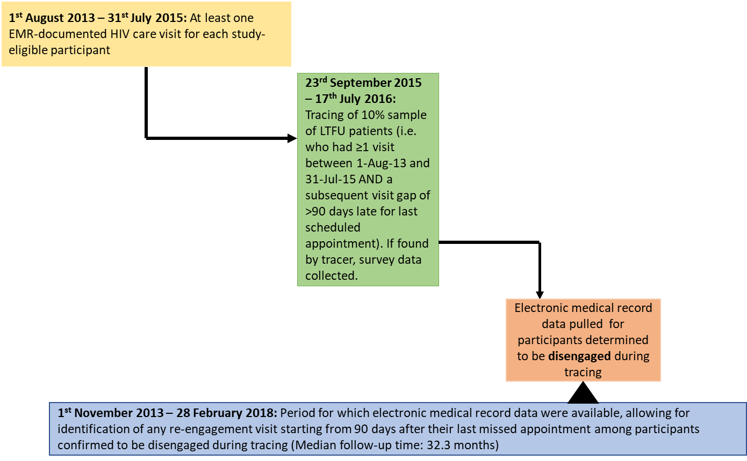

Supplemental Figure 2. Literature-informed social ecological conceptual framework of potential predictors of disengaged patient incident return to HIV care analyzed in study
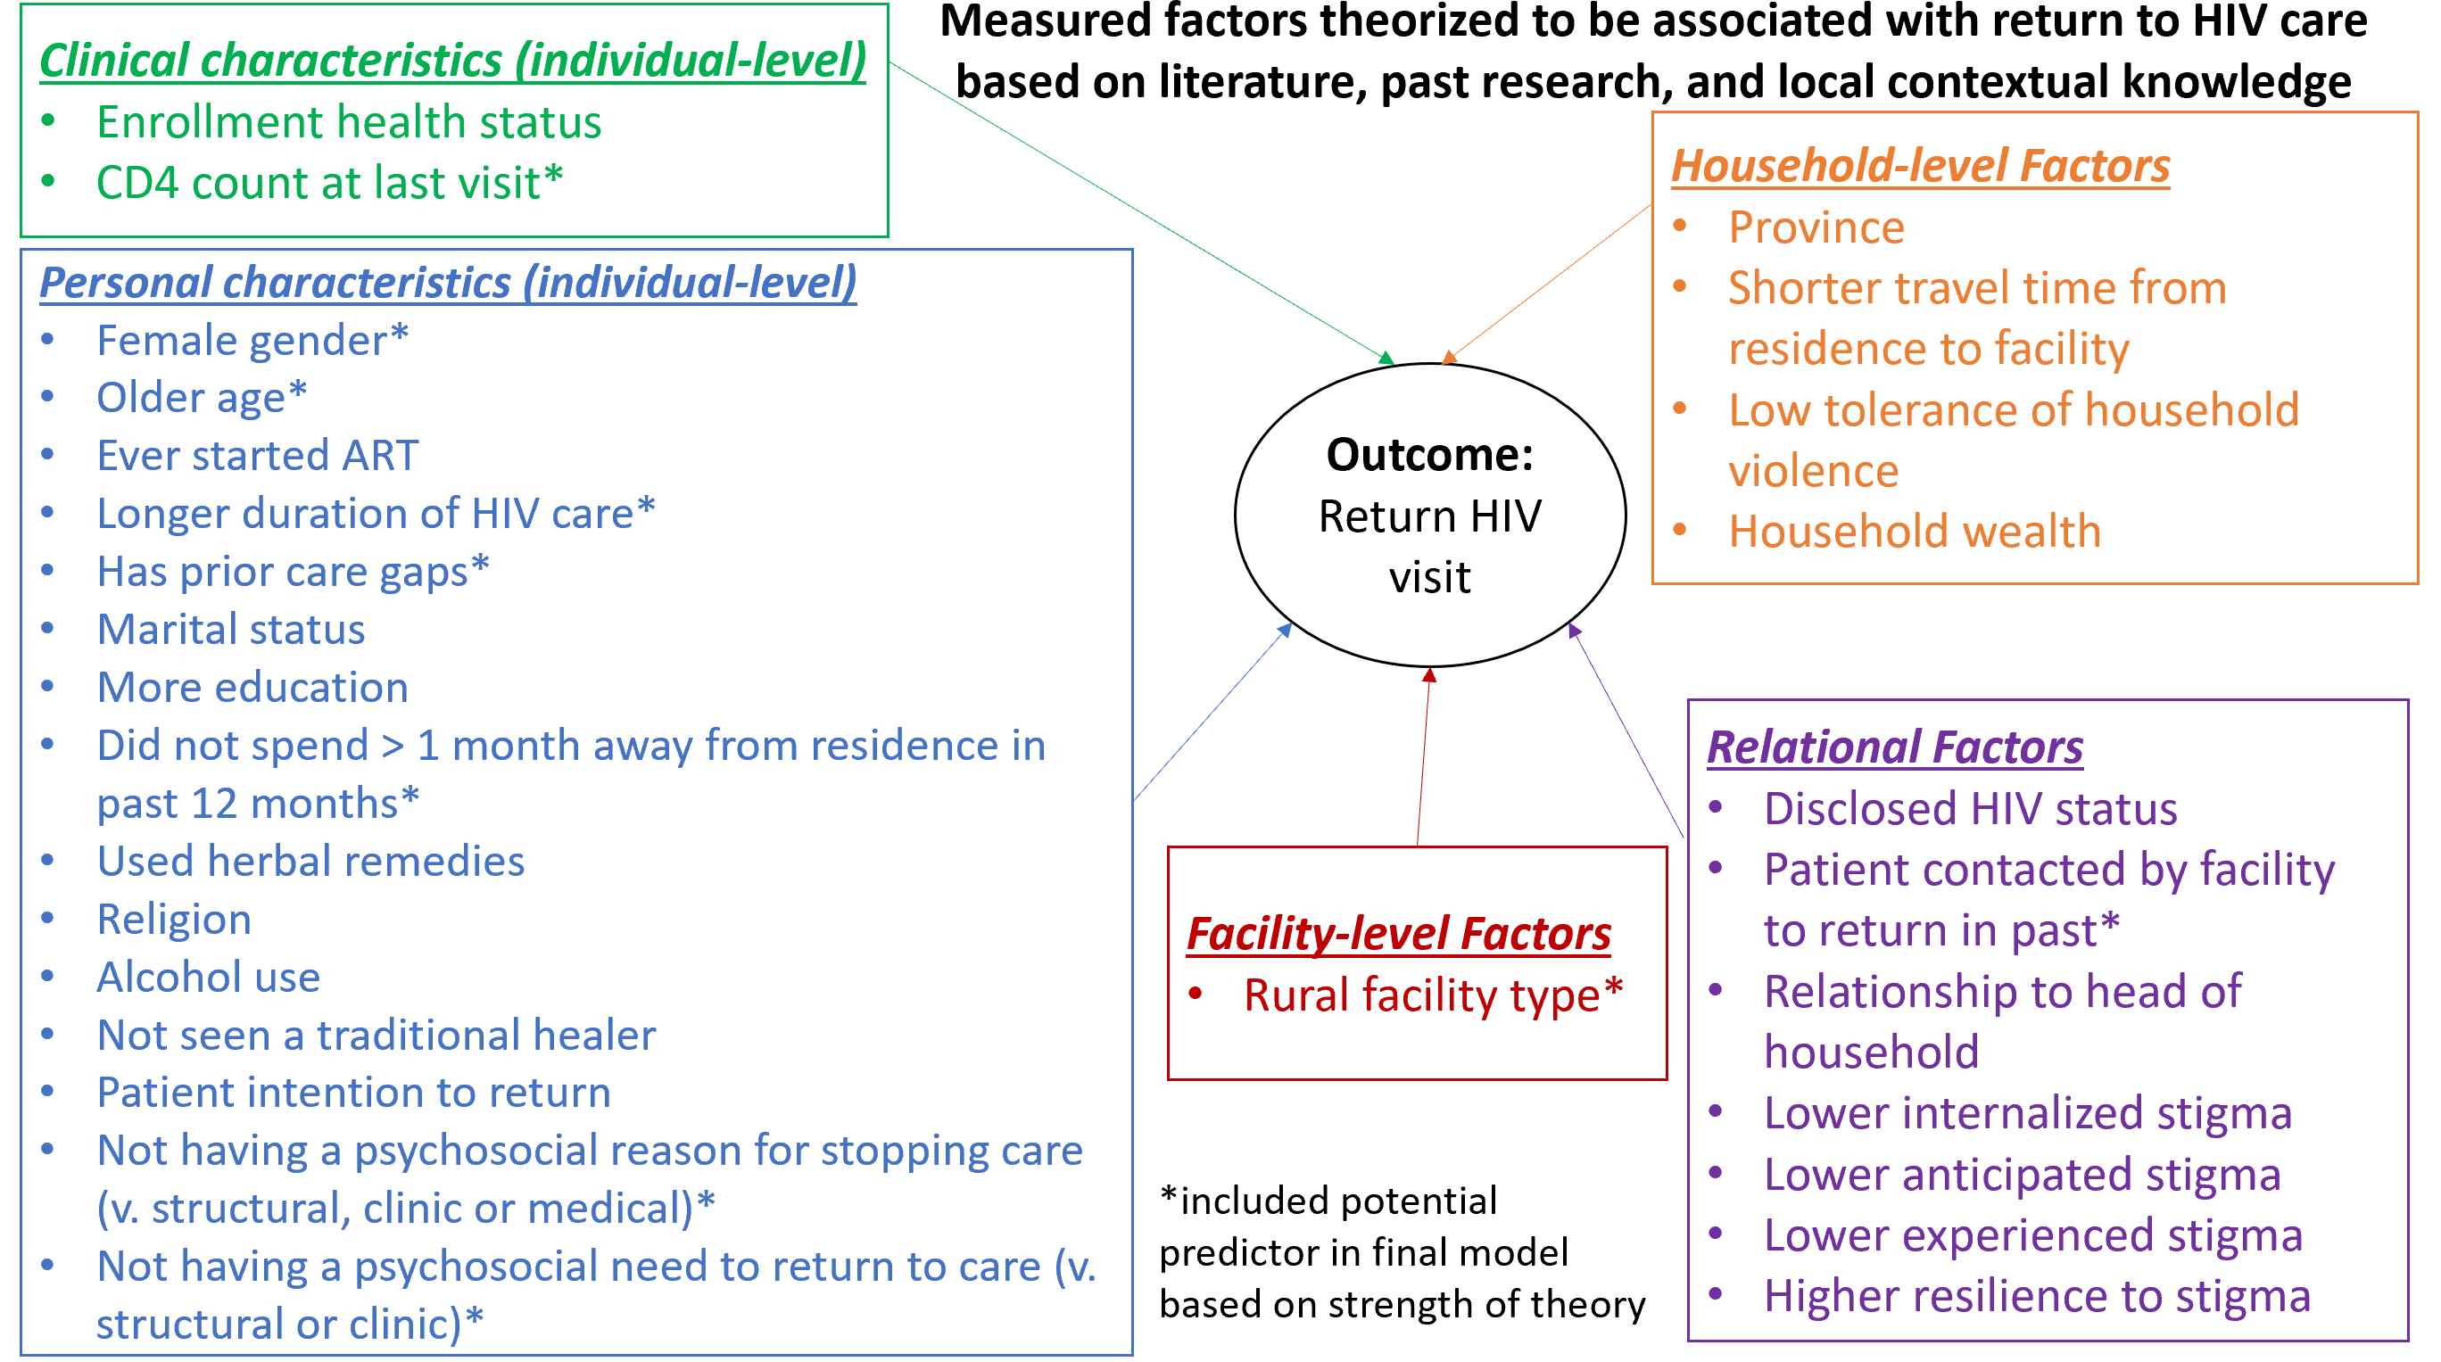
Supplemental Figure 3. Study sample flow diagram

Supplemental Table 1. Demographic comparison at time of LTFU of in-person traced LTFU patients determined to be disengaged or in-care
 | Disengaged |  | In-care |  | P-value*
 | Total: n=556 |  | Total: n=646
 | n | % | n | %
Gender |  |  |  |  | <0.01
Female | 324 | 58.3 | 444 | 68.7
Male | 232 | 41.7 | 202 | 31.3
Age (years) |  |  |  |  | 0.33
18-24 | 83 | 15.0 | 92 | 14.3
25-34 | 234 | 42.2 | 249 | 38.6
35-44 | 175 | 31.6 | 212 | 32.9
45+ | 62 | 11.2 | 92 | 14.3
Marital Status |  |  |  |  | 0.04
Single, Never Married | 115 | 20.7 | 98 | 15.2
Married | 314 | 56.5 | 399 | 61.8
Separated, Divorced, Widowed | 127 | 22.8 | 149 | 23.1
Education
No formal education | 40 | 7.2 | 55 | 8.5 | 0.37
Primary | 247 | 44.4 | 255 | 39.5
Secondary | 218 | 39.2 | 273 | 42.3
Tertiary | 51 | 9.2 | 62 | 9.6
Province |  |  |  |  | <0.01
Lusaka | 237 | 42.6 | 197 | 30.5
Eastern | 108 | 19.4 | 133 | 20.6
Southern | 118 | 21.2 | 178 | 27.6
Western | 93 | 16.7 | 138 | 21.4
Last CD4 count (cells/µmol) prior to loss |  |  |  |  | <0.01
<350 | 155 | 35.6 | 216 | 44.6
351-500 | 100 | 23.0 | 113 | 23.4
>500 | 180 | 41.4 | 155 | 32.0
Ever started ART prior to loss |  |  |  |  | <0.01
No | 309 | 55.6 | 94 | 14.6
Yes | 247 | 44.4 | 552 | 85.5
Facility Type |  |  |  |  | 0.13
Rural | 131 | 23.6 | 152 | 23.5
Urban | 301 | 54.1 | 319 | 49.4
Hospital | 124 | 22.3 | 175 | 27.1
Wald chi-square test

Supplemental Table 2. Multivariable Cox proportional hazards regression of predictors of return by 1-year post-disengagement
 | Return by 1 year (n=189), Statistical significance-driven adjustment^
Predictors of return | Hazard Ratio | 95% CI |  | p-value
Male sex v. Female | 1.54 | 0.74 | 3.19 | 0.25
Age at disengagement (years) |  |  |  | <0.01
18-24 | 1.00
25-34 | 1.45 | 0.47 | 4.48
35-44 | 2.17 | 0.69 | 6.88
45+ | 7.43 | 2.25 | 24.51
Education |  |  |  | <0.01
No formal education | 1.00
Primary | 5.94 | 0.75 | 47.31
Secondary | 1.59 | 0.17 | 14.45
Tertiary | 0.37 | 0.02 | 6.80
Did not spend >1 month away from usual residence in past year v. Did | 1.93 | 0.87 | 4.29 | 0.11
Used herbal remedies in past 6 months v. Did not | 8.88 | 2.25 | 35.00 | <0.01
Patient reported reasons for disengagement
Any structural reason for stopping care v. no structural | 2.31 | 1.02 | 5.22 | 0.05
Any psychosocial reason for stopping care v. no psychosocial | 0.24 | 0.10 | 0.59 | <0.01
Any clinic reason for stopping care v. no clinic | 0.21 | 0.08 | 0.56 | <0.01
^adjusted for: (theory-driven): sex, age, (univariate statistical significance <0.05 driven): education, mobility, herbal remedy use, having structural, psychosocial or clinical reasons for disengagement

