Table S1. Multiple logistic regression analyses testing associations between self-reported ART adherence and undetectable viral load*
 |  | Odds ratio | Lower CI | Higher CI | p-value
Baseline  (n=650) | Self-reported adherence | 1.457 | 1.024 | 2.075 | 0.037
Follow-up  (n=598) | Self-reported adherence | 1.447 | 1.009 | 2.074 | 0.045

* Regressions control for age, gender, rural versus urban location, informal housing, mode of infection, orphan status and
self-reported health.
CI - confidence interval

Table S2: Frequencies and bivariate tests by mode of infection and gender
Variables | Mode of infection |  | p -value | Gender |  | p -value
 | Vertical (769)  (n, %) | Horizontal (203)  (n, %) |  | Female (539)  (n, %) | Male (440)  (n, %)
Age  Above 15-19  Below 10-14 | 202 (26.3)  567 (73.7) | 156 (76.8)  47 (23.2) | 0.000 | 232 (43)  307 (57) | 130 (29.5)  310 (70.5) | 0.000
Gender  Female  Male | 390 (50.7)  379 (49.3) | 144 (70.9)  59 (29.1) | 0.000 | -- | -- | --
Location  Rural  Urban | 194 (25.3)  574 (74.7) | 65 (32.2)  137 (67.8) | 0.050 | 150 (27.9)  388 (72.1) | 111 (25.3)  328 (74.7) | 0.383
Socio-economic status  Informal housing  Formal housing | 134 (17.4)  634 (82.6) | 46 (22.7)  157 (77.3) | 0.104 | 108 (20)  431 (80) | 75 (17.1)  364 (82.9) | 0.249
Mode of transmission  Vertical  Horizontal | -- | -- | -- | 390 (73)  144 (27) | 379 (86.5)  59 (13.5) | 0.000
Time on Treatment  More than a year  Less than a year | 696 (90.5)  73 (9.5) | 106 (52.2)  97 (47.8) | 0.000 | 422 (52.2)  117 (21.7) | 386 (87.7)  54 (12.3) | 0.000
Bullied at baseline  Bullied  Not bullied | 451 (58.6)  318 (41.4) | 122 (60.1)  81 (39.9) | 0.749 | 323 (59.9)  216 (40.1) | 257 (58.4)  183 (41.6) | 0.648
Adherence at baseline  Adherent  Non-adherent | 532 (69.2)  237 (30.8) | 111 (54.7)  92 (45.3) | 0.000 | 330 (61.2)  209 (38.8) | 314 (71.4)  126 (28.6) | 0.001
Adherence at follow up  Adherent  Non-adherent | 517 (67.2)  252 (32.8) | 113 (55.7)  90 (44.3) | 0.003 | 350 (64.9)  189 (35.1) | 257 (58.4)  183 (41.6) | 0.648
Psychological distress at follow up (mean, SD) | 1.5 (2.6) | 2.3 (3.6) | 0.006 | 1.9 (3.0) | 1.4 (2.6) | 0.004
*** p<0.001; ** p<0.01; * p<0.05

Figure S1: Results of mediation analysis (PROCESS model 4; n=969)

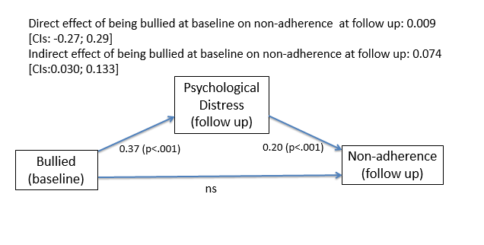

Figure S2: Interaction plot for the bullied x age interaction predicting psychological distress

Gradient of slope for Younger (10-14): -0,038 Gradient of slope for Older (15-19): 0,843
t-value of slope for Younger: -0,129 t-value of slope for Older: 2,191
p-value of slope for Younger: 0,898 p-value of slope for Older: 0,029

Figure S3: Interaction plot for the psychological distress x parental monitoring interaction predicting non-adherence

