Supplemental Digital Content

Supplemental Figure 1. Study enrollment schema

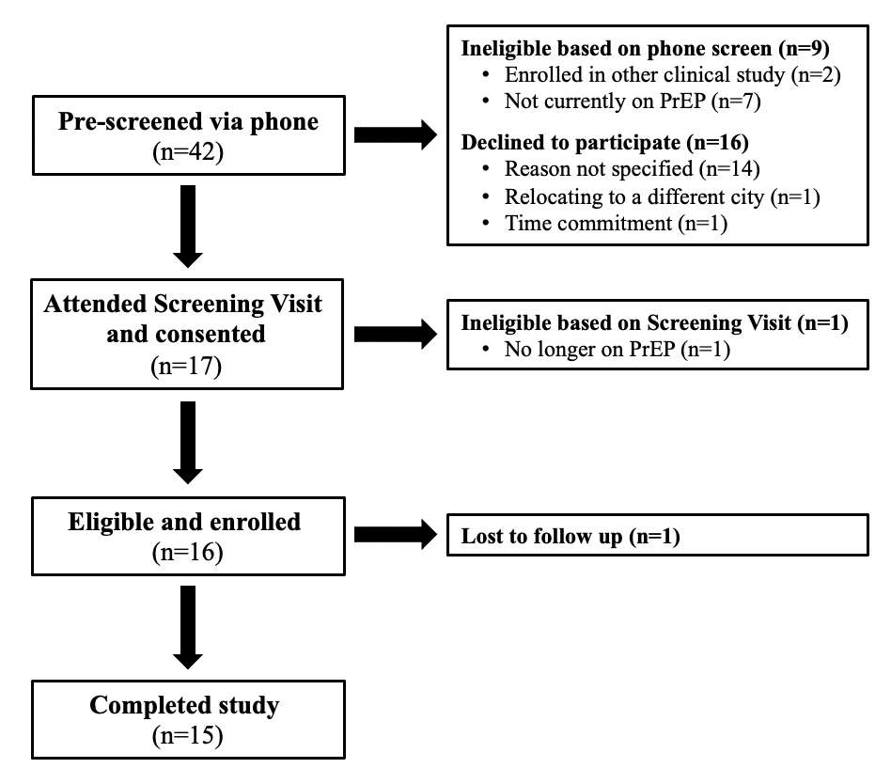

Supplemental Table 1. DPS-recorded ingestion events versus pill counts, by month over study period

 | Month 1 | Month 2 | Month 3 | Total
Total DPS-recorded ingestion events | 411 | 368 | 320 | 1,099
Reader-detected ingestion events | 337 | 323 | 262 | 922
Manually-reported ingestion events | 74 | 45 | 58 | 177
Total expected ingestion events from pill counts | 402 | 421 | 369 | 1,192
% of total expected ingestions recorded by DPS | 100%* | 87% | 87% | 92%

* In Month 1, the total number of DPS-recorded ingestion events (411) exceeded the total expected ingestion events from pill counts (402), as a result of one participant returning nine more unused pills than anticipated at the end of the month. These nine unused pills corresponded with nine manually-reported ingestions by one participant during Month 1.

Supplemental Figure 2. Schematic of reconciliation surrounding manually-reported digital pill system ingestion events

