Supplementary Appendix

Supplementary Appendix 1: Protocol on the management of infusion reactions
Supplementary Appendix 2: Participants experiencing more than one IRR
Supplementary Appendix 3: Proportions of infusions triggering an infusion related reaction by the cumulative number of received infusions.
Supplementary Appendix 4: Numbers of infusions triggering an infusion reaction by the cumulative number of received infusions and clinical phenotype.

Supplementary Appendix 1: Protocol on the management of infusion reactions
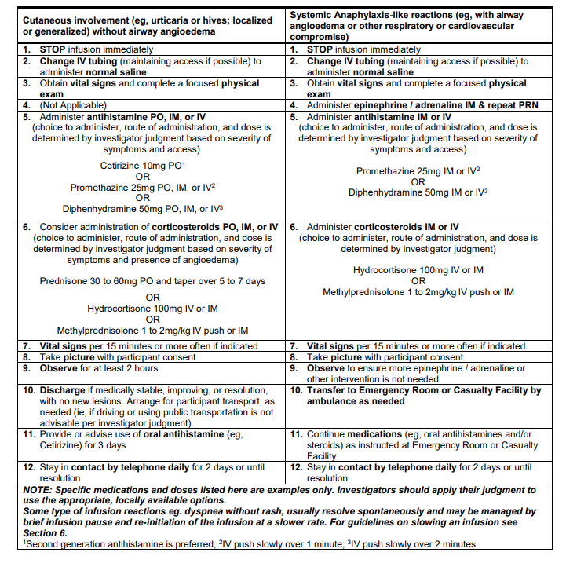

Supplementary Appendix 2: Participants experiencing more than one IRR
ID | Trial | Infusion No. | Age | Sex at birth | Race | Severity Grade | Treatment Assignment | IRR Category | Discontinuation status
1 | HVTN 703 / HPTN 081 | 1 | 24 | Female | Black | Moderate | VRC01 10mg/kg | Other (nasal congestion, throat irritation and difficulty swallowing) | No change
1 | HVTN 703 / HPTN 081 | 3 | 24 | Female | Black | Moderate | VRC01 10mg/kg | Other (flushing and pruritus) | No change
1 | HVTN 703 / HPTN 081 | 6 | 25 | Female | Black | Mild | VRC01 10mg/kg | Urticarial reaction | Permanently Discontinued
2 | HVTN 703 / HPTN 081 | 3 | 28 | Female | Black | Moderate | VRC01 10mg/kg | Dyspnea without rash | No change
2 | HVTN 703 / HPTN 081 | 9 | 29 | Female | Black | Moderate | VRC01 10mg/kg | Urticarial reaction | Permanently Discontinued
3 | HVTN 703 / HPTN 081 | 4 | 26 | Female | Black | Moderate | VRC01 10mg/kg | Other reaction (Infusion related reaction) | No change
3 | HVTN 703 / HPTN 081 | 5 | 26 | Female | Black | Moderate | VRC01 10mg/kg | Dyspnea without rash | Permanently Discontinued
4 | HVTN 703 / HPTN 081 | 2 | 33 | Female | Black | Mild | VRC01 10mg/kg | Other (chest discomfort) | No change
4 | HVTN 703 / HPTN 081 | 3 | 33 | Female | Black | Mild | VRC01 10mg/kg | Dyspnea without rash | No change
5 | HVTN 703 / HPTN 081 | 3 | 22 | Female | Black | Mild | VRC01 10mg/kg | Dyspnea without rash | No change
5 | HVTN 703 / HPTN 081 | 5 | 23 | Female | Black | Mild | VRC01 10mg/kg | Dyspnea without rash | No change
5 | HVTN 703 / HPTN 081 | 10 | 24 | Female | Black | Mild | VRC01 10mg/kg | Other (flushing, throat irritation and continous coughing) | No change
6 | HVTN 703 / HPTN 081 | 5 | 34 | Female | Black | Mild | VRC01 10mg/kg | Other reaction (Infusion related reaction) | No change
6 | HVTN 703 / HPTN 081 | 7 | 34 | Female | Black | Moderate | VRC01 10mg/kg | Other reaction (Infusion related reaction) | No change
7 | HVTN 703 / HPTN 081 | 3 | 23 | Female | Black | Mild | VRC01 10mg/kg | Other reaction (Infusion related reaction) | No change
7 | HVTN 703 / HPTN 081 | 4 | 23 | Female | Black | Mild | VRC01 10mg/kg | Other reaction (Infusion related reaction) | No change
8 | HVTN 703 / HPTN 081 | 4 | 33 | Female | Black | Moderate | VRC01 10mg/kg | Other (itchy maculo-papular rash) | No change
8 | HVTN 703 / HPTN 081 | 5 | 33 | Female | Black | Mild | VRC01 10mg/kg | Urticarial reaction | Permanently Discontinued
9 | HVTN 703 / HPTN 081 | 1 | 22 | Female | Black | Mild | VRC01 10mg/kg | Other (generalised pruritus) | No change
9 | HVTN 703 / HPTN 081 | 2 | 22 | Female | Black | Severe | VRC01 10mg/kg | Urticarial reaction | Permanently Discontinued
10 | HVTN 703 / HPTN 081 | 1 | 21 | Female | Black | Mild | VRC01 30mg/kg | Other reaction (Infusion related reaction) | No change
10 | HVTN 703 / HPTN 081 | 10 | 23 | Female | Black | Mild | VRC01 30mg/kg | Dyspnea without rash | Not Applicable
11 | HVTN 703 / HPTN 081 | 1 | 24 | Female | Black | Mild | VRC01 30mg/kg | Other (erythematous rash on trunk) | No change
11 | HVTN 703 / HPTN 081 | 2 | 24 | Female | Black | Moderate | VRC01 30mg/kg | Urticarial reaction | Permanently Discontinued
12 | HVTN 703 / HPTN 081 | 3 | 22 | Female | Black | Mild | VRC01 30mg/kg | Other (flushing, chest discomfort and headache) | No change
12 | HVTN 703 / HPTN 081 | 10 | 23 | Female | Black | Mild | VRC01 30mg/kg | Other (flushing) | Not Applicable
13 | HVTN 703 / HPTN 081 | 1 | 25 | Female | Black | Moderate | VRC01 30mg/kg | Other (generalised pruritus) | No change
13 | HVTN 703 / HPTN 081 | 3 | 26 | Female | Black | Moderate | VRC01 30mg/kg | Other (generalised pruritus) | No change
13 | HVTN 703 / HPTN 081 | 4 | 26 | Female | Black | Moderate | VRC01 30mg/kg | Other (generalised pruritus) | No change
13 | HVTN 703 / HPTN 081 | 5 | 26 | Female | Black | Mild | VRC01 30mg/kg | Other (generalised pruritus) | No change
14 | HVTN 704 / HPTN 085 | 1 | 24 | Female | Multi-racial | Mild | VRC01 30mg/kg | Urticarial reaction* | No change
14 | HVTN 704 / HPTN 085 | 2 | 24 | Female | Multi-racial | Mild | VRC01 30mg/kg | Urticarial reaction | Permanently Discontinued
15 | HVTN 703 / HPTN 081 | 4 | 35 | Female | Black | Mild | Placebo | Other reaction (Infusion related reaction) | No change
15 | HVTN 703 / HPTN 081 | 5 | 35 | Female | Black | Mild | Placebo | Other (flushing, dizziness and continous coughing) | No change
16 | HVTN 704 / HPTN 085 | 2 | 24 | Male | Other | Mild | Placebo | Other reaction (Pruritus) | No change
16 | HVTN 704 / HPTN 085 | 3 | 24 | Male | Other | Mild | Placebo | Other reaction (Pruritus) | Permanently Discontinued
*Participant did not disclose that they had an urticarial reaction that developed at home post-infusion hence infusion was not discontinued then.
Supplementary Appendix 3: Proportions of infusions triggering an infusion related reaction by the cumulative number of received infusions.

 | HVTN 704/HPTN 085 |  |  | HVTN 703/HPTN 081
Received  Infusion # | Number of Infusions | Number of IRRs | Proportion (%) (95% CI) | Number of Infusions | Number of IRRs | Proportion (%) (95% CI)
1 | 2699 | 18 | 0.67 (0.42, 1.05) | 1924 | 34 | 1.77 (1.27, 2.46)
2 | 2596 | 4 | 0.15 (0.06, 0.40) | 1851 | 19 | 1.03 (0.66, 1.60)
3 | 2533 | 12 | 0.47 (0.27, 0.83) | 1800 | 14 | 0.78 (0.46, 1.30)
4 | 2463 | 4 | 0.16 (0.06, 0.42) | 1754 | 12 | 0.68 (0.39, 1.19)
5 | 2413 | 3 | 0.12 (0.04, 0.36) | 1705 | 12 | 0.70 (0.40, 1.23)
6 | 2365 | 2 | 0.08 (0.02, 0.31) | 1660 | 6 | 0.36 (0.17, 0.79)
7 | 2314 | 0 | 0.00 (0.00, 0.17) | 1617 | 4 | 0.25 (0.10, 0.63)
8 | 2256 | 3 | 0.13 (0.05, 0.39) | 1568 | 3 | 0.19 (0.07, 0.56)
9 | 2179 | 1 | 0.05 (0.01, 0.26) | 1521 | 5 | 0.33 (0.14, 0.77)
10 | 2043 | 2 | 0.10 (0.03, 0.36) | 1407 | 2 | 0.14 (0.04, 0.52)

Supplementary Appendix 4: Numbers of infusions triggering an infusion reaction by the cumulative number of received infusions and clinical phenotype.
 | HVTN 704/HPTN 085 |  |  |  |  | HVTN 703/HPTN 081
 |  | Number (%) of infusion related reactions |  |  |  |  | Number (%) of infusion related reactions
Received Infusion # | Number of Infusions | Urticaria | Dyspnea with Rash | Dyspnea without Rash | Other | Number of Infusions | Urticaria | Dyspnea with Rash | Dyspnea without Rash | Other
1 | 2699 | 13 (0.48) | 0 (0.00) | 0 (0.00) | 5 (0.19) | 1924 | 24 (1.25) | 0 (0.00) | 0 (0.00) | 10 (0.52)
2 | 2596 | 2 (0.08) | 1 (0.04) | 0 (0.00) | 1 (0.04) | 1851 | 7 (0.38) | 0 (0.00) | 5 (0.27) | 7 (0.38)
3 | 2533 | 5 (0.20) | 2 (0.08) | 1 (0.04) | 4 (0.16) | 1800 | 0 (0.00) | 1 (0.06) | 3 (0.17) | 10 (0.56)
4 | 2463 | 3 (0.12) | 0 (0.00) | 1 (0.04) | 0 (0.00) | 1754 | 3 (0.17) | 0 (0.00) | 1 (0.06) | 8 (0.46)
5 | 2413 | 0 (0.00) | 0 (0.00) | 0 (0.00) | 3 (0.12) | 1705 | 3 (0.18) | 0 (0.00) | 5 (0.29) | 4 (0.23)
6 | 2365 | 1 (0.04) | 0 (0.00) | 1 (0.04) | 0 (0.00) | 1660 | 1 (0.06) | 0 (0.00) | 2 (0.12) | 3 (0.18)
7 | 2314 | 0 (0.00) | 0 (0.00) | 0 (0.00) | 0 (0.00) | 1617 | 1 (0.06) | 0 (0.00) | 2 (0.12) | 1 (0.06)
8 | 2256 | 1 (0.04) | 0 (0.00) | 1 (0.04) | 1 (0.04) | 1568 | 1 (0.06) | 0 (0.00) | 0 (0.00) | 2 (0.13)
9 | 2179 | 1 (0.05) | 0 (0.00) | 0 (0.00) | 0 (0.00) | 1521 | 1 (0.07) | 0 (0.00) | 2 (0.13) | 2 (0.13)
10 | 2043 | 0 (0.00) | 0 (0.00) | 0 (0.00) | 2 (0.10) | 1407 | 0 (0.00) | 0 (0.00) | 0 (0.00) | 2 (0.14)

