Supplemental Digital Content 2, PrOTECT AL Initial Survey
ProTECT AL (Pre-exposure prophylaxis Optimization Through Enhanced Continuum Tracking) Survey I

Start of Block: ProTECT AL Survey

Q1 Thank you for participating in this survey. All organizational information will be reported in aggregate form and de-identified. The purpose of collecting this data is to inform our interviews with community partners, understand current gaps in our PrEP care continuum, and to inform the development of future data management systems.

Q2 Last Name
________________________________________________________________

Q3 First Name
________________________________________________________________

Q4 Email
________________________________________________________________

Q5 Telephone (work) 000-000-0000
________________________________________________________________

Q6 What is the name of your organization?
________________________________________________________________

Q7 What is your primary profession/discipline (Select ONE)
- Advanced practice nurse (1)
- Registered nurse (2)
- Licensed practical nurse (3)
- Pharmacist (4)
- Physician (5)
- Physician Assistant (6)
- Epidemiologist (7)
- Health education specialist (8)
- Health Educator (9)
- Mental/ behavioral health professional (10)
- Social Worker (11)
- Community health worker (12)
- Other (13)

Display This Question:
If What is your primary profession/discipline (Select ONE) = Other

Q8 If other, please specify
________________________________________________________________

Q9 Your primary functional role (Select ONE)
- Administrator (director, coordinator, manager, supervisor) (1)
- Agency Board Member (2)
- Clinician / Care Provider (3)
- Case Manager (16)
- Client / Patient Counselor (4)
- Client / Patient Educator (5)
- Clinical / Medical Assistant (6)
- Disease Intervention Specialist / Partner Services Provider (7)
- Outreach Staff (8)
- Peer Support Provider (9)
- Researcher / Evaluator (10)
- Student / Graduate student (11)
- Teacher / Faculty (12)
- Trainer / TA Provider (13)
- Other (14)

Display This Question:
If Your primary functional role (Select ONE) = Other

Q10 If other, please specify
________________________________________________________________

Q11 Your principal employment setting (Select ONE)
- Academic Health Center (1)
- College/University (2)
- Community-Based Service Organization (CBO) (3)
- Community Health Center (e.g., Federally Qualified Health Center) (4)
- Other Non-profit Health Center (5)
- Community / Retail Pharmacy (6)
- Correctional Facility (7)
- HMO / Managed Care Organization (8)
- Hospital / Hospital-affiliated Clinic (9)
- Military Health System / Veterans Health Admin facility (10)
- Private Practice (Solo / Group) (11)
- Rural Health Center (12)
- State / Local Health Department (13)
- Tribal / Indian Health Service facility (14)
- Non-Health Setting (15)
- Other (16)

Display This Question:
If Your principal employment setting (Select ONE) = Other

Q12 If other, please specify
________________________________________________________________

Q13 Primary programmatic focus of your work (Select ONE)
- HIV / AIDS (1)
- STD (2)
- Reproductive Health / Family Planning (3)
- Recovery Support / Trauma / Domestic Violence (4)
- Labor and Delivery (5)
- Adolescent and / or Pediatric Health (6)
- Emergency Medicine / Urgent Care (7)
- Primary Care (e.g. General / Family Medicine) (8)
- Mental / Behavioral Health (9)
- Other Infectious Diseases (10)
- Other (11)

Display This Question:
If Primary programmatic focus of your work (Select ONE) = Other

Q14 If other, please specify
________________________________________________________________

Q15 Does your organization provide PrEP Education?
- Yes (1)
- No (2)

Q16 Does your organization provide PrEP referrals? (Referral services may range from maintaining a resource list of PrEP providers in the area to offering a "warm hand-off" to a local PrEP provider)
- Yes (1)
- No (2)

Q17 Does your organization link (i.e. ensure patients obtain a first visit) to PrEP care?
- Yes (1)
- No (2)

Q18 Does your organization screen (i.e. provide counseling to clients and conduct initial assessment of clients' risk for HIV) for PrEP?
- Yes (1)
- No (2)

Display This Question:
If Does your organization screen (i.e. provide counseling to clients and conduct initial assessment... = Yes

Q19 In the past year, how many patients were screened for PrEP services by your organization? (provide total number)
________________________________________________________________

Display This Question:
If Does your organization screen (i.e. provide counseling to clients and conduct initial assessment... = Yes

Q20 In the last year, what was the sex at birth for those screened for PrEP? (total number)
_______ Male (1)
_______ Female (2)

Display This Question:
If Does your organization screen (i.e. provide counseling to clients and conduct initial assessment... = Yes

Q21 In the last year, what was the gender identity of those screened for PrEP? (total number)
_______ Male (1)
_______ Female (2)
_______ Transgender (M to F) (3)
_______ Transgender (F to M) (4)
_______ Non-binary (5)
_______ Other (please specify in text box) (6)

Display This Question:
If Does your organization screen (i.e. provide counseling to clients and conduct initial assessment... = Yes

Q22 In the last year, what were the ages of those screened for PrEP? (total number)
_______ 15 to 18 years old (1)
_______ 19 to 24 years old (2)
_______ 25 to 44 years old (3)
_______ 45 to 64 years old (4)
_______ >65 years old (5)

Display This Question:
If Does your organization screen (i.e. provide counseling to clients and conduct initial assessment... = Yes

Q23 In the last year, what was the race of those screened for PrEP? (total number)
_______ Caucasian (1)
_______ African American (2)
_______ American Indian (3)
_______ Pacific Islander (4)
_______ Asian (5)
_______ Other (9)
_______ Did Not Disclose (10)

Display This Question:
If Does your organization screen (i.e. provide counseling to clients and conduct initial assessment... = Yes

Q24 In the last year, what was the ethnicity of those screened for PrEP? (total number)
_______ Hispanic (1)
_______ Non-Hispanic (2)
_______ Did Not Disclose (3)

Display This Question:
If Does your organization screen (i.e. provide counseling to clients and conduct initial assessment... = Yes

Q25 In the last year, what was the number of insured / uninsured of those screened for PrEP? (total number)
_______ Insured (1)
_______ Uninsured (2)

Display This Question:
If Does your organization screen (i.e. provide counseling to clients and conduct initial assessment... = Yes

Q26 Does your organization screen patients for PrEP living outside of Alabama?
- Yes (1)
- No (2)

Display This Question:
If Does your organization screen patients for PrEP living outside of Alabama? = Yes

Q27 If yes, how many? (total number)
________________________________________________________________

Display This Question:
If Does your organization screen (i.e. provide counseling to clients and conduct initial assessment... = Yes

Q28 In order to define geographic "hot spots" and areas where it maybe difficult to receive screening for PrEP, please indicate below the areas where your organization's patients who receive PrEP screening live.

Q73
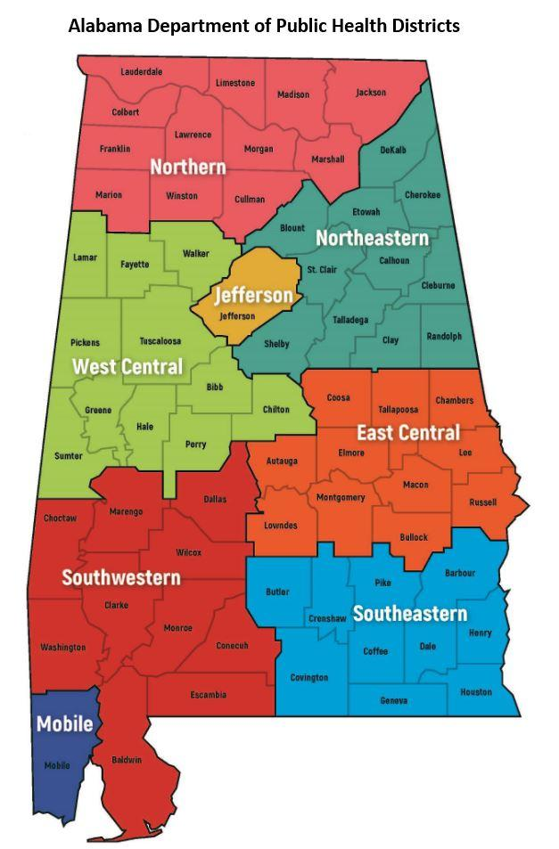

Display This Question:
If Does your organization screen (i.e. provide counseling to clients and conduct initial assessment... = Yes

Q29 ADPH Public Health Districts (PHD) where patients screened for PrEP live (Select all the apply)
- Northern (1)
- East Central (2)
- West Central (3)
- Jefferson (4)
- Northeastern (5)
- Southeastern (6)
- Southwestern (7)
- Mobile (8)

Display This Question:
If ADPH Public Health Districts (PHD) where patients screened for PrEP live (Select all the apply) = Northern

Q30 Counties in Northern PHD where your PrEP screened patients live (Select all the apply)
- Colbert (1)
- Cullman (2)
- Franklin (3)
- Jackson (4)
- Lauderdale (5)
- Lawrence (6)
- Limestone (7)
- Madison (8)
- Marion (9)
- Marshall (10)
- Morgan (11)
- Winston (12)

Display This Question:
If ADPH Public Health Districts (PHD) where patients screened for PrEP live (Select all the apply) = East Central

Q31 Counties in East Central PHD where your PrEP screened patients live (Select all the apply)
- Autauga (1)
- Bullock (2)
- Chambers (3)
- Coosa (4)
- Elmore (5)
- Lee (6)
- Lowndes (7)
- Macon (8)
- Montgomery (9)
- Russell (10)
- Tallapoosa (11)

Display This Question:
If ADPH Public Health Districts (PHD) where patients screened for PrEP live (Select all the apply) = Northeastern

Q32 Counties in Northeastern PHD where your PrEP screened patients live (Select all the apply)
- Blount (1)
- Calhoun (2)
- Cherokee (3)
- Clay (4)
- Dekalb (5)
- Cleburne (6)
- Etowah (7)
- Shelby (8)
- St. Clair (9)

Display This Question:
If ADPH Public Health Districts (PHD) where patients screened for PrEP live (Select all the apply) = Southeastern

Q33 Counties in Southeastern PHD where your PrEP screened patients live (Select all the apply)
- Barbour (1)
- Butler (2)
- Coffee (3)
- Dale (4)
- Geneva (5)
- Henry (6)
- Houston (7)
- Pike (8)

Display This Question:
If ADPH Public Health Districts (PHD) where patients screened for PrEP live (Select all the apply) = Southwestern

Q34 Counties in Southwestern PHD where your PrEP screened patients live (Select all the apply)
- Baldwin (1)
- Choctaw (2)
- Clarke (3)
- Conecuh (4)
- Dallas (5)
- Escambia (6)
- Marengo (7)
- Monroe (8)
- Washington (9)
- Wilcox (10)

Display This Question:
If ADPH Public Health Districts (PHD) where patients screened for PrEP live (Select all the apply) = West Central

Q35 Counties in West Central PHD where your PrEP screened patients live (Select all the apply)
- Bibb (1)
- Chilton (2)
- Fayette (3)
- Greene (4)
- Hale (5)
- Lamar (6)
- Perry (7)
- Pickens (8)
- Sumter (9)
- Tuscaloosa (10)
- Walker (11)

Q36 Does your organization provide PrEP care?
- Yes (1)
- No (2)

Display This Question:
If Does your organization provide PrEP care? = Yes

Q37 What date did you start providing services mm/yyyy
________________________________________________________________

Display This Question:
If Does your organization provide PrEP care? = Yes

Q38 How many patients have received PrEP services from your organization in the past year? (total number)
________________________________________________________________

Display This Question:
If Does your organization provide PrEP care? = Yes

Q39 Sex at birth of current PrEP patients (total number)
_______ Male (1)
_______ Female (2)

Display This Question:
If Does your organization provide PrEP care? = Yes

Q40 Gender identity of current PrEP patients (total number)
_______ Male (1)
_______ Female (2)
_______ Transgender (M to F) (3)
_______ Transgender (F to M) (4)
_______ Non-binary (5)

Display This Question:
If Does your organization provide PrEP care? = Yes

Q41 Ages of current PrEP patients (total number)
_______ 15 to 18 years old (1)
_______ 19 to 24 years old (2)
_______ 25 to 44 years old (3)
_______ 45 to 64 years old (4)
_______ >65 years old (5)

Display This Question:
If Does your organization provide PrEP care? = Yes

Q42 Race of current PrEP patients (total number)
_______ Caucasian (1)
_______ African American (2)
_______ American Indian (3)
_______ Pacific Islander (4)
_______ Asian (5)
_______ Other (7)
_______ Did Not Disclose (8)

Display This Question:
If Does your organization provide PrEP care? = Yes

Q43 Ethnicity of current PrEP patients (total number)
_______ Hispanic (1)
_______ Non-Hispanic (2)
_______ Did Not Disclose (3)

Display This Question:
If Does your organization provide PrEP care? = Yes

Q44 How many of your current PrEP patients are insured/uninsured? (provide total number)
_______ Insured (1)
_______ Uninsured (2)

Display This Question:
If Does your organization provide PrEP care? = Yes

Q45 In order to define geographic areas where it maybe difficult to receive PrEP care, please indicate below the areas where patients who receive PrEP care live.

Display This Question:
If Does your organization provide PrEP care? = Yes

Q46 Does your organization have current PrEP patients living outside of Alabama?
- Yes (1)
- No (2)

Display This Question:
If Does your organization have current PrEP patients living outside of Alabama? = Yes

Q47 If yes, how many?
________________________________________________________________

Display This Question:
If Does your organization provide PrEP care? = Yes

Q48 In what Public Health Districts do your current PrEP patients? (Select all the apply)
- Northern (1)
- East Central (2)
- West Central (3)
- Jefferson (4)
- Northeastern (5)
- Southeastern (6)
- Southwestern (7)
- Mobile (8)

Display This Question:
If In what Public Health Districts do your current PrEP patients? (Select all the apply) = Southwestern

Q49 In what counties in Southwestern PHD do your current PrEP patients? (Select all the apply)
- Baldwin (1)
- Choctaw (2)
- Clarke (3)
- Conecuh (4)
- Dallas (5)
- Escambia (6)
- Marengo (7)
- Monroe (8)
- Washington (9)
- Wilcox (10)

Display This Question:
If In what Public Health Districts do your current PrEP patients? (Select all the apply) = Northern

Q50 In what counties in Northern PHD do your current PrEP patients live? (Select all the apply)
- Colbert (1)
- Cullman (2)
- Franklin (3)
- Jackson (4)
- Lauderdale (5)
- Lawrence (6)
- Limestone (7)
- Madison (8)
- Marion (9)
- Marshall (10)
- Morgan (11)
- Winston (12)

Display This Question:
If In what Public Health Districts do your current PrEP patients? (Select all the apply) = East Central

Q51 In what counties in East Central PHD do your current PrEP patients live? (Select all the apply)
- Autauga (1)
- Bullock (2)
- Chambers (3)
- Coosa (4)
- Elmore (5)
- Lee (6)
- Lowndes (7)
- Macon (8)
- Montgomery (9)
- Russell (10)
- Tallapoosa (11)

Display This Question:
If In what Public Health Districts do your current PrEP patients? (Select all the apply) = West Central

Q52 In what counties in West Central PHD do your current PrEP patients live? (Select all the apply)
- Bibb (1)
- Chilton (2)
- Fayette (3)
- Greene (4)
- Hale (5)
- Lamar (6)
- Perry (7)
- Pickens (8)
- Sumter (9)
- Tuscaloosa (10)
- Walker (11)

Display This Question:
If In what Public Health Districts do your current PrEP patients? (Select all the apply) = Northeastern

Q53 In what counties in Northeastern PHD do your current PrEP patients live? (Select all the apply)
- Bount (1)
- Calhoun (2)
- Cherokee (3)
- clay (4)
- Dekalb (5)
- Cleburne (6)
- Etowah (7)
- Shelby (8)
- St. Clair (9)

Display This Question:
If In what Public Health Districts do your current PrEP patients? (Select all the apply) = Southeastern

Q54 In what counties in Southeastern PHD do your current PrEP patients live? (Select all the apply)
- Barbour (1)
- Butler (2)
- Coffee (3)
- Dale (4)
- Geneva (5)
- Henry (6)
- Houston (7)
- Pike (8)

Display This Question:
If Does your organization provide PrEP care? = Yes

Q55 Please provide additional patient information below (total numbers)
_______ Number of Active Patients (1)
_______ Number of Inactive Patients (2)
_______ Number of HIV Positive Patients (3)
_______ Number of PrEP Orientation Visits Pending (4)
_______ Number of No Show PrEP Orientation Visits (5)
_______ Number of Incomplete PrEP Orientation Visits (6)
_______ Number of Informed PrEP Orientation Visit No Shows (7)

End of Block: ProTECT AL Survey

