Supplemental Tables and Figures

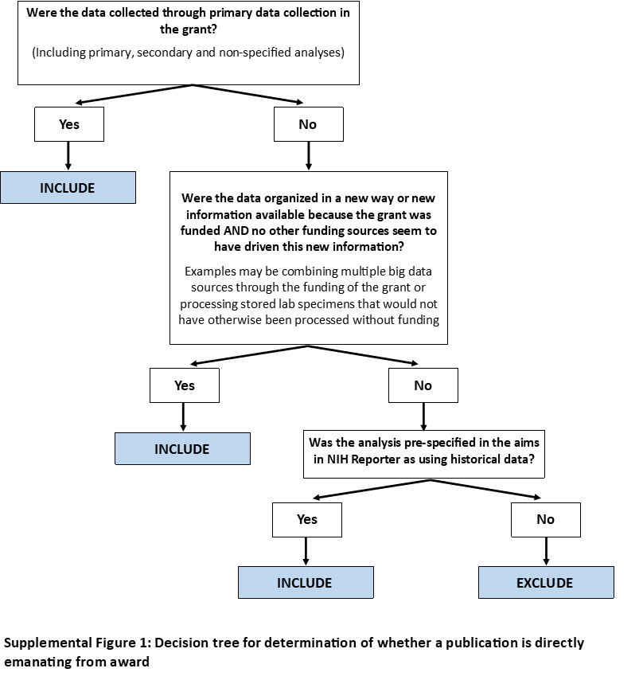

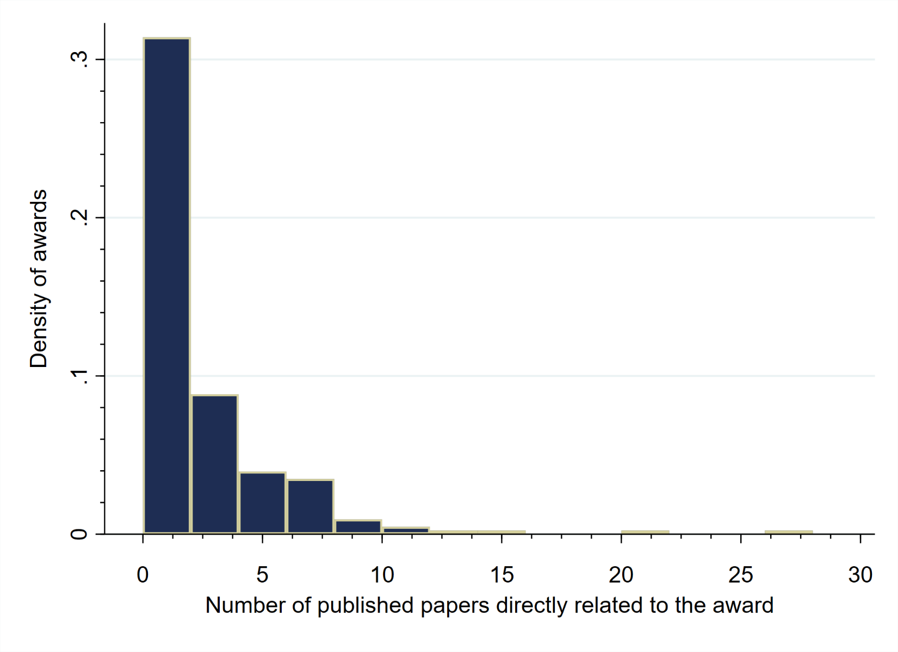
Supplemental Figure 2: Histogram of papers directly related to grant published by award

Supplemental Figure 3: Productivity related to awards by grant mechanism. The left y-axis and bars graph the proportion of original research papers published and linked to the award in NIH Reporter from time of funding to Jan 1, 2021 that were directly emanating from the award by grant mechanism. The right y-axis and line graph plots the mean average papers published by grant mechanism that were directly related to the award.

Supplemental Table 1: Average number of publications related to award by grant characteristics (n=215)
Characteristic | Mean [SD] | Median [IQR] | Range [Min, Max]
Overall | 2.0 [3.3] | 1 [0-2] | 0-28
Grant mechanism
R01 | 2.5 [4.3] | 1 [0-3] | 0-28
R34 | 1.2 [1.5] | 1 [0-2] | 0-5
R21 | 1.9 [2.1] | 1 [1-3] | 0-9
K-award | 2.5 [2.9] | 1 [1-4] | 0-10
U-award | 1.2 [2.7] | 0 [0-1] | 0-12
Other | 1.3 [1.6] | 1 [0-1.5] | 0-6
Year of award
2013 | 2.8 [3.4] | 2 [0-4] | 0-14
2014 | 2.6 [3.8] | 1 [0-4] | 0-20
2015 | 2.4 [4.5] | 1 [0-3] | 0-28
2016 | 1.4 [2.4] | 0 [0-2] | 0-10
2017 | 1.5 [2.3] | 0.5 [0-2] | 0-9
2018* | 0 [0] | 0 [0-0] | 0
Region of data collection
United States | 2.1 [2.9] | 1 [0-3] | 0-14
Global (Non-United States) | 1.9 [3.7] | 1 [0-2] | 0-28
* Only 3 grants published through March 2018

Supplemental Table 2: Multivariable Cox Model Assessing Predictors of Time-to-Publication for an Implementation Research & HIV-Related National Institutes of Health (NIH) Award Funded 2013-2017
Grant Characteristic | Time-to-First Publication* |  | Time-to-Any Publication**
 | HR [95% CI] | p-value | HR [95% CI] | p-value
Year of Award
2013 | REF |  | REF
2014 | 0.89 [0.49-1.62] | 0.70 | 1.46 [0.98-2.19] | 0.07
2015 | 1.13 [0.62-2.08] | 0.69 | 2.69 [1.73-4.17] | <0.01
2016 | 0.94 [0.50-1.76] | 0.85 | 3.00 [1.82-4.93] | <0.01
2017 | 1.57 [0.83-2.99] | 0.17 | 6.37 [3.75-10.81] | <0.01
Research conducted in US vs Globally
Global (non-US) | REF |  | REF
United States | 0.96 [0.67-1.39] | 0.85 | 1.04 [0.79-1.37] | 0.77
Award mechanism
R01 | REF |  | REF
R34 | 1.07 [0.57-2.04] | 0.83 | 0.94 [0.58-1.52] | 0.81
R21 | 1.73 [1.07-2.82] | 0.03 | 1.43 [1.03-1.97] | 0.03
K-award | 2.21 [1.26-3.87] | 0.01 | 1.69 [1.19-2.41] | <0.01
Other*** | 0.69 [0.39-1.22] | 0.20 | 0.70 [0.45-1.10] | 0.12
Note: Grants funded from Jan-Mar 2018 were excluded given the small sample size (n=3)
*212 Grants were represented in the time-to-first publication model
**In total there were 212 grants, which together published a total of 431 papers which are presented in the Time-to-Any Publication model accounting for clustering by award
***Other includes U awards, R00s, R03s and all other mechanisms
aHR=adjusted Hazards Ratio; CI=Confidence Interval

