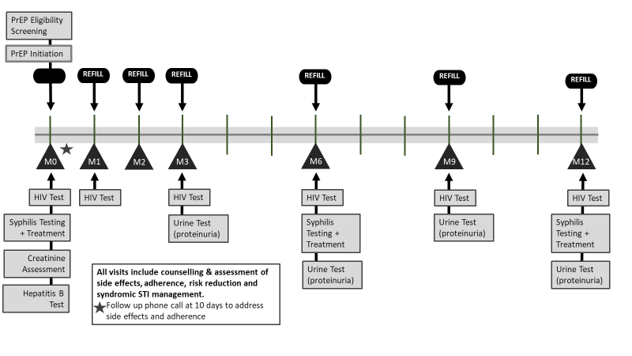
Note: HBsAg test for Hepatitis B; TPHA and VDRL tests for syphilis; and syndromic screening of other STIs
Figure 1: Initiation and follow up on timeline with minimum service package from initiation (M0) to month 12 (M12)

Table 1: Self-reported adherence questions and categorization for analysis
 | Question | Possible responses | Score assigned for analysis
 |  |  | Categorization | Score
1 | In the last 30 days, on how many days did you miss at least one dose of any of your PrEP medication? | __ __ [0–30] | ≥6 | 0
 |  |  | 2-5 | 1
 |  |  | 0-1 | 2
2 | In the past 30 days, how good a job did you do at taking your PrEP medication in the way you were supposed to? | Very poor | Poor | 0
 |  | Poor
 |  | Fair | Moderate | 1
 |  | Good
 |  | Very good | Good | 2
 |  | Excellent
3 | In the last 30 days, how often did you take your PrEP medication in the way you were supposed to? | Never | Rarely/Never | 0
 |  | Rarely
 |  | Sometimes | Sometimes | 1
 |  | Usually
 |  | Almost always | Always | 2
 |  | Always
 | Overall adherence grade | Average of Σ (scores) at previous visits
 |  |  | Poor | 0-2
 |  |  | Moderate | 3-5
 |  |  | Good | 6

Figure 2: Performance across the PrEP cascade

PrEP stock-out
Same day initiation reinstated
Event driven PrEP introduced, New sites
Figure 3: Number of new PrEP enrollments by month over time

Figure 4: PrEP continuation among FSW and MSM over 12 months follow up period

Table 2: Characteristics of clients who continued PrEP at M3, M6 and M12 of follow up
Characteristics | M3 follow up visit  # eligible # (% of eligible) |  | M6 follow up visit  # eligible # (% of eligible) |  | M12 follow up visit  # eligible # (% of eligible)
Age group
21-29yrs | 479 | 173 (36%) | 289 | 72 (25%) | 137 | 24 (18%)
30-49yrs | 278 | 103 (37%) | 186 | 58 (31%) | 73 | 14 (19%)
50yrs+ | 20 | 12 (60%) | 14 | 7 (50%) | 10 | 4 (40%)
Key population group
MSM | 453 | 202 (45%) | 288 | 99 (34%) | 142 | 38 (27%)
FSW | 330 | 87 (26%) | 203 | 38 (19%) | 79 | 4 (5%)
City
Yaoundé | 299 | 80 (27%) | 160 | 28 (18%) | 107 | 12 (11%)
Douala | 484 | 209 (43%) | 331 | 109 (33%) | 114 | 30 (26%)
Bertoua | 0 | 0 (-) | 0 | 0 (-) | 0 | 0 (-)
Bafoussam | 0 | 0 (-) | 0 | 0 (-) | 0 | 0 (-)
Experienced moderate-severe undesired effects during previous visit
No | 84 | 51 (60%) | 43 | 33 (77%) | 3 | 3 (100)
Yes | 34 | 27 (79%) | 9 | 6 (67%) | 1 | 1 (100)
Missed ≥6 doses during previous visit*
No | 266 | 221 (83%) | 158 | 110 (70%) | 35 | 29 (83%)
Yes | 24 | 15 (63%) | 17 | 10 (59%) | 10 | 6 (60%)
No assessment | 493 | 53 (11%) | 316 | 17 (5%) | 176 | 7 (4%)
How well client did in taking PrEP medication in the way they were supposed to*
Good | 126 | 111 (88%) | 85 | 66 (78%) | 29 | 25 (86%)
Moderate | 156 | 121 (78%) | 87 | 55 (63%) | 20 | 13 (65%)
Poor | 24 | 9 (38%) | 12 | 6 (50%) | 0 | 0 (-)
No assessment | 477 | 48 (10%) | 307 | 10 (3%) | 172 | 4 (2%)
Frequency of taking PrEP medication in the way they were supposed to*
Always | 161 | 139 (86%) | 107 | 76 (71%) | 30 | 24 (80%)
Sometimes | 121 | 92 (76%) | 73 | 51 (70%) | 19 | 14 (74%)
Rarely/never | 20 | 9 (45%) | 5 | 2 (40%) | 0 | 0 (-)
No assessment | 481 | 49 (11%) | 306 | 8 (3%) | 172 | 4 (2%)
* Self-reported based on 30 days before the previous visit, # (% of eligible) is the number of clients who continued PrEP & % of those eligible for follow up.

Table 3: Cox regression of factors associated with PrEP discontinuation
Model covariates | Unadjusted |  | Adjusted
 | HR (95% CI) | P-value | aHR (95% CI) | P-value
Key population group |  | <0.001 |  | < 0.001*
FSW | 1.7 (1.5-1.9) |  | 1.5 (1.2-1.9)
MSM | 1 |  | 1
City |  | <0.001 |  | <0.001*
Yaoundé | 1.7 (1.4-1.9) |  | 1.5 (1.2-1.8)
Bafoussam/Bertoua | 1.9 (1.5-2.4) |  | 3.1 (2.2-4.5)
Douala | 1 |  | 1
Age group |  | 0.349 |  | 0.511
21-29yrs | 1.3 (0.8-2.0) |  | 1.3 (0.8-2.3)
30-49yrs | 1.3 (0.9-2.1) |  | 1.2 (0.7-2.1)
50yrs+ | 1 |  | 1
Self-reported moderate/severe drug side effects |  | <0.001 |  | 0.245
No | 2.0 (1.6-2.5) |  | 1.2 (0.9-1.5)
Yes | 1 |  | 1
Completed adherence assessment at least once |  | <0.001 |  | a*
No | 8.2 (6.9-9.6)
Yes | 1
Average adherence level |  | <0.001 |  | <0.001*
Good | 0.4 (0.3-0.6) |  | 0.4 (0.3-0.6)
Moderate | 0.4 (0.3-0.5) |  | 0.3 (0.3-0.4)
Poor | 1 |  | 1
* Significant when adjusted for all other covariates in the multivariable model
a* Excluded as a degree of freedom reduced because of constant or linearly dependent covariates making model invalid

Figure 5: Doctor and beneficiary linked reasons for official interruption of PrEP

