**Supplemental Digital Content 1**

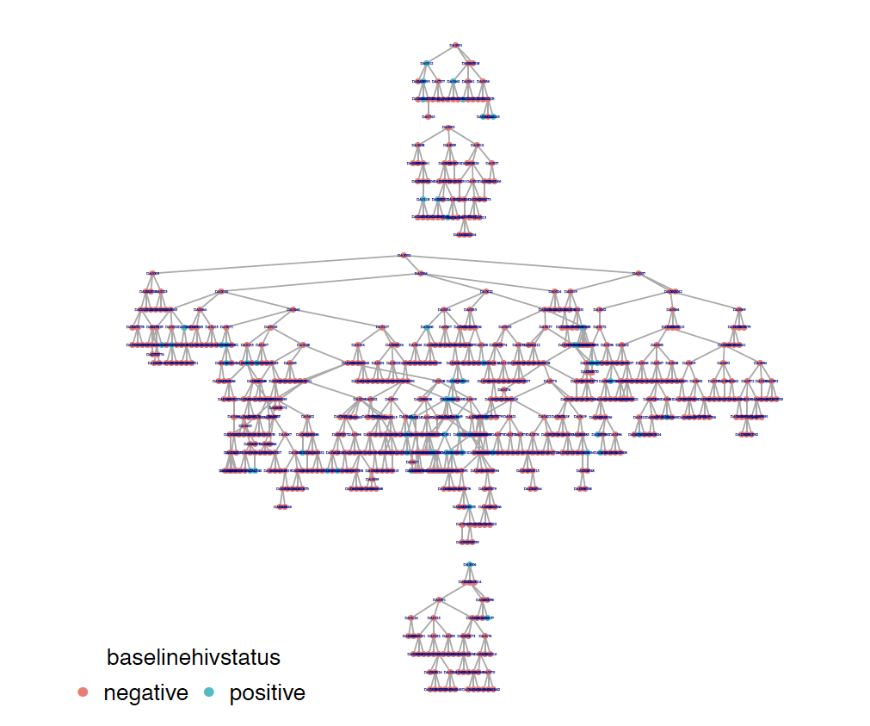

Figure Recruitment tree depicting the peer referral chains for each seed.