Appendix for
The Impact of COVID-19 Response on the HIV Epidemic in Men Who Have Sex with Men in San Francisco County: The Importance of Rapid Return to Normalcy
By Citina Liang, Sze-chuan Suen, Anthony Nguyen, Corrina Moucheraud, Ling Hsu, Ian W. Holloway, Edwin D. Charlebois, Wayne T. Steward

Table of Contents
Model Description and Parameters 2
Model description 2
Initial population 2
Birth dynamics 4
Transition probabilities 4
COVID-related Effects 9
COVID-19 deaths 9
Reduction in HIV Testing 10
Reduction in PrEP Initiation, Retention, and Adherence 10
Reduction in VLS 10
Reduction in Sexual Partnerships 11
Inputs for Sensitivity Analysis 11
Model Calibration and Validation 11
Supplemental Results 18
References 23

Model Description and Parameters

Model description
We adapted a microsimulation model that simulates the yearly HIV progression among MSM in Los Angeles County (LAC).^{1,2} The model consists of 14 health states that capture HIV status, PrEP use, diagnosis status, and viral suppression (VLS) status of each individual, each year. The model also tracks each individual’s race/ethnicity and age. Individuals move between health states according to transition probabilities associated with their health status in the current year. By repeatedly simulating these transitions each year, we can capture the trends of HIV progression in a cohort over a given period. To do so accurately, we need to correctly capture the characteristics of the MSM population in San Francisco County (SFC) and their transition likelihoods between health and treatment states. To start the simulation in 2012, we need an initial population that reflects the demographic and HIV prevalence trends in SFC.

Initial population
The initial simulated population consists of 58,204 MSM individuals based on an estimation reported by Hughes et al.,³ where the authors incorporate in- and out-migration by HIV status and race/ethnicity of MSM in SFC. We compared this number with another published paper by Grey et al. that predicted SFC’s number of MSM by using the American Community Survey, 2009-2013, with an estimation of 66,586.⁴ Hughes et al. also recognized the lower number reported in the Grey et al. paper and explained the difference as due to consideration of migration patterns.
We used the National HIV/AIDS Strategy (NHAS)⁵ data from 2012 to 2019 to initialize our simulation. We used data specific to SFC wherever possible in general, and proportions at the state or national level when county level data is not available. The initial population was stratified by age and race/ethnicity according to NHAS data.
SFC has a higher HIV prevalence and a different demographic composition for PLWH compared to the state and the nation. In 2012, according to SFC Epidemiology Report 2012, table 1.1, the proportion of diagnosed PLWH African American, Hispanic, White, and Others was 18%, 33%, 44%, and 5%, respectively, in California, compared to 13%, 17%, and 62% and 8% in SFC.⁶
This model is based on the structure of a previously published microsimulation model of LAC.^{1,2} However, this previous work only included three race/ethnicity groups: Non-Hispanic White, Non-Hispanic Black, and Hispanic. However, there is an important proportion of MSM not within these groups in SFC, which we now include in the simulation as an additional race/ethnicity group (generally termed “Other” as it captures multiple race groups). From the SFC Epidemiology Report 2014, figure 2.1, we see that although the proportion of diagnosed PLWH belonging to the Other race group is small, the new diagnoses in the Other race group is higher than that of African Americans from 2012 to 2014. The annual number of newly diagnosed MSM in the Other race group was 15.6% in 2012, as African American, Hispanic, White are 10.2%, 24.1%, 50.1%.⁷ We therefore also include the Other race group for all existing transition probabilities in the model.
We additionally modified the prior simulation to reflect the age distribution of the SFC population as much as possible in 2012, we used piecewise linear functions for each age bucket instead of uniform distributions, which allows a smoother age distribution. To further stratify the HIV positive MSM in SFC by HIV stage and VLS status, we follow the same process as Drabo et al. to formulate a quadratic programming optimization problem to identify a joint distribution applied in the model.^{1,2}
Appendix Table 1: Initial Population
Parameter | Value | Source
SFC MSM count | 58,204 | ³
Proportion of diagnosed PLWH | 0.93 | ⁷
Proportion of PLWH | 0.23 | Calculated
Susceptible MSM by race
Black | 0.056 | ⁷
Hispanic | 0.226 | ⁷
White | 0.571 | ⁷
Others | 0.147 | ⁷
PLWH by race
Black | 0.09 | ⁸
Hispanic | 0.19 | ⁸
White | 0.63 | ⁸
Others | 0.09 | ⁸
Susceptible/undiagnosed MSM by age
15-19 | 0.04 | ⁵
20-29 | 0.20 | ⁵
30-39 | 0.23 | ⁵
40-49 | 0.18 | ⁵
50-59 | 0.15 | ⁵
60-69 | 0.11 | ⁵
70-79 | 0.06 | ⁵
80-100 | 0.03 | ⁵
Diagnosed PLWH by age
15-19 | 0.001 | ⁸
20-29 | 0.042 | ⁸
30-39 | 0.130 | ⁸
40-49 | 0.337 | ⁸
50-59 | 0.327 | ⁸
60-69 | 0.139 | ⁸
70-79 | 0.023 | ⁸
80-100 | 0.002 | ⁸
Diagnosed PLWH by HIV stage
CD4 cell count $≥$500 | 0.32 | ^{1,2}
201 $≤$CD4 cell count $≤$ 499 | 0.36 | ^{1,2}
CD4 cell count $≤$ 200 | 0.32 | ^{1,2}
Undiagnosed PLWH by HIV stage
CD4 cell count $≥$500 | 0.413 | ^{1,2}
201 $≤$CD4 cell count $≤$ 499 | 0.503 | ^{1,2}
CD4 cell count $≤$ 200 | 0.084 | ^{1,2}

Birth dynamics
We followed the same model structure as the microsimulation model built for LAC.^{1,2} At the beginning of every year, MSM who turned age 15 would enter the model proportional to previous year population, and the group of new entrants is stratified by race. Details can be found in Appendix Table 2. In the model, people could die naturally or by AIDS, and under COVID-19 scenarios, we also incorporated COVID-19 death. The race/ethnicity composition of new entrants is shown in Appendix Table 2.

Appendix Table 2: Birth dynamics
Parameter | Value | Source
Number of new entrants as a proportion of simulated population in the prior year | 0.009 | Calculated
New entrants by race
Black | 0.054 | ⁵
Hispanic | 0.154 | ⁵
White | 0.415 | ⁵
Others | 0.377 | ⁵

Transition probabilities
SFC is unique in that it has a high level of PrEP coverage (81.1% in 2019), surpassing values from the California state average (25.1% in 2019) and national average (22.5% in 2019).⁹ SFC PrEP prescription trends have also showed steeper increases over time compared to the state and nation.¹⁰ We therefore used the AIDSVu’s PrEP data, where it collects raw data of PrEP prescriptions at the county level, and we used their best estimate of the number of male PrEP users in SFC for our simulation.¹⁰ To compare our model outcomes with AIDSVu’s data, we defined PrEP users in our model to be consistent with the AIDSVu definition, as those who had at least one day of prescribed TDF/FTC for PrEP in a calendar year.
We updated the PrEP adherence level and the probability of discontinuing PrEP uptake to SFC levels according to a published study, Liu et al., which followed PrEP users for roughly one year.¹¹ We followed the categories in Liu et al. and defined a person taking less than 4 doses a week as low adherence and no visit as non-detectable adherence. On average, 86.7% of the PrEP users in SFC are highly adherent, 10.8% have low adherence, and 2.4% have undetectable adherence levels. 17% of PrEP users were not retained in the study and were considered PrEP dropouts.¹¹

Appendix Figure 1: Calculation for PrEP Uptake
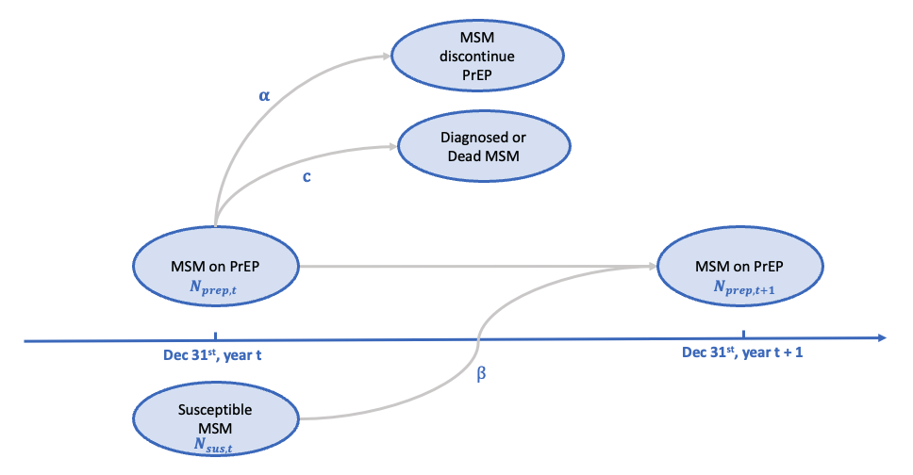
Variable definitions:
$N_{sus,t}:$number of susceptible MSM at the end of year t$$N_{prep,t}:number of PrEP users at the end of year t \\ α:probability that a MSM discontinues PrEP \\ β:probability that a susceptible MSM starts PrEP \\ c:pobability that a MSM become diagnosed or die$$
To assess the probability of PrEP uptake by year, we used AIDSVu’s best estimates of the number of male PrEP users from 2012 to 2018 in SFC as an estimate of the number of PrEP users.¹¹ We conceptualized the process of inflow and outflow into PrEP programs as shown in Appendix Figure 1, which can be represented in the equation below, which we used to solve for the probability of PrEP uptake.
$$N_{prep,t}- αN_{prep,t} -cN_{prep,t} + {βN}_{sus,t}=N_{prep,t+1}$$
Because the number of PrEP diagnoses and deaths were generally small, we assumed c to be equal to 0. From AIDSVu, we had the $N_{prep,t}$ and $N_{prep,t+1}$ values from 2012-2018. $α$ is known from the literature discussed above, and we are then solving for $β$. However, we did not find an empirical estimate of $N_{sus,t}$, and we therefore took this value from our simulation.
To estimate the likelihood an individual becomes infected, the model accounts for demographic-specific partnership frequencies through an equation published in our prior work.^{1,2} The equation considers the number of sexual partners an individual may have by race/ethnicity and age, the partnership preference of an individual (their own and their partners’), and the PrEP and ART adherence level of the total population. The likelihood of getting infected is calibrated by changing the race/ethnicity force of infection or age force of infection.
We followed the LAC model, using the national death probabilities by age derived from CDC data. The risk of death for people living with AIDS and not on treatment is four times of those people living with AIDS and on treatment.^{1,2} To reflect local SFC trends and account for the difference in AIDS death by age, we also included calibration constants as multipliers for AIDS death in each age buckets 15-29, 30-49, 50-69, 70-100, The multipliers are 1.8, 2.5, 2.9, 2.5, respectively.
We also followed the LAC model to formulate a quadratic programming optimization subproblem where we used SFC specific demographic data to determine the probability of an undiagnosed individual becomes diagnosed by his HIV stage, race/ethnicity, and age.^{1,2} Details are shown in Appendix Table 3.

Appendix Table 3: Transition Probabilities
Parameter | Value | Source
PrEP use by PrEP adherence level
Non-detectable | 0.024 | ¹¹
Low | 0.108 | ¹¹
High | 0.867 | ¹¹
Relative risk of HIV infection by PrEP adherence level
Non-detectable | 1 | ^{1,2}
Low | 0.42 | ^{1,2}
High | 0.1 | ^{1,2}
Proportion of high ART adherence | 0.95 | ^{1,2}
PrEP uptake by year
2012 | 0.007 | Calculated and calibrated
2013 | 0.007 | Calculated and calibrated
2014 | 0.026 | Calculated and calibrated
2015 | 0.046 | Calculated and calibrated
2016 | 0.047 | Calculated and calibrated
2017 | 0.043 | Calculated and calibrated
2018 and after | 0.041 | Calculated and calibrated
PrEP discontinuation | 0.17 | ¹¹
HIV stage transition given on treatment
HIV Stage 1 -> Stage 2 | 0.04 | ^{1,2}
HIV Stage 2 -> Stage 3 | 0.01 | ^{1,2}
HIV stage transition given off treatment
HIV Stage 1 -> Stage 2 | 0.34 | ^{1,2}
HIV Stage 2 -> Stage 3 | 0.14 | ^{1,2}
Attaining viral suppression by race and age
Black by age* | [0.08, 0.08, 0.21, 0.07] | ^{1,2}
Hispanic by age* | [0.11, 0.11, 0.21, 0.08] | ^{1,2}
White by age* | [0.12, 0.12, 0.22, 0.08] | ^{1,2}
Others by age* | [0.12, 0.12, 0.22, 0.08] | Assumption
Becoming virally unsuppressed, by race
Black | 0.070 | ^{1,2}
Hispanic | 0.036 | ^{1,2}
White | 0.047 | ^{1,2}
Others | 0.047 | Assumption
Diagnosis of HIV infection by stage, race, and age
HIV stage 1
Black by age* | [0.552, 0.576, 0.254, 0.025] | Calculated
Hispanic by age* | [0.641, 0.699, 0.158, 0.013] | Calculated
White by age* | [0.480, 0.394, 0.033, 0.004] | Calculated
Others by age* | [0.774, 0.845, 0.543, 0.024] | Calculated
HIV stage 2
Black by age* | [0.548, 0.569, 0.220, 0.022] | Calculated
Hispanic by age* | [0.643, 0.699, 0.131, 0.010] | Calculated
White by age* | [0.380, 0.260, 0.030, 0.003] | Calculated
Others by age* | [0.798, 0.865, 0.537, 0.023] | Calculated
HIV stage 3
Black by age* | [0.575, 0.622, 0.506, 0.127] | Calculated
Hispanic by age* | [0.655, 0.728, 0.522, 0.050] | Calculated
White by age* | [0.797, 0.864, 0.456, 0.021] | Calculated
Others by age* | [0.635, 0.705, 0.579, 0.131] | Calculated
Relative risk of death for people living with AIDS (without ART/with ART) | 4 | Calibrated
*Age: 15-29, 30-49, 50-69, 70-100

We used age-specific probabilities of death for different disease/treatment groups (people aware of their AIDS status and on ART treatment, people aware of their AIDS status and not on ART treatment, people living with AIDS and unaware of their status, people living with HIV stage 1 or stage 2, and MSM that not living with HIV). Among these groups of people, we assumed that the total probability of death for people living with AIDS and on treatment, and people living with HIV stage 1 or stage 2, was the same as the likelihood of death for dying from other causes. We then calibrated the probability of death between treatment status for people living with AIDS to find the likelihood for untreated AIDS mortality. See Appendix Figure 2 for details.

Appendix Figure 2. Death Probabilities

We also updated the mixing matrix that captures the partnership preference between our four /ethnicity groups (Black, Hispanic, White, and Other) and seven age buckets. See Appendix Figure 3.

Appendix Figure 3: Partnership Mixing Matrix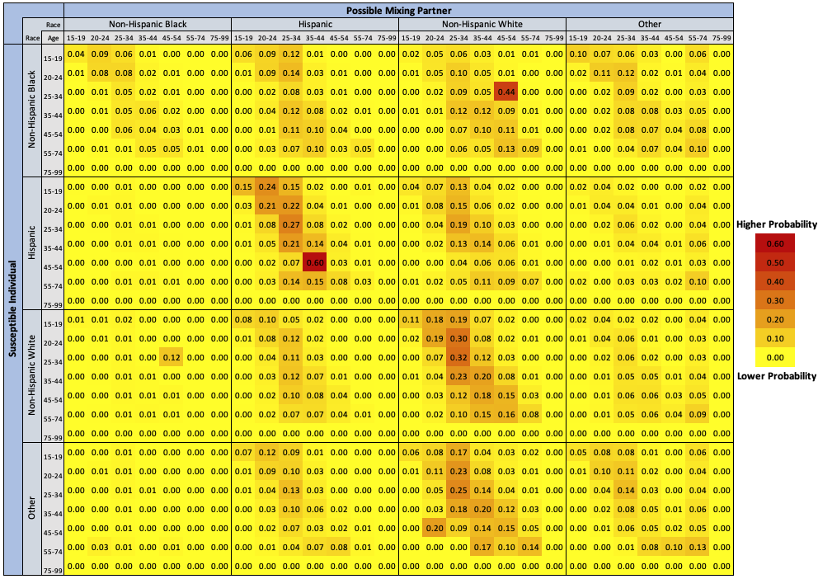

COVID-related Effects

COVID-19 affects the health of PLWH through possible COVID-19 death and disruptions in HIV care. In our model, the COVID-19 pandemic affects HIV disease progression in three principal aspects: HIV care initiation, HIV care continuum, and HIV transmission.

COVID-19 deaths
We used the values reported by the City and County of San Francisco on COVID-19 deaths to calculate the proportion of people in SFC who died from COVID-19 in 2020 and 2021.¹² As the 2022 COVID-19 data is incomplete for 2022 and onward, we assumed the COVID-19 mortality probability is the same as in 2021. Some studies have shown that HIV-positive patients have a higher risk of mortality than HIV-negative individuals.^{13,14} We therefore calculated the relative risk of COVID-19 death for HIV-positive individuals using the baseline risk of COVID-19 death and the relative risk of COVID-19 death for PLWH. Unfortunately, this relative risk was unavailable for SFC, so we used data from LAC’s HIV Surveillance Annual Report 2020to calculate it.¹⁴ The relative risk was calculated by dividing the likelihood of COVID-19 death among patients with COVID-19 and HIV coinfection over the likelihood of COVID-19 death among patients who only had COVID-19. In the simulation, people in the cohort risked COVID-19 death starting from 2020 until the year that all COVID-19-related effects end.

Reduction in HIV Testing
The 2020 SFC HIV Epidemiology Annual Report shows that the average number of monthly HIV testing in 2020 is 18% lower compared to 2019 at medical facilities and the average reduction is 44% at community sites during 2020. The testing rate at medical facilities did not recover to 2019’s average testing level until March 2021, and the HIV testing rate at community sites was persistently lower than 2019’s monthly average in the first quarter of 2021.¹⁵ Approximately 36% of health care institutes in SFC are community sites, and 64% are medical facilities.¹⁶ We therefore calculated a weighted average of HIV testing reduction using these values in SFC.

Reduction in PrEP Initiation, Retention, and Adherence
Other than HIV testing, there were also COVID-19-related disruptions on PrEP initiation, retention, and level of adherence. A study on 3,616 PrEP users in SFC shows that PrEP initiation decreased by 62.2% during shelter-in-place (SIP). The number rebounded after SIP but only reached 45.1% of pre-SIP levels.¹⁷ From the study data, which showed different initiation levels during SIP, we calculated the annual weighted average PrEP initiation probability by assuming that the PrEP initiation reduction was 45.1% for the ten non-SIP months and 62.2% for the two SIP months. The study concluded that PrEP discontinuation increased by 21% during SIP. The discontinuation probability dropped after SIP but gradually increased to a point in October that was higher than the SIP number. We therefore assumed 21% as the annual likelihood of PrEP discontinuation. The study also concluded that PrEP lapses increased by 79% during SIP, so we assumed lapses returned to normal levels post-SIP and calculated the weighted average as the annual reduction in high adherence to PrEP.

Reduction in VLS
COVID-19 also had a negative effect on the accessibility of antiretroviral treatment (ART), viral load lab test, and ART adherence,^{18–21} thus reducing the probability of MSM reaching VLS. Spinelli et al. analyzed a safety-net clinic in SFC and showed that the adjusted odds ratio of having unsuppressed viral loads post-COVID versus pre-COVID was 1.31. We used this result to calculate the reduction of achieving VLS during COVID-19 disruption periods using the definition of odds ratio.

Reduction in Sexual Partnerships
Some studies have shown there was a reduction in sexual partnerships or risky sexual behaviors among MSM due to COVID-19 in the US.^{19,22} The model used age- race/ethnicity-specific numbers of sexual partners and empirical preferential partnership patterns to simulate sexual transmissions. Therefore, we calculated the proportion of reduction in the average number of sexual partners among gay/bi males in SFC during 2020 compared to 2019 based on empirical data from the San Francisco Monthly STD report.²³ The report showed the reduction in partnerships started in March 2020 and increased to pre-COVID levels after May 2021 with an average of 25% reduction. Since our model uses an annual cycle time, we assumed the one-year partner reduction occurred over the entirety 2020 year of simulation.

Inputs for Sensitivity Analysis
Values for sensitivity analyses were taken from the literature. Upper bounds in reduction were assumed to be values reported during SIP, and lower bounds were assumed to be post-SIP values reported in 2020 or 2021. If no values were provided in the literature, we assumed 50% or 200% (for lower and upper bounds respectively) of the base case analysis.

Model Calibration and Validation

To ensure the simulated outcomes reflected empirical trends, we calibrated our outcomes to match fifteen calibration targets. We followed the LAC model and used a hierarchical process to calibrate the microsimulation.^{1,2} In calibrating the model, we changed uncertain calibration parameters and calibration constants to align model output with trends observed in the SFC NHAS⁸ data and AIDSVu data.¹⁰ For PrEP prescriptions, we used the data that counts male users, so we assumed the number of PrEP prescription for male users is the same for MSM users. In addition, we lowered the initial number of PLWH by 5% to better match the trend of calibration targets.
We visualized the simulated calibration parameters with empirical values from 2012 to 2019 to confirm that the simulation captured the HIV trends in SFC. Our simulated results agreed with the general trends in the empirical data in SFC among MSM. Error bounds around simulated values are 95% uncertainty intervals due to stochastic noise in the simulation. The bounds are generally small because we simulated the model with 40 iterations and 5,000 bootstrap resamples (see Appendix Figure 4).

Appendix Figure 4: Calibration Graphs (“o” represents empirical values and “x” represents model outputs)
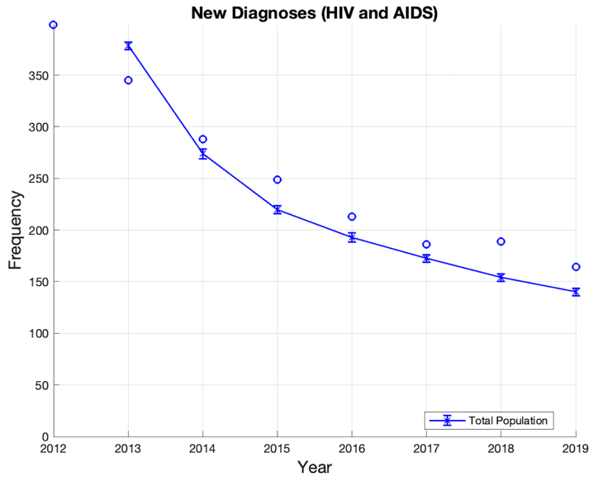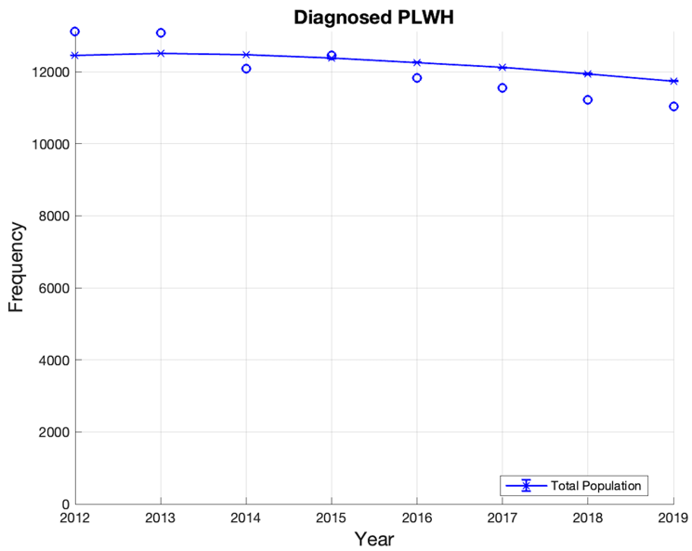
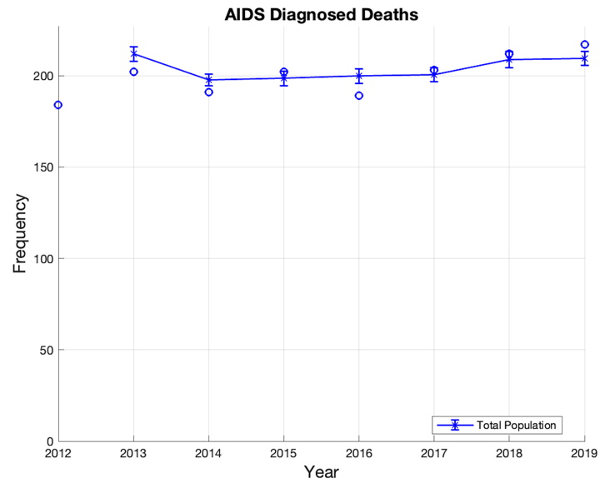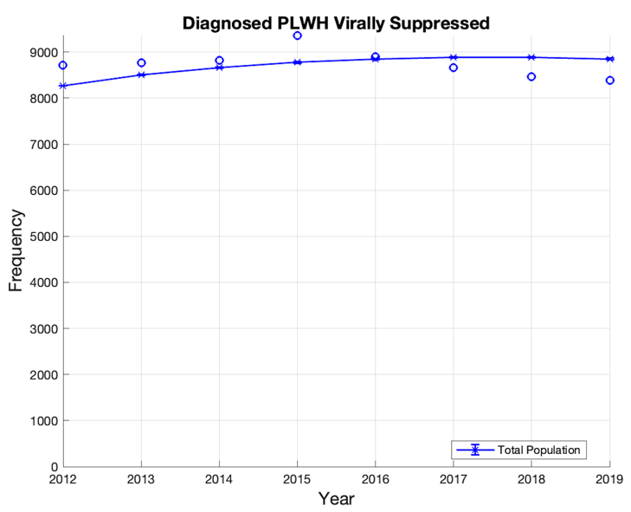
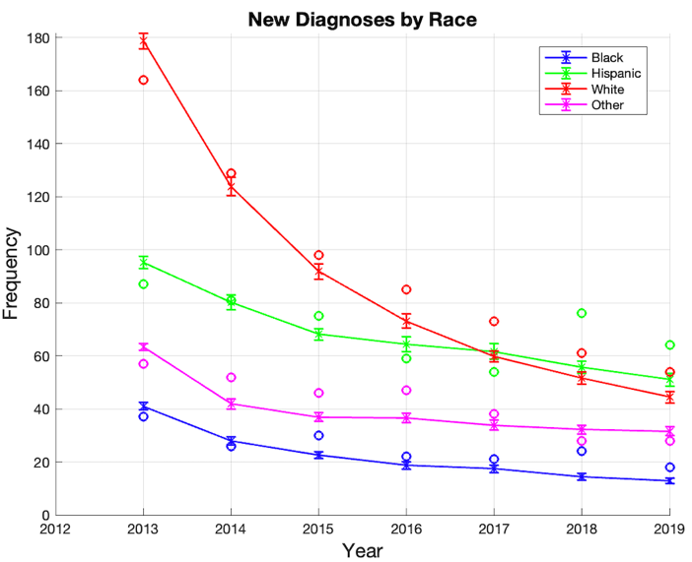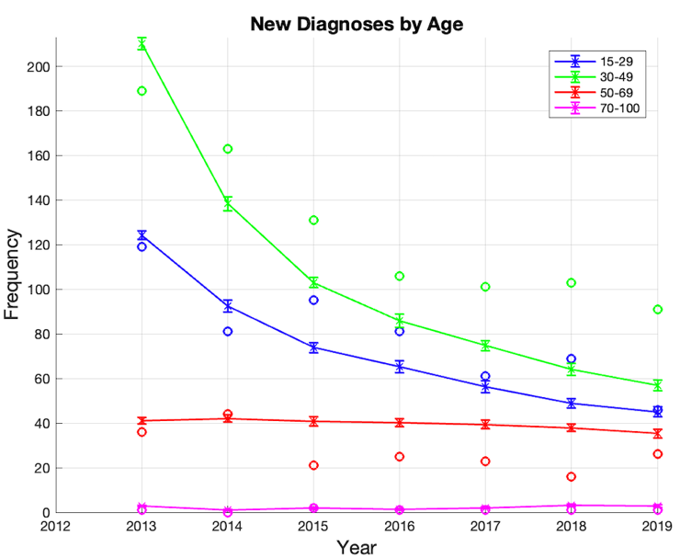
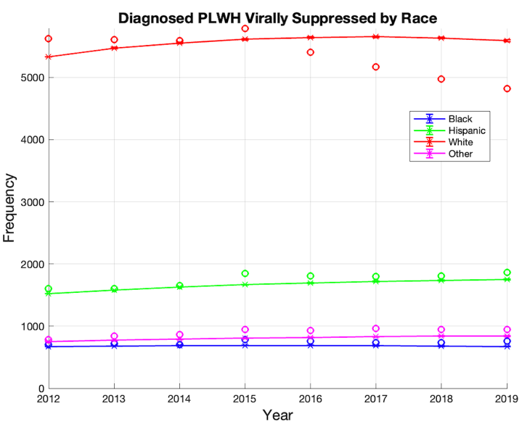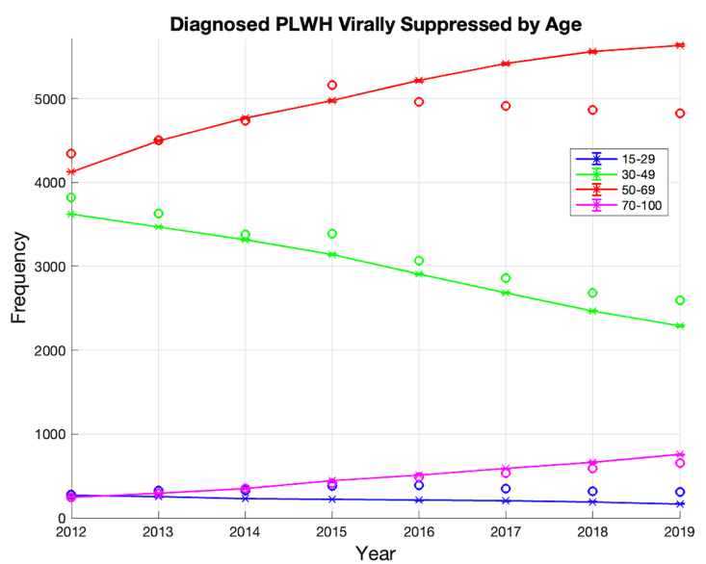
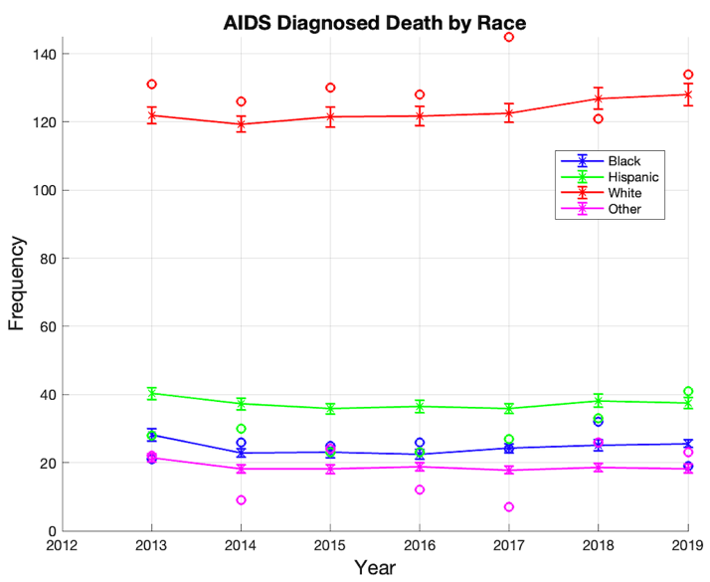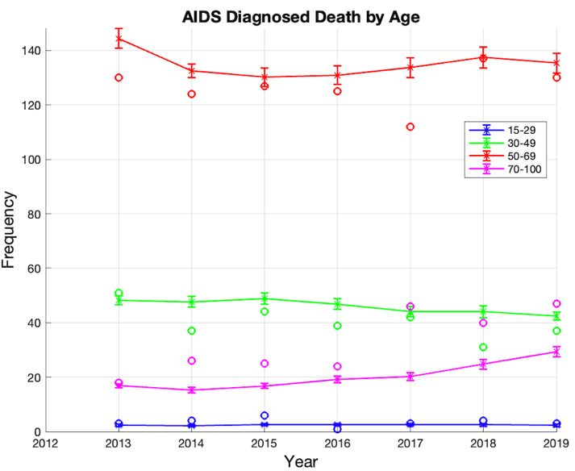

In the Appendix Table 4, we present a comparison of model outcomes with calibration data from NHAS data and AIDSVu and empirical data from other sources between 2012 and 2021. All values are MSM-specific if not specified.

Appendix Table 4: Calibration and Validation Results
Parameter | Model outcomes | Calibration values⁺ | Validation values⁺⁺ | Calibration value sources | Validation value sources
New Diagnoses by year and race
2013 | 379 | 345 | 346 | ⁸ | ¹⁵
Black | 41 | 37 | 35 | ⁸ | ¹⁵
Hispanic | 95 | 87 | 95 | ⁸ | ¹⁵
White | 180 | 164 | 162 | ⁸ | ¹⁵
Other | 63 | 57 | 67 | ⁸ | ¹⁵
2014 | 272 | 288 | 273 | ⁸ | ¹⁵
Black | 28 | 26 | 24 | ⁸ | ¹⁵
Hispanic | 75 | 81 | 77 | ⁸ | ¹⁵
White | 124 | 129 | 120 | ⁸ | ¹⁵
Other | 44 | 52 | 54 | ⁸ | ¹⁵
2015 | 219 | 249 | 242 | ⁸ | ¹⁵
Black | 22 | 30 | 28 | ⁸ | ¹⁵
Hispanic | 69 | 75 | 66 | ⁸ | ¹⁵
White | 91 | 98 | 103 | ⁸ | ¹⁵
Other | 38 | 46 | 52 | ⁸ | ¹⁵
2016 | 194 | 213 | 182 | ⁸ | ¹⁵
Black | 19 | 22 | 19 | ⁸ | ¹⁵
Hispanic | 65 | 59 | 50 | ⁸ | ¹⁵
White | 75 | 85 | 78 | ⁸ | ¹⁵
Other | 35 | 47 | 45 | ⁸ | ¹⁵
2017 | 172 | 186 | 173 | ⁸ | ¹⁵
Black | 18 | 21 | 20 | ⁸ | ¹⁵
Hispanic | 59 | 54 | 53 | ⁸ | ¹⁵
White | 61 | 73 | 65 | ⁸ | ¹⁵
Other | 34 | 38 | 35 | ⁸ | ¹⁵
2018 | 153 | 189 | 150 | ⁸ | ¹⁵
Black | 14 | 24 | 24 | ⁸ | ¹⁵
Hispanic | 56 | 76 | 60 | ⁸ | ¹⁵
White | 51 | 61 | 48 | ⁸ | ¹⁵
Other | 32 | 28 | 18 | ⁸ | ¹⁵
2019 | 140 | 164 | 120 | ⁸ | ¹⁵
Black | 13 | 18 | 15 | ⁸ | ¹⁵
Hispanic | 51 | 64 | 41 | ⁸ | ¹⁵
White | 44 | 54 | 42 | ⁸ | ¹⁵
Other | 32 | 28 | 22 | ⁸ | ¹⁵
2020 | 99 | - | 92 | - | ¹⁵
Black | 9 | - | 14 | - | ¹⁵
Hispanic | 38 | - | 38 | - | ¹⁵
White | 29 | - | 24 | - | ¹⁵
Other | 23 | - | 16 | - | ¹⁵
Diagnosed PLWH by year and race
2012 | 12450 | 13126 | 13575 | ⁸ | ²⁴
Black | 1136 | 1195 | 1299 | ⁸ | ²⁴
Hispanic | 2314 | 2443 | 2338 | ⁸ | ²⁴
White | 7878 | 8309 | 9128 | ⁸ | ²⁴
Other | 1122 | 1179 | 810 | ⁸ | ²⁴
2013 | 12515 | 12730 | 13449 | ⁸ | ²⁵
Black | 1138 | 1175 | 1191 | ⁸ | ²⁵
Hispanic | 2348 | 2391 | 2338 | ⁸ | ²⁵
White | 7876 | 8025 | 9112 | ⁸ | ²⁵
Other | 1153 | 1139 | 808 | ⁸ | ²⁵
2014 | 12475 | 12093 | 13541 | ⁸ | ²⁶
Black | 1131 | 1117 | 1195 | ⁸ | ²⁶
Hispanic | 2364 | 2396 | 2416 | ⁸ | ²⁶
White | 7815 | 7377 | 9096 | ⁸ | ²⁶
Other | 1166 | 1203 | 834 | ⁸ | ²⁶
2015 | 12386 | 12459 | 13862 | ⁸ | ²⁷
Black | 1119 | 1151 | 1200 | ⁸ | ²⁷
Hispanic | 2373 | 2563 | 2491 | ⁸ | ²⁷
White | 7719 | 7472 | 9012 | ⁸ | ²⁷
Other | 1174 | 1273 | 1159 | ⁸ | ²⁷
2016 | 12261 | 11837 | 13869 | ⁸ | ²⁸
Black | 1103 | 1098 | 1164 | ⁸ | ²⁸
Hispanic | 2379 | 2526 | 2556 | ⁸ | ²⁸
White | 7599 | 6959 | 8912 | ⁸ | ²⁸
Other | 1180 | 1254 | 1237 | ⁸ | ²⁸
2017 | 12116 | 11545 | 13878 | ⁸ | ²⁹
Black | 1086 | 1080 | 1155 | ⁸ | ²⁹
Hispanic | 2379 | 2509 | 2595 | ⁸ | ²⁹
White | 7467 | 6703 | 8831 | ⁸ | ²⁹
Other | 1185 | 1253 | 1297 | ⁸ | ²⁹
2018 | 11938 | 11215 | 13863 | ⁸ | ³⁰
Black | 1064 | 1066 | 1147 | ⁸ | ³⁰
Hispanic | 2373 | 2496 | 2656 | ⁸ | ³⁰
White | 7315 | 6417 | 8736 | ⁸ | ³⁰
Other | 1186 | 1236 | 1324 | ⁸ | ³⁰
2019 | 11742 | 11044 | 13775 | ⁸ | ³¹
Black | 1040 | 1088 | 1146 | ⁸ | ³¹
Hispanic | 2363 | 2524 | 2682 | ⁸ | ³¹
White | 7153 | 6191 | 8628 | ⁸ | ³¹
Other | 1187 | 1241 | 1319 | ⁸ | ³¹
2020 | 11493 | - | 13689 | - | ³²
Black | 1011 | - | 1132 | - | ³²
Hispanic | 2335 | - | 2717 | - | ³²
White | 6971 | - | 8489 | - | ³²
Other | 1176 | - | 1351 | - | ³²
2021 | 11234 | - | 13520 | - | ³³
Black | 981 | - | 1097 | - | ³³
Hispanic | 2304 | - | 2745 | - | ³³
White | 6785 | - | 8319 | - | ³³
Other | 1164 | - | 1359 | - | ³³
Proportion of VLS among diagnosed PLWH by year
2013 | 0.679 | - | 0.732 | - | ⁷
2014 | 0.693 | - | 0.734 | - | ³⁴
2015 | 0.707 | - | 0.743 | - | ³⁵
2016 | 0.720 | - | 0.745 | - | ³⁶
2017 | 0.733 | - | 0.747 | - | ³⁷
2019 | 0.754 | - | 0.758 | - | ³⁸
2020 | 0.756 | - | 0.711 | - | ¹⁵
2021 | 0.759 | - | 0.731 | - | ³⁹
PrEP users by year (calibration data source estimates male users, validation data source estimates all users aged ≥ 16)
2012 | 321 | 312 | - | ¹⁰ | -
2013 | 572 | 603 | - | ¹⁰ | -
2014 | 1588 | 1589 | - | ¹⁰ | -
2015 | 3216 | 3185 | - | ¹⁰ | -
2016 | 4488 | 4410 | - | ¹⁰ | -
2017 | 5303 | 5199 | 6293 | ¹⁰ | ⁴⁰
2018 | 5850 | 5999 | 7862 | ¹⁰ | ⁴⁰
2019 | 6242 | - | 8785 | - | ⁴⁰
2020 | 5510 | - | 8085 | - | ⁴⁰
2021 | 4951 | - | 7269* | - | ⁴⁰
* From January 2021 – September 2021

Note: the stratified model outcomes may not add up to total model outcomes due to rounding
⁺ We changed model parameters such that outcomes matched these values as closely as possible.
⁺⁺ We did not use these values during the calibration process (used here only for external validation)

The calibration values for new diagnoses and number of diagnosed PLWH data are from NHAS, and the validation data for these parameters are from San Francisco HIV Epidemiology Annual Report, Semi-annual Surveillance Report or Quarterly Surveillance Report. Both sources are credible, but discrepancies exist between them. We were unable to find empirical data on the number of MSM prescribed PrEP for validation, so we compare model values to the total number of adults prescribed PrEP (with an expectation that model values should be lower). However, model trends were similar to observed trends for this metric, especially during COVID-19.

Supplemental Results

In this section, we present additional information on model results. We compared the HIV outcomes by time under different scenarios. We calculated average and 95% uncertainty intervals by using 5000 bootstrap samples of 40 model iterations.

We report PrEP coverage (the proportion of people prescribed PrEP among those who has indications for PrEP) in the manuscript. We followed the definition provided in HIV surveillance data tables and assume 24.6% of susceptible MSM have indications for PrEP.^{41,42}

Appendix Figure 5: HIV outcomes over time under non-COVID counterfactual and COVID-19 scenarios (return to pre-COVID service levels by the end of 2022 versus return to pre-COVID service levels by the end of 2025)
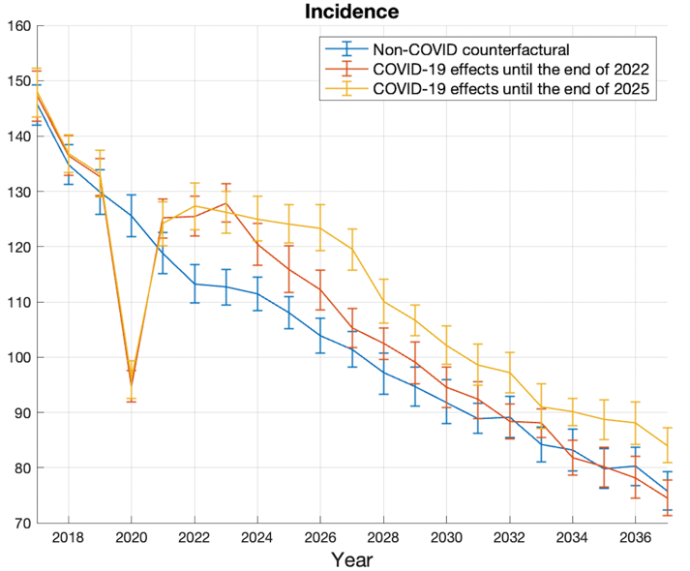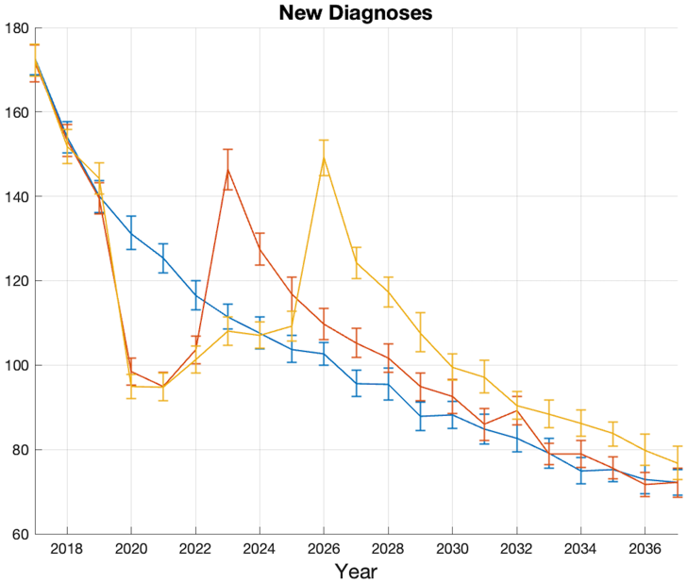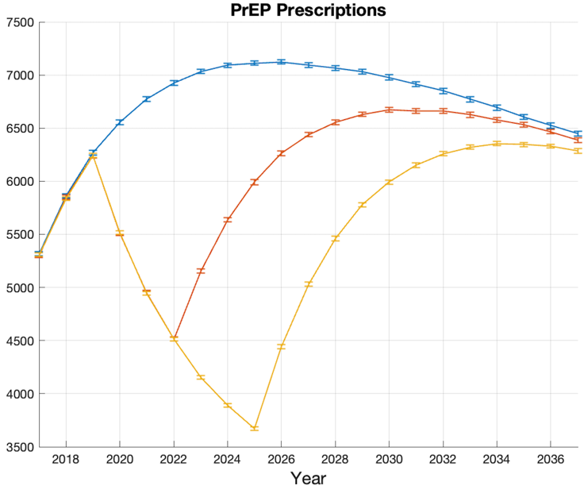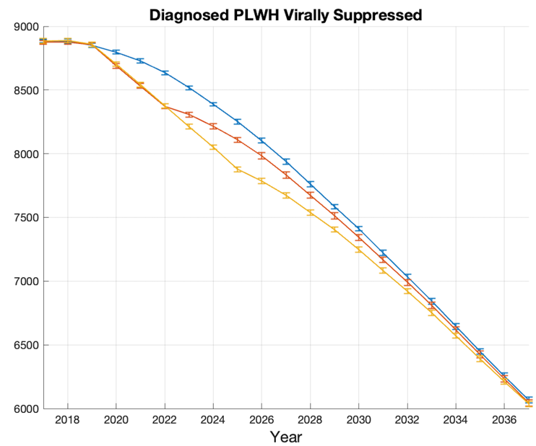
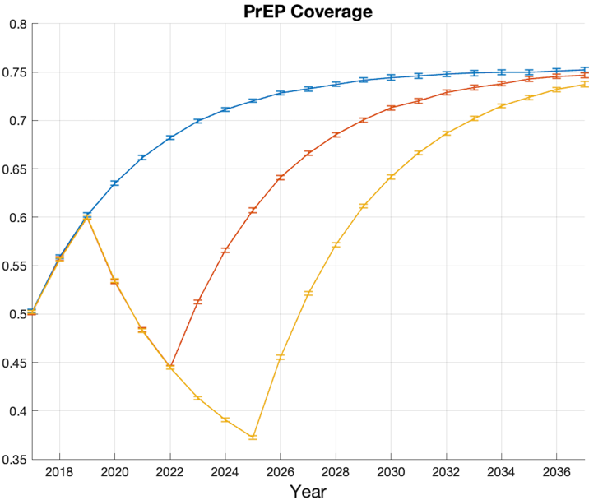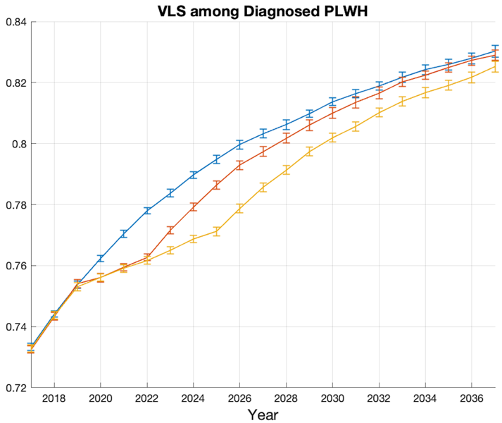

Appendix Figure 6: HIV outcomes over time under non-COVID counterfactual and COVID-19 scenarios (return to pre-COVID service levels by the end of 2022, return to pre-COVID service levels by the end of 2025, prioritized initiation of new patients from 2023 to 2025, and prioritized retention of existing patients from 2023 to 2025)

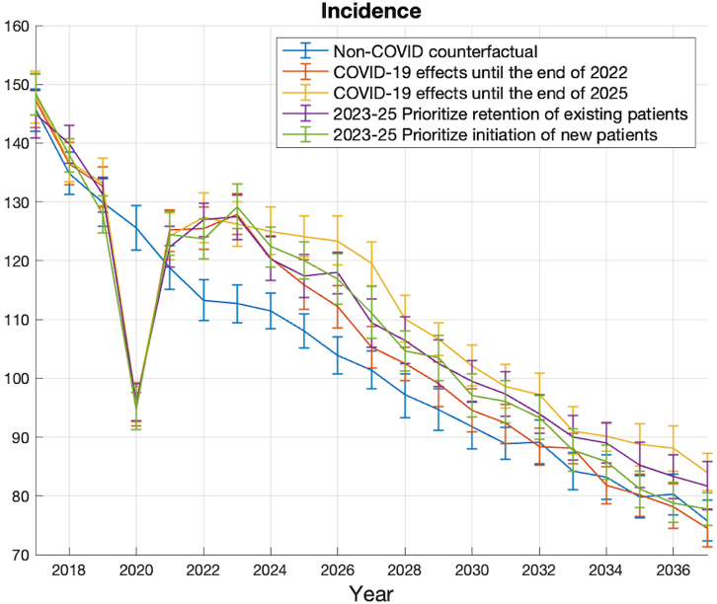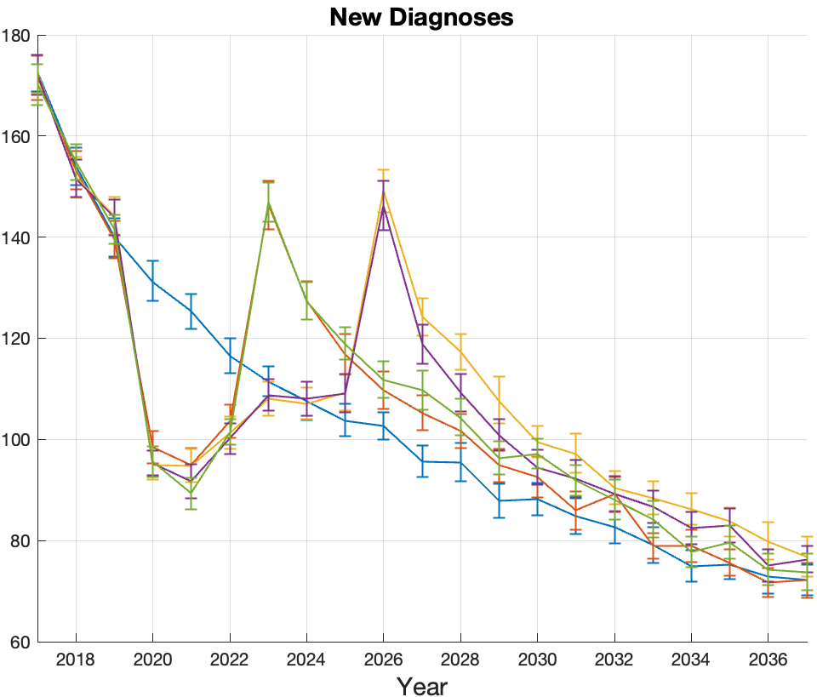
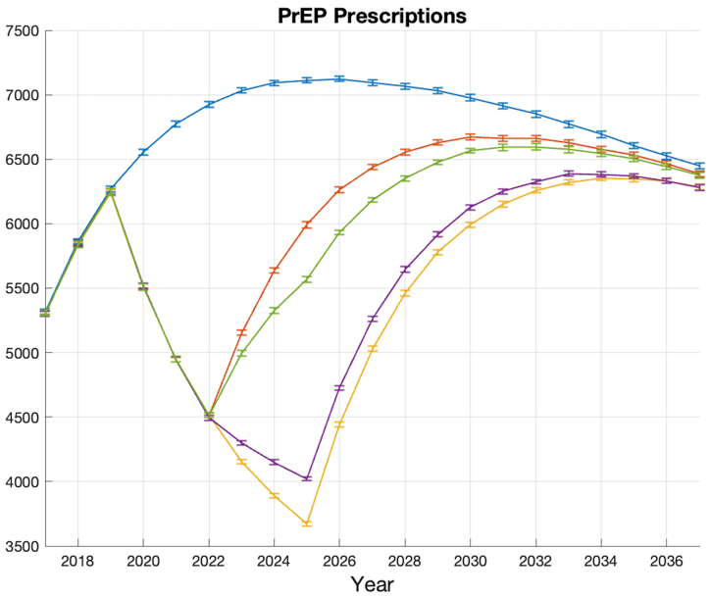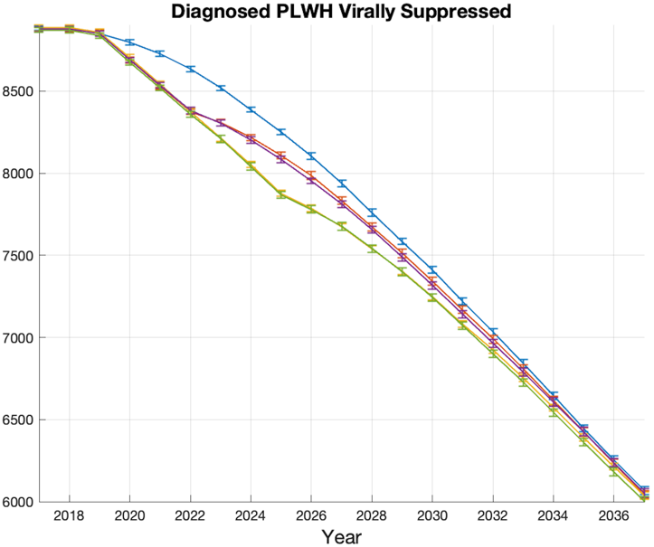

Appendix Table 5: Cumulative burden from 2020 to 2035 under four COVID-19 scenarios
 | Cumulative difference by 2035 | Cumulative difference by 2035 uncertainty interval LB | Cumulative difference by 2035 uncertainty interval UB
Scenario 1: COVID-19 effects until the end of 2022
VLS person-years | -1716 | -2021 | -1423
PrEP person-years | -13240 | -13457 | -13024
Incidence | 50 | 21 | 79
Diagnoses | 38 | 11 | 65
HIV death | 72 | 56 | 88
Scenario 2: COVID-19 effects until the end of 2025
VLS person-years | -3168 | -3420 | -2917
PrEP person-years | -25790 | -25972 | -25608
Incidence | 146 | 119 | 173
Diagnoses | 97 | 70 | 123
HIV death | 150 | 132 | 167
Scenario 3: Prioritize retention of existing patients
VLS person-years | -1948 | -2222 | -1672
PrEP person-years | -23782 | -23926 | -23639
Incidence | 98 | 65 | 132
Diagnoses | 54 | 25 | 85
HIV death | 84 | 67 | 102
Scenario 4: Prioritize initiation of new patients
VLS person-years | -3387 | -3677 | -3092
PrEP person-years | -15420 | -15597 | -15249
Incidence | 88 | 57 | 120
Diagnoses | 58 | 33 | 84
HIV death | 135 | 119 | 152

Appendix Table 6: Cumulative burden from 2020 to 2035 under sensitivity analyses (best and worst cases for scenarios COVID-19 effects until the end of 2022 and COVID-19 effects until the end of 2025)
 | Cumulative difference by 2035 | Cumulative difference by 2035 uncertainty interval LB | Cumulative difference by 2035 uncertainty interval UB
COVID-19 effects until the end of 2022 (worst-case scenario)
VLS person-years | -3497 | -3750 | -3247
PrEP person-years | -17111 | -17378 | -16820
Incidence | 164 | 139 | 190
Diagnoses | 110 | 89 | 132
HIV death | 150 | 132 | 168
COVID-19 effects until the end of 2022 (best-case scenario)
VLS person-years | -1432 | -1692 | -1174
PrEP person-years | -11938 | -12163 | -11704
Incidence | -51 | -77 | -27
Diagnoses | -52 | -73 | -32
HIV death | 19 | 1 | 37
COVID-19 effects until the end of 2025 (worst-case scenario)
VLS person-years | -6378 | -6609 | -6161
PrEP person-years | -32365 | -32535 | -32190
Incidence | 317 | 289 | 345
Diagnoses | 235 | 210 | 260
HIV death | 335 | 316 | 353
COVID-19 effects until the end of 2025 (best-case scenario)
VLS person-years | -1898 | -2136 | -1655
PrEP person-years | -23507 | -23716 | -23289
Incidence | 37 | 12 | 61
Diagnoses | 20 | -1 | 41
HIV death | 61 | 42 | 81

References

1. Drabo E, Moucheraud C, Nguyen A, et al. Using microsimulation modeling to inform EHE implementation strategies in Los Angeles County. Journal of Acquired Immune Deficiency Syndrome. doi:10.1097/QAI.0000000000002977
2. Nguyen A, Drabo EF, Garland WH, et al. Are Unequal Policies in Pre-Exposure Prophylaxis Uptake Needed to Improve Equality? An Examination Among Men Who Have Sex with Men in Los Angeles County. AIDS Patient Care STDS. 2022;36(8):300-312. doi:10.1089/apc.2022.0011
3. Hughes AJ, Chen YH, Scheer S, Raymond HF. A novel modeling approach for estimating patterns of migration into and out of San Francisco by HIV status and race among men who have sex with men. Journal of Urban Health. 2017;94(3):350-363. doi:10.1007/s11524-017-0145-2
4. Grey JA, Bernstein KT, Sullivan PS, et al. Estimating the population sizes of men who have sex with men in US states and counties using data from the American Community Survey. JMIR Public Health Surveill. 2016;2(1):e14. doi:10.2196/publichealth.5365
5. U.S. Census Bureau. American Community Survey: age and sex. Accessed May 28, 2022. https://data.census.gov/cedsci/table?q=San%20Francisco%20County,%20California&tid=ACSST1Y2012.S0101
6. San Francisco Department of Public Health Population Health Division. HIV/AIDS Epidemiology Annual Report 2012.; 2012. Accessed June 19, 2022. http://www.sfdph.org/dph/comupg/oprograms/hivepisec/default.asp
7. San Francisco Department of Public Health Population Health Division. HIV Epidemiology Annual Report 2014. Accessed May 28, 2022. https://www.sfdph.org/dph/files/reports/RptsHIVAIDS/HIV-EpidemiologyAnnualReport-2014.pdf
8. White House Office of National AIDS Policy. National HIV/AIDS Strategy for the United States.; 2020. Accessed June 19, 2022. https://hivgov-prod-v3.s3.amazonaws.com/s3fs-public/nhas-update.pdf
9. Centers for Disease Control and Prevention. Core Indicators for Monitoring the Ending the HIV Epidemic Initiative (Preliminary Data): National HIV Surveillance System Data Reported through September 2021; and Preexposure Prophylaxis (PrEP) Data Reported through June 2021.; 2022. Accessed July 4, 2022. https://www.cdc.gov/hiv/library/reports/surveillance-data-
10. Emory University’s Rollins School of Public Health in partnership with Gilead Sciences Inc, the Center for AIDS Research at Emory University (CFAR). San Francisco County - AIDSVu. Accessed May 5, 2022. https://aidsvu.org/
11. Liu AY, Cohen SE, Vittinghoff E, et al. HIV pre-exposure prophylaxis integrated with municipal and community based sexual health services. JAMA Intern Med. 2016;176(1):75. doi:10.1001/JAMAINTERNMED.2015.4683
12. San Francisco Digital Services team Office of the City Administrator. COVID-19 cases and deaths in San Francisco. Accessed May 29, 2022. https://sf.gov/data/covid-19-cases-and-deaths
13. Dong Y, Li Z, Ding S, et al. HIV infection and risk of COVID-19 mortality: A meta-analysis. Medicine. 2021;100(26):e26573. doi:10.1097/MD.0000000000026573
14. Division of HIV and STD Programs Department of Public Health County of Los Angeles. HIV surveillance annual report 2020. Accessed May 5, 2022. http://www.publichealth.lacounty.gov/dhsp/Reports/HIV/2020AnnualHIVSurveillanceReportUpdated9-2021_fig1fig2update.pdf
15. San Francisco Department of Public Health Population Health Division. HIV Epidemiology Annual Report 2020. Accessed May 18, 2022. https://www.sfdph.org/dph/files/reports/RptsHIVAIDS/AnnualReport2020-Purple_20210817Web.pdf
16. SFDPH Office of Managed Care. HealthySF Our Health Access Program Annual Report (Fiscal Year 2018-19).; 2020.
17. Broussard J., Moore K., Tourneau N., et al. HIV pre-exposure prophylaxis (PrEP) care in a LGBTQ community-based sexual health and wellness clinic after COVID-19 restrictions. In: IAS. ; 2021. Accessed May 5, 2022. https://theprogramme.ias2021.org/Abstract/Abstract/2052
18. Spinelli MA, Hickey MD, Glidden D v., et al. Viral suppression rates in a safety-net HIV clinic in San Francisco destabilized during COVID-19. AIDS. 2020;34(15):2328-2331. doi:10.1097/QAD.0000000000002677
19. Sanchez TH, Zlotorzynska M, Rai M, Baral SD. Characterizing the impact of COVID-19 on men who have sex with men across the United States in April, 2020. AIDS Behav. 2020;24(7):2024-2032. doi:10.1007/S10461-020-02894-2/TABLES/5
20. Santos GM, Ackerman B, Rao A, et al. Economic, Mental Health, HIV Prevention and HIV Treatment Impacts of COVID-19 and the COVID-19 Response on a Global Sample of Cisgender Gay Men and Other Men Who Have Sex with Men. AIDS Behav. 2021;25(2):311. doi:10.1007/S10461-020-02969-0
21. Ridgway JP, Schmitt J, Friedman E, et al. HIV Care Continuum and COVID-19 Outcomes Among People Living with HIV During the COVID-19 Pandemic, Chicago, IL. AIDS Behav. 2020;24(10):2770-2772. doi:10.1007/s10461-020-02905-2
22. McKay T, Henne J, Gonzales G, Quarles R, Gavulic KA, Garcia Gallegos S. The COVID-19 Pandemic and Sexual Behavior among Gay and Bisexual Men in the United States. SSRN Electronic Journal. Published online May 29, 2020. doi:10.2139/SSRN.3614113
23. San Francisco Department of Public Health. San Francisco Monthly STD Report, December 2020. Published 2020. Accessed May 18, 2022. https://www.sfdph.org/dph/files/reports/StudiesData/STD/STD122020.pdf
24. San Francisco Department of Public Health. Quarterly HIV/AIDS Surveillance Report: HIV/AIDS Cases Reported through December 2012.; 2013. Accessed July 4, 2022. http://www.sfdph.org/dph/files/reports/default.asp
25. San Francisco Department of Public Health. HIV Semi-Annual Surveillance Report: HIV Cases Reported through December 2013.; 2014. Accessed July 4, 2022. http://www.sfdph.org/dph/files/reports/default.asp
26. San Francisco Department of Public Health. HIV Semi-Annual Surveillance Report: HIV Cases Reported through December 2014.; 2015. Accessed July 4, 2022. http://www.sfdph.org/dph/files/reports/default.asp
27. San Francisco Department of Public Health. HIV Semi-Annual Surveillance Report: HIV Cases Reported through December 2015.; 2016. Accessed July 4, 2022. http://www.cdc.gov/hiv/library/reports/surveillance/.
28. San Francisco Department of Public Health. HIV Semi-Annual Surveillance Report: HIV Cases Reported through December 2016.; 2017. Accessed July 4, 2022. https://www.cdc.gov/hiv/library/reports/hiv-surveillance.html.
29. San Francisco Department of Public Health. HIV Semi-Annual Surveillance Report: HIV Cases Reported through December 2017.; 2018. Accessed July 4, 2022. https://www.cdph.ca.gov/Programs/CID/DOA/Pages/OA_case_surveillance_reports.aspx
30. San Francisco Department of Public Health. HIV Semi-Annual Surveillance Report: HIV Cases Reported through December 2018.; 2019. Accessed July 4, 2022. https://www.cdph.ca.gov/Programs/CID/DOA/Pages/OA_case_surveillance_reports.aspx
31. San Francisco Department of Public Health. HIV Semi-Annual Surveillance Report: HIV Cases Reported through December 2019.; 2020. Accessed July 4, 2022. https://www.cdph.ca.gov/Programs/CID/DOA/Pages/OA_case_surveillance_reports.aspx
32. San Francisco Department of Public Health. HIV Semi-Annual Surveillance Report: HIV Cases Diagnosed through December 2020 and Reported through February 2021.; 2021. Accessed July 4, 2022. https://www.cdph.ca.gov/Programs/CID/DOA/Pages/OA_case_surveillance_reports.aspx.
33. San Francisco Department of Public Health. HIV Semi-Annual Surveillance Report: HIV Cases Diagnosed through December 2021 and Reported through February 2022.; 2022. Accessed July 4, 2022. https://www.cdph.ca.gov/Programs/CID/DOA/Pages/OA_case_surveillance_reports.aspx.
34. San Francisco Department of Public Health Population Health Division. HIV Epidemiology Annual Report 2015. Accessed November 14, 2022. https://sfdph.org/dph/files/reports/RptsHIVAIDS/AnnualReport2015-20160831.pdf
35. San Francisco Department of Public Health Population Health Division. HIV Epidemiology Annual Report 2016. Accessed November 14, 2022. https://sfdph.org/dph/files/reports/RptsHIVAIDS/Annual-Report-2016-20170831.pdf
36. San Francisco Department of Public Health Population Health Division. HIV Epidemiology Annual Report 2017. Accessed November 14, 2022. https://sfdph.org/dph/files/reports/RptsHIVAIDS/AnnualReport2017-Green-20180904-Web.pdf
37. San Francisco Department of Public Health Population Health Division. HIV Epidemiology Annual Report 2018. Accessed November 14, 2022. https://sfdph.org/dph/files/reports/RptsHIVAIDS/HIV-Epidemiology-Annual-Report-2018.pdf
38. San Francisco Department of Public Health Population Health Division. HIV Epidemiology Annual Report 2019. Accessed November 14, 2022. https://sfdph.org/dph/files/reports/RptsHIVAIDS/AnnualReport2019_Indigo_20200929_Web_fixed.pdf
39. San Francisco Department of Public Health Population Health Division. HIV Epidemiology Annual Report 2021. Accessed November 14, 2022. https://sfdph.org/dph/files/reports/RptsHIVAIDS/AnnualReport2021-Red.pdf
40. Centers for Disease Control and Prevention. Core Indicators for Monitoring the Ending the HIV Epidemic Initiative: National HIV Surveillance System Data Reported through December 2021; and Preexposure Prophylaxis (PrEP) Data Reported through September 2021.; 2022. Accessed July 4, 2022. http://wwwn.cdc.gov/dcs/ContactUs/Form
41. Centers for Disease Control and Prevention. Core indicators for monitoring the ending the HIV epidemic initiative (preliminary data): national HIV surveillance system data reported through March 2022; and preexposure prophylaxis (PrEP) data reported through December 2021. Published 2022. Accessed May 5, 2022. https://www.cdc.gov/hiv/library/reports/surveillance-data-tables/index.html
42. Smith DK, Handel M van, Wolitski RJ, et al. Vital signs: estimated percentages and numbers of adults with indications for preexposure prophylaxis to prevent HIV acquisition-United States, 2015. Accessed July 9, 2022. http://www.cdc.gov/nchs/nsfg.htm.

