Supplementary Figure S1: Peri- and postmenopausal trends of patients with active non-injection drug use (non-IDU) during eight years before and after menopause onset.

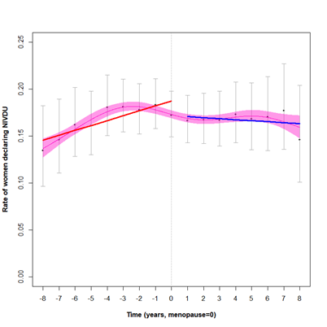
Supplementary Figure S2: Peri- and postmenopausal trends in viral (non)suppression in women with depression (B.), women being in psychiatric care (C.) and women with active injection drug use (D.) during eight years before and after menopause onset.

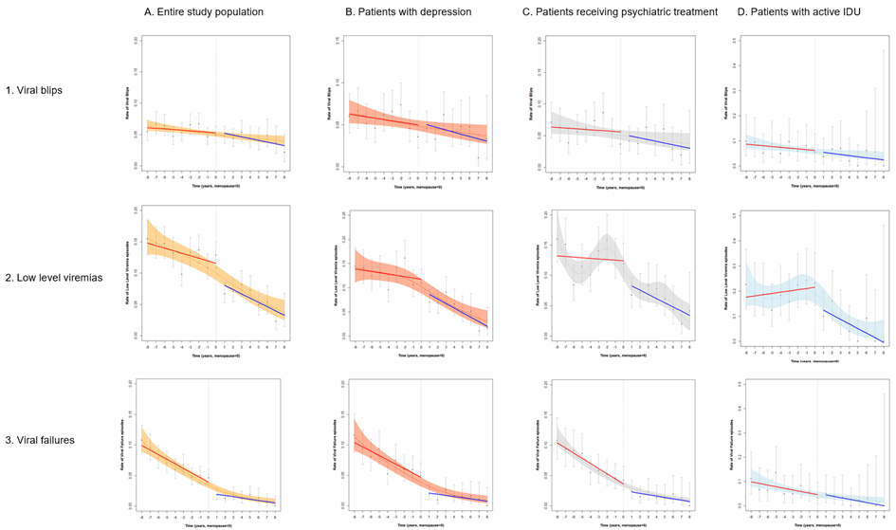
Rate of events over time (black solid), point-wise 95% confidence intervals (grey), fitted cubic spline (6 knots, yellow, orange, grey and blue dashed with 95% confidence intervals shaded), interrupted time series for peri- (red) and post-menopause (blue).

