Supporting Table 1: Summary of study activities by trial arm. Study visits among intervention participants occurred at least every 12 weeks (at baseline, week-4, 12, 24, 36, and 48). Study visits among control participants occurred at baseline, week-24, and week-48.

Procedures | Intervention | Standard of care “control”
Routine Antenatal care and postnatal care services including HIV testing and partner testing and notification offered in public health facilities | Yes | Yes
Referral of clients/mothers to the adjacent HIV clinic within the health facilities for routine HIV prevention services by Ministry of Health staff | No | Yes
Enhanced distribution of Condoms i.e All intervention participants without a product choice selected at the study visit were given condoms as an option | Yes | No
Nurse /midwife training on and implementation of client-centered choice for biomedical prevention product: oral PrEP and PEP (including PEP pill-in-pocket) with the option to switch over time | Yes | No
Nurse/midwife training on and implementation of pill-in-pocket for PEP and of flexible refill duration for PrEP | Yes | No
Nurse /Midwife training on and implementation of client-centered choices for HIV testing: self-test or rapid test with the option to switch over time | Yes | No
Nurse/midwife training on and implementation for client-centered choices for DCP delivery site: facility or out-of-facility with the option to switch over time | Yes | No
Nurse/midwife training on and implementation of client-centered care, including structured assessment of barriers to biomedical prevention and personalized plans in response | Yes | No
Nurse/midwife training on and implementation of mobile phone number access for client questions, available 24/7 | Yes | No

Supporting Table 2: Choice of Dynamic Choice for HIV Prevention (DCP) intervention components over time

Table 2a. Product choice

Time | N | Condoms Only | PEP | PrEP | None
Baseline | 203 | 3 (1%) | 2 (1%) | 198 (98%) | 0 (0%)
W4 | 169 | 6 (4%) | 1 (1%) | 148 (88%) | 14 (8%)
W12 | 192 | 11 (6%) | 5 (3%) | 158 (82%) | 18 (9%)
W24 | 186 | 5 (3%) | 0 (0%) | 141 (76%) | 40 (22%)
W36 | 188 | 4 (2%) | 13 (7%) | 129 (69%) | 42 (22%)

Table 2b: Choice of visit location
Time | N | Not off-site | Off-site
Baseline | 203 | 159 (78%) | 44 (22%)
W4 | 171 | 122 (71%) | 49 (29%)
W12 | 192 | 134 (70%) | 58 (30%)
W24 | 186 | 91 (49%) | 95 (51%)
W36 | 188 | 101 (54%) | 87 (46%)

Table 2c: Choice of HIV testing Modality

Time | N | Rapid test | Self-test
Baseline | 203 | 134 (66%) | 69 (34%)
W4 | 171 | 91 (53%) | 80 (47%)
W12 | 192 | 158 (82%) | 34 (18%)
W24 | 186 | 80 (43%) | 106 (57%)
W36 | 188 | 127 (68%) | 61 (32%)

Supporting Figure 1: Choice of Dynamic Choice for HIV Prevention (DCP) intervention components over time

Figure 1a. Product choice

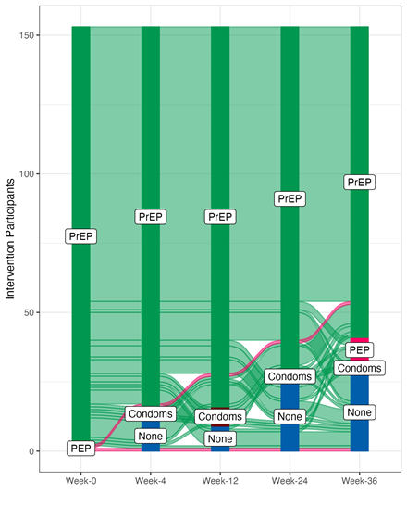

Figure 1b: Choice of visit location
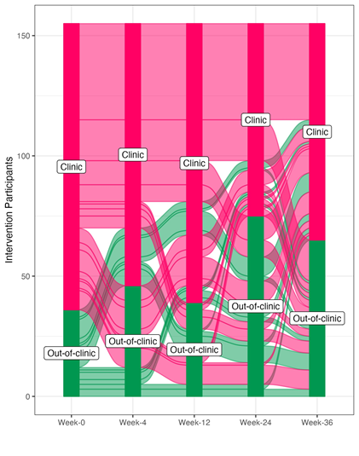

Figure 1c: Choice of HIV testing Modality
