Dynamics of weight change after antiretroviral therapy initiation in treatment naive HIV-1 patients: results from the Belgian HIV Cohort 2015-2021

Jens T. Van Praet, Ben Serrien, Nathalie Ausselet, Gilles Darcis, Rémy Demeester, Paul De Munter, Jean-Christophe Goffard, Agnès Libois, Peter Messiaen, Linos Vandekerchove, Jean Cyr Yombi and Dominique Van Beckhoven; on behalf of the Belgian HIV Cohort Study Group

Supplementary materials

Supplementary table 1. Baseline characteristics of 728 treatment naive patients according to their antiretroviral treatment
Variable | Overall  (N = 728) | FTC/TAF/BIC  (N = 407) | DTG/3TC/ABC  (N = 201) | FTC/TAF/cEVG  (N = 120)
Follow-up time, months (IQR) | 13.5 (7.6 - 15.9) | 11.8 (5.9 - 15.5) | 14.6 (11.2 - 16.3) | 14.2 (10.1 - 16.1)
Time from diagnosis to ART initiation, months (IQR) | 0.66 (0.30 - 1.41) | 0.43 (0.23 - 0.81) | 1.41 (0.76 - 2.56) | 0.99 (0.43 - 1.68)
HIV reference center, n
1 | 44 | 18 | 19 | 7
2 | 128 | 71 | 13 | 44
3 | 22 | 18 | 3 | 1
4 | 76 | 60 | 16 | 0
5 | 13 | 7 | 4 | 2
6 | 89 | 39 | 31 | 19
7 | 91 | 53 | 32 | 6
8 | 54 | 39 | 12 | 3
9 | 88 | 28 | 42 | 18
10 | 123 | 74 | 29 | 20
Year of HIV diagnosis, n
2015 | 54 | 0 | 52 | 2
2016 | 99 | 0 | 66 | 33
2017 | 85 | 0 | 40 | 46
2018 | 67 | 11 | 21 | 35
2019 | 179 | 171 | 6 | 2
2020 | 118 | 114 | 4 | 0
2021 | 125 | 111 | 12 | 2
Weight at baseline, kg (IQR) | 74 (65 - 83) | 74 (65 - 82) | 76 (67 - 84) | 74 (65 - 85)
Height, cm (IQR) | 175 (170 - 180) | 176 (170 - 180) | 174 (169 - 180) | 175 (170 - 182)
missing, n | 199 | 139 | 29 | 31
BMI at baseline, n (%)
normal weight 18.5 - 25 kg/m² | 282 (53) | 154 (57) | 87 (51) | 41 (46)
underweight <18.5 kg/m² | 19 (4) | 11 (4) | 4 (2) | 4 (5)
overweight  25 - 30 kg/m² | 173 (33) | 83 (31) | 57 (33) | 33 (37)
obese  >30 kg/m² | 55 (10) | 20 (8) | 24 (14) | 11 (12)
missing, n | 199 | 139 | 29 | 31
Sex, n (%)
male | 597 (82) | 328 (81) | 174 (87) | 95 (79)
female | 131 (18) | 79 (19) | 27 (13) | 25 (21)
Age, years (IQR) | 39 (30 - 50) | 39 (30 - 50) | 39 (30 - 49) | 37 (30 - 47)
Mode of transmission, n (%)
Heterosexual | 277 (40) | 162 (43) | 67 (35) | 48 (41)
MSM | 397 (58) | 209 (55) | 122 (63) | 66 (57)
IDU/other | 13 (2) | 7 (2) | 4 (2) | 2 (2)
missing, n | 41 | 29 | 8 | 4
Ethnicity, n (%)
white | 483 (72) | 262 (71) | 145 (76) | 76 (68)
black | 139 (21) | 77 (21) | 37 (19) | 25 (22)
other | 52 (7) | 31 (8) | 10 (5) | 11 (10)
missing, n | 54 | 37 | 9 | 8
Nationality, n (%)
Belgian | 391 (54) | 216 (54) | 118 (59) | 57 (48)
other | 329 (46) | 184 (46) | 83 (41) | 62 (52)
missing, n | 8 | 7 | 0 | 1
Province, n (%)
Antwerpen | 23 (3) | 17 (4) | 2 (1) | 4 (3)
Brabant Wallon | 19 (3) | 13 (3) | 4 (2) | 2 (2)
Brussels | 209 (29) | 126 (31) | 39 (20) | 44 (37)
Hainaut | 65 (9) | 29 (7) | 26 (13) | 10 (8)
Liège | 70 (10) | 24 (6) | 33 (17) | 13 (11)
Limburg | 36 (5) | 29 (7) | 7 (4) | 0 (0)
Luxembourg | 12 (2) | 2 (1) | 5 (3) | 5 (4)
Namur | 22 (3) | 9 (2) | 11 (6) | 2 (2)
Oost-Vlaanderen | 104 (14) | 62 (15) | 24 (12) | 18 (15)
Vlaams Brabant | 60 (8) | 42 (10) | 16 (8) | 2 (2)
West-Vlaanderen | 102 (14) | 51 (13) | 33 (17) | 18 (15)
missing, n | 3 | 1 | 1 | 1
Median tax. inc. municipality, € (IQR) | 25,390 (20,570 - 27,259) | 25,605 (20,570 - 27,289) | 25,377 (21,196 - 27,294) | 23,964 (20,562 - 26,726)
missing, n | 6 | 3 | 1 | 2
Ever smoker, n (%)
no | 286 (49) | 147 (51) | 76 (43) | 63 (56)
yes | 292 (51) | 144 (49) | 99 (57) | 49 (44)
missing, n | 150 | 116 | 26 | 8
SBP at baseline, mmHg (IQR) | 125 (117 - 136) | 126 (116 - 136) | 124 (118 - 138) | 125 (120 - 135)
missing, n | 55 | 27 | 9 | 19
DBP at baseline (mmHg) | 80 (70 - 85) | 80 (70 - 87) | 78 (70 - 81) | 78 (70 - 84)
missing, n | 55 | 27 | 9 | 19
Acute HIV at diagnosis, n (%)
no | 589 (90) | 361 (89) | 132 (92) | 96 (92)
yes | 65 (10) | 46 (11) | 11 (8) | 8 (8)
missing, n | 74 | 0 | 58 | 16
CD4 cells/µl at diagnosis, n (IQR)
< 200 | 164 (23) | 104 (26) | 37 (19) | 23 (20)
200 - 350 | 156 (22) | 89 (22) | 32 (16) | 35 (30)
350 - 500 | 168 (24) | 92 (23) | 51 (26) | 25 (22)
> 500 | 224 (32) | 118 (29) | 74 (38) | 33 (28)
missing,n | 15 | 4 | 7 | 4
VL in copies/ml at diagnosis, n (%)
200 - 1000 | 36 (5) | 10 (2.6) | 19 (10) | 8 (7)
1000 - 10000 | 100 (15) | 56 (14) | 26 (13) | 18 (17)
> 10000 | 552 (80) | 322 (83) | 148 (77) | 82 (76)
missing, n | 39 | 19 | 8 | 12
AIDS-defining illness or AIDS-defining cancer at baseline, n (%)
no | 687 (94) | 379 (93) | 192 (96%) | 116 (97)
yes | 41 (6) | 28 (6.9) | 9 (4) | 4 (3.3)
VL denotes viral load, ART antiretroviral therapy, IQR interquartile range, FTC emtricitabine, TAF tenofovir alafenamide, BIC bictegravir, cEVG cobicistat/elvitegravir, DTG dolutegravir, 3TC lamivudine and ABC abacavir.

Supplementary Table 2. Slopes of weight and BMI change over time and contrasts between slopes by ART regimen.
 |  | Weight (kg per month) |  | BMI (kg/m² per month)
 |  | Slope [95% CI] | Contrast between slopes [95% CI] * | Slope [95% CI] | Contrast between slopes [95% CI] *
FTC/TAF/BIC | 0 – 6 months | 0.72 [0.61; 0.82] | ref. | 0.24 [0.20; 0.27] | ref.
 | 6 – 18 months | 0.16 [0.07; 0.25] | ref. | 0.05 [0.02; 0.08] | ref.
DTG/3TC/ABC | 0 – 6 months | 0.49 [0.34; 0.64] | 0.23 [0.04; 0.41] | 0.16 [0.11; 0.21] | 0.07 [0.01; 0.13]
 | 6 – 18 months | 0.12 [0.02; 0.22] | 0.04 [-0.09; 0.18] | 0.04 [0.00; 0.07] | 0.02 [-0.03; 0.06]
FTC/TAF/cEVG | 0 – 6 months | 0.64 [0.44; 0.84] | 0.08 [-0.15; 0.30] | 0.21 [0.14; 0.28] | 0.03 [-0.05; 0.10]
 | 6 – 18 months | 0.10 [-0.05; 0.24] | 0.06 [-0.11; 0.23] | 0.03 [-0.02; 0.08] | 0.02 [-0.04; 0.08]
*in comparison with FTC/TAF/BIC
CI denotes confidence interval, FTC emtricitabine, TAF tenofovir alafenamide, BIC bictegravir, cEVG cobicistat/elvitegravir, DTG dolutegravir, 3TC lamivudine and ABC abacavir.

Supplementary Table 3. Contrasts between slopes of weight and BMI change: sensitivity analysis with exclusion of patients with a baseline weight/BMI below the 2.5th percentile (weight: 51 kg, BMI: 18.0 kg/m²) or above the 97.5th percentile (weight: 107 kg, BMI: 34.6 kg/m²).
 |  | Weight (kg per month) |  | BMI (kg/m² per month)
 |  | Slope [95% CI] | Contrast between slopes [95% CI] * | Slope [95% CI] | Contrast between slopes [95% CI] *
FTC/TAF/BIC | 0 – 6 months | 0.70 [0.59; 0.81] | ref. | 0.24 [0.20; 0.28] | ref.
 | 6 – 18 months | 0.18 [0.09; 0.27] | ref. | 0.06 [0.03; 0.09] | ref.
DTG/3TC/ABC | 0 – 6 months | 0.47 [0.32; 0.63] | 0.23 [0.04; 0.42] | 0.16 [0.10; 0.21] | 0.08 [0.02; 0.15]
 | 6 – 18 months | 0.12 [0.02; 0.22] | 0.06 [-0.07; 0.20] | 0.03 [-0.00; 0.07] | 0.03 [-0.02; 0.07]
FTC/TAF/cEVG | 0 – 6 months | 0.61 [0.40; 0.82] | 0.09 [-0.14; 0.33] | 0.20 [0.13; 0.27] | 0.04 [-0.04; 0.12]
 | 6 – 18 months | 0.06 [-0.09; 0.21] | 0.12 [-0.05; 0.30] | 0.02 [-0.03; 0.07] | 0.04 [-0.02; 0.10]
*in comparison with FTC/TAF/BIC
CI denotes confidence interval, FTC emtricitabine, TAF tenofovir alafenamide, BIC bictegravir, cEVG cobicistat/elvitegravir, DTG dolutegravir, 3TC lamivudine and ABC abacavir.

Supplementary Table 4. Contrasts between slopes of weight and BMI change: sensitivity analysis using viral load as a time-varying covariate in place of the baseline value to account for potential differential adherence between ART regimes.
 |  | Weight (kg per month) |  | BMI (kg/m² per month)
 |  | Slope [95% CI] | Contrast between slopes [95% CI] * | Slope [95% CI] | Contrast between slopes [95% CI] *
FTC/TAF/BIC | 0 – 6 months | 0.65 [0.53; 0.77] | ref. | 0.21 [0.17; 0.25] | ref.
 | 6 – 18 months | 0.17 [0.08; 0.26] | ref. | 0.06 [0.03; 0.09] | ref.
DTG/3TC/ABC | 0 – 6 months | 0.44 [0.29; 0.60] | 0.20 [0.02; 0.39] | 0.15 [0.10; 0.20] | 0.06 [0.01; 0.13]
 | 6 – 18 months | 0.12 [0.02; 0.23] | 0.05 [-0.09; 0.18] | 0.04 [0.01; 0.07] | 0.02 [-0.05; 0.10]
FTC/TAF/cEVG | 0 – 6 months | 0.59 [0.38; 0.79] | 0.06 [-0.17; 0.29] | 0.19 [0.12; 0.26] | 0.02 [-0.03; 0.06]
 | 6 – 18 months | 0.10 [-0.04; 0.25] | 0.07 [-0.11; 0.24] | 0.03 [-0.02; 0.08] | 0.02 [-0.03; 0.08]
*in comparison with FTC/TAF/BIC
CI denotes confidence interval, FTC emtricitabine, TAF tenofovir alafenamide, BIC bictegravir, cEVG cobicistat/elvitegravir, DTG dolutegravir, 3TC lamivudine and ABC abacavir.

Supplementary Figure 1. Flowchart of study population selection
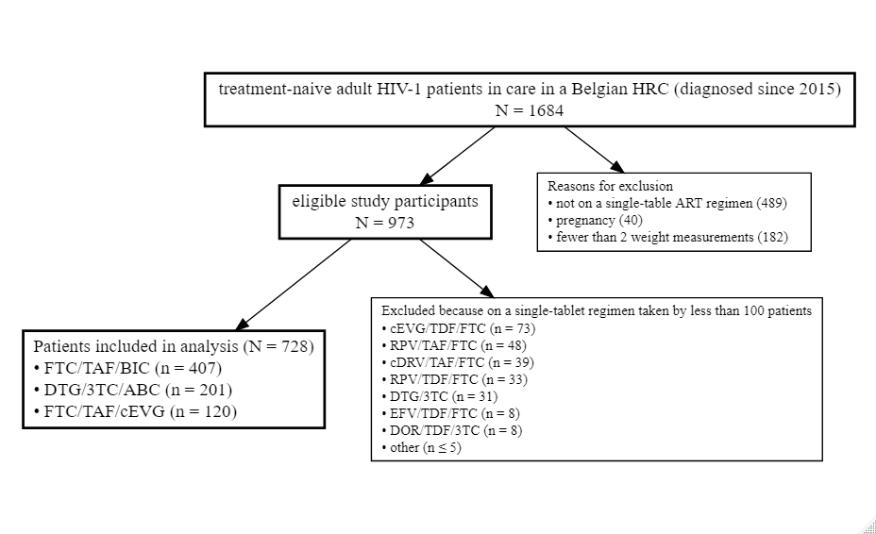

Supplementary Figure 2. Observed weight and BMI trajectories (thin gray lines) from diagnosis to end of follow-up.
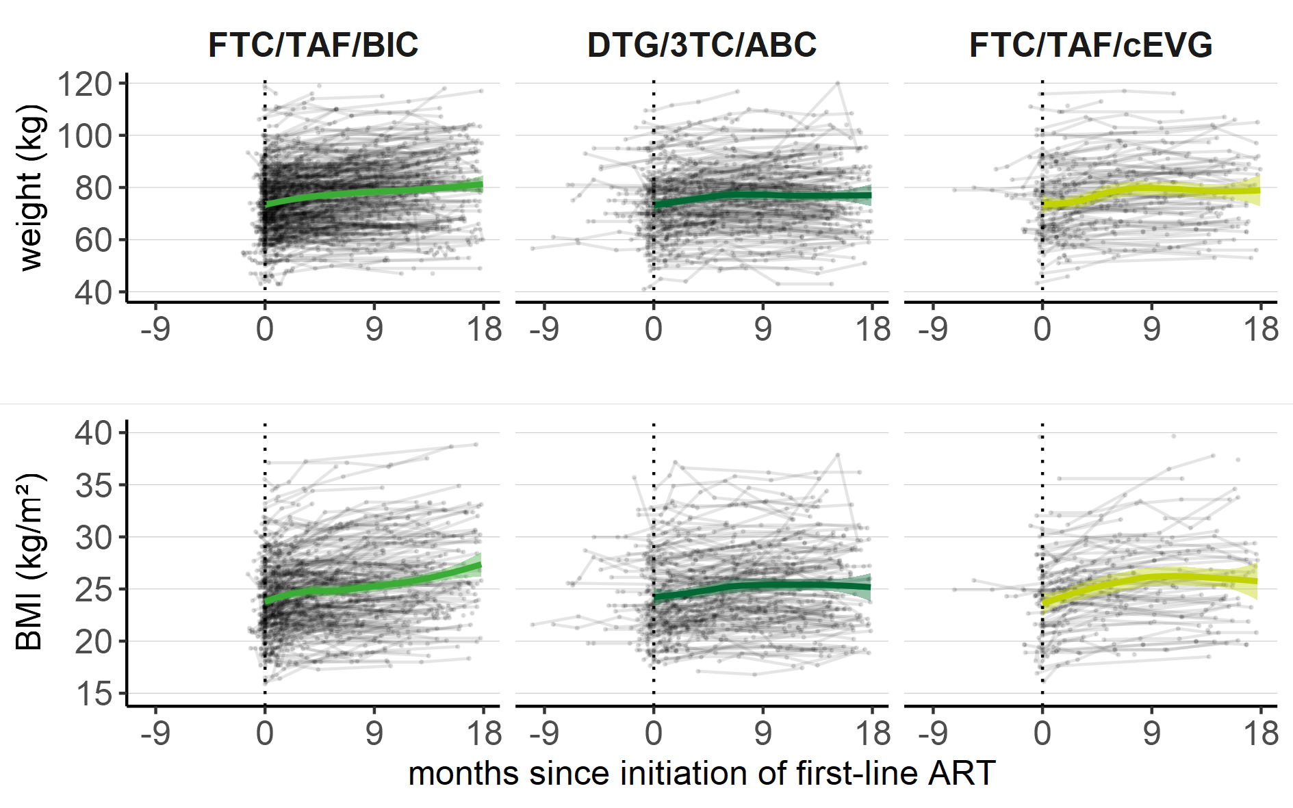
Negative time indicates weight measurements between diagnosis and ART initiation (not modelled). Nonparametric LOESS smoother and 95% CI are shown from ART initiation (time = 0) onwards. LOES denotes locally estimated scatterplot smoothing, CI confidence interval.

Supplementary Figure 3. Adjusted regression coefficients and 95% CI of fixed effects in the models for weight (left panel) and BMI (right panel).
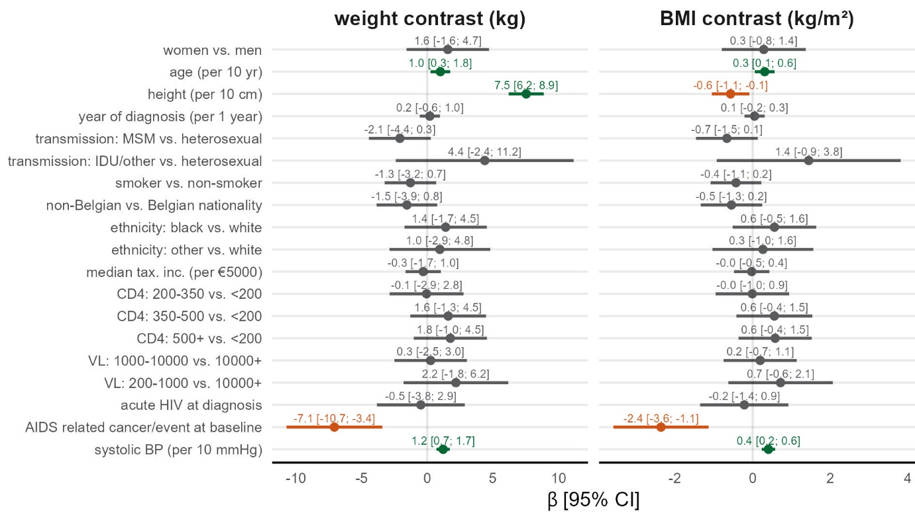
Colors indicate whether the association was significantly positive (green), - negative (red) or non-significant (gray). VL denotes viral load, CI confidence interval.

Supplementary Methods

Multiple Imputation of missing data
Twenty-fold multilevel multiple imputation with the mice package for R [1] was performed to account for missing data in baseline-covariates. Table S3 contains an overview of the amount of missing data per variable which ranged between 0% and 27% (height and BMI). Baseline (level 2) covariates were imputed using 2l-only predictive mean matching (continuous variables), 2l-only logistic regression (binary variables) and 2l-only polytomous regression (categorical variables). BMI was imputed passively using the observed weight and imputed height. Subject-ID was the cluster variable. Congeniality with the analysis model was secured by keeping weight, time, ART exposure, time*ART exposure interaction and baseline covariates in the imputation model for each variable. The following auxiliary covariates were included in the imputation model to make the missing-at-random assumption more tenable: time between diagnosis and ART initiation, clinical stage at diagnosis, place of residence (province), whether the medical visit occurred during a hard or soft COVID-lockdown period (during which missing data was more frequent), reason of censoring. Convergence of the mean and standard deviation of the MCMC chains was assessed visually and with the potential scale reduction factor (< 1.1); this was okay after 30 iterations.
Multivariable linear mixed models
The R package lme4 [2] was used to fit the multivariable linear mixed models describing the weight and BMI trends over time. Models were fitted using spline functions of time on ART and their interactions with type of ART exposure. We used flexible cubic splines with 5 degrees of freedom to visually explore ART-specific trends over time [3]. Piecewise linear time effects (1st-degree B-splines) with knots at chosen time points were used to numerically describe the rates of change in weight and BMI [3]. Number and placement of knots was done according to optimization of the Akaike information criterion (AIC). A model with 1 knot at 6 months past ART initiation yielded the best fit and approximated the flexible cubic splines well. Choice of the random effects structure to account for clustering of observations within subjects and (partial) clustering of subjects in HRCs was also done according to the AIC (models were fitted with restricted maximum likelihood and an unconstrained variance-covariance matrix to determine the random effects structure). The minimal AIC was obtained for a model with random intercepts and slopes for time by subject. Models with random intercepts for HRC were singular indicating small differences between centers and were not retained. All models included fixed effects for the following covariates: age (linear), height (linear), sex (male, female), likely mode of transmission (hetero, MSM, IDU/other), ethnicity (white, black, other), nationality (Belgian, other), median taxable income of the municipality (linear), year of HIV diagnosis (linear), acute HIV infection as defined by detection of p24 antigen or viral RNA in the plasma in combination with a negative or indetermined immunoassay result (yes/no), having an AIDS-defining illness or cancer at baseline, smoker at baseline (yes, no), baseline systolic blood pressure (linear), baseline CD4 (< 200, 200 - 350, 350 - 500, > 500), baseline VL (200 – 1.000, 1.000 – 10.000, >10.000). Among the continuous covariates, only baseline CD4 and -VL were entered in the model as categorical variables; others were entered as linear terms based on a graphical inspection of their relationship with weight and BMI (model fit in terms of the AIC was similar if we included them as linear terms or using B-splines with 5 degrees-of-freedom). Interaction effects were explored between sex and ethnicity and sex and age [3], but these were not retained in the final model as they did not improve the fit of the model (AIC) and the CI of the regression coefficients included the null value. Model summaries with 95% Confidence Intervals (CI) were obtained for each parameter or linear combinations thereof.

Supplementary References
1. van Buuren S, Groothuis-Oudshoorn K. mice: Multivariate Imputation by Chained Equations in R. J Stat Softw 2011; 45(3): 1-67.
2. Bates D, Maechler M, Bolker B, Walker S. Fitting Linear Mixed-Effects Models Using lme4. J Stat Software 2015; 67(1)
3. Mallon PWG, Brunet L, Hsu RK, et al. Weight gain before and after switch from TDF to TAF in a US cohort study. J Int Aids Soc 2021; 24(4).

