Appendix Figure 1. Study sample flow diagram

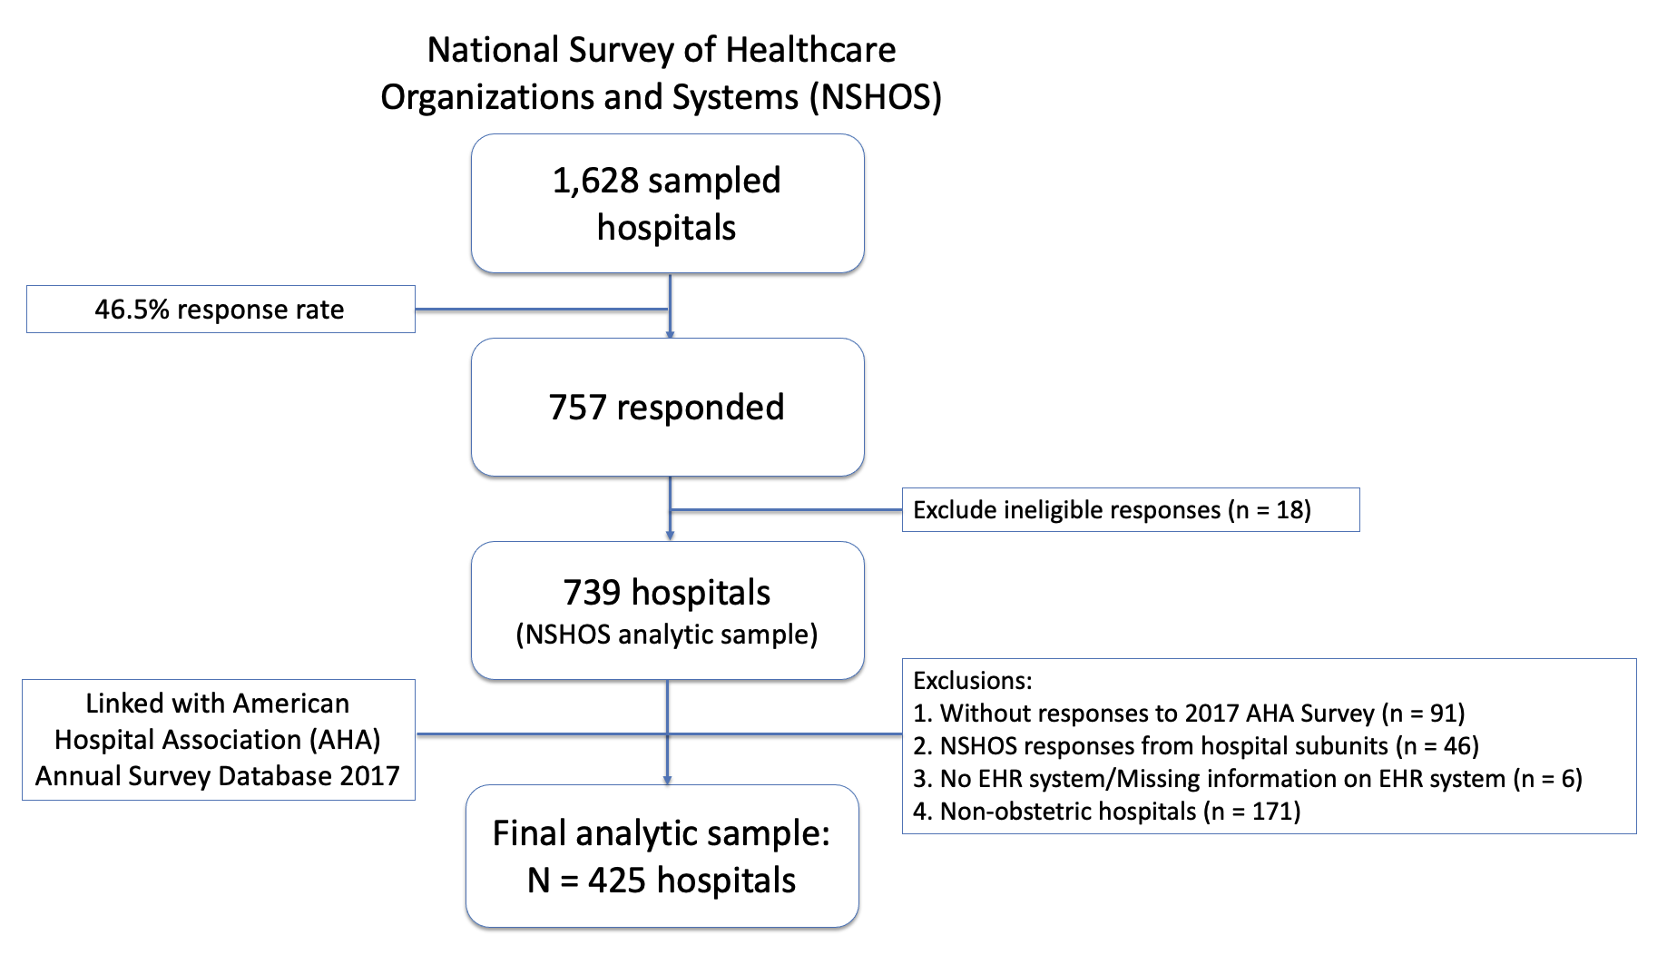

Appendix Table 1. Characteristics of hospital-level survey respondents and non-respondents in NSHOS
 | Respondents  (n=753) | Non-Respondents  (n=884) | Sample Frame*  (n=4,534)
Organizational Characteristics
% Non-Profit (n) | 83.5% (629) | 79.2% (700) | 71.8% (3,255)
% General Acute (n) | 73.7% (555) | 82.5% (729) | 74% (3,352)
% Critical Access (n) | 26.2% (197) | 17.5% (154) | 26% (1,180)
% Teaching Hospital (n) | 25.9% (195) | 26.2% (232) | 21.1% (957)
% Community Hospital (n) | 73.8% (556) | 82.5% (729) | 73.9% (3,352)
Size
Mean # of Physicians† (SD) | 116.0 (188.9) | 128.5 (198.6) | 87.1 (151.2)
Mean # of Associate Providers‡ (SD) | 16.7 (30.3) | 16.8 (28.6) | 12.6 (22.8)
Mean # Beds§ (SD) | 184.6 (191.1) | 192.1 (179.4) | 160.4 (166.2)
Geography
% Urban (n) | 52.5% (395) | 61.8% (546) | 48.5% (2,200)
% Suburban (n) | 20.3% (153) | 20.3% (153) | 21.0% (950)
% Rural (n) | 27.2% (205) | 27.2% (205) | 30.5% (1,384)
% Midwest (n) | 33.2% (250) | 27.9% (247) | 28.8% (1,304)
% Northeast (n) | 15.0% (113) | 18.8% (166) | 13.5% (613)
% South (n) | 32.0% (241) | 32.8% (290) | 38.4% (1,740)
% West (n) | 19.8% (149) | 20.5% (181) | 19.3% (877)
System Characteristic
% Independent (n) | 6.9% (52) | 3.2% (28) | 18.5% (840)
% Simple System (n) | 34.9% (263) | 31.5% (278) | 28.7% (1,301)
% Complex System (n) | 58.2 % (438) | 65.4% (578) | 52.8% (2,393)
Mean # of Owner Subsidiaries (SD) | 4.4 (7.4) | 4.9 (7.8) | 6.0 (8.5)
Mean # of Acute Care Hospitals (SD) | 26.2 (48.1) | 30.8 (53.7) | 48.3 (79.2)
Mean # of Medical Groups (SD) | 126.0 (175.3) | 132.3 (176.9) | 157.7 (196.0)
Mean # of states operating in (SD) | 5.1 (7.8) | 5.9 (8.7) | 8.7 (12.0)
% Part of ACO (n) | 22.5% (158) | 22.3% (191) | 20.5% (758)
*Includes surveyed and non-surveyed organizations
†Physicians = All MD/DO; Sum of Primary Care and Specialist Physicians
‡Associate Providers = Non-physician clinicians (e.g. NP, PA, CNS, etc)
§Based on OneKey data (“Staffed” beds)

Appendix Table 2. Characteristics of respondents and non-respondents in AHA survey
 | Respondents | Non-Respondents
 | (n=648) | (n=91) | p value
Organizational capabilities | % (n) | % (n)
EHR system
Single EHR | 56.2% (338) | 51.7% (47) | 0.42
Multiple EHRs | 30.4% (183) | 29.7% (27) | 0.89
Mixture of EHR & paper systems | 13.5% (81) | 18.7% (17) | 0.18
EHR connected to primary care | 51.0% (307) | 37.4% (34)* | 0.02
Barriers to the adoption of evidence-based clinical treatments (Mean (SD)) | 51.5 (25.5) | 52.7 (24.0) | 0.64
Any quality improvement method | 70.4% (424) | 53.9% (49)** | 0.002
Dissemination of best patient care practices (Mean (SD)) | 81.9 (23.5) | 76.7 (23.9) | 0.05
Structural Characteristics
Health system member | 72.9% (439) | 67.0% (61) | 0.24
Ownership
Public | 16.5% (99) | 19.8% (18) | 0.43
Private, non-profit | 78.7% (474) | 56.0% (51)*** | < 0.001
Private, for profit | 4.8% (29) | 24.2% (22)*** | <0.001
Joint commission accreditation | 64.3% (387) | 64.8% (59) | 0.92
Teaching hospital | 49.8% (300) | 40.7% (37) | 0.1
Demographic characteristics
US Census Region
Northeast | 14.5% (87) | 19.8% (18) | 0.19
Midwest | 35.7% (215) | 20.9% (19)** | 0.005
South | 31.4% (189) | 33.0% (30) | 0.76
West | 18.4% (111) | 26.4% (24) | 0.08
Race/ethnicity, Percentage (Mean (SD))
% Hispanic | 11.6 (13.4) | 14.1 (16.5) | 0.18
% Black | 9.8 (12.1) | 9.2 (11.7) | 0.61
% Asian | 3.8 (5.6) | 3.7 (4.4) | 0.9
% AIAN/NHPI^{ϕ} | 1.5 (2.6) | 2.0 (4.6) | 0.27
Rurality
Urban | 56.3% (339) | 53.3% (48) | 0.6
Large-rural | 17.4% (105) | 20.0% (18) | 0.55
Small-rural | 26.3% (158) | 26.7% (24) | 0.93
Percentage of population below census poverty level
< 10% | 25.5% (149) | 22.0% (20) | 0.47
10-20% | 50.9% (297) | 47.3% (43) | 0.52
20-30% | 16.6% (97) | 18.7% (17) | 0.62
>30% | 7.0% (41) | 12.1% (11) | 0.09
^{ϕ} American Indian & Alaska Native/ Native Hawaiian, Other Pacific Islander
Chi-square test/t-test significant levels: * p < .05, ** p < .01, *** p < .001

