Appendix 1A: Website images
Image 1: Study website dashboard indicating next actions for participants to complete, including the symptom screening survey.
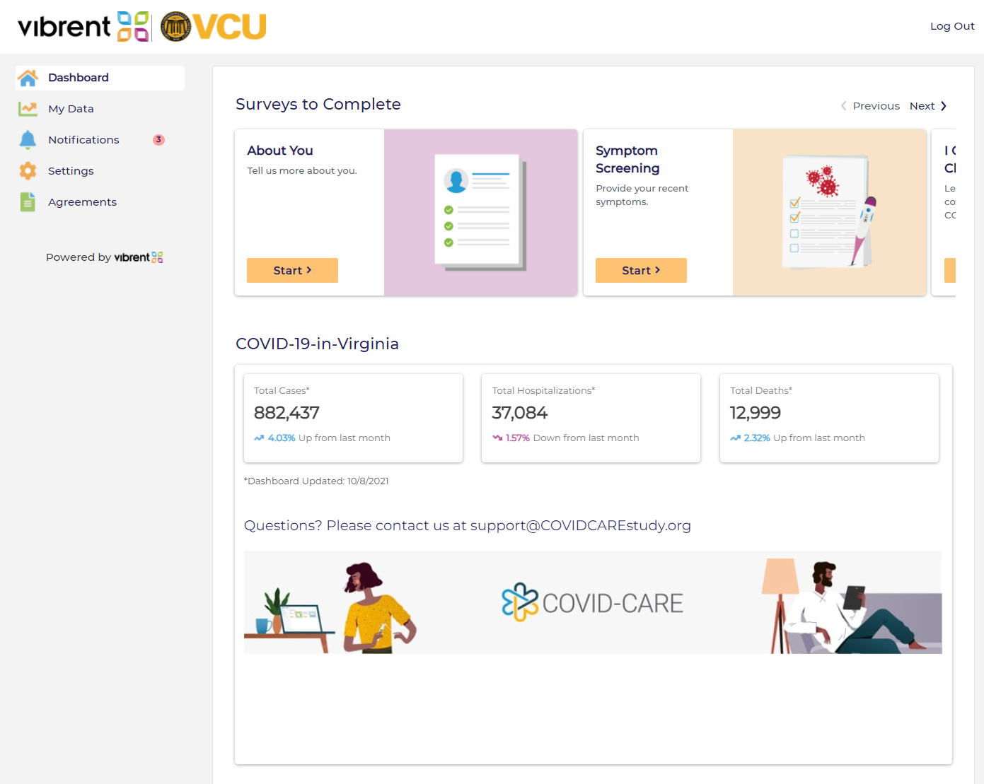

Image 2: An example symptom screening survey question on the study website.

