Identification and Prognosis of Patients with
Interstitial Pneumonia with Autoimmune Features - Supplementary Material
Table of Contents:

Supplementary Figure 1. Visual schematic of Interstitial Pneumonia with Autoimmune Features (IPAF) classification criteria. 2
Supplementary Methods 1. Definitions of IPAF Morphologic Domain Criteria. 3
Definition of Nonspecific Interstitial Pneumonia (NSIP) and Organizing Pneumonia (OP) in Patients Classified as IPAF: 3
Definitions of Additional Histopathologic Patterns: 4
Definitions of Multicompartment Criteria: 4
Supplementary Methods 2. Definitions of Mixed Connective Tissue Disease (MCTD), Antisynthetase Syndrome, and anti-MDA5 Dermatomyositis. 5
Supplementary Methods 3. Updated classification of patients with a Multidisciplinary Discussion (MDD) diagnosis of Idiopathic Pulmonary Fibrosis (IPF) or Unclassifiable. 5
Supplementary Table 1: Comparison of the baseline clinical and therapeutic characteristics of MDD diagnoses prior to final study classification. 7
Supplementary Figure 2. Relationship between initial MDD diagnoses and final study classification after retrospective review of follow-up data. 9
Supplementary Figure 3: Relative proportion of different connective tissue diseases (CTDs) in patients with connective tissue disease-associated interstitial lung disease (CTD-ILD). 10
Supplementary Figure 4: Relative proportions of patients with a given CTD-ILD who were diagnosed with interstitial lung disease (ILD) either prior to, or concurrently with, their CTD diagnosis. 11
Supplementary Table 2: Domains and domain criteria fulfilled by the cohort of patients classified as IPAF (n=60). 12
Supplementary Figure 5: Proportion of patients with CTD-ILD and IPAF with clinical features comprising the IPAF clinical domain. 14
Supplementary Table 3: Frequency of positive, negative, and missing serologies for patients fulfilling IPAF criteria (n=60). 15
Supplementary Figure 6: Transplant-free survival rate by type of CTD-ILD. 16
Supplementary Table 4. Age and sex-adjusted transplant-free survival of patients classified as IPAF versus patients with CTD-ILD versus patients with IPF. 17
Supplementary Figure 7: Transplant-free survival of a modified IPAF cohort which now includes an additional n=11 patients with antisynthetase antibodies with a prior study classification of CTD-ILD, versus CTD-ILD and IPF. 18
Supplementary Table 5. Characteristics of patients initially classified as IPAF who were eventually diagnosed with classifiable disease during follow-up. 20
References for Supplementary Material: 21

Supplementary Figure 1. Visual schematic of Interstitial Pneumonia with Autoimmune Features (IPAF) classification criteria.
ILD = interstitial lung disease; HRCT = high-resolution computed tomography; CTD = connective tissue disease; NSIP = non-specific interstitial pneumonia; OP = organizing pneumonia; LIP = lymphoid interstitial pneumonia; PFT = pulmonary function testing; † = includes airflow obstruction, bronchiolitis, or bronchiectasis; ‡ Refer to the article’s Supplementary Methods 1 for our specific definition(s) of these parameters. Produced from criteria published in Fischer et. al.[1]

Supplementary Methods 1. Definitions of IPAF Morphologic Domain criteria.

Definition of Nonspecific Interstitial Pneumonia (NSIP) and Organizing Pneumonia (OP) in Patients Classified as IPAF:
If not explicitly recorded during the Multidisciplinary Discussion (MDD), NSIP on high-resolution computed tomography (HRCT) in patients classified as IPAF was defined based on the following criteria: [2–4]
- The absence of “definite usual interstitial pneumonia (UIP)” per the MDD, and
- MDD radiographic description indicates symmetric, basilar-predominant reticulation and/or basilar-predominant ground glass opacities, and
- The absence of consolidation, and
- Findings are persistent (sustained over the course of at least two sequential computed tomography (CT) images) and idiopathic (e.g., not attributable to aspiration, infection, pulmonary edema, medication use, or other identifiable causes), and
- The treating pulmonologist and/or treating radiologist indicate possible NSIP

If not explicitly recorded during the MDD, OP on HRCT in patients classified as IPAF was defined based on the following criteria: [2,4]
- The absence of “definite” UIP per the MDD and
- MDD radiographic description indicates the presence of ground glass opacities, and
- The presence of consolidation, and
- Findings are persistent (sustained over the course of at least two sequential CT images) and idiopathic (e.g., not attributable to aspiration, infection, pulmonary edema, medication use, or other identifiable causes), and
- The treating pulmonologist and/or treating radiologist indicate possible OP

The presence of NSIP, OP, or NSIP+OP on histopathology in patients classified as IPAF was established based on the documentation of these findings by the pathologist.

Definitions of Additional Histopathologic Patterns:
We established the IPAF morphologic histopathologic patterns of “interstitial lymphoid aggregates with germinal centers” and “diffuse lymphoplasmacytic infiltration” based on documentation of these findings by the pathologist.

Definitions of Multicompartment Criteria:
We defined components of the multicompartment criteria within the IPAF morphologic domain as follows:

- intrinsic airways disease was established on the basis of forced expiratory volume in one second / forced vital capacity (FEV1/FVC) < 0.70 or idiopathic air trapping in multiple lobes on HRCT (each in the absence of a history of obstructive lung disease or “ever” tobacco use), constrictive or follicular bronchiolitis on histopathology, or severe non-traction bronchiectasis on HRCT;
- pulmonary vasculopathy was established based on the presence of cardiac catheterization hemodynamics indicating a mean pulmonary artery pressure ≥ 25 mmHg and a pulmonary capillary wedge pressure ≤ 15 mmHg, or the presence of an FVC %predicted / DLCO %predicted ratio > 1.6 on at least two consecutive pulmonary function tests (PFTs), or the presence of vasculopathy on pulmonary histopathology [5,6]
- unexplained pleural or pericardial effusion or thickening was established based on their presence on HRCT (pleural) or echocardiographic (pleural, pericardial) imaging in the absence of an identifiable cause.

Supplementary Methods 2. Definitions of Mixed Connective Tissue Disease (MCTD), Antisynthetase Syndrome, and anti-MDA5 Dermatomyositis.
Due to their potential overlap with IPAF classification criteria, we established diagnoses of MCTD based on either Kahn’s or Alarcon-Segovia’s criteria [7,8]. Similarly, given that the presence of an antisynthetase antibody in patients with NSIP or OP would alone merit classification as IPAF, we established a diagnosis of the antisynthetase syndrome based on the criteria proposed by Solomon et. al. with modification based on the more recent idiopathic inflammatory myopathy classification criteria—patients with a positive anti-Jo1 antibody fulfilling the major criterion of dermato- or polymyositis required an IIM classification of “Definite IIM,” given the inclusion of Jo1 within the IIM classification criteria, whereas those with non-Jo1 antisynthetase antibodies required an IIM classification of only “Probable IIM” [9,10]. We established a diagnosis of anti-MDA5 dermatomyositis based on the presence of ILD in association with characteristic cutaneous features and the presence of a detectable anti-MDA5 antibody [11].

Supplementary Methods 3. Updated classification of patients with a Multidisciplinary Discussion (MDD) diagnosis of Idiopathic Pulmonary Fibrosis (IPF) or Unclassifiable.
Patients with an initial MDD diagnosis of IPF (n=125) were reclassified as “IPAF” (n=4) or “CTD-ILD” (n=5) based on the presence of the aforementioned classification criteria for IPAF and CTD-ILD (at baseline) (Supplementary Figure 2). Patients with an initial MDD diagnosis of IPF (n=125) were assigned a final study classification of “Other or Unclassifiable” (n=3) only if additional radiographic or histopathologic data acquired after the date of MDD was deemed inconsistent with idiopathic UIP. Finally, patients initially given a non-IPF MDD diagnosis were reclassified as IPF (n=13) only if additional radiologic or histopathologic information obtained after the date of the MDD indicated the presence of UIP without an alternate cause throughout the entirety of follow-up.

Supplementary Table 1: Comparison of the baseline clinical and therapeutic characteristics of MDD diagnoses prior to final study classification.
IPF = idiopathic pulmonary fibrosis; CTD-ILD = connective tissue disease interstitial lung disease; COP = cryptogenic organizing pneumonia; iNSIP = idiopathic nonspecific interstitial pneumonia; LIP = lymphoid interstitial pneumonia. Denominators or sample sizes within parentheses are provided for missing values. Race (Other) includes Latino, Native American, Pacific Islander, or unknown. Continuous variables are reported as mean ± S.D or as median [interquartile range]. Discrete variables are reported as counts (% of group total). FVC = forced vital capacity; FEV1 = forced expiratory volume in one second; TLC = total lung capacity; DLCO = diffusing capacity of carbon monoxide; 6MWT = 6-minute walk test; UIP = usual interstitial pneumonia; HRCT = high-resolution computed tomography (of the chest); “ILD glucocorticoid-sparing therapy” includes mycophenolate mofetil, azathioprine, tacrolimus, rituximab, or cyclophosphamide “Non-ILD glucocorticoid-sparing therapy” includes methotrexate, anti-TNFα biologics, anakinra, leflunomide, and hydroxychloroquine; “immunosuppression during follow-up” excludes immunosuppressive treatments rendered after lung transplant; “Antifibrotics” includes pirfenidone or nintedanib.
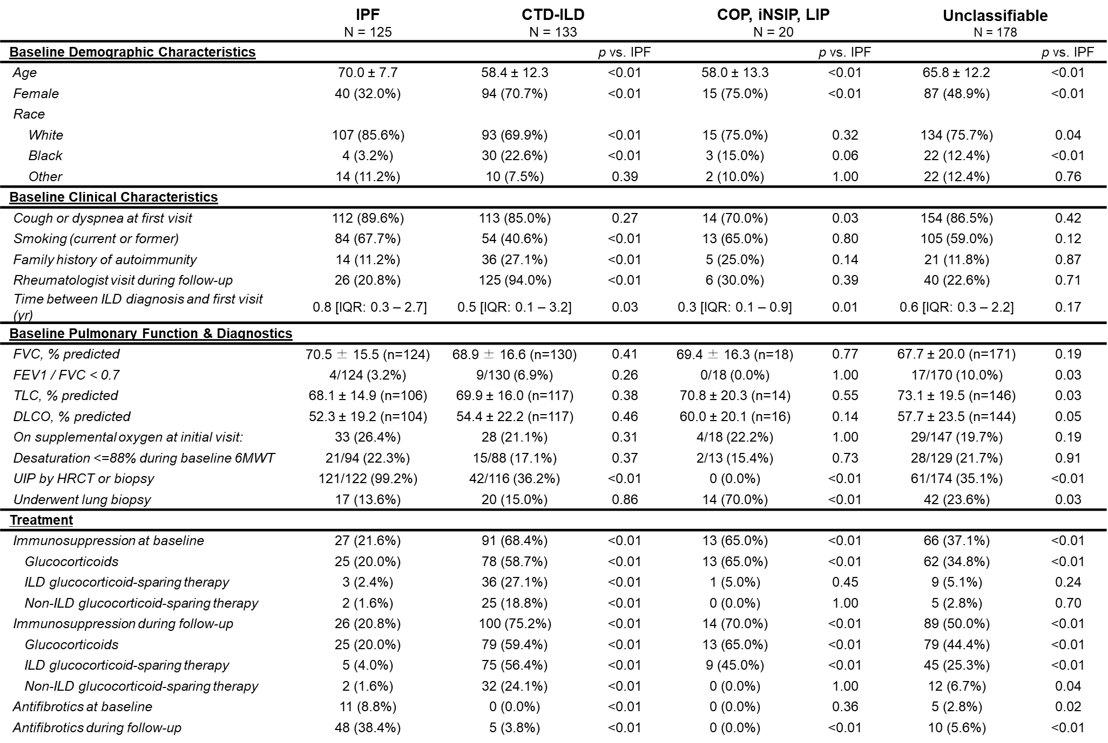

Supplementary Figure 2. Relationship between initial MDD diagnoses and final study classification after retrospective review of follow-up data.
MDD diagnoses for the 26 patients with MDD classifications of CTD-ILD that were subsequently classified as IPAF included the following: 10 UCTD, 4 MCTD, 3 DM/PM, 3 RA, 2 ASyS, 2 SLE, 1 SSc, and 1 SS. UCTD = undifferentiated connective tissue disease; MCTD = mixed connective tissue disease; DM/PM = polymositis/dermatomyositis; RA = rheumatoid arthritis; ASyS = antisynthetase syndrome; SLE = systemic lupus erythematosus; SSc = systemic sclerosis; SS = Sjogren’s syndrome. iNSIP = idiopathic nonspecific interstitial pneumonia; COP = cryptogenic organizing pneumonia; LIP = lymphoid interstitial pneumonia; IPAF = interstitial pneumonia with autoimmune features; CTD-ILD = connective tissue disease-associated interstitial lung disease; IPF = idiopathic pulmonary fibrosis.
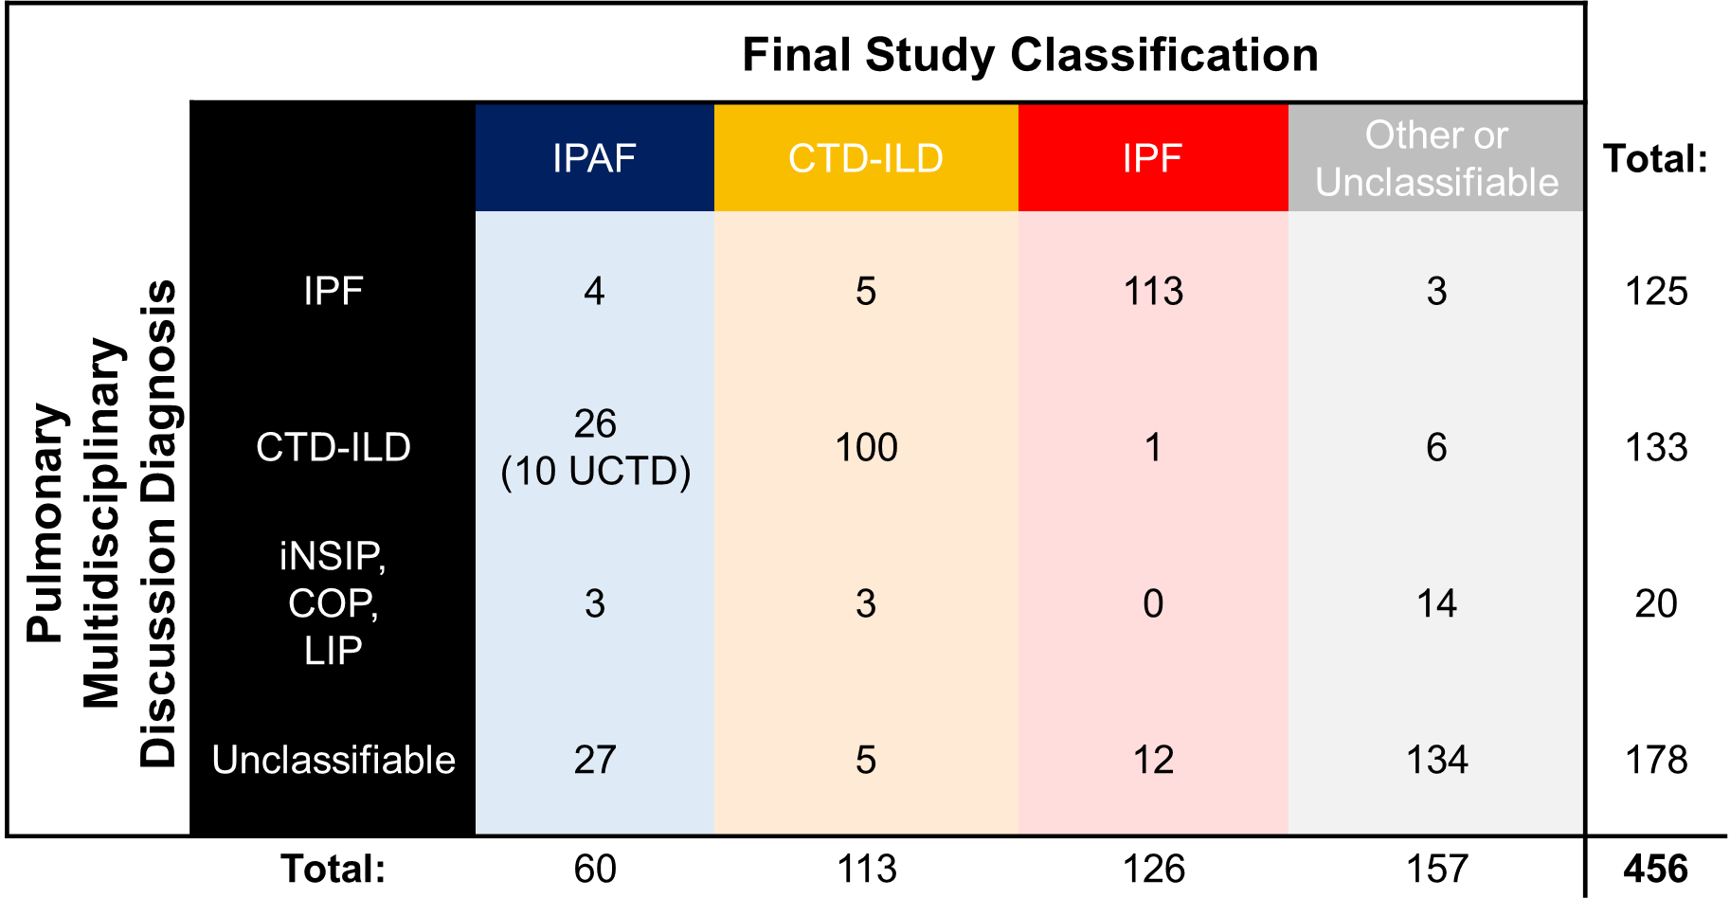

Supplementary Figure 3: Relative proportion of different connective tissue diseases (CTDs) in patients with connective tissue disease-associated interstitial lung disease (CTD-ILD).
The compound bar graph indicates the proportion of a given CTD with a UIP pattern. Antisynthetase/MDA5 = antisynthetase syndrome or anti-MDA5 antibody dermatomyositis; DM or PM = dermatomyositis or polymyositis; Sjögren’s = Sjögren’s syndrome; AAV = ANCA-associated vasculitis; “Other” includes 1 patient with a SSc/RA overlap, 1 patient with AAV/RA overlap, and 1 patient with primary antiphospholipid syndrome.

Supplementary Figure 4: Relative proportions of patients with a given CTD-ILD who were diagnosed with interstitial lung disease (ILD) either prior to, or concurrently with, their CTD diagnosis.
“ILD diagnosed ‘prior to’ CTD” in patients with CTD-ILD was specified as an ILD diagnosis established more than 6 months prior to the date of CTD diagnosis. “ILD diagnosed ‘concurrently with’ CTD” in patients with CTD-ILD was specified as an ILD diagnosis established within 6 months of the date of CTD diagnosis. Pairwise statistical comparisons were performed for the most commonly observed CTD-ILDs, depicted below. Additional pairwise comparisons not depicted did not meet the threshold for statistical significance. MDA5 = anti-MDA5 dermatomyositis; Sjögren’s = Sjögren’s syndrome.

Supplementary Table 2: Domains and domain criteria fulfilled by the cohort of patients classified as IPAF (n=60).
NSIP = nonspecific interstitial pneumonia; OP = organizing pneumonia; LIP = lymphoid interstitial pneumonia.
 | Number of Patients (n) | % of Domain Total | % of IPAF Total
Clinical Domain | 24 | - | 40.0%
Distal digital fissuring | 0 | 0.0% | 0.0%
Distal digital tip ulceration | 0 | 0.0% | 0.0%
Inflammatory arthritis | 10 | 41.7% | 16.7%
Palmar telangiectasia | 0 | 0.0% | 0.0%
Raynaud’s phenomenon | 15 | 62.5% | 25.0%
Unexplained digital edema | 0 | 0.0% | 0.0%
Gottron’s sign | 0 | 0.0% | 0.0%
Serologic Domain | 57 | - | 95.0%
ANA ≥ 1:320 | 27 | 47.4% | 45.0%
ANA (nucleolar) and < 1:320 | 4 | 7.0% | 6.7%
ANA, (centromere) and < 1:320 | 0 | 0.0% | 0.0%
RF ≥ 2x upper limit of normal | 8 | 14.0% | 13.3%
Anti-CCP | 16 | 28.1% | 26.7%
Anti-dsDNA | 6 | 5.3% | 5.0%
Anti-Ro or La (SS-A or SS-B) | 15 | 26.3% | 25.0%
Anti-ribonucleoprotein (RNP) | 5 | 5.3% | 5.0%
Anti-Smith (Sm) | 2 | 1.8% | 1.7%
Anti-topoisomerase (Scl-70) | 2 | 3.5% | 3.3%
Anti-tRNA synthetase (e.g., Jo-1, PL-7,  PL-12, EJ, OJ, Ks, Zo, YRS) | 8 | 14.0% | 13.3%
Anti-PM-Scl | 0 | 0.0% | 0.0%
Anti-MDA-5 | 0 | 0.0% | 0.0%
Morphologic Domain | 49 | - | 81.7%
Suggestive radiology patterns by HRCT | 30 | 61.2% | 50.0%
NSIP | 29 | 59.2% | 48.3%
OP | 1 | 2.0% | 1.7%
NSIP with OP overlap | 0 | 0.0% | 0.0%
LIP | 0 | 0.0% | 0.0%
Histopathology patterns | 21 | 42.9% | 35.0%
NSIP | 10 | 20.4% | 16.7%
OP | 3 | 6.1% | 5.0%
NSIP with OP overlap | 2 | 4.1% | 3.3%
LIP | 0 | 0.0% | 0.0%
Interstitial lymphoid aggregates with  germinal centers | 5 | 10.2% | 8.3%
Diffuse lymphoplasmacytic infiltration (with  or without lymphoid follicles) | 1 | 2.0% | 1.7%
Multi-compartment involvement | 16 | 32.7% | 26.7%
Unexplained pleural effusion or thickening | 4 | 8.2% | 6.7%
Unexplained pericardial effusion or  thickening | 2 | 4.1% | 3.3%
Unexplained intrinsic airways disease (by  PFT, imaging, or pathology) | 7 | 14.3% | 11.7%
Unexplained pulmonary vasculopathy | 6 | 12.2% | 10.0%

Supplementary Figure 5: Proportion of patients with CTD-ILD and IPAF with clinical features comprising the IPAF clinical domain.
The distribution of clinical domain features for patients classified as IPAF is also depicted in Figure 2. Raynaud’s = Raynaud’s phenomenon.
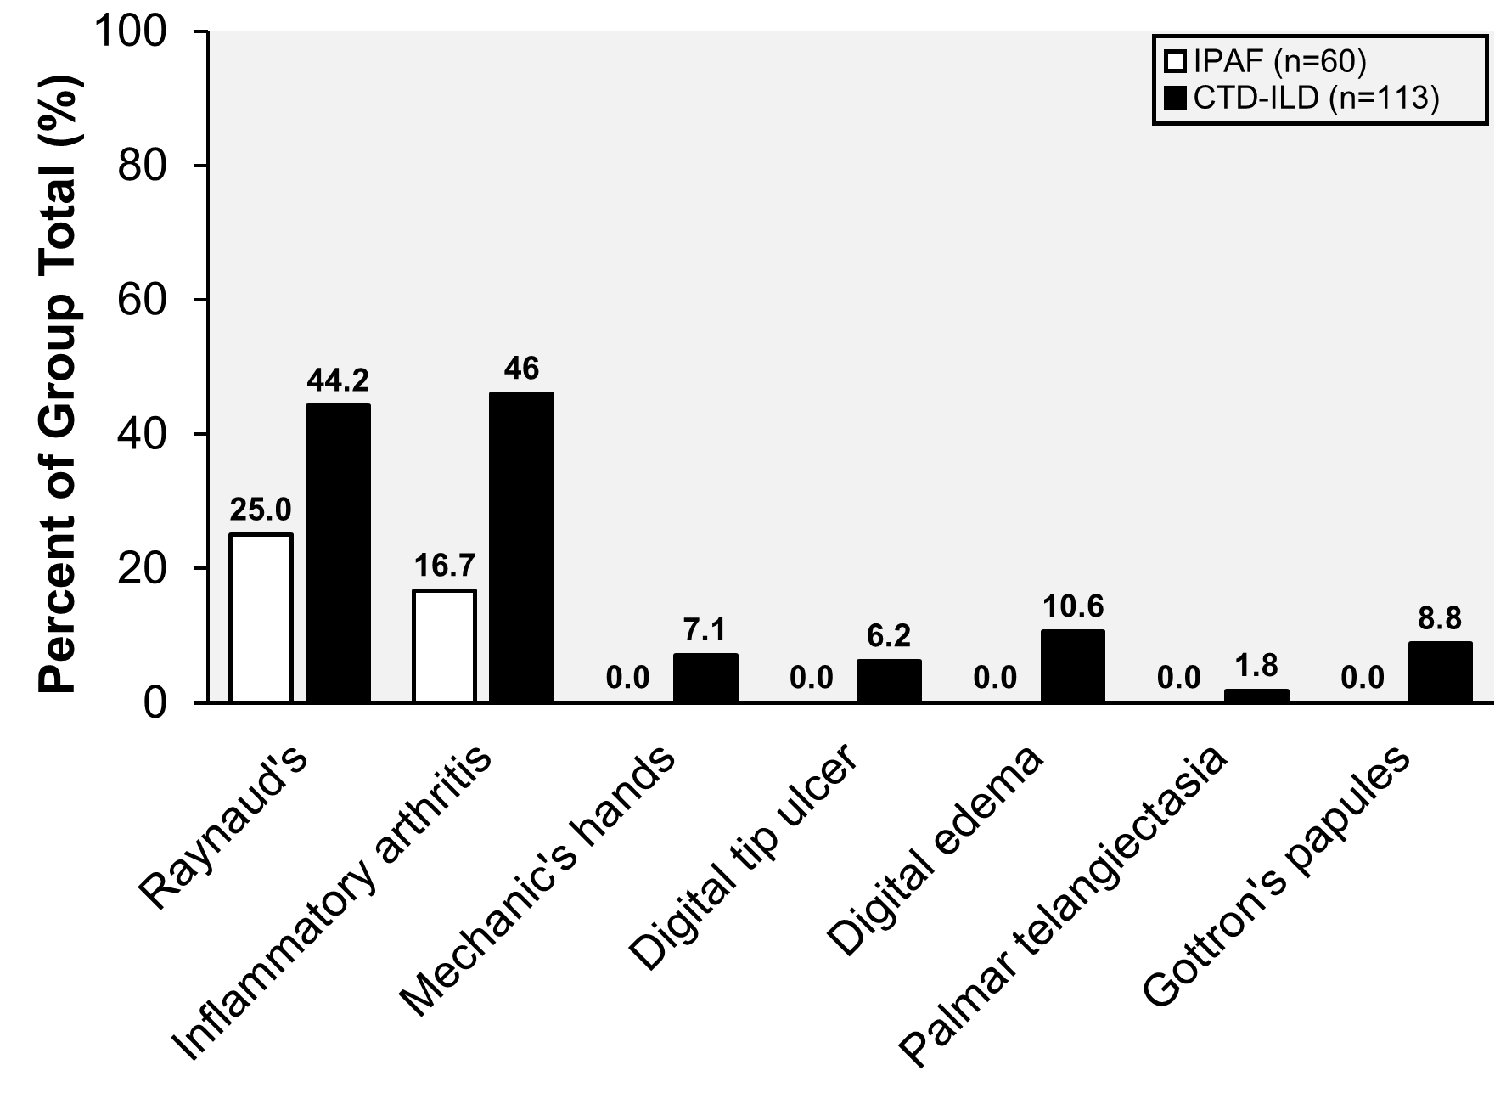

Supplementary Table 3: Frequency of positive, negative, and missing serologies for patients fulfilling IPAF criteria (n=60).
Percentages are calculated based on the total number of IPAF patients (n=60). Percentages for nuclear antigens dsDNA, Sm, RNP, and Scl70 were calculated based on the total number of positive ANA tests (n=31). ANA testing at our institution routinely indicates the presence of cytoplasmic speckling when present regardless of the presence of a nuclear staining pattern. While there were no missing ANA results in this study, we reported cytoplasmic speckling as “missing” if ANA testing was performed outside of our institution given that we could not be certain that these findings would be routinely reported.
 | Positive | Negative | Missing
All IPAF Patients (n=60) | n (%) | n (%) | n (%)
ANA | 31 (51.7%) | 29 (48.3%) | 0 (0.0%)
dsDNA | 3 (9.7%) | 21 (67.7%) | 7 (22.6%)
Anti-Sm | 1 (3.2%) | 21 (67.7%) | 9 (29.0%)
Anti-RNP | 3 (9.7%) | 22 (71.0%) | 6 (19.4%)
Anti-Scl70 | 2 (6.5%) | 26 (83.9%) | 3 (9.7%)
RF ≥ 2x upper limit of normal | 8 (13.3%) | 49 (81.7%) | 3 (5.0%)
Anti-CCP | 16 (26.7%) | 39 (65.0%) | 5 (8.3%)
Anti-SS-A, Anti-SS-B | 16 (26.7%) | 41 (68.3%) | 3 (5.0%)
Anti-Jo1 | 5 (8.3%) | 46 (76.7%) | 9 (15.0%)
Non-Jo1 myositis-specific antibodies (e.g., PL-7,  PL-12, EJ, OJ, Ks, Zo, YRS, PM-Scl,  MDA5) | 3 (5.0%) | 23 (38.3%) | 34 (56.7%)
Cytoplasmic speckling on ANA | 10 (16.7%) | 32 (53.3%) | 18 (30.0%)

Supplementary Figure 6: Transplant-free survival rate by type of CTD-ILD.
There were no significant differences in the unadjusted transplant-free survival rates amongst the most common CTD-ILDs in the study cohort (log-rank p = 0.13). Pairwise comparisons of the unadjusted transplant-free survival rate of IPAF versus different CTD-ILDs identifies a significantly longer transplant-free survival in patients with IIM/Synthetase ILD (log-rank p < 0.01). Additional pairwise comparisons did not meet the threshold for statistical significance. Sjögren’s = Sjögren’s syndrome; IIM/Synthetase = Idiopathic inflammatory myopathy-associated/antisynthetase-associated ILD.

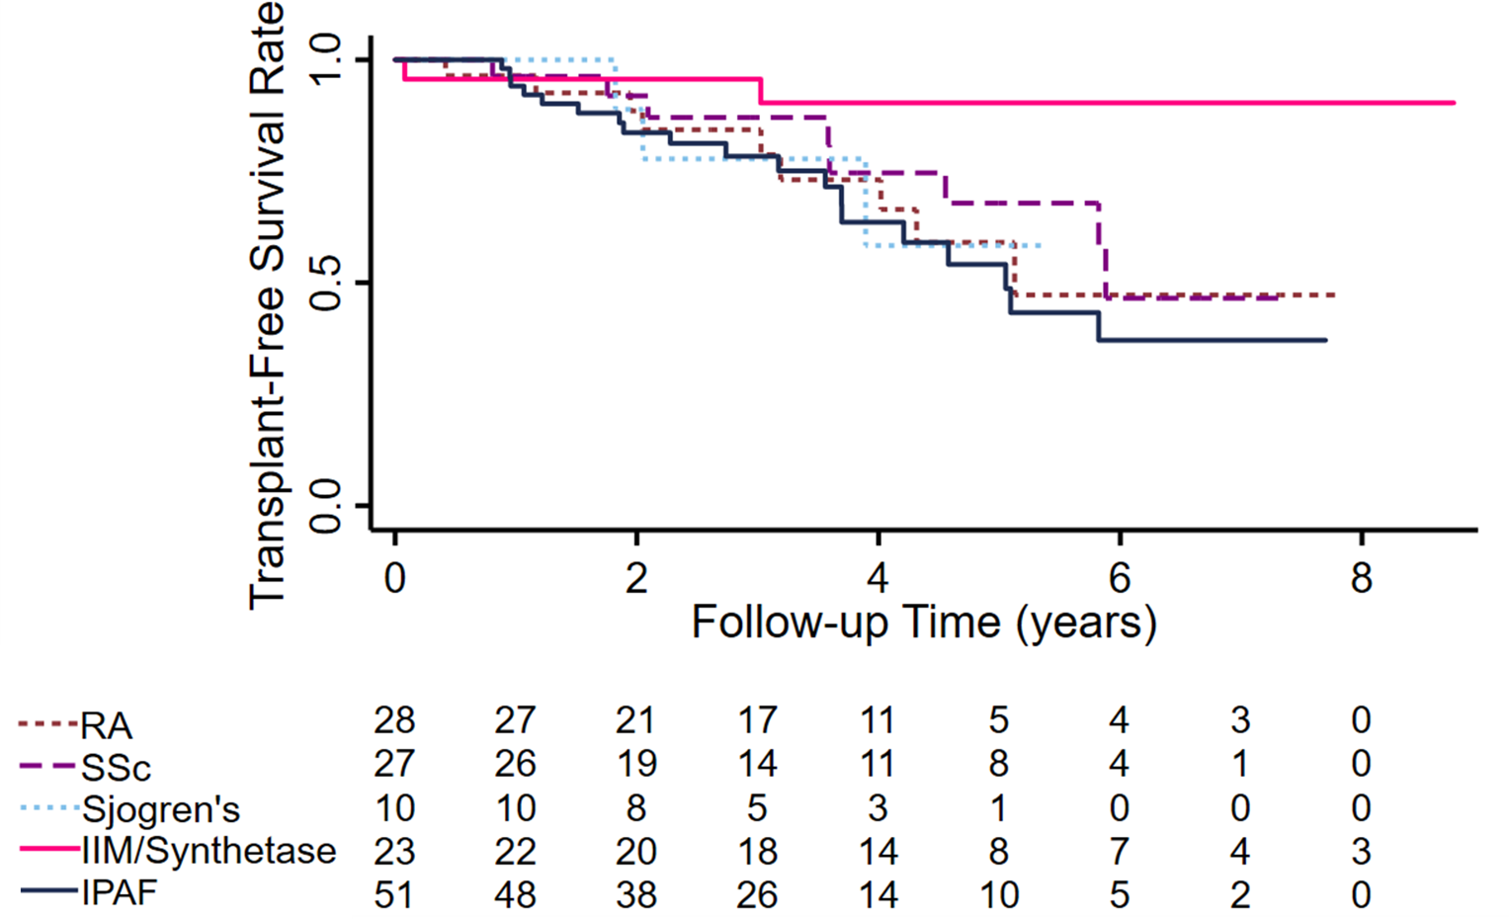

Supplementary Table 4. Age and sex-adjusted transplant-free survival of patients classified as IPAF versus patients with CTD-ILD versus patients with IPF.
Survival analysis excludes those patients whose first ILD clinic visit occurred prior to 2011 as described under Materials and Methods. There was no statistically significant difference in transplant-free survival between patients classified as IPAF and patients with CTD-ILD (p = 0.24 versus IPAF) or patients with IPF (p = 0.30 versus IPAF) after adjusting for age and sex. Both age and sex are components of the ILD-GAP model which differed significantly between patients with IPF and patients with either IPAF or CTD-ILD (Table 1).

Age and Sex-Adjusted
Transplant-Free Survival Analysis
 | HR [95% CI] | p
Classification
IPAF | Reference | -
CTD-ILD | 0.70  [0.38 – 1.28] | 0.24
IPF | 0.74  [0.42 – 1.31] | 0.30
Age (per 10-year increase) | 1.36  [1.09 – 1.70] | 0.01
Male sex | 1.63  [1.04 – 2.58] | 0.04

Supplementary Figure 7: Transplant-free survival of a modified IPAF cohort which now includes an additional n=11 patients with antisynthetase antibodies with a prior study classification of CTD-ILD, versus CTD-ILD and IPF.
Antisynthetase and anti-MDA5 antibodies are included in the IPAF serologic domain, and patients with these antibodies are therefore often classified as IPAF in other IPAF cohort studies. In our study, patients with antisynthetase and anti-MDA5 antibodies were specifically classified as CTD-ILD provided that they fulfilled criteria defined in Supplementary Methods 2. To clarify the impact of our approach to antisynthetase syndrome/anti-MDA5 classification, we repeated our transplant-free survival analysis of IPAF versus CTD-ILD versus IPF by reassigning n=11 CTD-ILD patients with ASyS or anti-MDA5 antibodies (n=11 antisynthetase antibodies, n=0 anti-MDA5) that did not exhibit features of inflammatory myopathy to the IPAF cohort, as would have been done in most prior IPAF studies. Transplant-free survival of the modified cohort is shown using dotted lines, superimposed over the transplant-free survival of the published study cohort, and indicates a modest improvement in the transplant-free survival of the IPAF cohort. The risk table includes the original cohort data, as it appears in Figure 3, as well as data from analysis of the modified cohort.
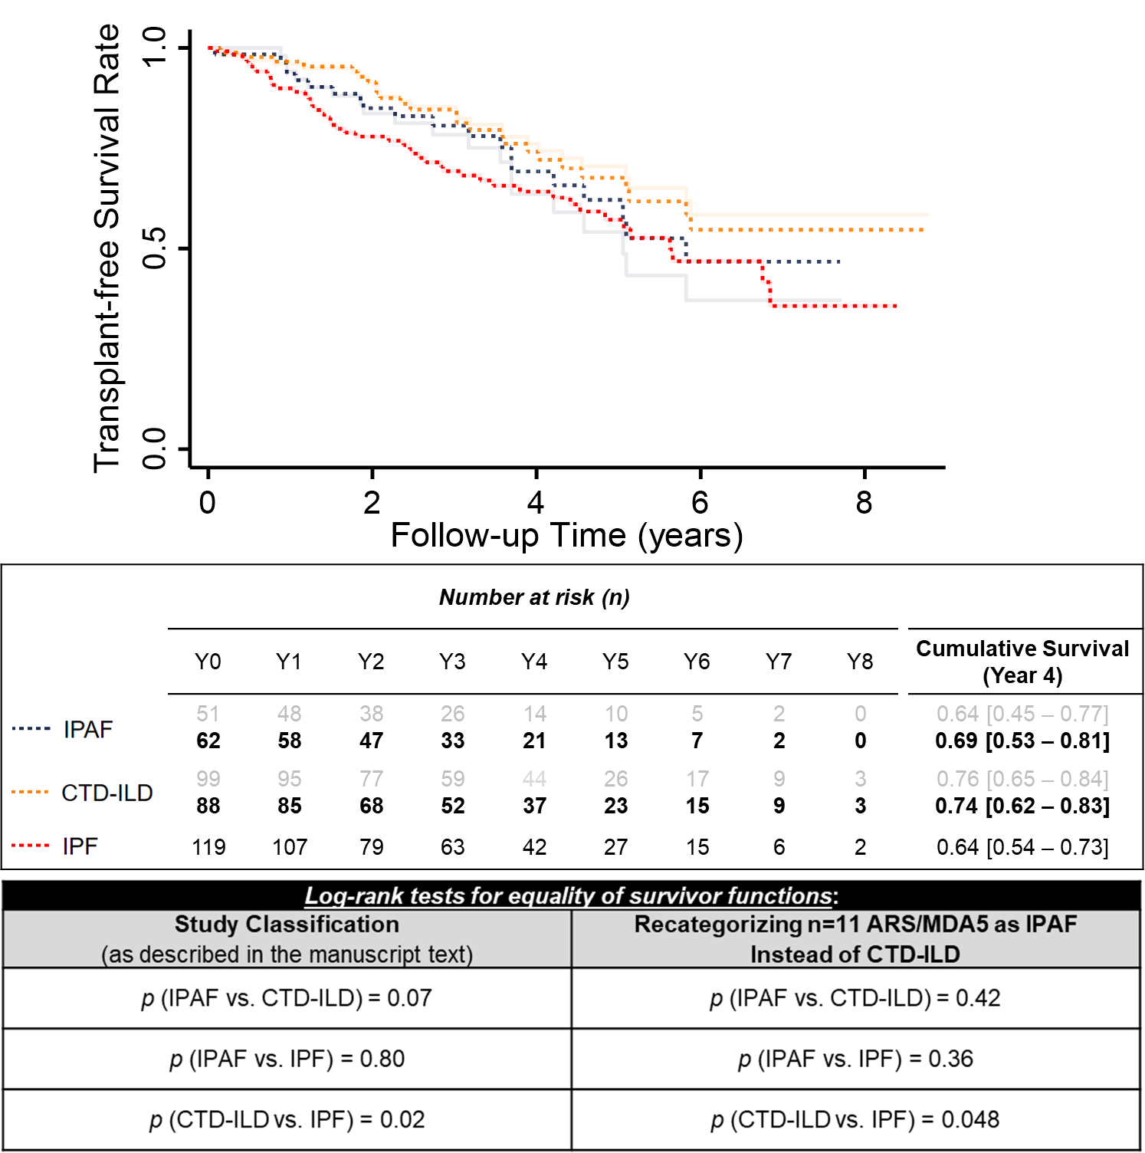

Supplementary Table 5. Characteristics of patients initially classified as IPAF who were eventually diagnosed with classifiable disease during follow-up.
“Time from ILD Dx to IPAF” refers to the difference, in years, between the date of ILD diagnosis and the date of IPAF classification. “Time from IPAF to CTD-ILD Dx” refers to the difference, in years, between the date of IPAF classification and the date of disease diagnosis. F = female; M = male; NSIP = nonspecific interstitial pneumonia; OP = organizing pneumonia; PFTs = pulmonary function tests; CCP = anti-cyclic citrullinated peptide antibodies; PAP = pulmonary alveolar proteinosis. ELP = endogenous lipoid pneumonia. 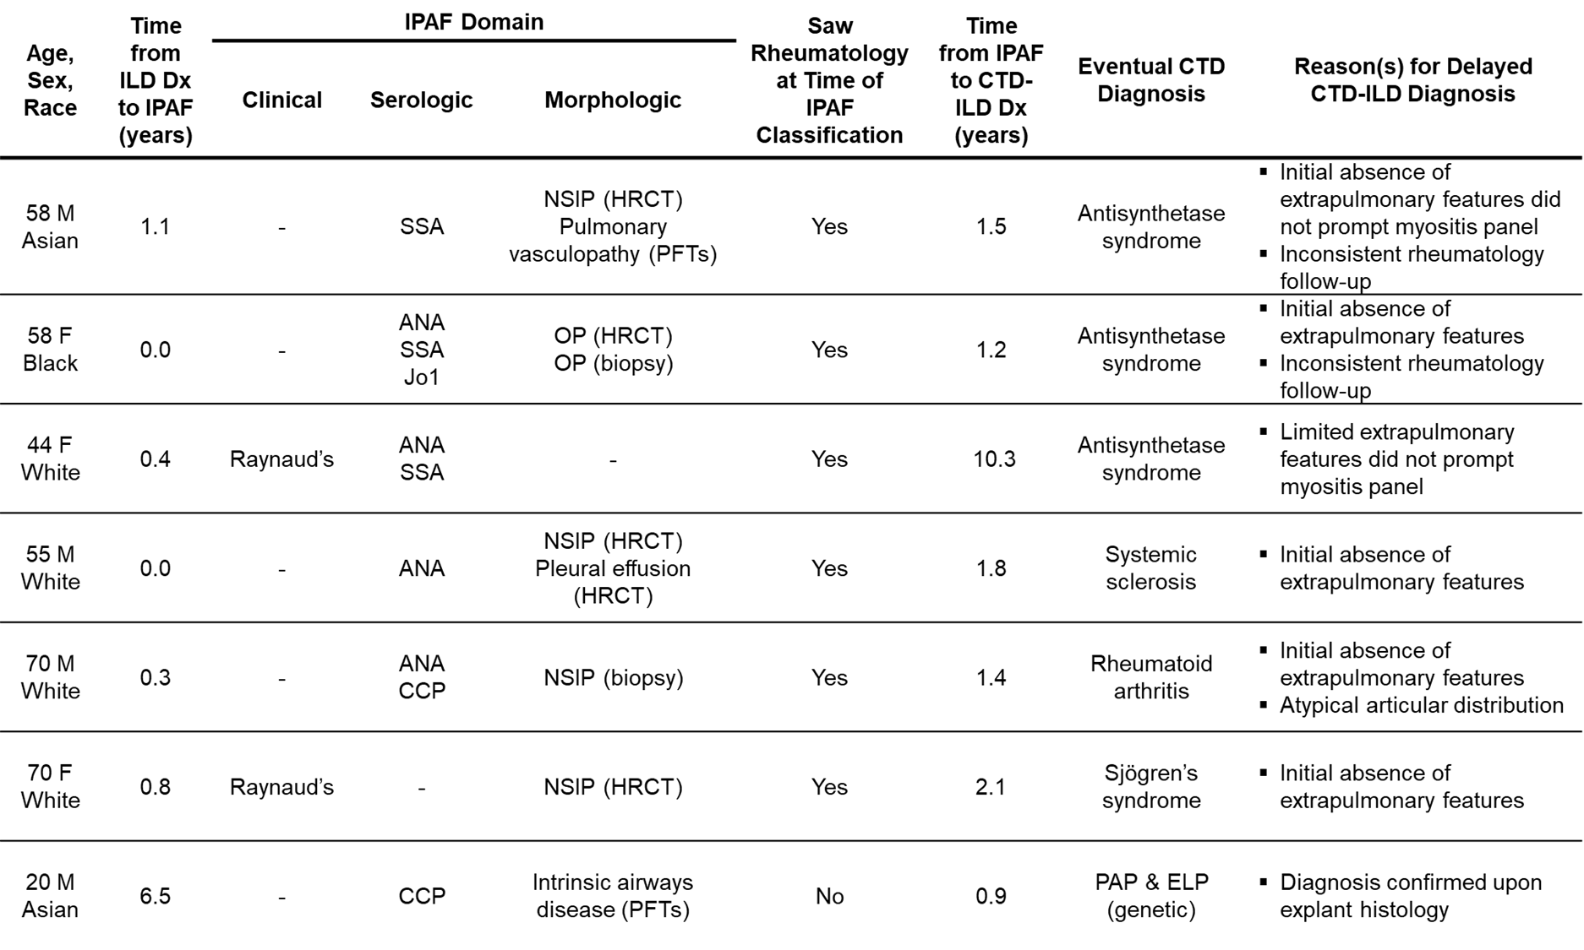

References for Supplementary Material:
1. Fischer A, Antoniou KM, Brown KK, et al. An official European Respiratory Society/American Thoracic Society research statement: Interstitial pneumonia with autoimmune features. Eur Respir J [Internet]. (2015);46:976–87.
2. Travis WD, Costabel U, Hansell DM, et al. An official American Thoracic Society/European Respiratory Society statement: Update of the international multidisciplinary classification of the idiopathic interstitial pneumonias. Am J Respir Crit Care Med. (2013);188:733–48.
3. Travis WD, Hunninghake G, King TE, et al. Idiopathic nonspecific interstitial pneumonia: Report of an American Thoracic Society Project. Am J Respir Crit Care Med. (2008);177:1338–47.
4. Sverzellati N, Lynch DA, Hansell DM, et al. American Thoracic Society-European Respiratory Society Classification of the Idiopathic Interstitial Pneumonias: Advances in Knowledge since 2002. Radiographics. (2015);35:1849–72.
5. Mecoli CA, Shah AA, Boin F, et al. Vascular complications in systemic sclerosis: a prospective cohort study. Clin Rheumatol. (2018);37:2429–37.
6. Steen VD, Graham G, Conte C, et al. Isolated diffusing capacity reduction in systemic sclerosis. Arthritis Rheum. (1992);35:765–70.
7. Farhey Y, Hess E V. Mixed connective tissue disease. Arthritis Care Res. (1997);10:333–42.
8. J M Amigues, A Cantagrel, M Abbal BM. Comparative study of 4 diagnosis criteria sets for mixed connective tissue disease in patients with anti-RNP antibodies. Autoimmunity Group of the Hospitals of Toulouse. J Rheumatol. (1996);23:2055–62.
9. Solomon J, Swigris JJ, Brown KK. Myositis-related interstitial lung disease and antisynthetase syndrome. J Bras Pneumol [Internet]. (2013);37:100–9.
10. Witt LJ, Curran JJ, Strek ME. The Diagnosis and Treatment of Antisynthetase Syndrome. Clin Pulm Med. (2016);23:218–26.
11. Kurtzman DJB, Vleugels RA. Anti-melanoma differentiation–associated gene 5 (MDA5) dermatomyositis: A concise review with an emphasis on distinctive clinical features. J Am Acad Dermatol [Internet]. (2018);78:776–85.

