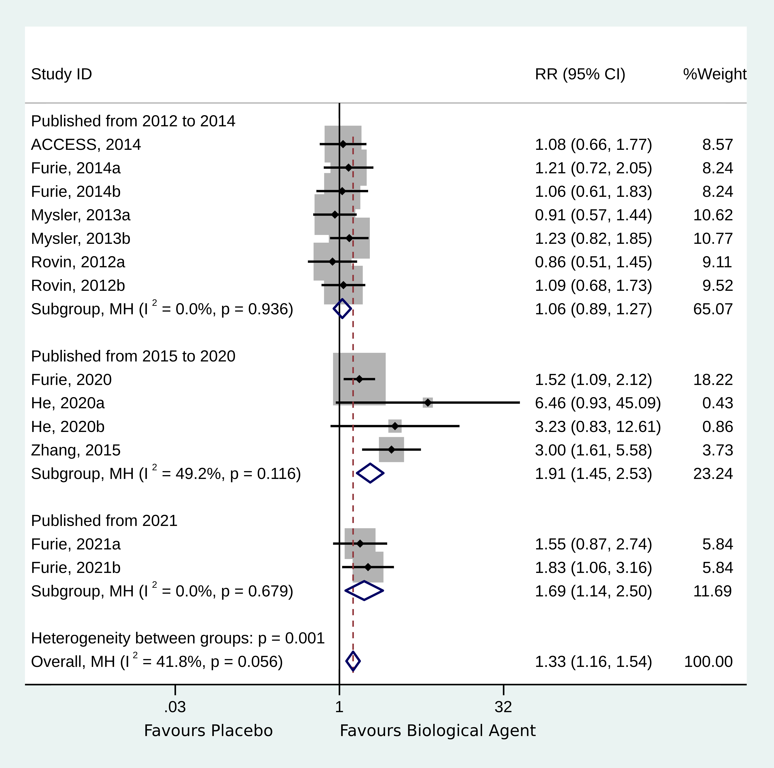
Supplementary Figure S1. Forest plot of complete response by publication time. 1: Published from 2012 to 2014. 2: Published from 2015 to 2020. 3: Published in 2021. 4: Overall.

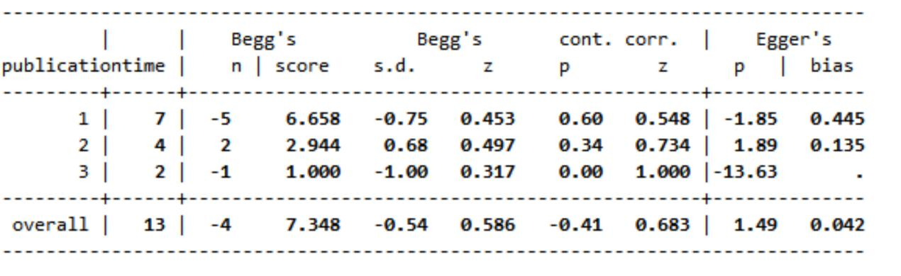

Supplementary Figure S2. Publication bias of complete response by publication time.

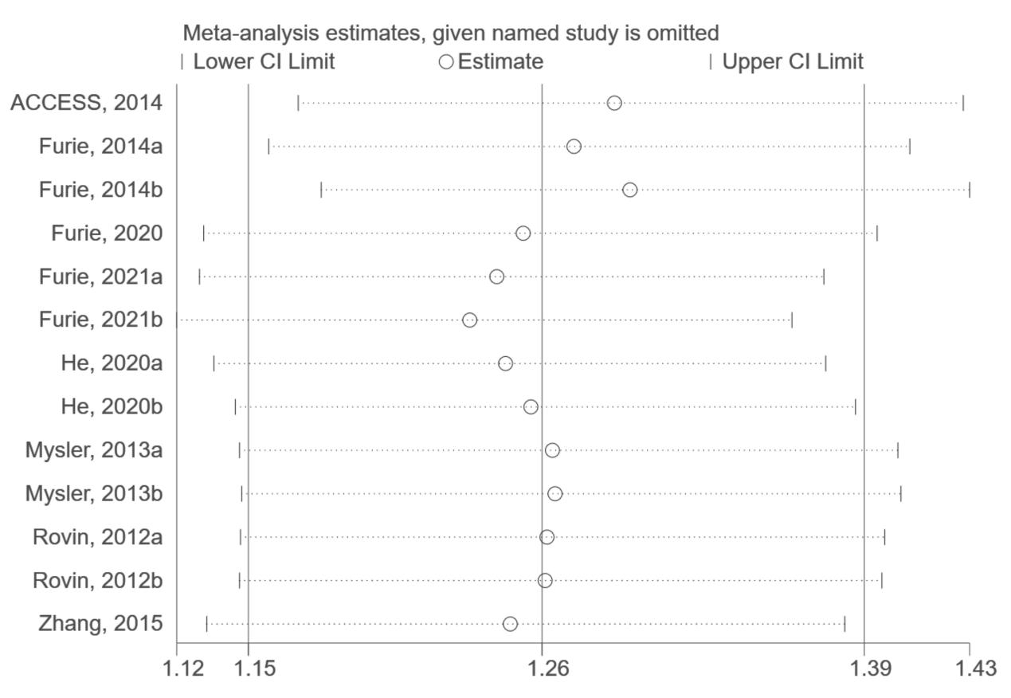

Supplementary Figure S3. Sensitivity analysis of overall response.

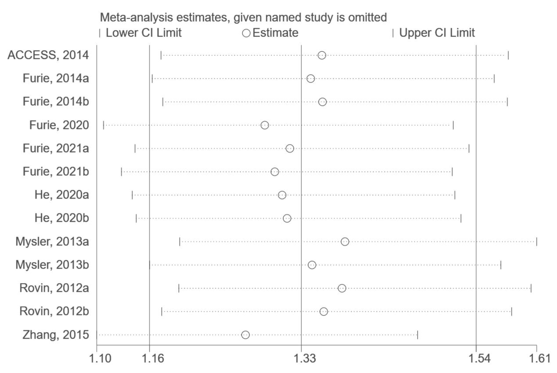

Supplementary Figure S4. Sensitivity analysis of complete response.

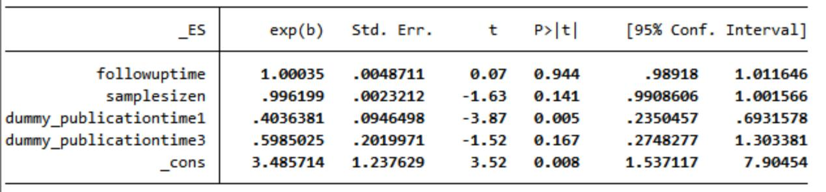

Supplementary Figure S5. Meta-regression of complete response.

Supplementary Table S1. Search strategy
PubMed |  | Search strategy | Numbers
Patient | #1 | "Lupus Nephritis"[Mesh] | 7078
 | #2 | ((((((Lupus Glomerulonephritis[Title/Abstract]) OR (Nephritis, Lupus[Title/Abstract])) OR (Lupus Nephritides[Title/Abstract])) OR (Nephritides, Lupus[Title/Abstract])) OR (Glomerulonephritis, Lupus[Title/Abstract])) OR (Glomerulonephritides, Lupus[Title/Abstract])) OR (Lupus Glomerulonephritides[Title/Abstract]) | 12,754
 | #3 | #1 OR #2 | 13,234
Intervention | #4 | "Biological Factors"[Mesh] | 3,455,749
 | #5 | ((((((((((((((Biological Agent[Title/Abstract]) OR (Agent, Biological[Title/Abstract])) OR (Biological Factor[Title/Abstract])) OR (Biologic Agents[Title/Abstract])) OR (Agents, Biologic[Title/Abstract])) OR (Factors, Biological[Title/Abstract])) OR (Biologic Factors[Title/Abstract])) OR (Factors, Biologic[Title/Abstract])) OR (Factor, Biologic[Title/Abstract])) OR (Biologic Factor[Title/Abstract])) OR (Biological Agents[Title/Abstract])) OR (Agents, Biological[Title/Abstract])) OR (Biologic Agent[Title/Abstract])) OR (Agent, Biologic[Title/Abstract])) OR (Factor, Biological[Title/Abstract]) | 12,097
 | #6 | #4 OR #5 | 3,464,439
 | #7 | (((((((((((((((((Belimumab[Title/Abstract]) OR (Tabalumab[Title/Abstract])) OR (Blisibimod[Title/Abstract])) OR (Atacicept[Title/Abstract])) OR (Rituximab[Title/Abstract])) OR (Ocrelizumab[Title/Abstract])) OR (Epratuzumab[Title/Abstract])) OR (Bortezomib[Title/Abstract])) OR (Abatacept[Title/Abstract])) OR (P140[Title/Abstract])) OR (lupuzor[Title/Abstract])) OR (Edratide[Title/Abstract])) OR (pConsensus[Title/Abstract])) OR (Sifalimumab[Title/Abstract])) OR (Rontalizumab[Title/Abstract])) OR (Anifrolumab[Title/Abstract])) OR (AMG811[Title/Abstract])) OR (Toculizumab[Title/Abstract]) | 34,630
 | #8 | #6 AND #7 | 3,491,192
Outcome | #9 | ((((((((((complete remission) OR (complete response)) OR (total remission)) OR (overall response)) OR (total response)) OR (overall remission)) OR (partial remission)) OR (partial response)) OR (urinary protein)) OR (renal activity index)) OR (AI) | 4,154,938
P+I+O | #10 | #3 AND #8 AND #9 | 2680
Study type | #11 | (randomized controlled trial[pt] OR controlled clinical trial[pt] OR randomized[tiab] OR placebo[tiab] OR clinical trials as topic[mesh:noexp] OR randomly[tiab] OR trial[ti] NOT (animals[mh] NOT humans [mh])) | 1,306,134
P+I+O+S | #12 | #10 AND #11 | 132
Embase |  | Search strategy | Numbers
Patient | #1 | 'lupus erythematosus nephritis'/exp | 18,540
 | #2 | 'glomerulonephritis, lupoid':ab,ti OR 'lupoid nephritis':ab,ti OR 'lupus erythematosus, nephritis':ab,ti OR 'lupus glomerulonephritis':ab,ti OR 'lupus kidney':ab,ti OR 'lupus nephritis':ab,ti OR 'lupus nephropathy':ab,ti OR 'nephritis, lupus erythematosus':ab,ti OR 'nephritis, systemic lupus erythematosus':ab,ti OR 'systemic lupus erythematosis, nephritis':ab,ti | 15,359
 | #3 | #1 OR #2 | 20,419
Intervention | #4 | 'biological product'/exp | 807,796
 | #5 | 'biologic agent':ab,ti OR 'biologic agents':ab,ti OR 'biologic product':ab,ti OR 'biologic products':ab,ti OR 'biological agent':ab,ti OR 'biological agents':ab,ti OR 'biological products':ab,ti | 19,455
 | #6 | #4 OR #5 | 820,316
 | #7 | 'Belimumab':ab,ti OR 'Tabalumab':ab,ti OR 'Blisibimod':ab,ti OR 'Atacicept':ab,ti OR 'Rituximab':ab,ti OR 'Ocrelizumab':ab,ti OR 'Epratuzumab':ab,ti OR 'Bortezomib':ab,ti OR 'Abatacept':ab,ti OR 'P140':ab,ti OR 'lupuzor':ab,ti OR 'Edratide':ab,ti OR 'pConsensus':ab,ti OR 'Sifalimumab':ab,ti OR 'Rontalizumab':ab,ti OR 'Anifrolumab':ab,ti OR 'AMG811':ab,ti OR 'Toculizumab':ab,ti | 77,306
 | #8 | #6 OR #7 | 893,217
Outcome | #9 | 'complete remission':ab,ti OR 'complete response':ab,ti OR 'total remission':ab,ti OR 'overall response':ab,ti OR 'total response':ab,ti OR 'overall remission':ab,ti OR 'partial remission':ab,ti OR 'partial response':ab,ti OR 'urinary protein':ab,ti OR 'renal activity index':ab,ti OR 'AI':ab,ti | 245,293
P+I+O | #10 | #3 AND #8 AND #9 | 206
Study type | #11 | 'clinical trial'/de OR 'randomized controlled trial'/de OR 'randomization'/de OR 'single blind procedure'/de OR 'double blind procedure'/de OR 'crossover procedure'/de OR 'placebo'/de OR 'prospective study'/de OR 'randomi?ed controlled' NEXT/1 trial* OR rct OR 'randomly allocated' OR 'allocated randomly' OR 'random allocation' OR allocated NEAR/2 random OR single NEXT/1 blind* OR double NEXT/1 blind* OR (treble OR triple) NEAR/1 blind* OR placebo* | 2,589,380
P+I+O+S | #12 | #10 AND #11 | 87
Cochrane |  | Search strategy | Numbers
Patient | #1 | MeSH descriptor: [Lupus Nephritis] explode all trees | 261
 | #2 | (Lupus Glomerulonephritis):ti,ab,kw OR (Nephritis, Lupus):ti,ab,kw OR (Lupus Nephritides):ti,ab,kw OR (Nephritides, Lupus):ti,ab,kw OR (Glomerulonephritis, Lupus):ti,ab,kw OR (Glomerulonephritides, Lupus):ti,ab,kw OR (Lupus Glomerulonephritides):ti,ab,kw | 937
 | #3 | #1 OR #2 | 937
Intervention | #4 | MeSH descriptor: [Biological Factors] explode all trees | 77,906
 | #5 | (Biological Agent):ti,ab,kw OR (Agent, Biological):ti,ab,kw OR (Biological Factor):ti,ab,kw OR (Biologic Agents):ti,ab,kw OR (Agents, Biologic):ti,ab,kw OR (Factors, Biological):ti,ab,kw OR (Biologic Factors):ti,ab,kw OR (Factors, Biologic):ti,ab,kw OR (Factor, Biologic):ti,ab,kw OR (Biologic Factor):ti,ab,kw OR (Biological Agents):ti,ab,kw OR (Agents, Biological):ti,ab,kw OR (Biologic Agent):ti,ab,kw OR (Agent, Biologic):ti,ab,kw OR (Factor, Biological):ti,ab,kw | 14,199
 | #6 | #4 OR #5 | 89,923
 | #7 | (Belimumab):ti,ab,kw OR (Tabalumab):ti,ab,kw OR (Blisibimod):ti,ab,kw OR (Atacicept):ti,ab,kw OR (Rituximab):ti,ab,kw OR (Ocrelizumab):ti,ab,kw OR (Epratuzumab):ti,ab,kw OR (Bortezomib):ti,ab,kw OR (Abatacept):ti,ab,kw OR (P140):ti,ab,kw OR (lupuzor):ti,ab,kw OR (Edratide):ti,ab,kw OR (pConsensus):ti,ab,kw OR (Sifalimumab):ti,ab,kw OR (Rontalizumab):ti,ab,kw OR (Anifrolumab):ti,ab,kw OR (AMG811):ti,ab,kw OR (Toculizumab):ti,ab,kw | 8722
 | #8 | #6 OR #7 | 97,955
P+I | #9 | #3 AND #8 | 181
Outcome | #10 | (complete remission) OR (complete response) OR (total remission) OR (overall response) OR (total response)OR (overall remission) OR (partial remission) OR (partial response) OR (urinary protein) OR (renal activity index) OR (AI) | 129,494
P+I+O | #11 | #9 AND #10 | 91 (1R+90T)

Supplementary Table S2. Characteristics of the included studies
Author, Year | Country | Sample size (n) | Intervention | Control | Age (M/sd) | Follow-up times | Participants | Outcome
ACCESS, 2014 (18) | USA,  Mexico | 66/68 | Abatacept | Placebo | 32.0±10.1/ 32.7±12.0 | 24 weeks | Active lupus nephritis | Overall response, complete response, AEs, UPr:Cr
Furie, 2014 (19) | North America, Europe, South America, Asia, Australia, India, South Africa, and Turkey | 99/99/100 | Abatacept | Placebo | 31.0±9.5/ 30.5±10.6/ 31.8±9.0 | 52 weeks | Active class III or IV glomerulonephritis (with or without class V) | Overall response, complete response, AEs
Furie, 2020 (13) | 21 countries | 224/224 | Belimumab | Placebo | 33.7±10.7/ 33.1±10.6 | 104 weeks | Biopsy proven lupus nephritis | Overall response, complete response, AEs
Furie, 2021 (20) | North America, South America, Europe and Israel | 63/62 | Obinutuzumab | Placebo | 33.1±9.8/ 31.9±10.1 | a.52 weeks; b.104 weeks | Class III or IV active or active/chronic LN within 6 months of screening | Overall response, complete response, AEs
Ginzler, 2012 (21) | USA | 4/2 | Atacicept | Placebo | / | 14 days | Active LN (class III or IV LN) | UPr:Cr
He, 2020 (22) | China | 13/12 | IL-2 | Placebo | / | a.12 weeks; b.24 weeks | SLE patients | Overall response, complete response
Mysler, 2013 (23) | USA | 128/127/126 | Ocrelizumab | Placebo | 30.6 (16–60)/ 31.9 (16–69)/ 31.3 (17–66) | 48 weeks | SLE, including a history of antinuclear antibody positivity and active LN | Overall response, complete response, AEs
Rovin, 2012 (12) | USA | 72/72 | Rituximab | Placebo | 31.8 ± 9.6/ 29.4 ± 9.3 | a.52 weeks; b.78 weeks | SLE was required to have a history of antinuclear antibody positivity, class III or class IV (± class V) LN | Overall response, complete response, AEs
Zhang, 2015 (24) | China | 42/42 | Rituximab | Placebo | / | 12 months | Refractory severe LN | Overall response, complete remission

ACCESS: the Abatacept and Cyclophosphamide Combination: Efficacy and Safety Study; AEs: adverse events; UPr:Cr: Urinary protein-to-creatinine ratio; LN: lupus nephritis; SLE: systemic lupus erythematosus.

Supplementary Table S3. Cochrane criteria for the quality of RCTs

Study | Random sequence generation (selection bias) | Allocation concealment (selection bias) | Blinding of participants and personnel (performance bias) | Blinding of outcome assessment (detection bias) | Incomplete outcome data (attrition bias) | Selective reporting (reporting bias) | Other bias | Total quality scores
ACCESS, 2014 (18) |  | * | * | * | * | * | * | 6
Furie, 2014 (19) |  | * | * | * | * | * | * | 6
Furie, 2020 (13) | * | * | * | * | * | * | * | 7
Furie, 2021 (20) | * | * | * | * | * | * | * | 7
Ginzler, 2012 (21) |  | * | * | * | * | * | * | 6
He, 2020 (22) |  | * | * | * | * | * | * | 6
Mysler, 2013 (23) |  | * | * | * | * | * | * | 6
Rovin, 2012 (12) |  | * | * | * | * | * | * | 6
Zhang, 2015 (24) |  | * | * | * | * | * | * | 6

