Supplementary Figures
Supplementary Figure 1 Distribution of study patients by degree of thrombocytopenia and response to treatment.

Supplementary Figure 2 Framework of prediction model based on variational autoencoder.
Supplementary Figure 3 Correlation Analysis of Features. ALT, Alanine aminotransferase; ALP, Alkaline phosphatase; C3, Complement-3; FIB, Fibrinogen; AnuA, Anti-nucleosome antibody; AMA-M2, Anti-mitochondrial antibody-M2; ACA-IgG, Anti-cardiolipin antibodies-IgG; ACA-IgM, Anti-cardiolipin antibodies-IgM.
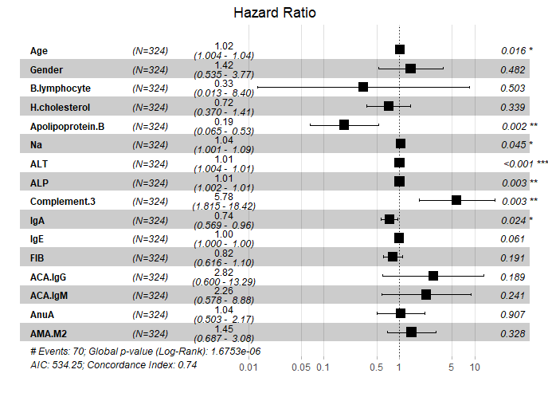
Supplementary Figure 4 Forest Diagrams of Multivariate Analysis. ALT, Alanine aminotransferase; ALP, Alkaline phosphatase; C3, Complement-3; FIB, Fibrinogen; AnuA, Anti-nucleosome antibody; AMA-M2, Anti-mitochondrial antibody-M2; ACA-IgG, Anti-cardiolipin antibodies-IgG；ACA-IgM, Anti-cardiolipin antibodies-IgM.

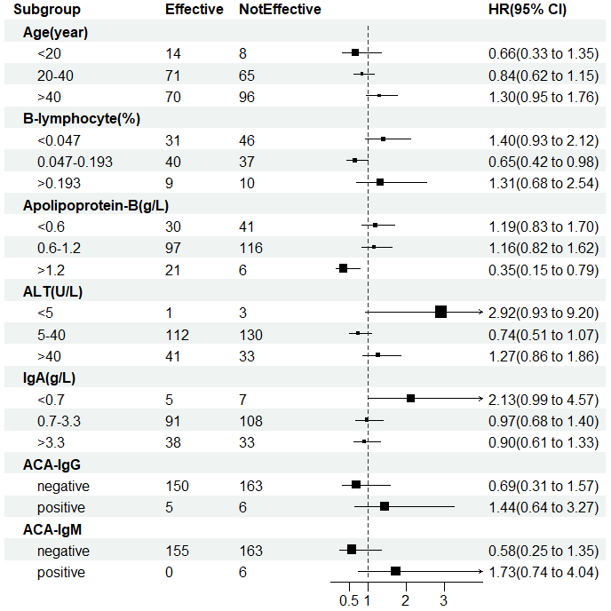
Supplementary Figure 5 Stratified Analysis of Single Indicator. ALT, Alanine aminotransferase; ACA-IgG, Anti-cardiolipin antibodies-IgG; ACA-IgM, Anti-cardiolipin antibodies-IgM.

Supplementary Figure 6 Treatment Effectiveness Probability Curve. (A) B-lymphocyte; (B) Apolipoprotein-B.
Supplementary Figure 7 Efficacy Probability Curve of Antibodies. (A) AMA-M2, Anti-mitochondrial antibody-M2; (B) AunA, Anti-nucleosome antibody; (C) ARPA, Anti-ribosomal p protein antibody; (D) ds-DNA, Anti-dsDNA antibody.

Supplementary Figure 8 Distribution of Generated Data and Original Data. (A) B-lymphocyte; (B) IgE; (C) AMA-M2, Anti-mitochondrial antibody-M2; (D) Treatment Effect.

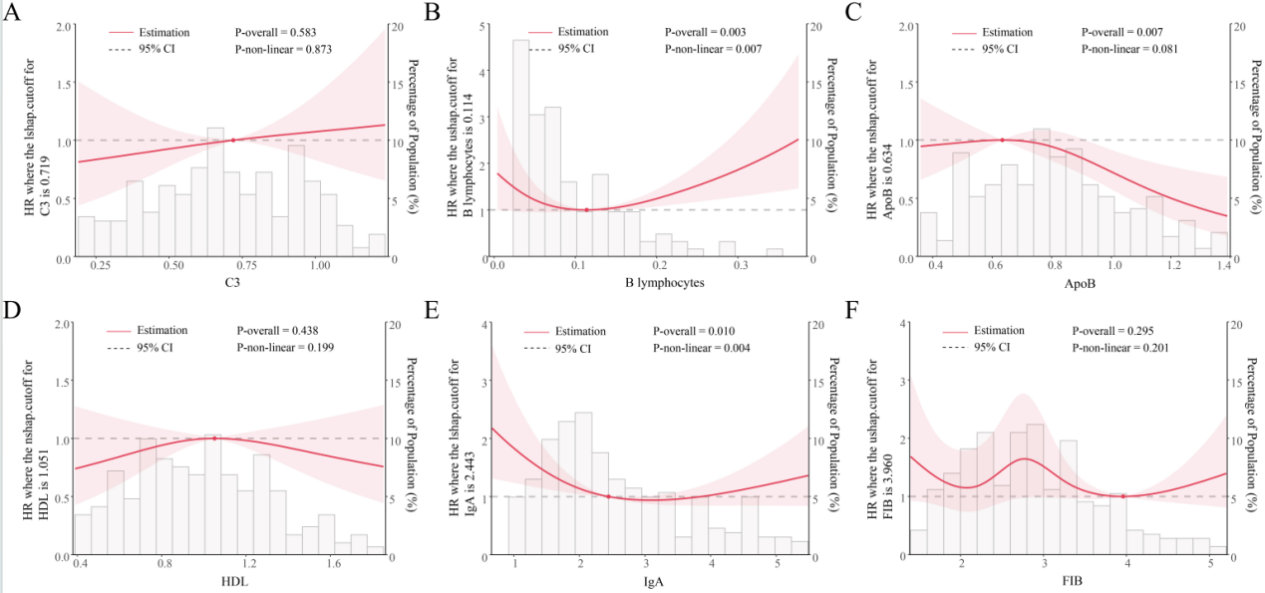
Supplementary Figure 9 RCS analysis for the factors. (A) C3, Complement-3; (B) B-lymphocyte; (C) Apo-B, Apolipoprotein-B; (D) H-cholesterol; (E) IgA; (F) FIB, Fibrinogen.

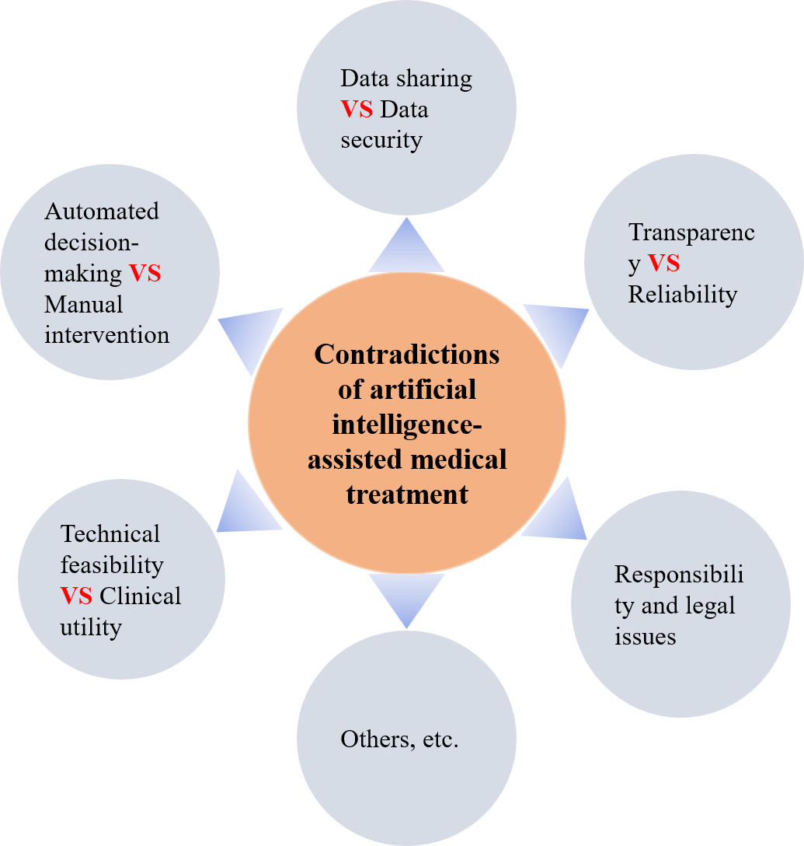
Supplementary Figure 10 Contradictions of artificial intelligence-assisted medical treatment.
Supplementary Figure 11 Analysis of feature importance based on different machine learning algorithms. (A)(B)(C)(D)

Supplementary Tables
Supplementary Table 1 Demographic and Clinical Characteristics of Patients in Mild-Group
Variable | Mild-Ineffective  (n=99) | Mild-Effective  (n=98) | P value
Age | 45.77±16.87 | 39.24±14.38 | 0.008
Female | 11/99=0.111 | 9/98=0.092 | 0.832
Male | 88/99=0.889 | 89/98=0.908 | 0.832
Blood lymphocytes
B-lymphocyte | 0.094±0.142 | 0.082±0.078 | 0.490
Biochemical
H-cholesterol | 1.00±0.032 | 0.97±0.044 | 0.135
Apolipoprotein-B | 0.78±0.27 | 0.88±0.31 | 0.032
Na | 140.89±7.01 | 139.24±4.22 | 0.020
ALT | 30.62±41.19 | 39.96±43.93 | 0.186
ALP | 96.46±107.23 | 91.21±92.08 | 0.683
Complement
C3 | 0.72±0.27 | 0.63±0.30 | 0.020
Immunoglobulin
IgA | 2.54±1.54 | 2.56±1.31 | 0.463
IgE | 161.18±229.59 | 259.27±373.42 | 0.047
Blood coagulation
FIB | 2.93±0.94 | 2.98±0.95 | 0.862
Antibodies
ACA-IgG | 2/99=0.020 | 3/98=0.031 | 0.991
ACA-IgM | 2/99=0.020 | 0/98=0.000 | /
AnuA | 21/99=0.212 | 32/98=0.327 | 0.074
AMA-M2 | 12/99=0.121 | 8/98=0.082 | 0.469
Data are mean±SD, n (%), where n is the total number of patients with valid data in each group. Statistical analysis was performed with the Mann–Whitney U test and the χ2 test.

Supplementary Table 2 Single indicator stratified analysis
Subgroup | Effective | Not Effective | HR | Low | High
Sex
Male | 13 | 21 | 1.695 | 1.069 | 2.687
Female | 142 | 148 | 0.5901 | 0.3722 | 0.9354
Age(year)
<20 | 14 | 8 | 0.6634 | 0.3258 | 1.351
20-40 | 71 | 65 | 0.8405 | 0.616 | 1.147
>40 | 70 | 96 | 1.296 | 0.9548 | 1.759
B-lymphocyte(%)
<0.047 | 31 | 46 | 1.405 | 0.9311 | 2.119
0.047-0.193 | 40 | 37 | 0.6548 | 0.4243 | 0.9831
>0.193 | 9 | 10 | 1.311 | 0.6771 | 2.539
H-cholesterol(mmol/L)
<0.94 | 74 | 70 | 0.9931 | 0.7274 | 1.356
0.94-2 | 70 | 91 | 1.074 | 0.7878 | 1.456
>2 | 4 | 2 | 0.4166 | 0.1017 | 1.707
Apolipoprotein-B(g/L)
<0.6 | 30 | 41 | 1.188 | 0.833 | 1.695
0.6-1.2 | 97 | 116 | 1.157 | 0.8232 | 1.625
>1.2 | 21 | 6 | 0.3504 | 0.155 | 0.7921
Na(mmol/L)
<135 | 16 | 10 | 1.022 | 0.5387 | 1.939
135-145 | 129 | 148 | 0.8329 | 0.5095 | 1.362
>145 | 7 | 8 | 1.488 | 0.7267 | 3.046
ALT(U/L)
<5 | 1 | 3 | 2.923 | 0.929 | 9.2
5-40 | 112 | 130 | 0.7383 | 0.5069 | 1.075
>40 | 41 | 33 | 1.266 | 0.859 | 1.864
ALP(U/L)
<47 | 39 | 28 | 0.784 | 0.5217 | 1.178
47-185 | 107 | 121 | 1.198 | 0.8495 | 1.691
>185 | 8 | 17 | 0.9994 | 0.6024 | 1.658
C3(g/L)
<0.8 | 87 | 87 | 0.8944 | 0.6442 | 1.242
0.8-1.6 | 47 | 61 | 1.118 | 0.8052 | 1.552
IgA(g/L)
<0.7 | 5 | 7 | 2.127 | 0.9899 | 4.571
0.7-3.3 | 91 | 108 | 0.972 | 0.6754 | 1.399
>3.3 | 38 | 33 | 0.8995 | 0.6102 | 1.326
IgE(U/ml)
0-100 | 67 | 86 | 1.159 | 0.8353 | 1.608
>100 | 67 | 62 | 0.8628 | 0.6219 | 1.197
FIB(g/L)
<2 | 27 | 25 | 1.005 | 0.6557 | 1.542
2-4 | 100 | 119 | 1.101 | 0.7715 | 1.571
>4 | 19 | 16 | 0.8192 | 0.4885 | 1.374
ACA-IgG
negative | 150 | 163 | 0.6932 | 0.3061 | 1.57
positive | 5 | 6 | 1.443 | 0.6369 | 3.267
ACA-IgM
negative | 155 | 163 | 0.5782 | 0.2472 | 1.352
positive | 0 | 6 | 1.73 | 0.7395 | 4.045

Supplementary Table 3 Feature Values and Encoding Methods
Variable | Data Type | Range of values | Median | Encoding
Age | Continuous | 0-80 | 45 | Normalization
Sex | Categorical | Male:0, Female:1 | / | Label Encoding
B-lymphocyte | Continuous | 0.047-0.193% | 0.12% | Normalization
H-cholesterol | Continuous | 0.94-2mmol/L | 1.47 | Normalization
Apolipoprotein-B | Continuous | 0.6-1.2g/L | 0.9 | Normalization
Na | Continuous | 135-145mmol/L | 140 | Normalization
ALT | Continuous | 5-40U/L | 22.5 | Normalization
ALP | Continuous | 47-185U/L | 116 | Normalization
C3 | Continuous | 0.8-1.6g/L | 1.2 | Normalization
IgA | Continuous | 0.7-3.3g/L | 2 | Normalization
IgE | Continuous | 0-100IU/ml | 50 | Normalization
FIB | Continuous | 2-4g/L | 3 | Normalization
ACA-IgG | Categorical | Negative:0,Positive:1 | / | Label Encoding
ACA-IgM | Categorical | Negative:0,Positive:1 | / | Label Encoding
AnuA | Categorical | Negative:0,Positive:1 | / | Label Encoding
AMA-M2 | Categorical | Negative:0,Positive:1 | / | Label Encoding

Supplementary Table 4 Comparison of Multi-Classifier Evaluation
Model | Sensitivity | Specificity | Accuracy | YI
RF | 0.85 | 0.64 | 0.75 | 0.49
GB | 0.85 | 0.64 | 0.75 | 0.49
LR | 0.77 | 0.82 | 0.79 | 0.59
KNN | 0.85 | 0.73 | 0.79 | 0.58
SVM | 0.92 | 0.73 | 0.83 | 0.65
NN | 0.92 | 0.73 | 0.83 | 0.65
CSNN | 0.85 | 0.82 | 0.83 | 0.67
VAE+NN | 0.85 | 0.91 | 0.88 | 0.76
KNN, k-nearest neighbor; RF, random forest; GB, gradient boosting; LR, logistic regression; SVM, support vector machine; NN, neural network; CSNN, cost-sensitive neural network; VAENN, neural network based on Variational Autoencoder.

Supplementary Table 5 Means and Standard Deviations of Generated Data and Original Data
Variable | Original data mean | Generated data mean | Original data std | Generated data std
Age | 40.7474 | 40.6667 | 15.0326 | 9.2245
Sex | 0.9474 | 0.9725 | 0.2245 | 0.1636
B-lymphocyte | 0.0816 | 0.0883 | 0.1003 | 0.0885
H-cholesterol | 1.0831 | 1.0506 | 0.4153 | 0.1704
Apolipoprotein-B | 0.8275 | 0.8254 | 0.2981 | 0.1413
Na | 139.4293 | 139.477 | 3.4408 | 1.6577
ALT | 32.7161 | 31.3295 | 39.6191 | 10.9249
ALP | 82.6574 | 83.7563 | 56.5692 | 45.496
C3 | 0.7039 | 0.7059 | 0.2897 | 0.1634
IgA | 2.4249 | 2.3244 | 1.292 | 0.865
IgE | 249.7052 | 269.3706 | 370.527 | 277.8516
FIB | 2.867 | 2.9355 | 1.0717 | 0.387
IgG | 0.0211 | 0.0 | 0.1443 | 0.0
IgM | 0.0316 | 0.0 | 0.1758 | 0.0
AnuA | 0.3158 | 0.4637 | 0.1625 | 0.3691
AMAM2 | 0.1368 | 0.3445 | 0.1062 | 0.3084
Treatment effect | 0.6 | 0.63 | 0.2426 | 0.23

