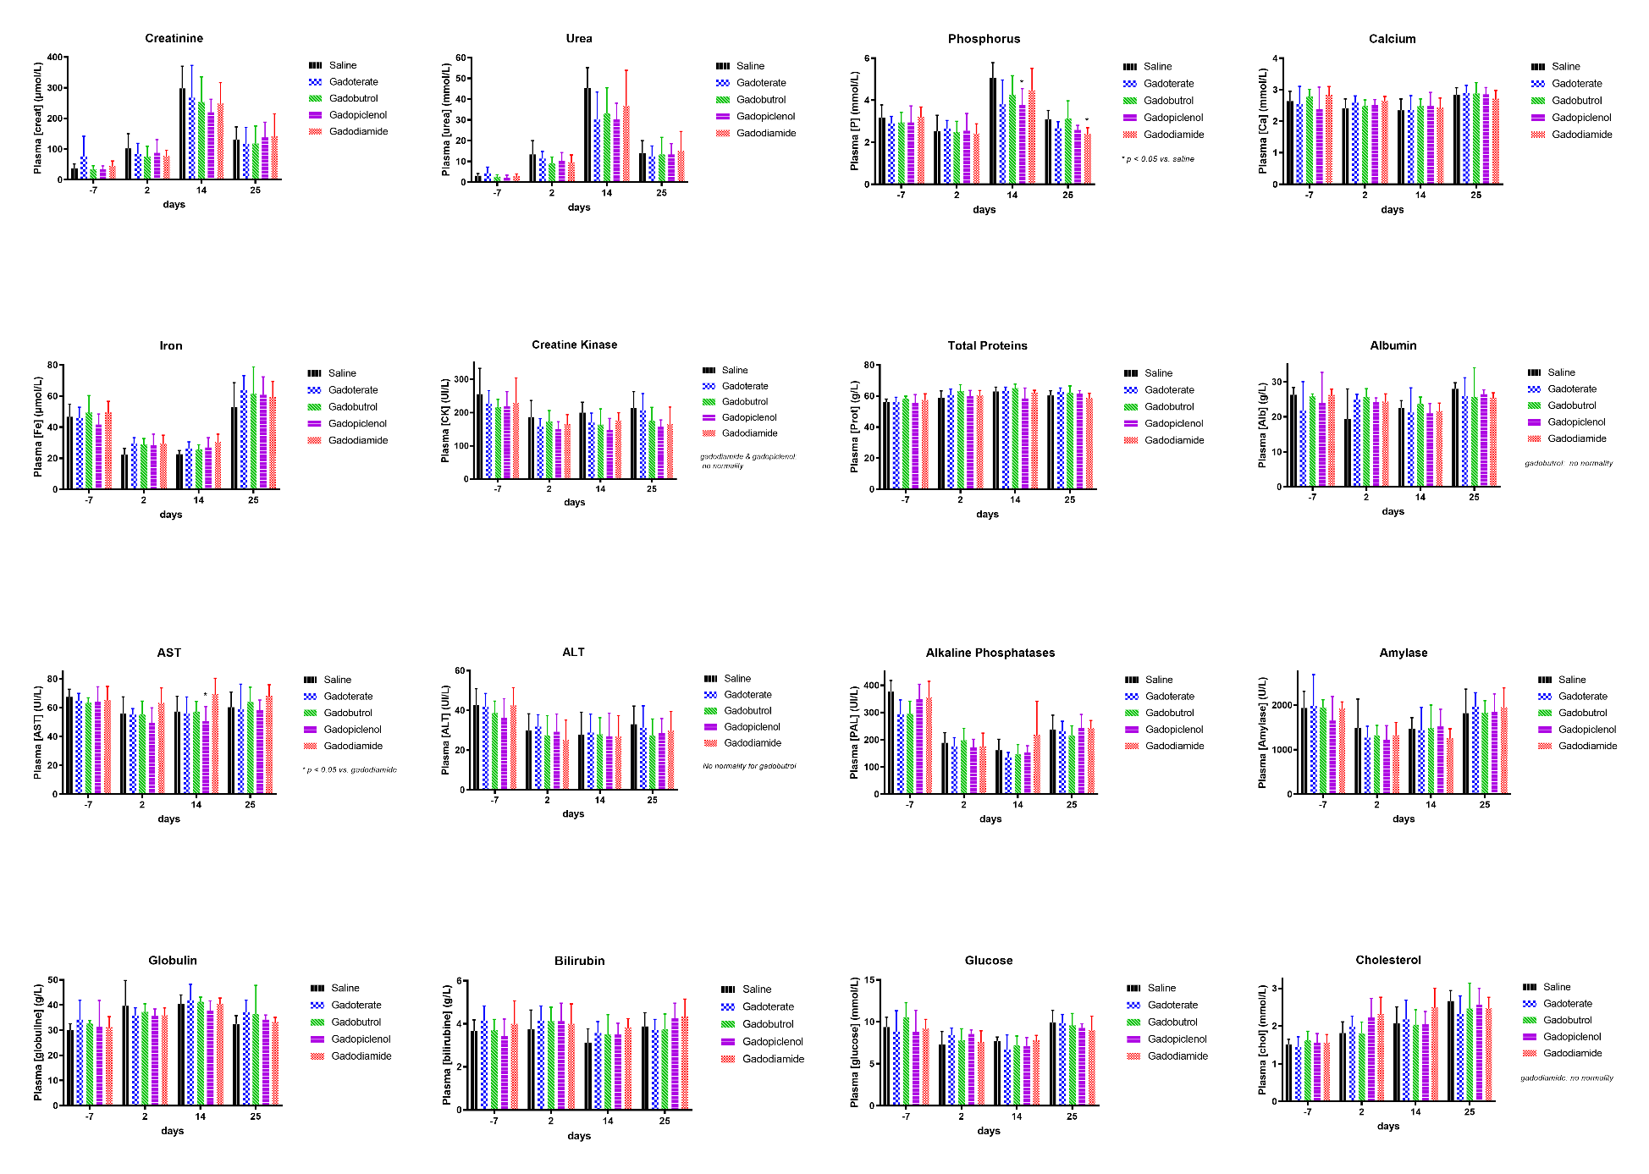
Supplemental Digital Content: Plasma biochemical parameters (mean + SD) in rats fed an adenine diet for 3 weeks and treated with five consecutive daily injections of GBCAs (2.5 mmol/kg) from Day 0 to 4.
AST, Aspartate Aminotransferase; ALT, Alanine Aminotransferase

