Supplemental Digital Content
Supplemental Digital Content 1: Blood serum ion concentrations and CK values, as well as mean quantitative MRI measures for all investigated muscles acquired at different time points. Edema volume was only determined within GM.
 |  |  | t0 |  | t1 |  | t2
 |  |  | mean | SD | mean | SD | mean | SD
Blood | Na [mM] |  | 139.1 | 1.2 | 139.2 | 1.5 | 138.7 | 1.4
 | K [mM] |  | 4.13 | 0.18 | 4.10 | 0.20 | 4.03 | 0.23
 | CK |  | 120 | 51 | 136 | 56 | 2263 | 3435
Muscle tissue | aTSC [mM] | GM | 17.7 | 2.9 | 27.9 | 4.4 | 23.6 | 10.9
 |  | GL | 15.9 | 2.5 | 27.0 | 4.6 | 20.6 | 8.9
 |  | SOL | 19.1 | 2.1 | 23.4 | 4.0 | 18.2 | 2.4
 |  | TA | 16.3 | 2.1 | 15.3 | 3.4 | 17.1 | 3.1
 | aTPC [mM] | GM | 98 | 11 | 92 | 9 | 109 | 14
 |  | GL | 96 | 13 | 88 | 9 | 109 | 14
 |  | SOL | 99 | 7 | 97 | 6 | 99 | 7
 |  | TA | 100 | 11 | 101 | 19 | 97 | 14
 | ¹H T₂ [ms] | GM | 34.0 | 0.9 | 35.2 | 0.6 | 42.3 | 6.2
 |  | GL | 34.4 | 1.4 | 35.4 | 1.0 | 41.3 | 6.0
 |  | SOL | 35.9 | 0.8 | 36.3 | 0.8 | 37.3 | 1.4
 |  | TA | 32.2 | 0.8 | 32.0 | 0.5 | 32.3 | 0.6
 | Muscle volume [L] | GM | 1.5 | 0.5 | 1.6 | 0.5 | 1.8 | 1.0
 |  | GL | 0.8 | 0.3 | 0.9 | 0.3 | 0.6 | 0.3
 |  | SOL | 2.2 | 0.4 | 2.2 | 0.7 | 2.3 | 0.7
 |  | TA | 0.7 | 0.2 | 0.4 | 0.2 | 0.5 | 0.2
 | V [ml] | GM | 19 | 19 | 39 | 31 | 142 | 99

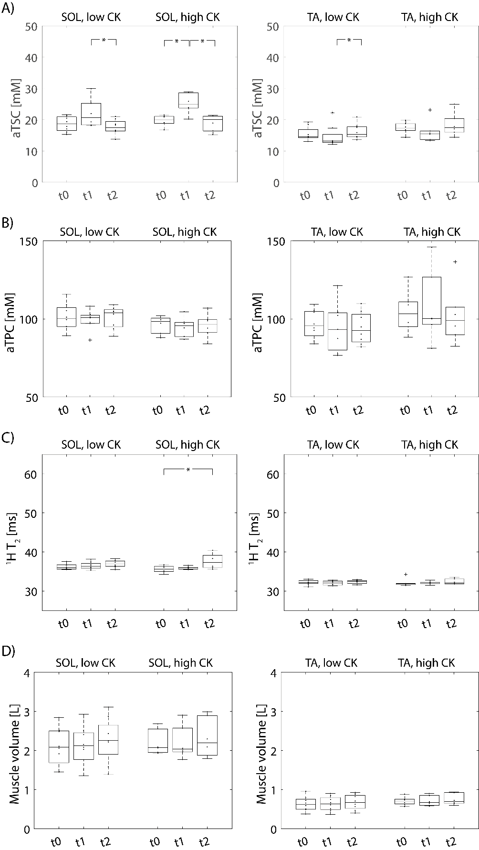
Supplemental Digital Content 2: aTSC (A), aTPC (B), ¹H T₂ relaxation times (C) and muscle volume (D) of non-exercised muscles (SOL and TA) in low and high CK subjects at baseline (t0), directly after exercise (t1) and 48 h after training (t2). While aTSC was increased at t1 both in high and low CK subjects, the remaining measures mostly remained at baseline level in both subject groups.
Significant differences between measurement time points were marked with an asterisk (*).
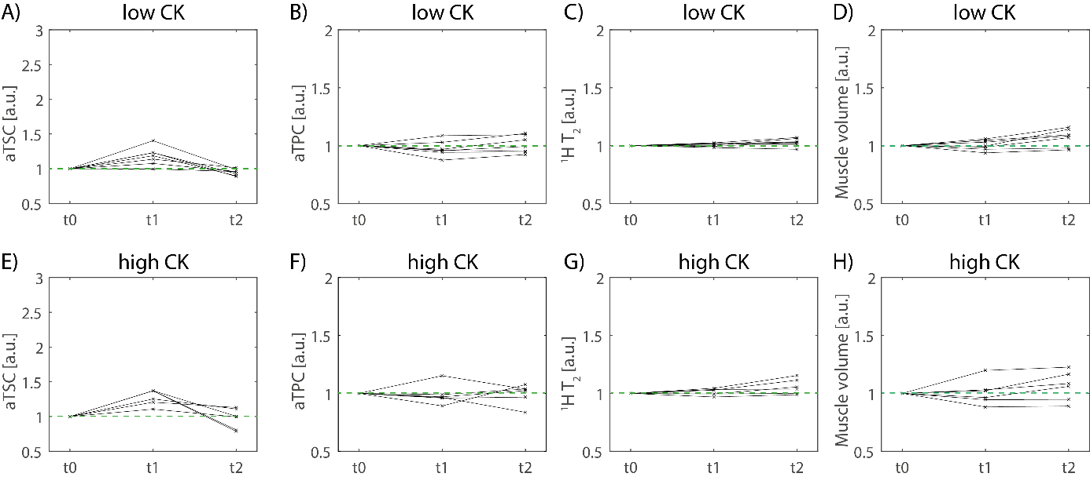
Supplemental Digital Content 3: Evolution of aTSC (A, E), aTPC (B, F), ¹H T₂ relaxation times (C, G) and muscle volume (D, H) relative to baseline values (compare green dashed lines) in soleus (SOL) muscle. Subjects were divided according to their CK level at t2 relative to t0 into low CK (CK_{t2} < 10·CK_{t0}, upper row) and high CK participants (CK_{t2} ≥ 10·CK_{t0}, lower row). aTSC was slightly increased in SOL directly after exercise in both groups, while aTPC showed no clear tendencies.

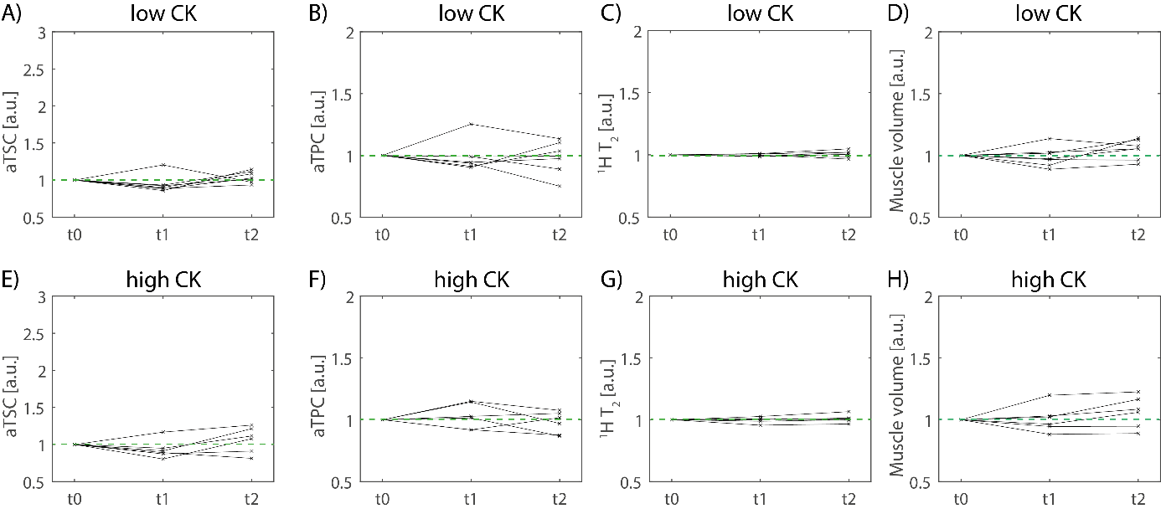
Supplemental Digital Content 4: Evolution of aTSC (A, E), aTPC (B, F), ¹H T₂ relaxation times (C, G) and muscle volume (D, H) relative to baseline values (compare green dashed lines) in tibialis anterior (TA) muscle. Subjects were divided according to their CK level at t2 relative to t0 into low CK (CK_{t2} < 10·CK_{t0}, upper row) and high CK participants (CK_{t2} ≥ 10·CK_{t0}, lower row). The evolution of all evaluated measures did not show clear tendencies after exercise.

