Supplemental Material
Table S1: Detailed WOMAC scores at baseline and detailed clinical assessment
Variable | Overall | Missing | Placebo | Glucocorticoid | Hyaluronic acid | PRP | P**
WOMAC pain: walking (median [IQR]) | 0.50 [0.00, 1.00] | 0.0 | 0.50 [0.12, 0.88] | 0.50 [0.00, 1.00] | 0.50 [0.00, 1.00] | 0.50 [0.00, 0.50] | 0.45
WOMAC pain: climbing stairs (median [IQR]) | 1.00 [0.50, 1.00] | 0.0 | 1.00 [0.50, 1.00] | 1.00 [0.50, 1.00] | 1.00 [0.62, 1.00] | 0.50 [0.50, 1.00] | 0.33
WOMAC pain: sleeping at night (median [IQR]) | 0.00 [0.00, 0.50] | 0.0 | 0.00 [0.00, 0.50] | 0.00 [0.00, 0.50] | 0.00 [0.00, 0.50] | 0.00 [0.00, 0.50] | 0.98
WOMAC pain: resting (median [IQR]) | 0.00 [0.00, 0.50] | 0.8 | 0.00 [0.00, 0.50] | 0.25 [0.00, 0.50] | 0.50 [0.00, 0.50] | 0.00 [0.00, 0.50] | 0.88
WOMAC pain: standing (median [IQR]) | 0.50 [0.00, 0.50] | 0.8 | 0.50 [0.00, 0.50] | 0.50 [0.00, 0.50] | 0.50 [0.00, 0.50] | 0.50 [0.00, 0.50] | 0.60
WOMAC pain: TOTAL (median [IQR]) | 2.00 [1.00, 3.50] | 0.0 | 2.00 [1.50, 3.50] | 2.25 [1.00, 3.50] | 2.25 [1.50, 3.75] | 2.00 [0.50, 3.50] | 0.57
WOMAC stiffness: morning (median [IQR]) | 1.30 [0.00, 2.50] | 0.8 | 1.30 [0.00, 2.50] | 1.30 [0.32, 2.50] | 1.30 [0.00, 2.50] | 1.30 [1.30, 2.50] | 0.59
WOMAC stiffness: evening (median [IQR]) | 1.30 [0.00, 2.50] | 0.8 | 1.30 [1.30, 2.50] | 1.30 [0.32, 2.50] | 1.30 [0.32, 3.47] | 1.30 [0.32, 2.50] | 0.91
WOMAC stiffness: TOTAL (median [IQR]) | 2.60 [1.30, 5.00] | 0.8 | 2.60 [1.30, 3.80] | 3.20 [1.30, 5.00] | 2.60 [1.30, 6.30] | 2.60 [1.60, 4.70] | 0.91
WOMAC phys. function: descending stairs (median [IQR]) | 0.30 [0.10, 0.30] | 0.8 | 0.10 [0.10, 0.30] | 0.30 [0.10, 0.30] | 0.30 [0.10, 0.30] | 0.10 [0.10, 0.30] | 0.18
WOMAC phys. function: ascending stairs (median [IQR]) | 0.10 [0.05, 0.30] | 0.8 | 0.10 [0.10, 0.10] | 0.10 [0.03, 0.30] | 0.30 [0.10, 0.30] | 0.10 [0.00, 0.25] | 0.09
WOMAC phys. function: rising from sitting (median [IQR]) | 0.10 [0.00, 0.30] | 0.8 | 0.10 [0.00, 0.30] | 0.10 [0.00, 0.25] | 0.10 [0.03, 0.30] | 0.10 [0.10, 0.10] | 0.64
WOMAC phys. function: standing (median [IQR]) | 0.10 [0.00, 0.10] | 0.8 | 0.10 [0.00, 0.10] | 0.10 [0.00, 0.30] | 0.10 [0.00, 0.10] | 0.05 [0.00, 0.10] | 0.25
WOMAC phys. function: bending to floor (median [IQR]) | 0.10 [0.00, 0.30] | 0.8 | 0.10 [0.00, 0.30] | 0.10 [0.10, 0.30] | 0.10 [0.00, 0.25] | 0.10 [0.10, 0.30] | 0.73
WOMAC phys. function: walking on even floor (median [IQR]) | 0.10 [0.00, 0.10] | 0.8 | 0.10 [0.00, 0.10] | 0.10 [0.00, 0.10] | 0.00 [0.00, 0.25] | 0.10 [0.00, 0.10] | 0.78
WOMAC phys. function: getting in/out of car (median [IQR]) | 0.10 [0.00, 0.30] | 0.8 | 0.10 [0.00, 0.10] | 0.10 [0.00, 0.30] | 0.10 [0.00, 0.25] | 0.10 [0.00, 0.10] | 0.70
WOMAC phys. function: going shopping (median [IQR]) | 0.10 [0.00, 0.10] | 0.8 | 0.10 [0.00, 0.10] | 0.10 [0.00, 0.25] | 0.10 [0.00, 0.30] | 0.10 [0.00, 0.10] | 0.72
WOMAC phys. function: putting on socks (median [IQR]) | 0.10 [0.00, 0.10] | 0.8 | 0.00 [0.00, 0.10] | 0.10 [0.00, 0.10] | 0.10 [0.00, 0.10] | 0.10 [0.00, 0.10] | 0.37
WOMAC phys. function: rising from bed (median [IQR]) | 0.10 [0.00, 0.30] | 0.8 | 0.10 [0.00, 0.10] | 0.10 [0.00, 0.30] | 0.10 [0.00, 0.25] | 0.10 [0.00, 0.25] | 0.62
WOMAC phys. function: taking off socks (median [IQR]) | 0.10 [0.00, 0.10] | 0.8 | 0.00 [0.00, 0.10] | 0.10 [0.00, 0.25] | 0.10 [0.00, 0.10] | 0.10 [0.00, 0.10] | 0.55
WOMAC phys. function: lying in bed (median [IQR]) | 0.00 [0.00, 0.10] | 0.8 | 0.00 [0.00, 0.10] | 0.00 [0.00, 0.10] | 0.00 [0.00, 0.10] | 0.00 [0.00, 0.10] | 0.65
WOMAC phys. function: getting in/out of bath (median [IQR]) | 0.10 [0.00, 0.10] | 0.8 | 0.10 [0.00, 0.10] | 0.10 [0.00, 0.30] | 0.10 [0.00, 0.30] | 0.10 [0.00, 0.10] | 0.33
WOMAC phys. function: sitting (median [IQR]) | 0.00 [0.00, 0.10] | 0.8 | 0.00 [0.00, 0.10] | 0.00 [0.00, 0.10] | 0.00 [0.00, 0.10] | 0.00 [0.00, 0.10] | 0.73
WOMAC phys. function: getting on/off toilet (median [IQR]) | 0.10 [0.00, 0.10] | 0.8 | 0.00 [0.00, 0.10] | 0.05 [0.00, 0.10] | 0.05 [0.00, 0.10] | 0.10 [0.00, 0.10] | 0.63
WOMAC phys. function: doing heavy domestic duties (median [IQR]) | 0.10 [0.10, 0.30] | 0.8 | 0.10 [0.10, 0.30] | 0.30 [0.10, 0.30] | 0.30 [0.10, 0.30] | 0.20 [0.10, 0.30] | 0.66
WOMAC phys. function: doing light domestic duties (median [IQR]) | 0.10 [0.00, 0.10] | 0.8 | 0.00 [0.00, 0.10] | 0.10 [0.00, 0.10] | 0.10 [0.00, 0.10] | 0.10 [0.00, 0.10] | 0.66
WOMAC phys. function: TOTAL (median [IQR]) | 1.70 [0.75, 3.00] | 0.8 | 1.40 [0.70, 2.30] | 2.05 [0.90, 3.72] | 1.85 [0.80, 3.45] | 1.40 [0.72, 2.48] | 0.53
Tenderness medial joint space = yes (%) | 45 (37.5) | 0.0 | 12 (40.0) | 11 (36.7) | 14 (46.7) | 8 (26.7) | 0.48
Tenderness lateral joint space = yes (%) | 18 (15.0) | 0.0 | 6 (20.0) | 6 (20.0) | 4 (13.3) | 2 (6.7) | 0.41
Tenderness patella = yes (%) | 20 (16.7) | 0.0 | 7 (23.3) | 7 (23.3) | 2 (6.7) | 4 (13.3) | 0.22
Tenderness pes anserinus = yes (%) | 18 (15.1) | 0.8 | 5 (17.2) | 4 (13.3) | 3 (10.0) | 6 (20.0) | 0.72
Tenderness Gerdy’s tubercle = yes (%) | 7 (5.9) | 0.8 | 0 (0.0) | 4 (13.3) | 2 (6.7) | 1 (3.3) | 0.21
Tenderness inferior margin patella = yes (%) | 11 (9.2) | 0.0 | 5 (16.7) | 1 (3.3) | 3 (10.0) | 2 (6.7) | 0.40
Tenderness tibial tuberosity = yes (%) | 4 (3.4) | 0.8 | 3 (10.3) | 0 (0.0) | 1 (3.3) | 0 (0.0) | 0.05
Tenderness insertion quadriceps tendon = yes (%) | 11 (9.2) | 0.8 | 1 (3.4) | 5 (16.7) | 0 (0.0) | 5 (16.7) | 0.03
Crepitation = no (%) | 84 (70.6) | 0.8 | 22 (73.3) | 20 (69.0) | 17 (56.7) | 25 (83.3) | 0.16
Lachman = positive (%) | 20 (16.8) | 0.8 | 4 (13.3) | 4 (13.8) | 5 (16.7) | 7 (23.3) | 0.80
Lachman test = soft endpoint (%) | 15 (75.0) | 83.3 | 3 (75.0) | 3 (75.0) | 5 (100.0) | 4 (57.1) | 0.43
Posterior drawer test = positive (%) | 1 (0.8) | 0.0 | 0 (0.0) | 0 (0.0) | 0 ( 0.0) | 1 (3.3) | 1.00
Apley Grinding test= positive (%) | 21 (17.5) | 0.0 | 5 (16.7) | 4 (13.3) | 6 (20.0) | 6 (20.0) | 0.95
Lateral collateral ligament 0°= lift off (%) | 3 (2.5) | 1.7 | 0 (0.0) | 1 (3.3) | 2 ( 6.9) | 0 (0.0) | 0.33
Lateral collateral ligament 30° = lift off (%) | 4 (3.3) | 0.0 | 0 (0.0) | 2 (6.7) | 2 ( 6.7) | 0 (0.0) | 0.33
Medial collateral ligament 0° = lift off (%) | 1 (0.8) | 0.0 | 0 (0.0) | 1 (3.3) | 0 (0.0) | 0 (0.0) | 1.00
Medial collateral ligament 30° = lift off (%) | 5 (4.2) | 0.0 | 0 (0.0) | 3 (10.0) | 0 (0.0) | 2 (6.7) | 0.17
Pain hip internal rotation = yes (%) | 10 (8.3) | 0.0 | 1 (3.3) | 2 (6.7) | 3 (10.0) | 4 (13.3) | 0.69
Pain hip external rotation = yes (%) | 3 (2.5) | 0.0 | 2 (6.7) | 1 (3.3) | 0 (0.0) | 0 (0.0) | 0.62

Table S2: Simultaneous tests for general linear hypothesis with multiple comparison of means (-differences between groups in the first 6 months since the injection) regarding pain evaluation with NRS score.

Linear hypothesis | Estimate Std. | Error | z value | Pr(>|z|)
Placebo versus Glucocorticoid=0 | 3.170 | 3.827 | 0.83 | 0.82
Placebo versus Hyaluronic Acid=0 | -1.767 | 3.859 | -0.46 | 0.96
Placebo versus PRP=0 | 0.773 | 3.956 | 0.20 | 1.00
Glucocorticoid versus Hyaluronic Acid=0 | -4.936 | 3.845 | -1.28 | 0.54
Glucocorticoid versus PRP=0 | -2.397 | 3.933 | -0.61 | 0.92

Figures S1-5:

These figures highlight the fact that the observed differences among treatments over time are very small compared to the variability among and within patients. In addition, we also clearly see that the effect of placebo is of the same magnitude as the other treatments.

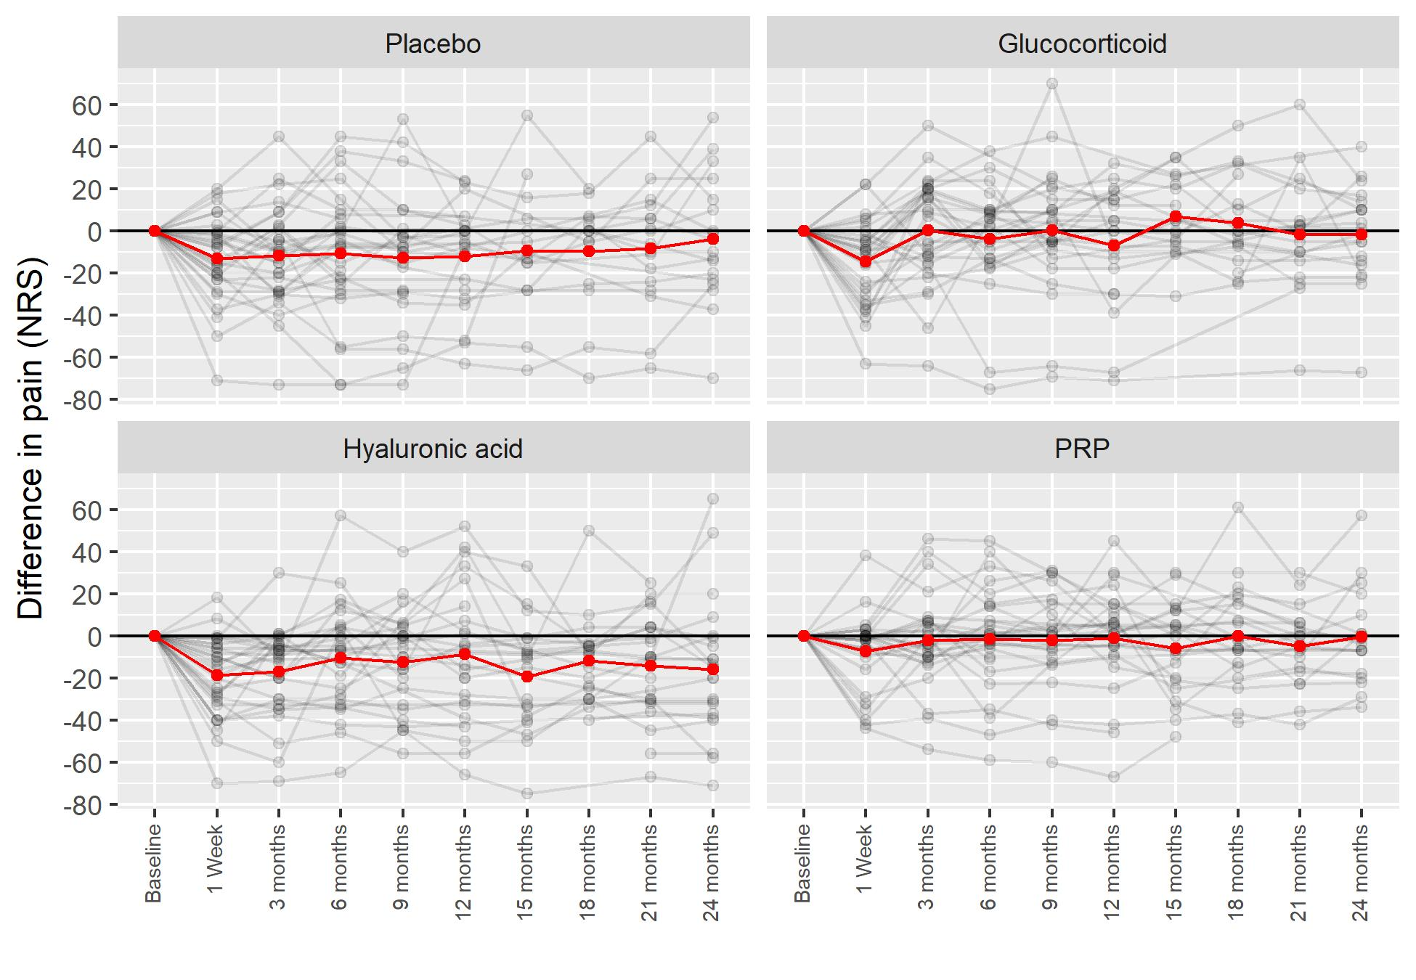
Figure S1. The primary outcome regarding the difference in intensity of knee pain compared to baseline data on the numerical rating scale (NRS). The red lines connect the mean values of data. Note: The “between-patients” variability is fairly large, the “within-patients” variability is smaller than across patients.

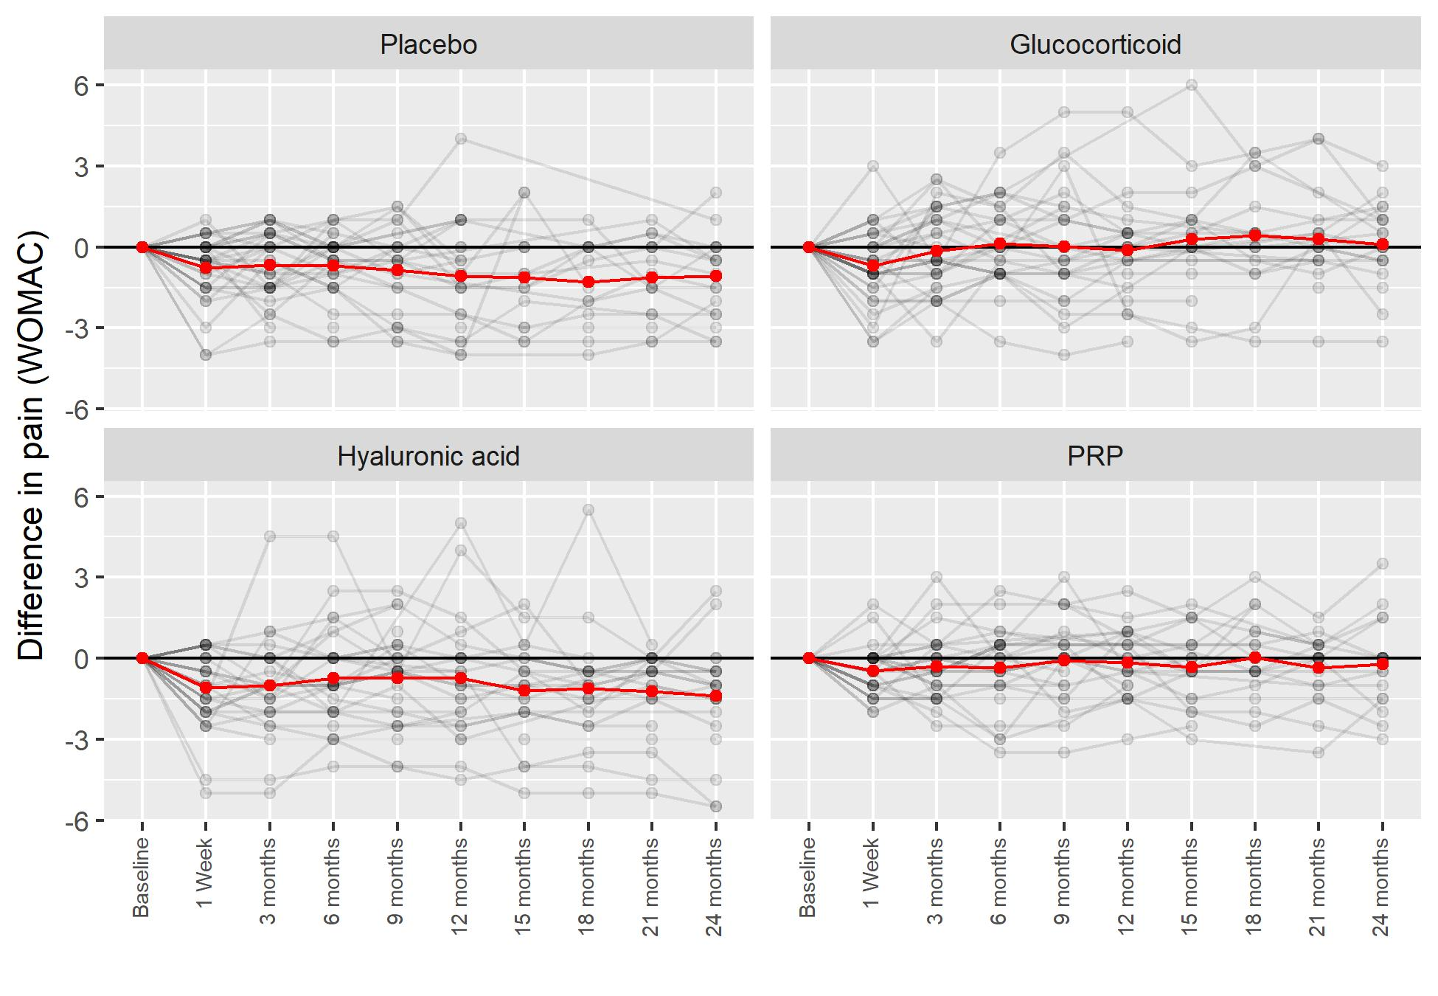

Figure S2. Primary outcome regarding the difference of knee pain compared to baseline data assessed with the WOMAC score (= sum of all WOMAC score pain points). The red lines connect the mean values of data.

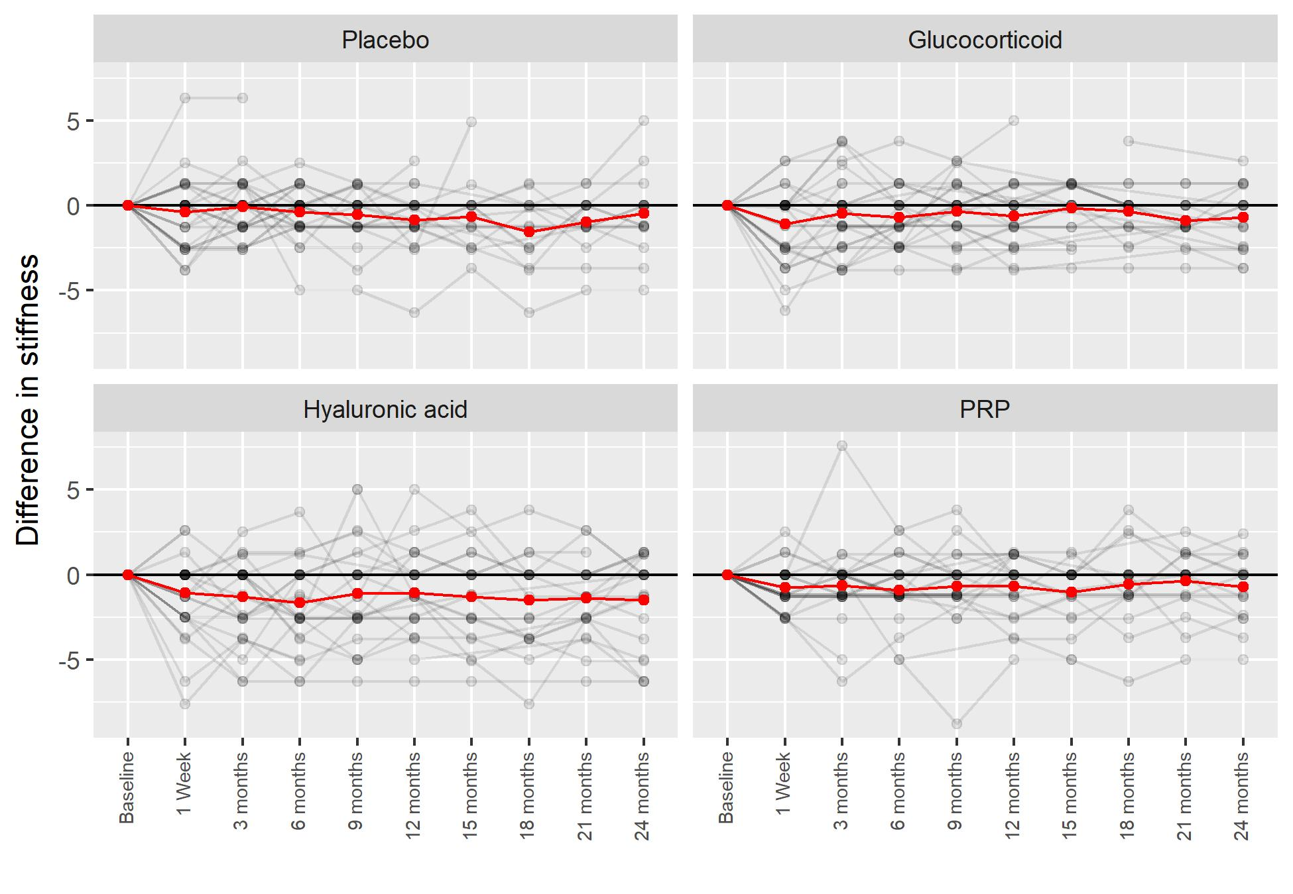

Figure S3. Secondary outcome regarding the difference of knee stiffness compared to baseline data assessed with the WOMAC score (= sum of all WOMAC score stiffness points). The red lines connect the mean values of data.

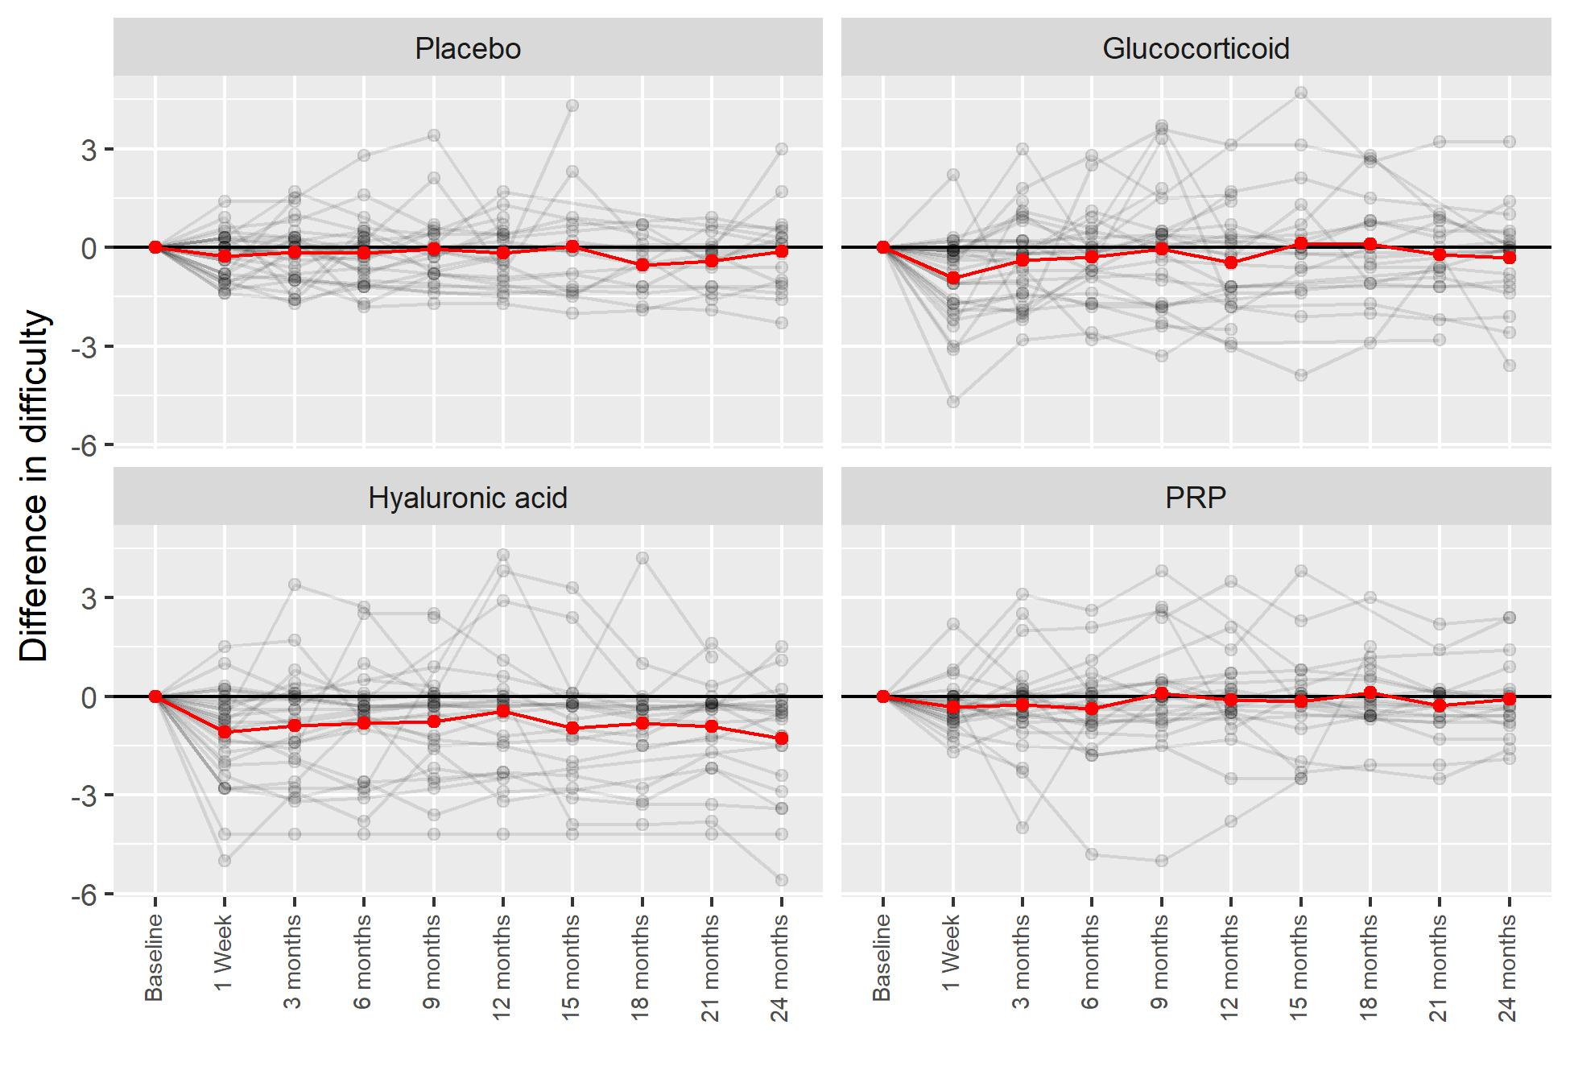

Figure S4. Secondary outcome regarding differences in difficulties experienced in the previous 48 hours compared to baseline data assessed with the WOMAC score (= sum of all WOMAC score difficulty points). The red lines connect the mean values of data.

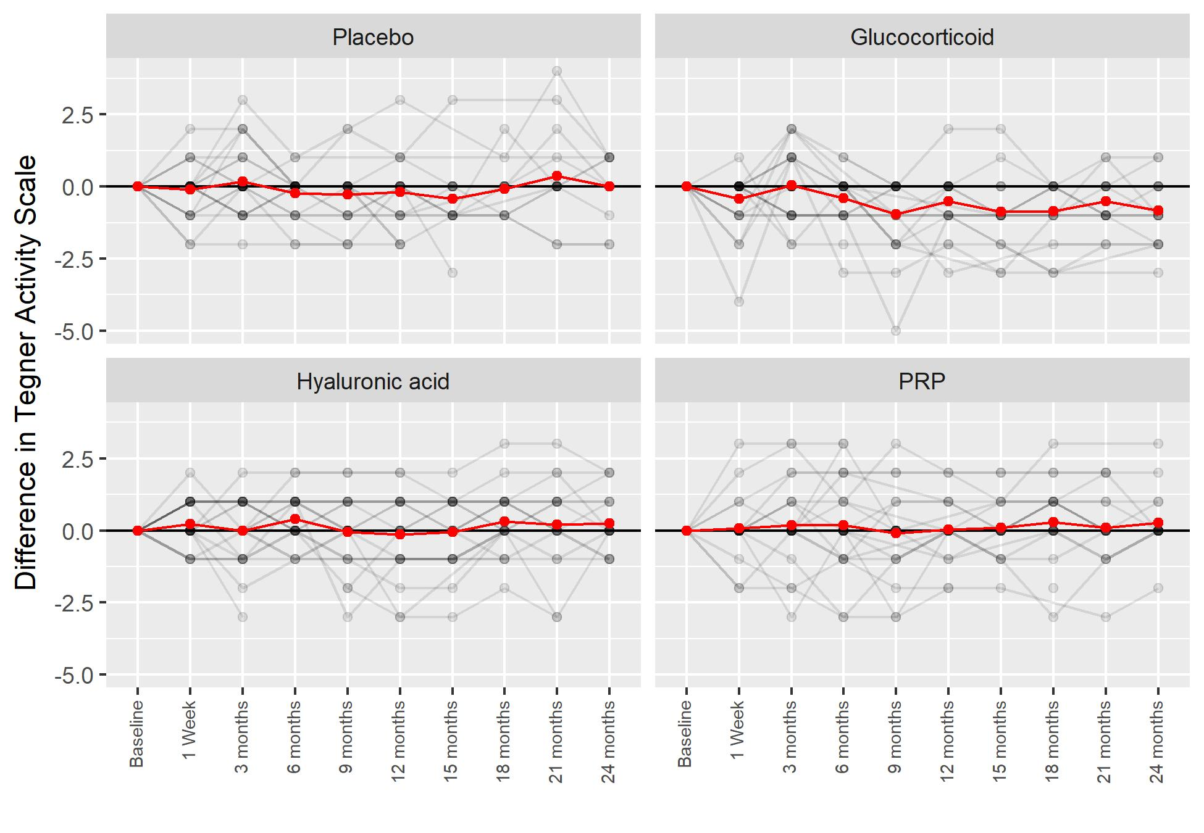

Figure S5. Secondary outcome of Tegner Activity Scale shown as differences compared to baseline data. The red lines connect the mean values of data.

