Supplementary data
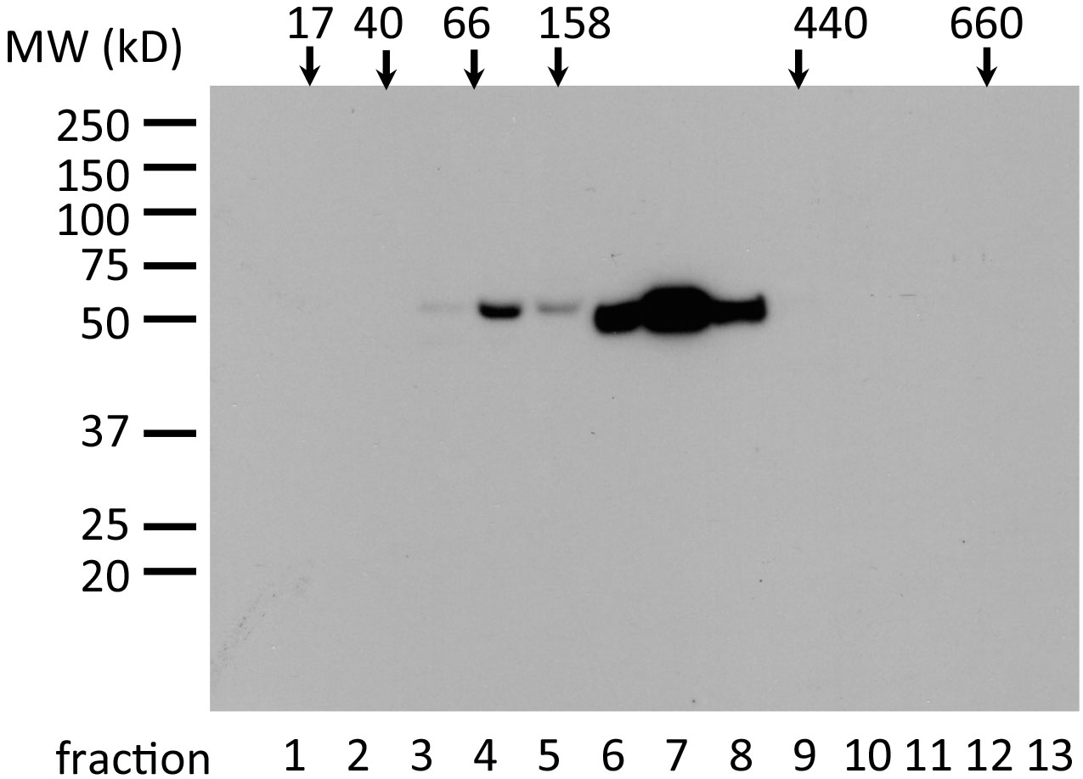
Velocity gradient of the plasma sample from burned mouse. To confirm the endogenous molecular size of the detected band at 50kD for fibrinogen-γ, velocity gradient ultracentrifugation (47) was performed on a 5% to 30% sucrose gradient and fractionated. The calculated molecular weight of the main fraction corresponds to 300kD to 400kD, matching the endogenous molecular size of fibrinogen of 340kD.

47. Tang Z, Scherer PE, Okamoto T, Song K, Chu C, Kohtz DS, Nishimoto I, Lodish HF, and Lisanti MP. Molecular cloning of caveolin-3, a novel member of the caveolin gene family expressed predominantly in muscle. The Journal of biological chemistry 271(4):2255-2261, 1996.

