**ESM figure 1:** Flow chart showing screening and enrollment procedure of patients from ICU between January 2012 and September 2013.

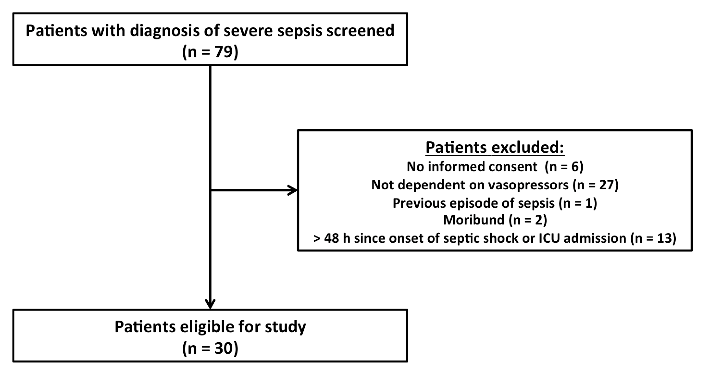

**ESM figure 2:** Example of CD62E+ MV (orange circles) generated in vitro by stimulating renal microvascular endothelial cells with different concentrations of tumor necrosis factor alpha.

Top row: MV labeled with specific antibody (CD62E-PE).

Bottom row: MV labeled with matched irrelevant antibody (Isotype-PE).

(FSC = Forward scatter, TNF = Tumor necrosis factor alpha, PE = Phycoerythrin)

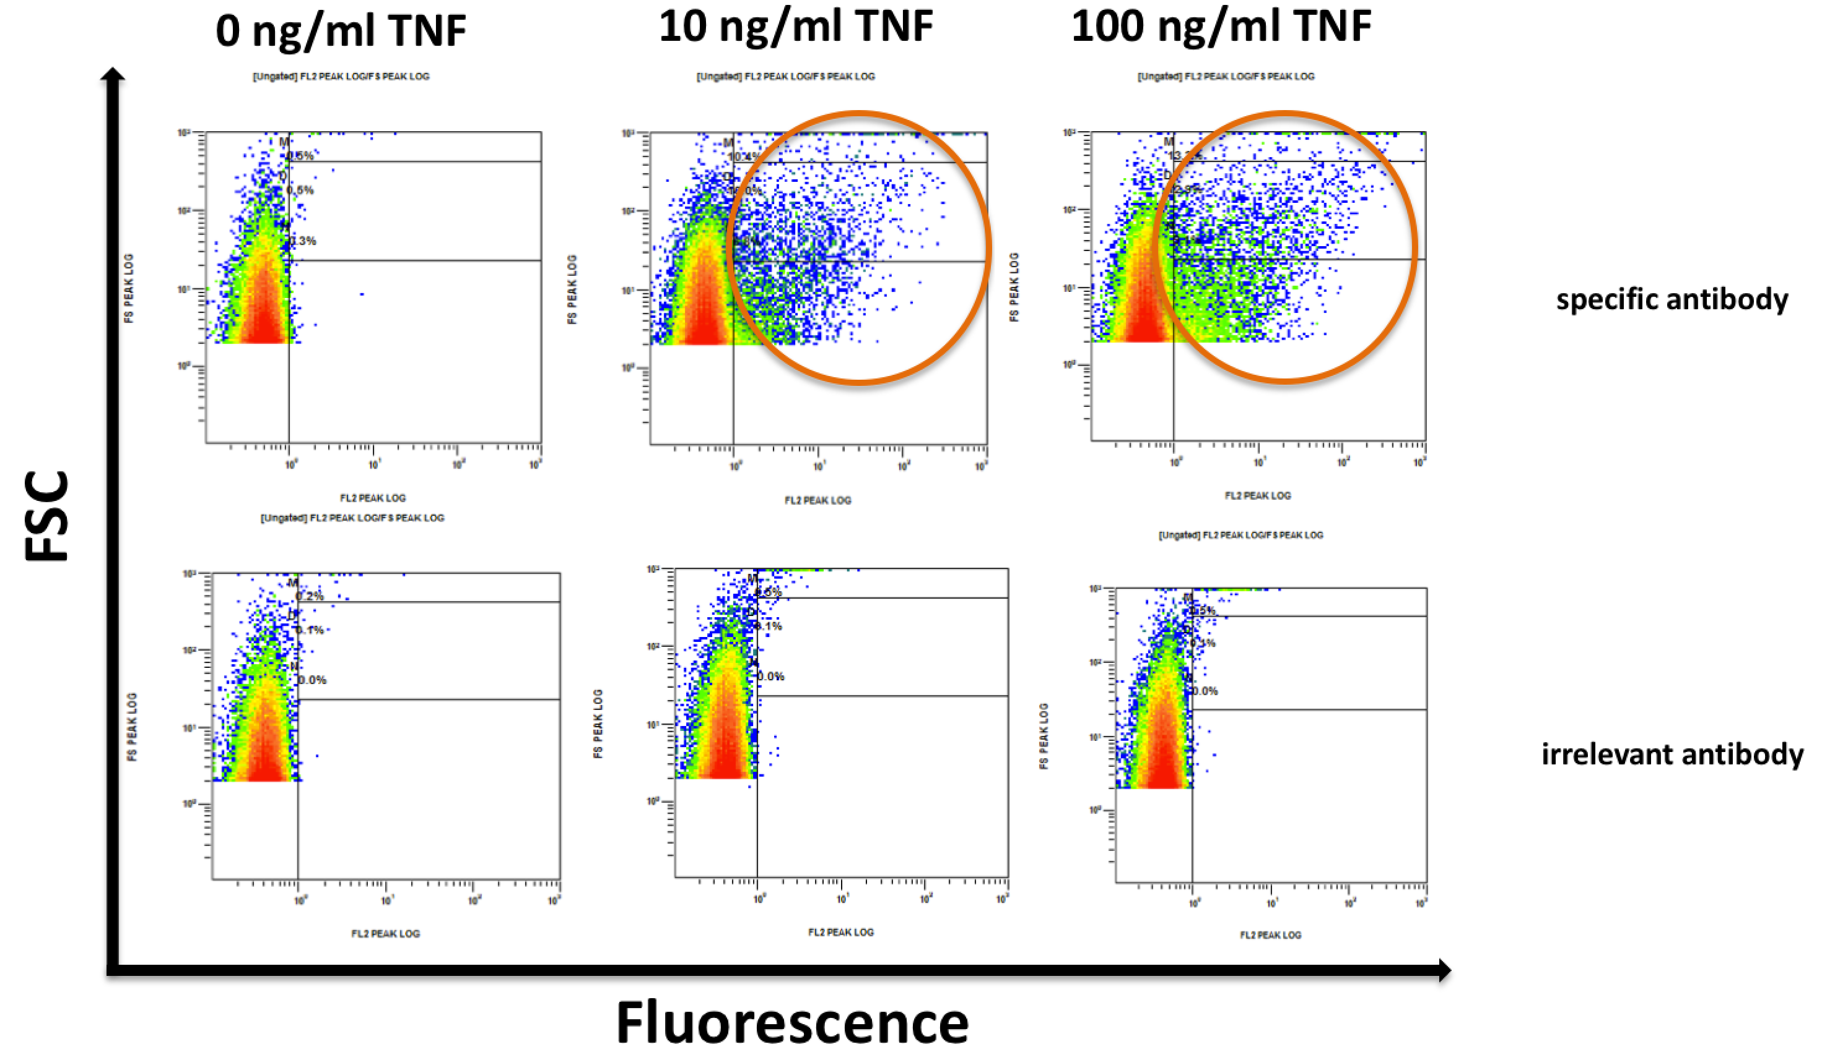

**ESM figure 3:** Gating strategy for analysis of MV in flow cytometry.

Top left: Set-up of MV-gate in scatter plot by analyzing 0.3 µm and 1 µm polystyrene beads.

Bottom left: Analysis of PFP from a patient with septic shock by using the predefined MV-gate.

Right: Dot-plot and density-plots showing MV labeled with different markers in PFP from a patient with septic shock. (MV = Microvesicles, AV = AnnexinV, FS = Forward scatter, SS = Side scatter, Bead-EQ = Bead equivalents) 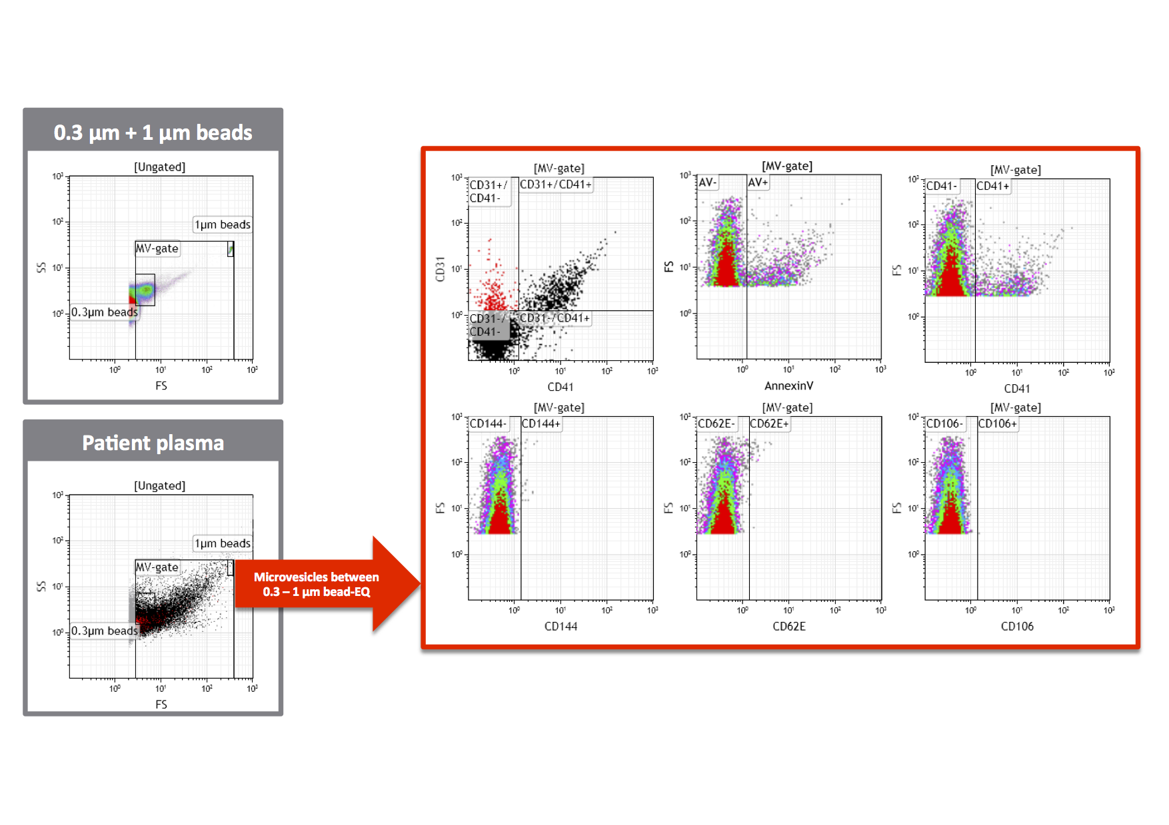

**ESM figure 4**: CD45 expression of CD31+/CD41- MV released from THP-1 cells.

Left figure: Gating of MV on side scatter (SS) and forward scatter (FS) on dot plot.

Middle figure: Gating of CD31+/CD41- MV (red) on dot plot.

Right figure: Gating of CD45 positive (green) CD31+/CD41- MV.

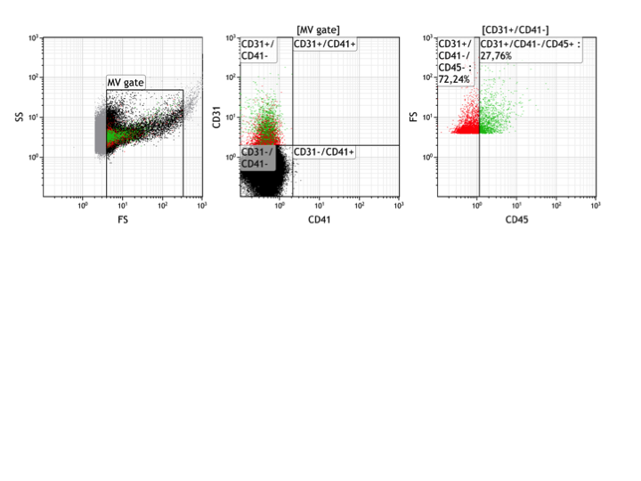

**ESM figure 5**: Expression of leukocyte markers (CD45, CD66b, CD14, CD20 or CD3) on CD31+/CD41- MV released from stimulated THP-1 cells in vitro.

Macintosh HD:Users:GeorgLehner:Desktop:Microvesicles 48h septic shock analysis 08-2014:FINAL DOCUMENTS:ICM Revision 1 - 11.04.2015:Analyse 30 Pat:Revision 2 - 06-2015:THP-1 MV.pdf

Bars represent mean and standard deviation (n = 4).

**ESM figure 6:** Histogram showing CD45 expression on THP-1 cells. THP-1 cells labeled with isotype control antibodies (green) and antibodies specific for CD45 (red).

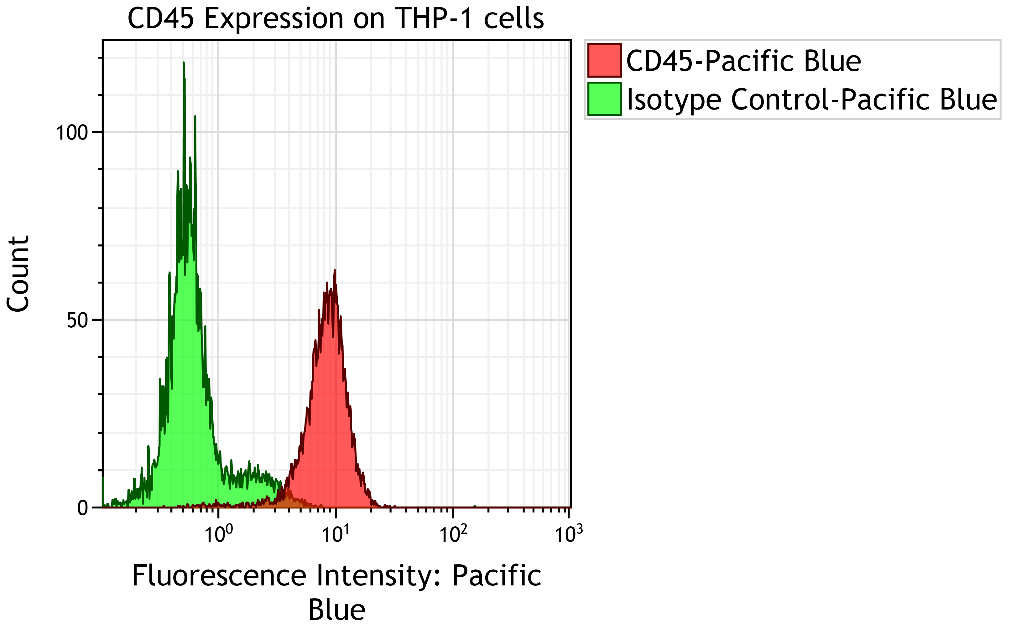

**ESM table 1:** Antibody panels.

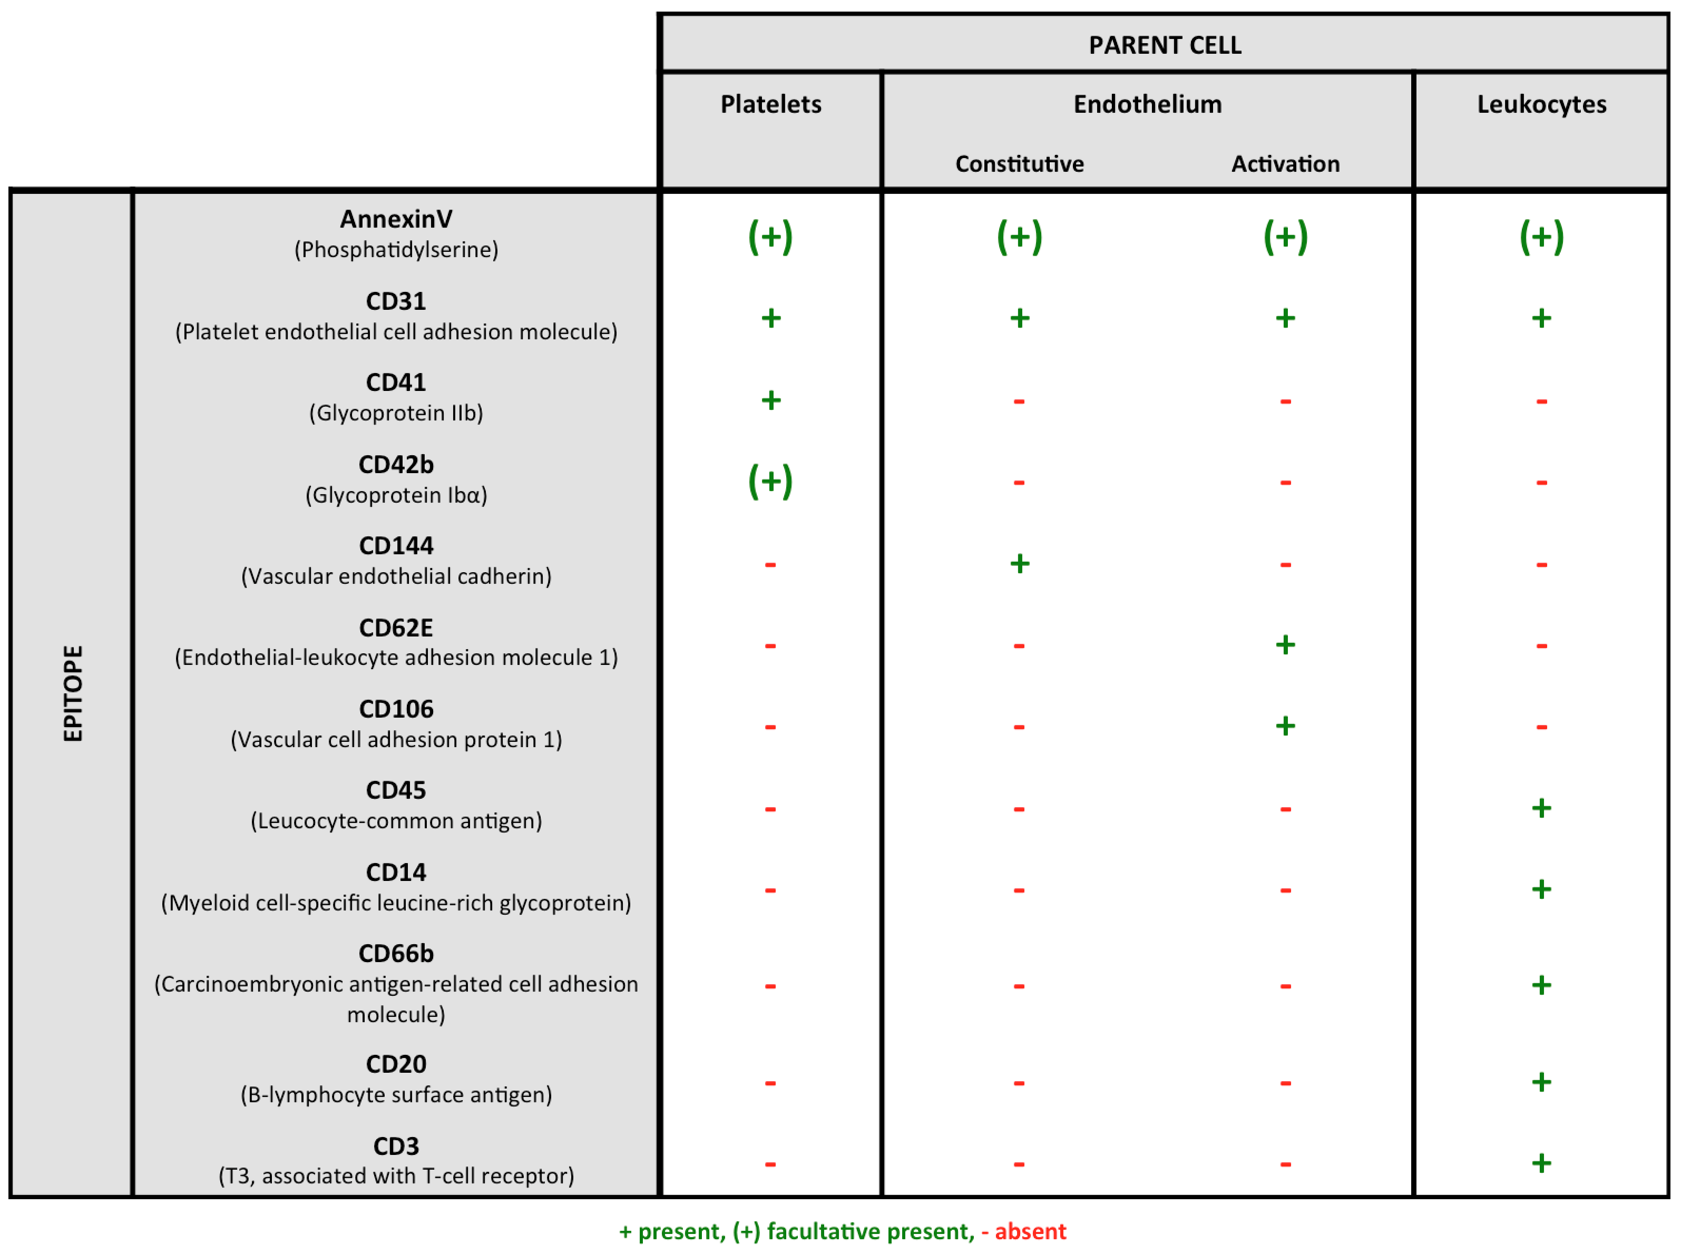

**ESM table 2:** Cytokine levels of patients with septic shock and healthy volunteers.

|  |  |  |  |
| --- | --- | --- | --- |
|  | Septic shock  (n=30) | Healthy volunteers (n=18) | p |
| IL 6 [pg/ml] | 84.3 (43.5-291.8) | 2.0 (1-3.1) | < 0.001 |
| IL 10 [pg/ml] | 26.0(10.8-72.9) | 1.0 (0.7-1.6) | < 0.001 |
| TNF-alpha [pg/ml] | 103.8 (88-122.3) | 30.3 (22.8-39.2) | < 0.001 |
| sE-selectin [pg/ml] | 13862.6 (6143.4-21156.3) | 2991.8 (1767.4-5396.7) | < 0.001 |

Data are presented as median (25th-75th percentile).

IL = Interleukin

TNF = Tumor necrosis factor

sE-selectin = Soluble E-selectin

**ESM table 3:** Characteristics of patients with septic shock stratified according to counts of CD62E+ microvesicles (threshold: CD62E+ MV ≥5/µl).

|  |  |  |  |
| --- | --- | --- | --- |
|  | CD62E+ MV  ≥5/µl  (n=4) | CD62E+ MV  <5/µl  (n=23) | p |
| Bilirubin [mg/dl] | 3.7 (1.4-11.4) | 1.0 (0.5-2.2) | 0.082 |
| **AST [U/l]** | **194.5 (92-5-367)** | **35.0 (22-114)** | **0.041** |
| ALT [U/l] | 73.5 (29-105.3) | 34.0 (14-57) | 0.272 |
| **PT [%]** | **43.0 (36.3-55.8)** | **60.0 (53-73)** | **0.041** |
| **AT III [%]** | **32.0 (24-40)** | **56.0 (41-70)** | **0.016** |
| **sE-selectin [pg/ml]** | **20396.9 (19346.5-21875.1)** | **11699.4 (5215.9-18782.9)** | **0.011** |
| **IL 6 [pg/ml]** | **400.6 (212.7-1723.5)** | **62.1 (43.2-210.4)** | **0.027** |

Data are presented as median (25th-75th percentile).

AST = Aspartat-aminotransferase

ALT = Alanine-aminotransferase

PT = Prothrombin time

AT III = Antithrombin III

IL = Interleukin

sE-selectin = Soluble E-selectin

**ESM table 4:** Calculated microvesicle count [MV/µl] in a size range between 0.3 µm-0.5 µm in patients with septic shock and healthy volunteers.

|  |  |  |  |
| --- | --- | --- | --- |
|  | Patients with septic shock (n = 30) | Healhty volunteers (n = 18) | p |
| ***CD144+*** | ***1 (0.7-4); 21*** | ***0.5 (0.5-1); 15*** | ***0.036*** |
| ***CD62E+*** | ***1 (0.5-2.3); 27*** | ***0.5 (0-0.5); 15*** | ***0.006*** |
| ***CD106+*** | ***0 (0-0.5); 29*** | ***1 (0-1.4); 18*** | ***0.032*** |
| ***CD62E+/CD106-*** | ***1 (0.5-2.3); 27*** | ***0.5 (0-0.5); 15*** | ***0.008*** |
| CD144+/CD106+ | 0 (0-0.2); 29 | 0 (0-0); 18 | 0.511 |
| CD144+/CD62E+ | 0.5 (0-1); 27 | 0 (0-0.5); 18 | 0.163 |
| CD144+/CD106+/CD62E+ | 0 (0-0); 29 | 0 (0-0); 18 | 0.702 |
| ***AnnexinV+*** | ***317.5 (218.2-499.6); 21*** | ***183.1 (135.4-343.9); 17*** | ***0.039*** |
| ***CD31+*** | ***161.1 (81-247.2); 29*** | ***95.6 (74.9-137.9); 18*** | ***0.038*** |
| CD41+ | 136.7 (59.3-285.6); 29 | 138 (106.4-212); 18 | 0.793 |
| CD42b+ | 23.3 (12-44.9); 30 | 12.3 (6.5-29.2); 18 | 0.088 |
| ***CD31+/CD41-*** | ***35.3 (14.3-59.7); 28*** | ***9.8 (7-13.8); 18*** | ***<0.001*** |
| ***CD31+/CD42b-*** | ***129.2 (73.1-221.9); 29*** | ***78.1 (64-114.8); 18*** | ***0.049*** |
| ***CD31+/CD41-/CD42b-*** | ***35.3 (14.3-59.7); 28*** | ***9.7 (7.3-15.3); 17*** | ***<0.001*** |
| CD41+/CD42b+ | 23 (12-44.9); 30 | 12.3 (5.3-28.3); 18 | 0.088 |
| ***CD31+/AnnexinV-*** | ***25.1 (10.6-53.4); 27*** | ***8.6 (5.6-15.1); 15*** | ***<0.001*** |
| CD31+/AnnexinV+ | 118.4 (64.9-193.8); 30 | 80.2 (64.9-124); 18 | 0.085 |
| CD41+/AnnexinV- | 17.4 (7.4-41.3); 28 | 21.3 (11.1-50.9); 17 | 0.325 |
| CD41+/AnnexinV+ | 121.5 (56-227.7); 30 | 112.2 (84.3-167.1); 18 | 0.983 |
| CD42b+/AnnexinV- | 2.6 (1-5.4); 27 | 2 (0.5-3.5); 13 | 0.213 |
| CD42b+/AnnexinV+ | 20.4 (9.5-42.1); 30 | 10.7 (5.1-22.5); 18 | 0.053 |
| **CD31+/CD42b-/AnnexinV-** | **22.9 (10.2-46.7); 27** | **7 (5-13.2); 14** | **<0.001** |
| CD31+/CD42b-/AnnexinV+ | 101.5 (57.8-172.7); 30 | 64.5 (55.1-94.7); 18 | 0.106 |
| ***CD31+/CD41-/AnnexinV-*** | ***15.5 (7.3-33.8); 26*** | ***3 (2.5-5.1); 10*** | ***<0.001*** |
| ***CD31+/CD41-/AnnexinV+*** | ***16.8 (7.3-33.2); 28*** | ***5.9 (4.1-8.9); 18*** | ***0.001*** |

Data are presented as median (25th-75th percentile); n.

**ESM table 5:** Characteristics at the time of blood sampling of patients with septic shock who died within 48 hours after blood draw vs. those who survived.

|  |  |  |  |
| --- | --- | --- | --- |
|  | Patients who died within 48 hours (n=6) | Patients who survived longer than 48 hours (n=24) | p |
| Leukocytes [G/l] | 18.9 (7-41.2) | 10.5 (6-18.7) | 0.321 |
| Platelets [G/l] | 106.5 (53-226.3) | 83.0 (58.5-171.3) | 0.743 |
| HCO3- [mmol/l] | 11.6 (7.1-13.5) | 18.9 (16.4-21.8) | < 0.001 |
| pH | 7.037 (6.889-7.168) | 7.322 (7.221-7.373) | 0.002 |
| Phosphate [mmol/l] | 2.8 (1.5-5.4) | 1.2 (1-1.5) | 0.017 |
| Chloride [mmol/l] | 93.0 (84-101.5) | 103.5 (97.5-110.8) | 0.009 |
| Lactate [mg/dl] | 168.5 (42.8-183.3) | 26.0 (17.3-43.5) | 0.001 |
| Norepinephrine dose [µg/kg/min] | 1.5 (0.59-4.24) | 0.2 (0.07-0.35) | 0.001 |
| Mean arterial pressure [mmHg] | 25 (13.8-45) | 55 (50-60) | 0.003 |
| Heart rate [bpm] | 155 (136-173) | 120 (100-130) | 0.008 |
| Horowitz index | 78 (35-96) | 159 (128-237) | 0.002 |
| Urinary output [ml/24h] | 25 (0-275) | 1700 (1050-2300) | 0.003 |
| sE-selectin [pg/ml] | 15197.8 (4871.9-20222.1) | 13532.7 (6901.3-19999.5) | 0.820 |
| IL 10 [pg/ml] | 205.1 (75.5-345.8) | 19.1 (8.1-40) | 0.001 |
| IL 6 [pg/ml] | 170.1 (41.9-3250.2) | 84.3 (43.3-260.9) | 0.494 |
| TNF-alpha[pg/ml] | 119.5 (97.5-170.3) | 93.1 (87.6-118.1) | 0.174 |

Data are presented as median (25th-75th percentile).

mmHg = Millimeter mercury

bpm = Beats per minute

IL = Interleukin

TNF = Tumor necrosis factor

sE-selectin = Soluble E-selectin