Supplementary File 1. Diagnostic criteria for severe sepsis and septic shock
First: The patients should meet the diagnostic criteria sepsis. Sepsis=Infection (documented or suspected)+at least two of the following:
- Fever (> 38.3°C) or hypothermia (core temperature < 36°C)
- Heart rate > 90/min–1
- Tachypnea: RR>20/min or on mechanical ventilation
- Altered mental status
- Significant edema or positive fluid balance (> 20 mL/kg over 24 hr)
- Hyperglycemia (plasma glucose > 7.7 mmol/L) in the absence of diabetes
- Leukocytosis (WBC count > 12,000 μL⁻¹) or Leukopenia (WBC count < 4000 μL⁻¹) or normal WBC count with greater than 10% immature forms

Second: Severe Sepsis=Sepsis induced hypoperfusion or organ dysfunction. Sepsis+any one of the following:
- Sepsis-induced hypotension: MAP<70mmHg
- Lactate≥2 mmol/L
- Urine output < 0.5 mL/kg/hr for more than 2 hrs despite adequate fluid resuscitation
- Acute lung injury with PaO₂/FIO₂ < 250 in the absence of pneumonia as infection source
- Acute lung injury with PaO₂/FIO₂ < 200 in the presence of pneumonia as infection source
- Creatinine > 176.8 μmol/L
- Bilirubin > 34.2 μmol/L
- Platelet count < 100,000 μL
- INR > 1.5
Septic shock is defined as sepsis-induced hypotension persisting despite adequate fluid resuscitation.

Supplementary Fig. 1. A flow chart for processing and examining sample

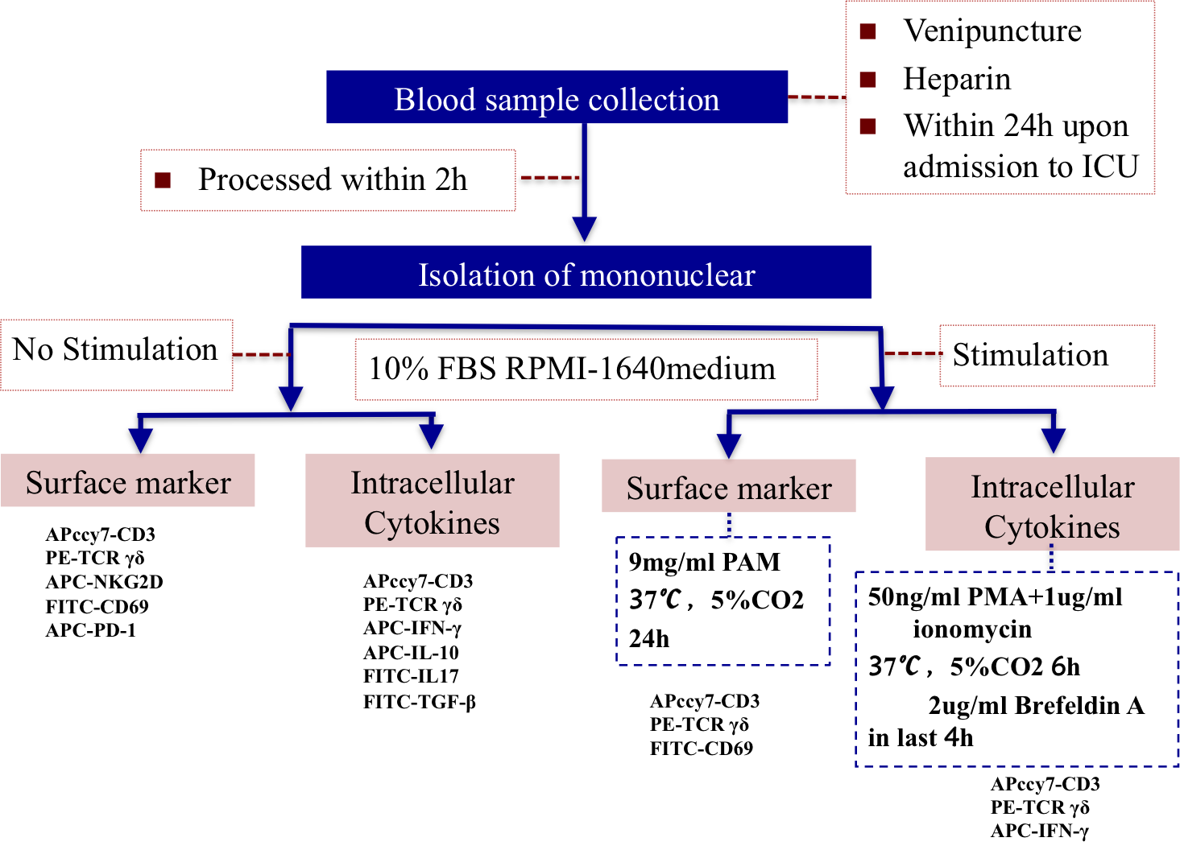

Supplementary Fig. 2. Flow cytometry plot and gate for percentage of γδ T cells
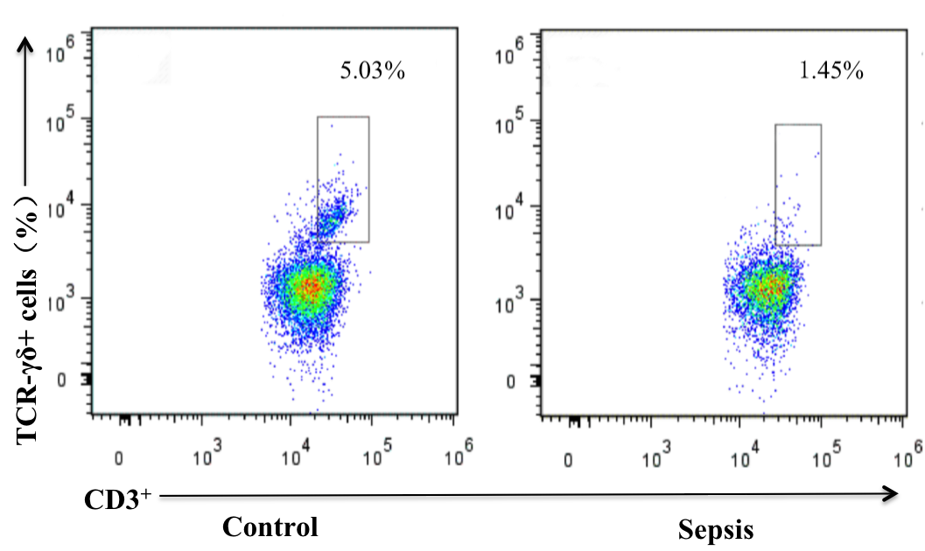

Supplementary Fig. 3. Flow cytometry plot of intracellular staining for IFN-γ (left panel) and histogram for surface staining of CD69 (right panel)
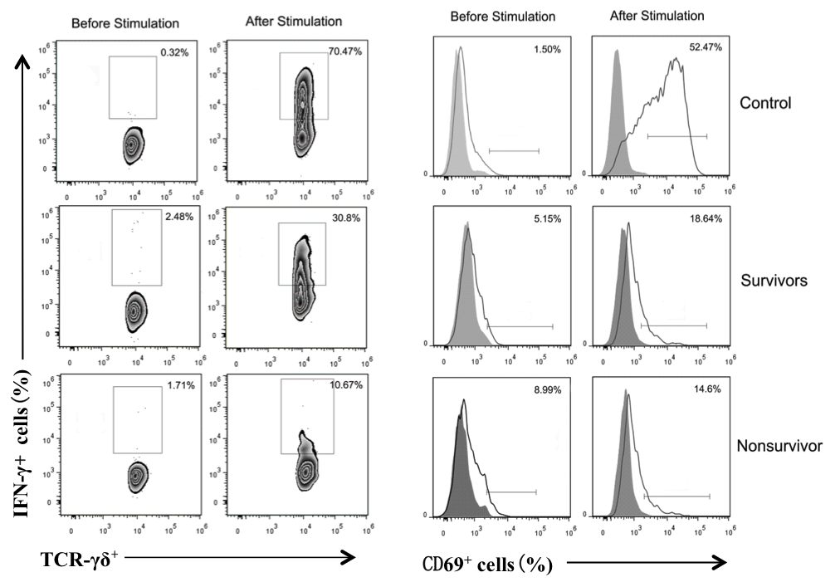

Supplementary Fig. 4. An example for the gating strategy for intracellular cytokines production by γδ T cells exported from Flowjo software
