Supplemental Data

Table 1. Correlation of baseline plasma HBP level with platelet count.

Day | Slope | Spearman R | P-Value
1 | -0.39 ± 0.11 | -0.19 | 0.0006
2 | -0.47 ± 0.11 | -0.25 | <0.0001
3 | -0.50 ± 0.12 | -0.27 | <0.0001
4 | -0.49 ± 0.13 | -0.23 | <0.0001
5 | -0.54 ± 0.14 | -0.22 | 0.0002

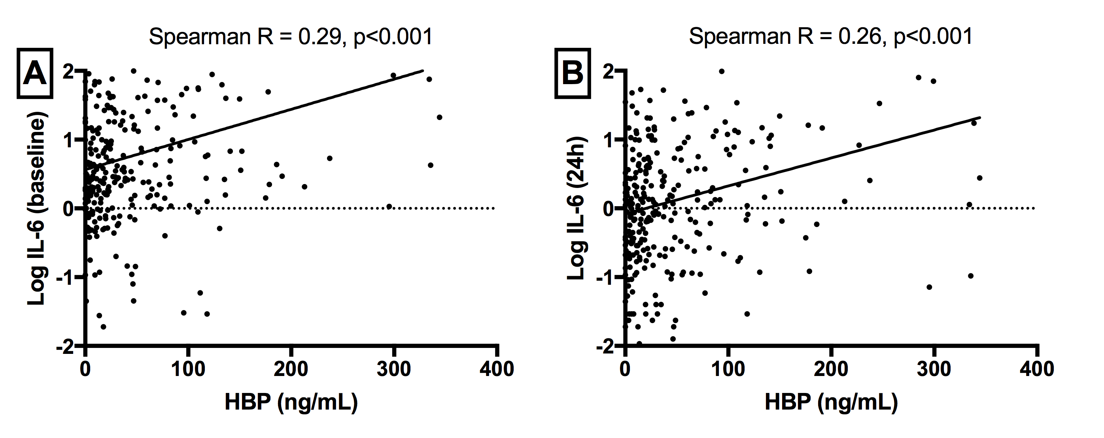

Figure 1. Correlation of baseline plasma HBP levels with with log-transformed plasma levels of interleukin (IL)-6 at (A) baseline and (B) 24 hours.

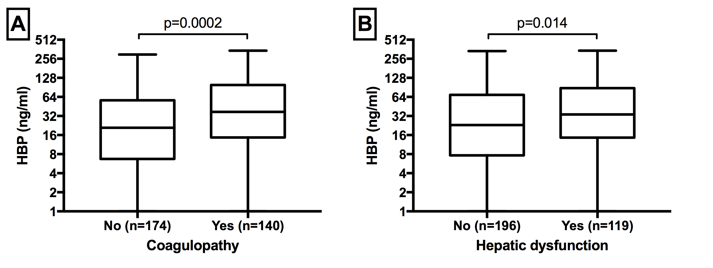

Figure 2. Association of baseline plasma HBP levels with (A) development of coagulopathy (moderate to severe Brussels score; platelets ≤ 80 x 10³/mm³) and
B) hepatic dysfunction (moderate to severe Brussels score; bilirubin ≥ 2 mg/dL)

