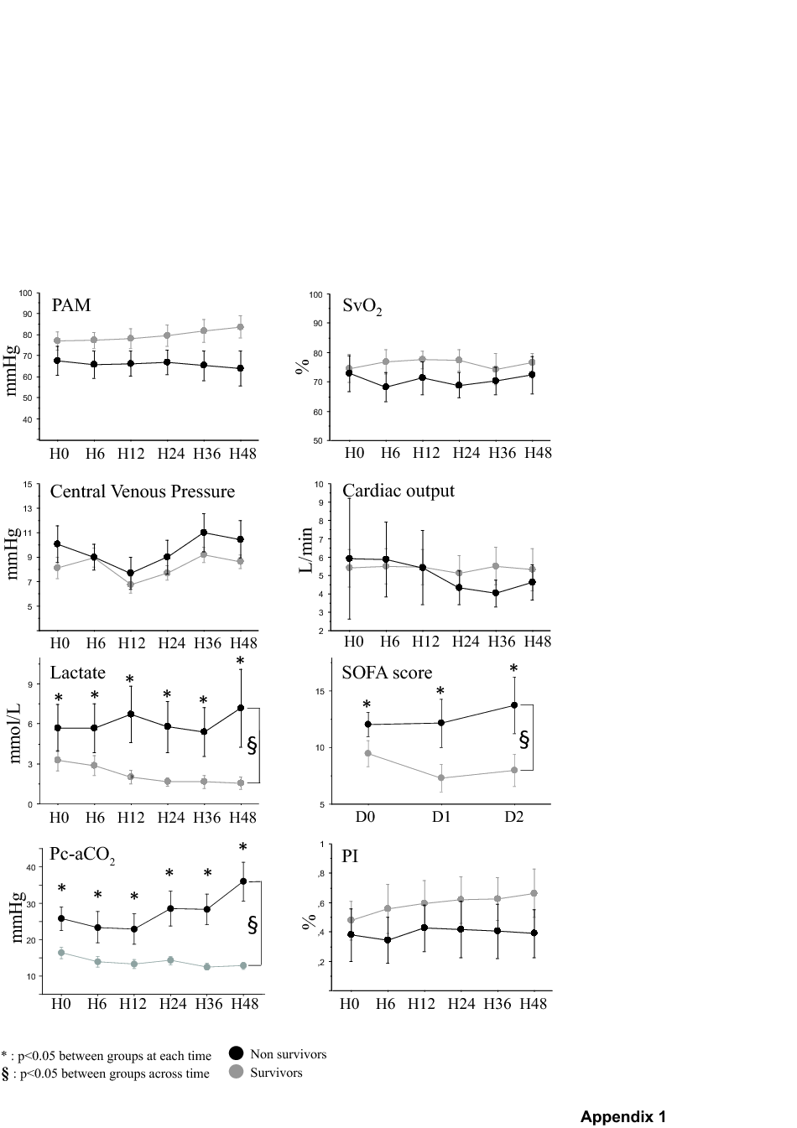
Supplementary data:
Appendix 1: Evolution of the parameters during the first 48 hours after inclusion in shocked patients (MAP, ScvO₂, CVP, cardiac output, lactate, SOFA score, Pc-aCO2 and PI at 37°C) during first 48 hours in shocked patients according to prognosis (black : non survivor and grey : survivors)

