Supplementary data

Supplementary eAppendix 1: Codes associated with infection

Codes associated with infection
Gastrointestinal infection
001, Cholera;
002, Typhoid/paratyphoid fever;
003, Other salmonella infection;
004, Shigellosis;
005, Other food poisoning;
008, Intestinal infection not otherwise classified;
009, Ill-defined intestinal infection;
562.01, Diverticulitis of small intestine without hemorrhage;
562.03, Diverticulitis of small intestine with hemorrhage;
562.11, Diverticulitis of colon without hemorrhage;
562.13, Diverticulitis of colon with hemorrhage;

Tuberculosis
010, Primary tuberculosis infection;
011, Pulmonary tuberculosis;
012, Other respiratory tuberculosis;
013, Central nervous system tuberculosis;
014, Intestinal tuberculosis; 015, Tuberculosis of bone and joint; 016, Genitourinary tuberculosis;
017, Tuberculosis not otherwise classified;
018, Miliary tuberculosis;

Zoonosis
020, Plague;
021, Tularemia;
022, Anthrax;
023, Brucellosis;
024, Glanders;
025, Melioidosis;
026, Rat-bite fever;
027, other bacterial zoonoses;

Other mycobacterial disease
030, Leprosy;
031, Other mycobacterial disease;

Syphilis
090, Congenital syphilis;
091, Early symptomatic syphilis;
092, Early syphilis latent;
093, Cardiovascular syphilis;
094, Neurosyphilis;
095, Other late symptomatic syphilis;
096, Late syphilis latent;
097, Other and unspecified syphilis;
102, Yaws;
103, Pinta;
104, Other spirochetal infection;

037, Tetanus;

Other bacterial diseases
040, Other bacterial diseases;
041, Bacterial infection in other diseases not otherwise specified;

Systematic fungal infection
110, Dermatophytosis;
111, Dermatomycosis not otherwise classified or specified;
112, Candidiasis;
114, Coccidioidomycosis;
115, Histoplasmosis;
116, Blastomycotic infection;
117, Other mycoses;
118, Opportunistic mycoses;
117.9, Disseminated fungal infection
112.5, Dissemintaed candidal infection
112.81, Disseminated fungal endocarditis
039, Actinomycotic infections;

CNS infection
320, Bacterial meningitis;
322, Meningitis, unspecified;
324, Central nervous system abscess;
325, Phlebitis of intracranial sinus;
036, Meningococcal infection;

Cardiovascular infection
420, Acute pericarditis;
421, Acute or subacute endocarditis;
451, Thrombophlebitis;

Upper respiratory tract infection
461, Acute sinusitis;
462, Acute pharyngitis;
463, Acute tonsillitis;
464, Acute laryngitis/ tracheitis;
465, Acute upper respiratory infection of multiple sites/not otherwise specified;
101, Vincent’s angina;
034, Streptococcal throat/scarlet fever;
032, Diphtheria;

Lower respiratory tract infection
481, Pneumococcal pneumonia;
482, Other bacterial pneumonia;
485, Bronchopneumonia with organism not otherwise specified;
486, Pneumonia, organism not otherwise specified;
491.21, Acute exacerbation of obstructive chronic bronchitis;
494, Bronchiectasis;
510, Empyema;
513, Lung/mediastinum abscess;
033, Whooping cough;
484, Pneumonia classified in elsewhere
483, Pneumonia by other pathogens

Intra-abdominal infection
540, Acute appendicitis;
541, Appendicitis not otherwise specified;
542, Other appendicitis;
566, Anal and rectal abscess;
567, Peritonitis;
569.5, Intestinal abscess;
569.83, Perforation of intestine;
572.0, Abscess of liver;

Biliary tract infection
572.1, Portal pyremia;
575.0, Acute cholecystitis;

Genitourinary tract infection
590, Kidney infection;
597, Urethritis/urethral syndrome;
599.0, Urinary tract infection not otherwise specified;
601, Prostatic inflammation;
098, Gonococcal infections;

Gynecological infection
614, Female pelvic inflammation disease;
615, Uterine inflammatory disease;
616, Other female genital inflammation; 681, Cellulitis, finger/ toe;
098, Gonococcal infections;

Skin and appendix structure infection
682, Other cellulitis or abscess;
683, Acute lymphadenitis;
686, Other local skin infection;
035, Erysipelas;

Musculoskeletal infection
711.0, Pyogenic arthritis;
730, Osteomyelitis;

Primary bacteremia
790.7, Bacteremia;

Catheter related bloodstream infection
996.6, Infection or inflammation of device/graft;

Post-operative complication
998.5, Postoperative infection;

Nosocomial infection
999.3, Infectious complication of medical care not otherwise classified.

Septicemia
038.0, Streptococcal septicemia
038.1, Staphylococcal septicemia
038.2, Pneumococcal septicemia [Streptococcus pneumoniae septicemia]
038.3, Septicemia due to anaerobes
038.4, Septicemia due to other gram-negative organisms
038.8, Other specified septicemias
Excludes: septicemia (due to):
anthrax (022.3)
gonococcal (098.89)
herpetic (054.5)
meningococcal (036.2)
septicemic plague (020.2)
038.9, Unspecified septicemia
995.92, Severe sepsis

Supplementary eAppendix 2: ICD-9-CM codes of organ dysfunction associated with sepsis

Cardiovascular dysfunction/Shock
785.5, Shock
458, Hypotension

Acute respiratory dysfunction
96.7, Mechanical ventilation
57001B, 57002B, 57023B, 57029C, use of ventilators

Central nervous system dysfunction
348.3, Neurologic Encephalopathy
293, Transient organic psychosis
348.1, Anoxic brain damage

Hematologic system dysfunction
287.4, Hematologic Secondary thrombocytopenia
287.5, Thrombocytopenia, unspecified
286.9, Other/unspecified coagulation defect
286.6, Defibrination syndrome

Hepatic system dysfunction
570, Hepatic Acute and subacute necrosis of liver
572.2, Hepatic encephalopathy
572.4, Hepatorenal syndrome
572.8, Other squeal of chronic liver disease
573.4, 573.8, Hepatic infarction
V42.7, Liver replaced by transplant

Renal system dysfunction
584, Acute renal failure
58014C, Use of CVVH

Metabolic system dysfunction
250.1, Diabetic ketoscidosis
250.2, Hyperosmolar hyperglycemic state
Supplementary efigure1. Standardized difference graph before and after propensity score matching.
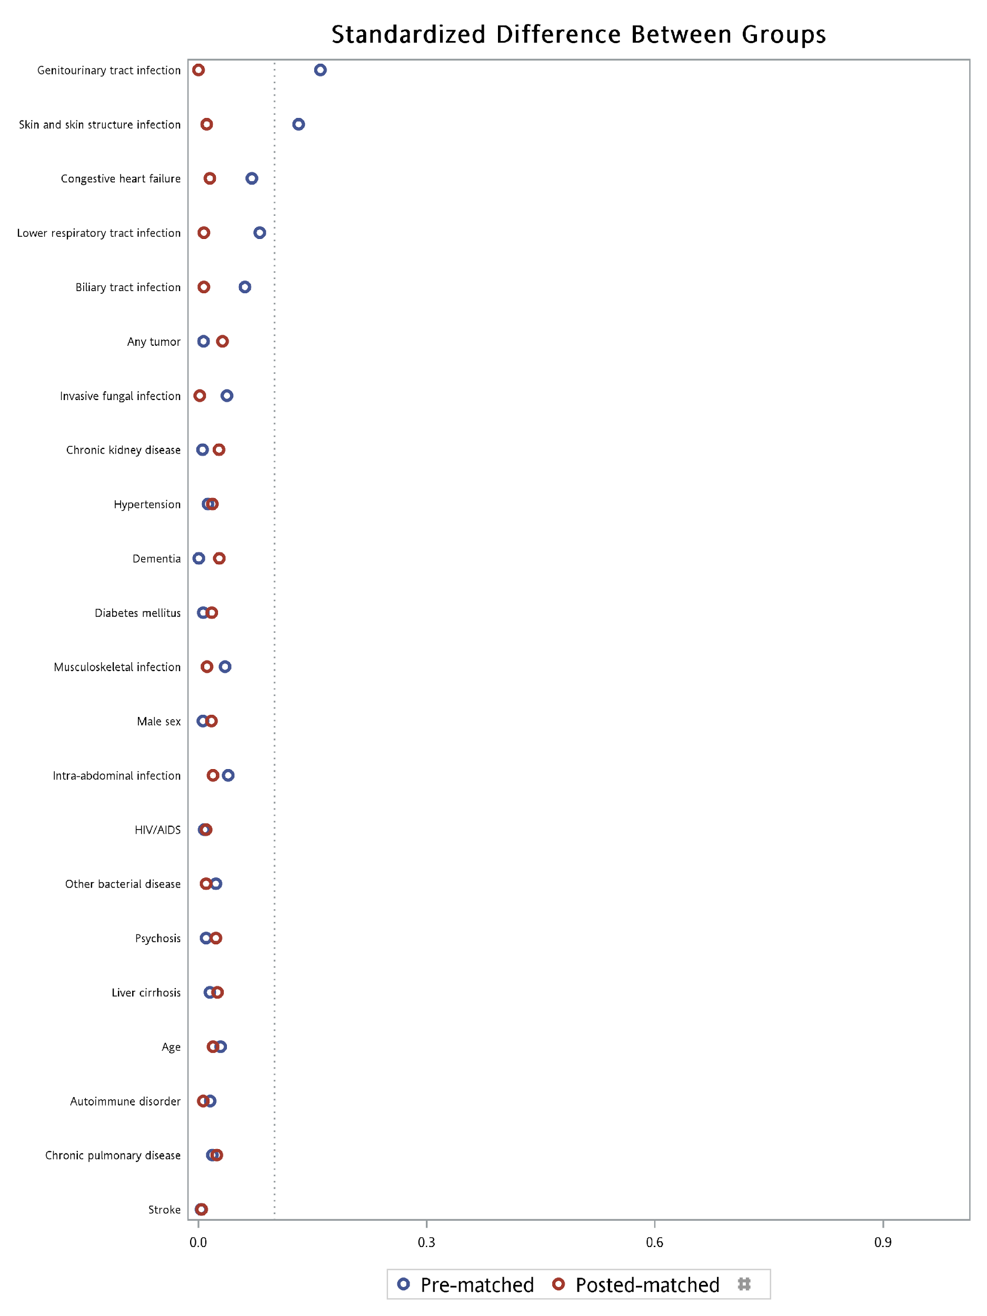

Supplementary eFigure 2. Secular trend of the incidence of sepsis and septic shock, stratified by source of admission (ED-admitted vs. Non-ED admitted)

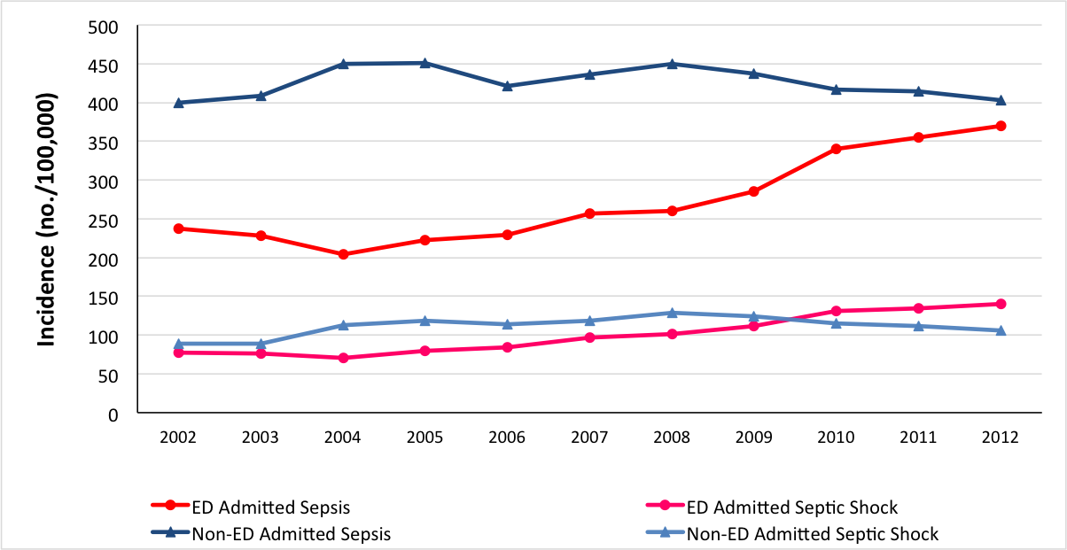

Supplementary eFigure 3. Trend of mortality for patients with sepsis and septic shock, stratified by source of admission.

