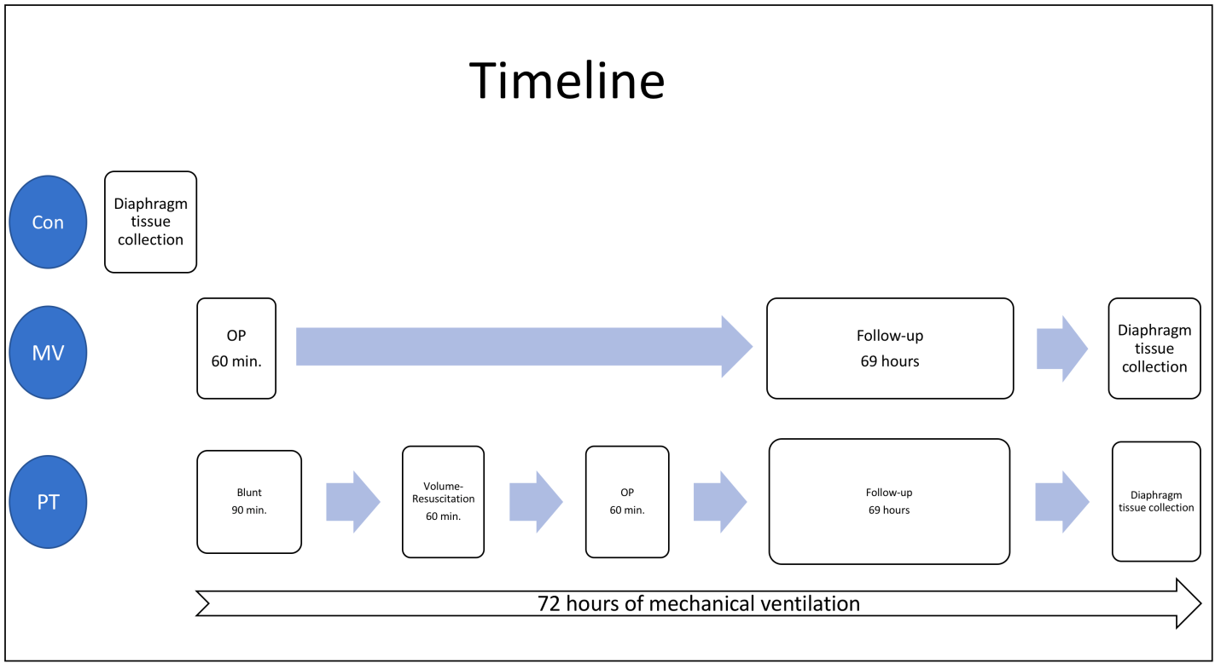

Supplemental Figure 1: Flowchart of the experimental timeline.

