The Prognostic Usefulness of the Lactate/Albumin Ratio for Predicting Clinical Outcomes in Out-of-hospital Cardiac Arrest: A Prospective, Multi-centre Observational Study (KoCARC Study)
Supplements

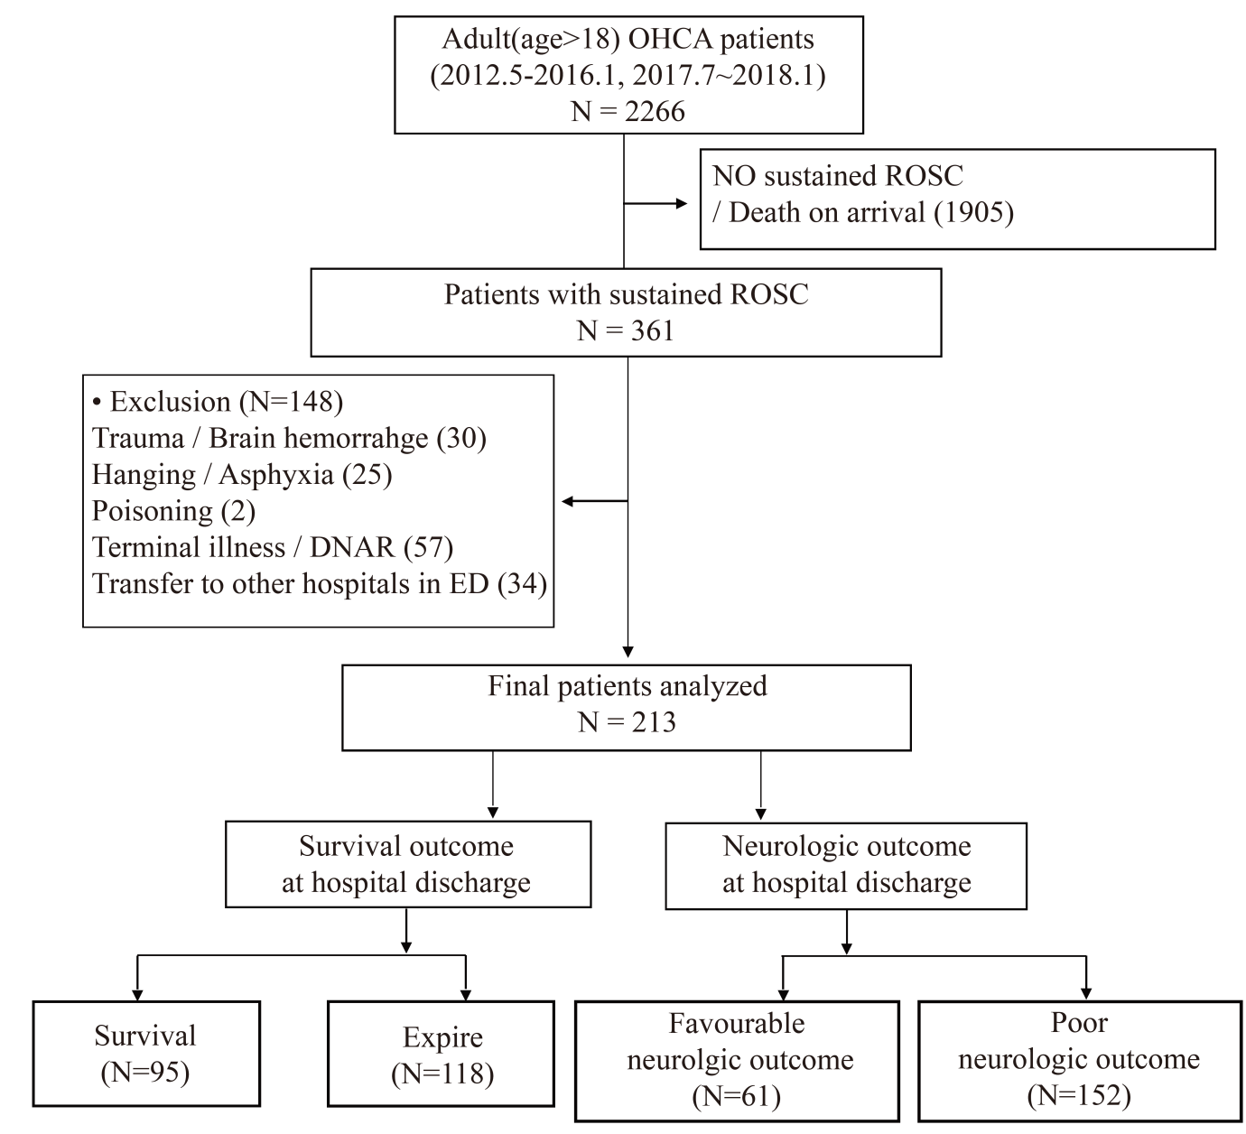
Supplement 1. Flow diagram of patient enrolment in the validation cohort.

Supplement 2. Univariate logistic regression analysis for predictors of good neurological outcome and survival discharge.
Variables | Good neurologic outcome |  | Survival discharge
 | OR (95% CI) | P | OR (95% CI) | P
Age (per 1 year) | 0.958 (0.945-0.970) | <0.001 | 0.964 (0.952-0.975) | <0.001
Female sex (vs male) | 0.286 (0.154-0.530) | <0.001 | 0.549 (0.357-0.844) | 0.006
Arrest to ROSC time (per 1 min) | 0.915 (0.897-0.934) | <0.001 | 0.939 (0.926-0.952) | <0.001
Bystander CPR | 1.514 (0.968-2.368) | 0.069 | 1.006 (0.692-1.464) | 0.974
Witnessed collapse (vs non-witnessed) | 2.246 (1.281-3.940) | 0.005 | 2.364 (1.497-3.732) | <0.001
Initial shockable rhythm (vs non-shockable) | 10.529 (6.276-17.665) | <0.001 | 3.527 (2.354-5.286) | <0.001
Times of defibrillation shock (per 1 time) | 0.969 (0.878-1.069) | 0.532 | 0.947 (0.860-1.043) | 0.27
Laboratory data
Glucose (per 100 mg/dL) | 0.869 (0.742-1.018) | 0.082 | 0.966 (0.856-1.090) | 0.576
White blood cell count (per 10³/μL) | 1.028 (0.995-1.062) | 0.094 | 1.021 (0.992-1.051) | 0.16
Haemoglobin (per 1 g/dL) | 1.566 (1.397-1.755) | <0.001 | 1.389 (1.277-1.512) | <0.001
ALT (per 100 IU/L) | 0.964 (0.901-1.031) | 0.285 | 0.940 (0.877-1.007) | 0.08
Total bilirubin (per 1 mg/dL) | 0.728 (0.512-1.035) | 0.077 | 0.757 (0.586-0.977) | 0.032
CK-MB (per 1 mcg/L) | 0.989 (0.975-1.003) | 0.132 | 0.997 (0.990-1.005) | 0.501
Troponin I (per 1 mcg/L) | 1.002 (0.971-1.035) | 0.896 | 0.993 (0.960-1.027) | 0.67
D-dimer (per 1 mcg/mL) | 0.998 (0.994-1.002) | 0.308 | 1.000 (0.997-1.002) | 0.808
Comorbidity
Hypertension | 0.559 (0.349-0.897) | 0.016 | 0.720 (0.490-1.058) | 0.094
Diabetes mellitus | 0.455 (0.259-0.798) | 0.006 | 0.534 (0.344-0.831) | 0.005
Dyslipidaemia | 1.701 (0.733-3.947) | 0.216 | 1.394 (0.647-3.002) | 0.397
Management in hospital
ECMO cardio-pulmonary resuscitation | 0.634 (0.185-2.169) | 0.467 | 0.324 (0.095-1.103) | 0.071
Coronary revascularisation procedures
No | Ref (1) |  | Ref (1)
Yes (≤24 h) | 10.860 (3.708-31.803) | <0.001 | 21.989 (4.875-99.180) | <0.001
Yes (>24 h) | 4.273 (2.573-7.095) | <0.001 | 3.453 (2.181-5.469) | <0.001
Application of TTM | 1.388 (0.874-2.205) | 0.165 | 1.939 (1.311-2.868) | <0.001
Lactate/albumin ratio | 0.473 (0.389-0.574) | <0.001 | 0.553 (0.479-0.638) | <0.001

*P<0.05
ALT, alanine aminotransferase; CPR, cardiopulmonary resuscitation; ECMO, extra corporeal membrane oxygenation; ROSC, return of spontaneous circulation; TTM, targeted temperature management

Supplement 3. Comparing clinical markers for the prediction of favourable neurologic outcome (A) and survival discharge (B) using the area under the curve using the Delong method.
(A)
Variables | AUC (95% CI) | P | P  (vs LAR) | P  (vs First monitored rhythm) | P  (vs Witnessed arrest) | P  (vs ACLS duration) | P  (vs BLS duration) | P  (vs Arrest to ROSC)
LAR | 0.820 (0.772-0.867) | <0.001* | Ref | 0.068 | <0.001* | 0.443 | 0.259 | 0.367
First monitored rhythm | 0.762 (0.713-0.812) | <0.001* | 0.068 | Ref | <0.001* | 0.018* | 0.572 | 0.019*
Witnessed arrest | 0.582 (0.538-0.626) | <0.001* | <0.001* | <0.001* | Ref | <0.001* | <0.001* | <0.001*
ACLS duration | 0.842 (0.794-0.889) | <0.001* | 0.443 | 0.018* | <0.001* | Ref | 0.052 | 0.84
BLS duration | 0.783 (0.736-0.831) | <0.001* | 0.259 | 0.572 | <0.001* | 0.052 | Ref | <0.001*
Duration of arrest to ROSC | 0.845 (0.801-0.890) | <0.001* | 0.367 | 0.019* | <0.001* | 0.84 | <0.001* | Ref
*P<0.05
ACLS, advanced cardiac life support; AUC, area under cover; CI, confidence interval; BLS, basic life support; ROSC, return of spontaneous circulation.

(B)
Variables | AUC (95% CI) | P | P  (vs LAR) | P  (vs First monitored rhythm) | P  (vs Witnessed arrest) | P  (vs ACLS duration) | P  (vs BLS duration) | P  (vs Arrest to ROSC)
LAR | 0.780 (0.739-0.822) | <0.001* | Ref | <0.001* | <0.001* | 0.893 | 0.02* | 0.915
First monitored rhythm | 0.637 (0.592-0.682) | <0.001* | <0.001* | Ref | 0.084 | <0.001* | 0.013 | <0.001*
Witnessed arrest | 0.586 (0.547-0.626) | <0.001* | <0.001* | 0.084 | Ref | <0.001* | <0.001* | <0.001*
ACLS duration | 0.777 (0.733-0.821) | <0.001* | 0.893 | <0.001* | <0.001* | Ref | 0.02 | 0.715
BLS duration | 0.714 (0.666-0.762) | <0.001* | 0.02* | 0.013* | <0.001* | 0.02* | Ref | <0.001*
Duration of arrest to ROSC | 0.783 (0.740-0.826) | <0.001* | 0.915 | <0.001* | <0.001* | 0.715 | <0.001* | Ref
*P<0.05
ACLS, advanced cardiac life support; AUC, area under cover; CI, confidence interval; BLS, basic life support; ROSC, return of spontaneous circulation

Supplement 4. Sensitivity, specificity, accuracy, and odds ratio of the LAR, nomogram using the LAR and several meaningful clinical markers for predicting favourable neurologic outcome (A) and survival discharge (B).
(A)
Variables | Cutoff point | Sensitivity (95% CI) | Specificity (95% CI) | Accuracy (95% CI) | OR (95% CI) | p-value
LAR | < 2.82 | 0.768(0.684-0.853) | 0.786(0.747-0.824) | 0.782(0.747-0.818) | 0.082(0.048-0.140) | <0.001*
Nomogram using the LAR | ≥ 179 | 0.889(0.824-0.954) | 0.887(0.856-0.917) | 0.887(0.860-0.914) | 62.500(30.337-128.762) | <0.001*
First monitored rhythm | Shockable rhythm | 0.725(0.634-0.817) | 0.800(0.762-0.837) | 0.787(0.751-0.822) | 10.529(6.276-17.665) | <0.001*
Witnessed arrest | Witnessed | 0.821(0.744-0.898) | 0.329(0.284-0.373) | 0.418(0.376-0.460) | 2.246(1.281-3.940) | 0.005*
ACLS duration | < 3.5 min | 0.747(0.660-0.835) | 0.830(0.794-0.865) | 0.815(0.782-0.848) | 0.069(0.041-0.117) | <0.001*
BLS duration | ≤ 21 min | 0.863(0.794-0.932) | 0.683(0.639-0.727) | 0.716(0.677-0.754) | 0.074(0.040-0.137) | <0.001*
Duration of Arrest to ROSC | ≤ 26 min | 0.842(0.769-0.915) | 0.776(0.737-0.816) | 0.788(0.753-0.823) | 0.054(0.030-0.098) | <0.001*
*P<0.05
ACLS, advanced cardiac life support; AUC, area under cover; CI, confidence interval; BLS, basic life support; min, minute; ROSC, return of spontaneous circulation

(B)
Variables | Cutoff point | Sensitivity (95% CI) | Specificity (95% CI) | Accuracy (95% CI) | OR (95% CI) | p-value
LAR | < 3.62 | 0.801(0.739-0.864) | 0.644(0.595-0.693) | 0.691(0.651-0.730) | 0.137(0.088-0.214) | <0.001*
Nomogram using the LAR | ≥ 207 | 0.795(0.730-0.859) | 0.804(0.763-0.845) | 0.801(0.767-0.836) | 15.866(9.891-25.448) | <0.001*
First monitored rhythm | Shockable rhythm | 0.487(0.407-0.566) | 0.788(0.746-0.830) | 0.700(0.661-0.739) | 3.527(2.354-5.286) | <0.001*
Witnessed arrest | Witnessed | 0.814(0.753-0.875) | 0.351(0.302-0.399) | 0.489(0.446-0.531) | 2.364(1.497-3.732) | <0.001*
ACLS duration | < 6.5 min | 0.731(0.661-0.800) | 0.682(0.634-0.730) | 0.697(0.657-0.736) | 0.172(0.113-0.260) | <0.001*
BLS duration | < 23 min | 0.718(0.647-0.789) | 0.666(0.618-0.714) | 0.681(0.641-0.721) | 0.197(0.131-0.297) | <0.001*
Duration of arrest to ROSC | < 32.5 min | 0.763(0.696-0.830) | 0.712(0.666-0.758) | 0.727(0.689-0.765) | 0.126(0.082-0.194) | <0.001*
*P<0.05
ACLS, advanced cardiac life support; AUC, area under cover; CI, confidence interval; BLS, basic life support; min, minute; ROSC, return of spontaneous circulation

