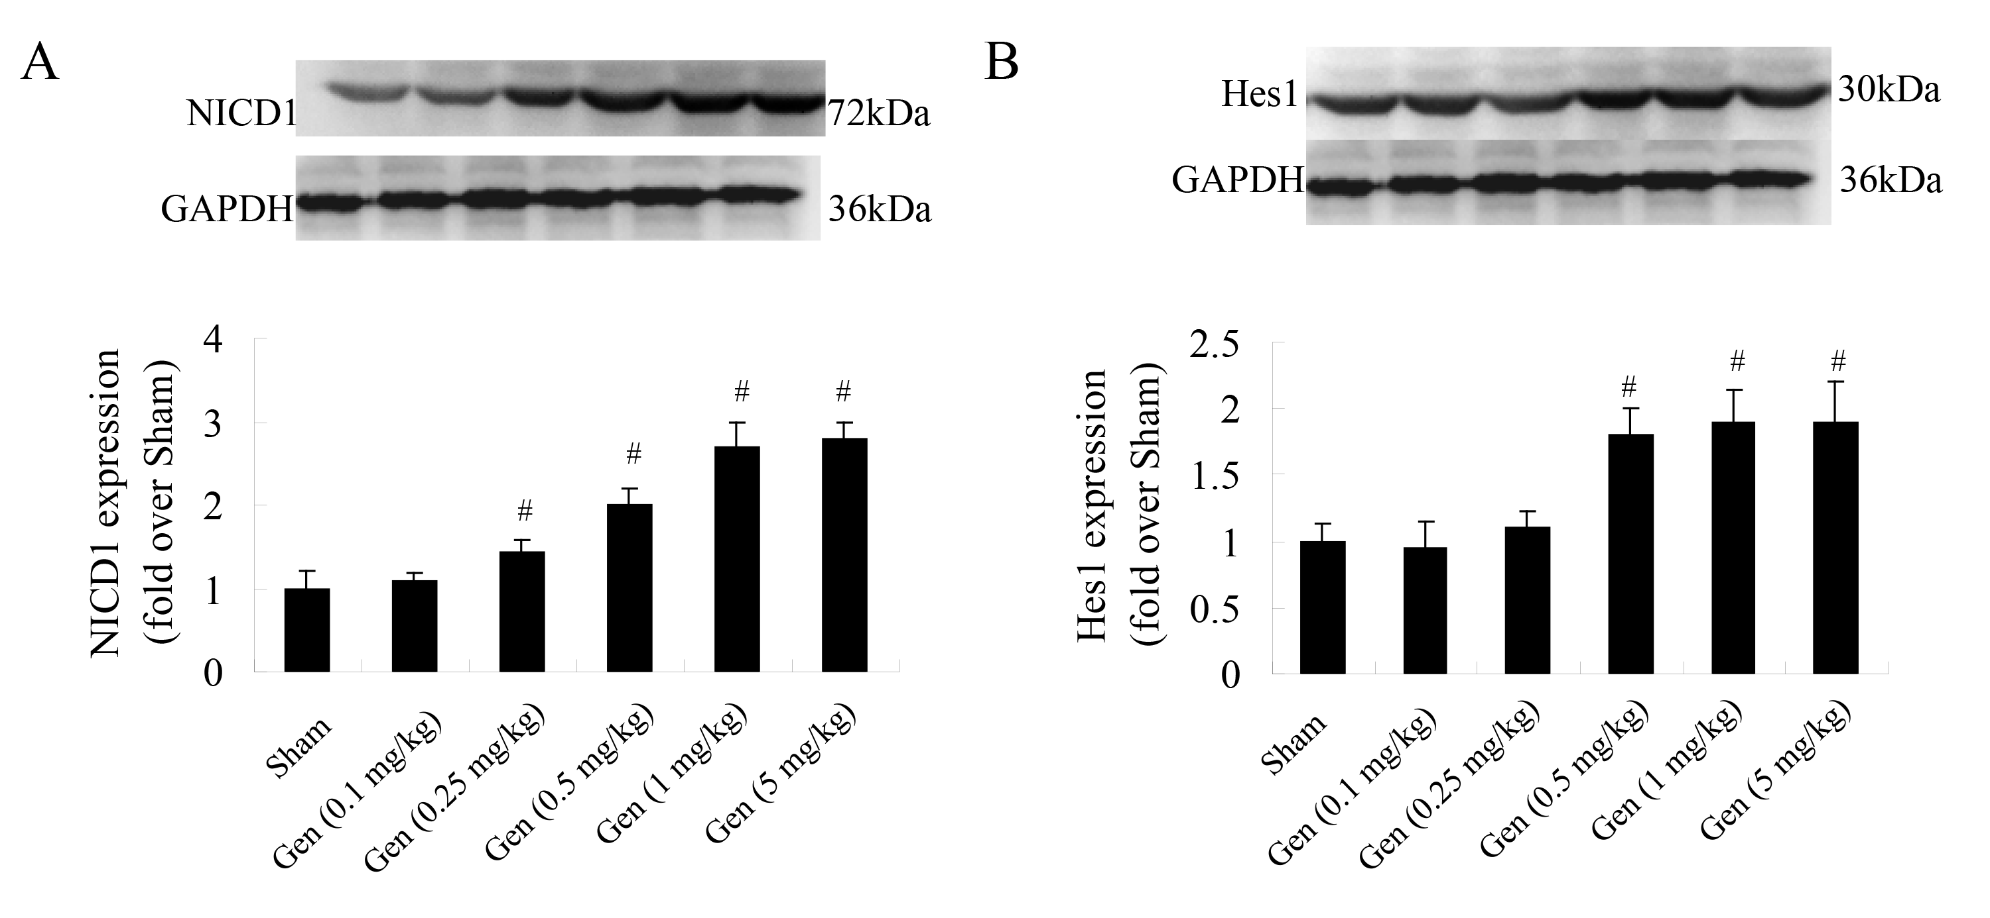

Supplemental Fig.1. Gen activated myocardial Notch1 pathway in sham-burn mice. Mice were randomly divided into sham and Gen (0.1, 0.25, 0.5, 1 or 5 mg/kg) groups. Mice in the Gen groups were subjected to room temperature water, followed by Gen intraperitoneal injection. Mice in sham group were subjected to an identical procedure except that the animals were injected with vehicle. The protein levels of NICD1 (A) and Hes1 (B) in myocardial tissues were determined by Western blots at 12 h. Data are expressed as mean ± SEM, n = 6 per group, #P < 0.05 vs the sham group.

