Supplementary appendix

Methods

Clinical definitions
Comorbidities were defined as the following: hypertension was documented or the patient on anti-hypertensive medication; congestive heart failure equaled a score of 2–4 from the New York Heart Classification Association (NYHA) or a left ventricular ejection fraction of ≤ 45%; chronic respiratory insufficiency was characterized by restrictive, obstructive or vascular lung disease resulting in severe pulmonary hypertension, chronic mechanical ventilation or home oxygen therapy; patients with chronic renal insufficiency presented with a creatinine level ≥ 177 µmol/L or have reported chronic renal insufficiency; patients with diabetes mellitus were using anti-diabetic medication and/or insulin therapy; hematological malignancies comprised of any kind of lymphoma, leukemia or multiple myeloma and non-metastatic solid tumors were any form of neoplasm without metastases; and an immune deficiency was defined as the use of immunosuppressants at admission, chemo- or radiation therapy the year before admission or documented humoral or cellular deficiencies.
Analysis plan
A heatmap was constructed providing a detailed overview for different levels of bilirubin and different levels of the modifying variable on 30-day mortality by taking the mean observed 30-day mortality for each combination.
The logistic regression analysis with 30-day mortality as central determinant and utilization of B-splines for modelling bilirubin as covariate was applied for assessing the impact of other variables on the relationship between early hyperbilirubinemia and 30-day mortality. Those variables were the circulatory, pulmonary and renal SOFA score to compare the effects to the SOFA coagulation score.

Results

Outcome
The following patient baseline characteristics were chosen as potential confounders and/or effect modifiers in the relationship between early hyperbilirubinemia and mortality: age, congestive heart failure, chronic respiratory insufficiency, immune deficiency, hematological malignancies, alcohol or drug abuse, sepsis, use of vasoactive medication, AKI, ARDS, thrombocytopenia and prolonged prothrombin time (PT). Congestive heart failure, chronic respiratory insufficiency, alcohol and drug abuse, and prolonged PT were not identified as confounding or effect modifying variables (p ≥ 0.05 for all). Age, immune deficiency, hematological malignancy, sepsis, use of vasoactive medication, AKI, ARDS and thrombocytopenia were significant confounders (p < 0.05, for all).

eTable 1. Association between early hyperbilirubinemia and 30-day mortality.
Effect | OR (95% CI)
Hyperbilirubinemia | 1.85 (1.53 – 2.23)
Hyperbilirubinemia, adjusted for: | 1.31 (1.06 – 1.60)
Age > 65 years  Immune deficiency  Hematologic malignancy  Sepsis  Use of vasoactive medication  AKI  ARDS | 1.42 (1.23 - 1.63)  1.02 (0.82 - 1.28)  2.55 (1.83 - 3.55)  1.16 (0.98 - 1.36)  2.08 (1.78 - 2.42)  2.22 (1.74 - 2.56)  1.19 (0.96 - 1.47)

Observed 30-day mortality did not increase with bilirubin levels in patients with a normal platelet count (eFigure 1).

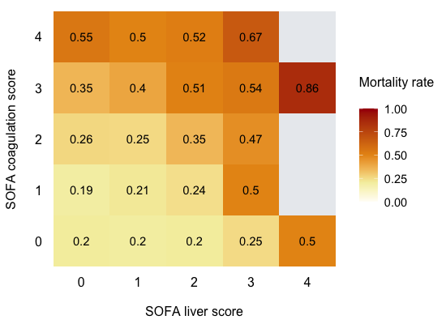

eFigure 1. Heatmap showing observed mean 30-day mortality rate for each combination of SOFA liver and SOFA coagulation score. Grey tiles reflect combinations with patients and were excluded from analyses. SOFA coagulation score (x 10⁹/L): 0 (≥ 150), 1 (< 150), 2 (< 100), 3 (< 50) to 4 (< 20). SOFA liver score (µmol/L): 0 (< 20), 1 (= 20–32), 2 (= 33–101), 3 (= 102–203) to 4 (≥ 204). Abbreviations: SOFA, sequential organ failure assessment.

The divergent effect of low or normal platelet counts (SOFA coagulation score) on the relationship between hyperbilirubinemia and mortality is visualized in Figure 3B and eFigure 2A (identical figures). The effect of circulatory, pulmonary and renal dysfunction, stratified for the individual SOFA scores, on the association between hyperbilirubinemia and mortality are presented in eFigure 2B–D. While mortality increases incrementally with higher bilirubin levels and more severe circulatory, pulmonary and renal organ dysfunction, 30-day mortality is not affected by increased bilirubin levels in patients with a normal platelet count.

A B
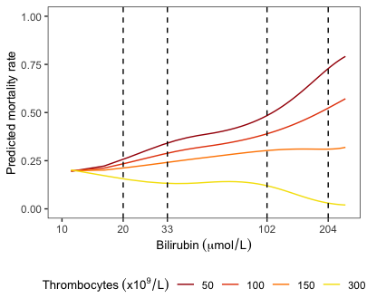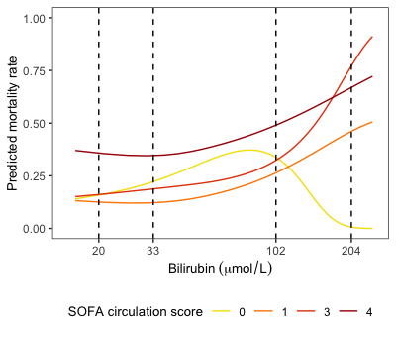
C D
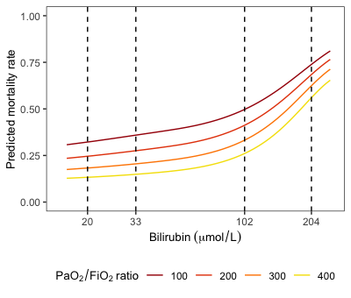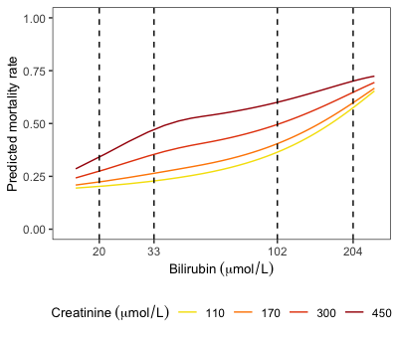

eFigure 2. Impact of individual SOFA scores on the relationship between hyperbilirubinemia and 30-day mortality. 30-day mortality was predicted by means of logistic regression using B-splines for modelling bilirubin levels. If available, continuous variables were chosen above dichotomous ones for superior curve-fitting. The dashed lines depict the cut-off values for the SOFA liver score ranging from 0 (< 20 µmol/L), 1 (= 20–32 µmol/L), 2 (= 33–101 µmol/L), 3 (= 102–203 µmol/L) to 4 (≥ 204 µmol/L). A: SOFA coagulation score. B: SOFA circulation score. SOFA circulation = 2 was excluded due to small number of patients. C: SOFA respiration score. D: SOFA renal score.

