A 29-mRNA Host Response Whole-Blood Signature Improves Prediction of 28-day Mortality and 7-day ICU-care in Adults Presenting to the Emergency Department With Suspected Acute Infection and/or Sepsis

Running title: Host response mRNA signature for sepsis mortality and ICU-care risk prediction

Antigone Kostaki¹, James W. Wacker², Asimina Safarika¹, Nicky Solomonidi¹, Konstantinos Katsaros³, George Giannikopoulos⁴, Ioannis M. Koutelidakis⁵,
Catherine A. Hogan², Florian Uhle², Oliver Liesenfeld², Timothy E. Sweeney²,
Evangelos J. Giamarellos-Bourboulis¹

¹4th Department of Internal Medicine, National and Kapodistrian University of Athens, Medical School, Greece;
²Inflammatix Inc., Burlingame, CA, United States;
³Department of Surgery, Nafplion General Hospital, Greece;
⁴Department of Internal Medicine, Syros General Hospital, Greece;
⁵2nd Department of Surgery, Aristotle University of Thessaloniki, Greece

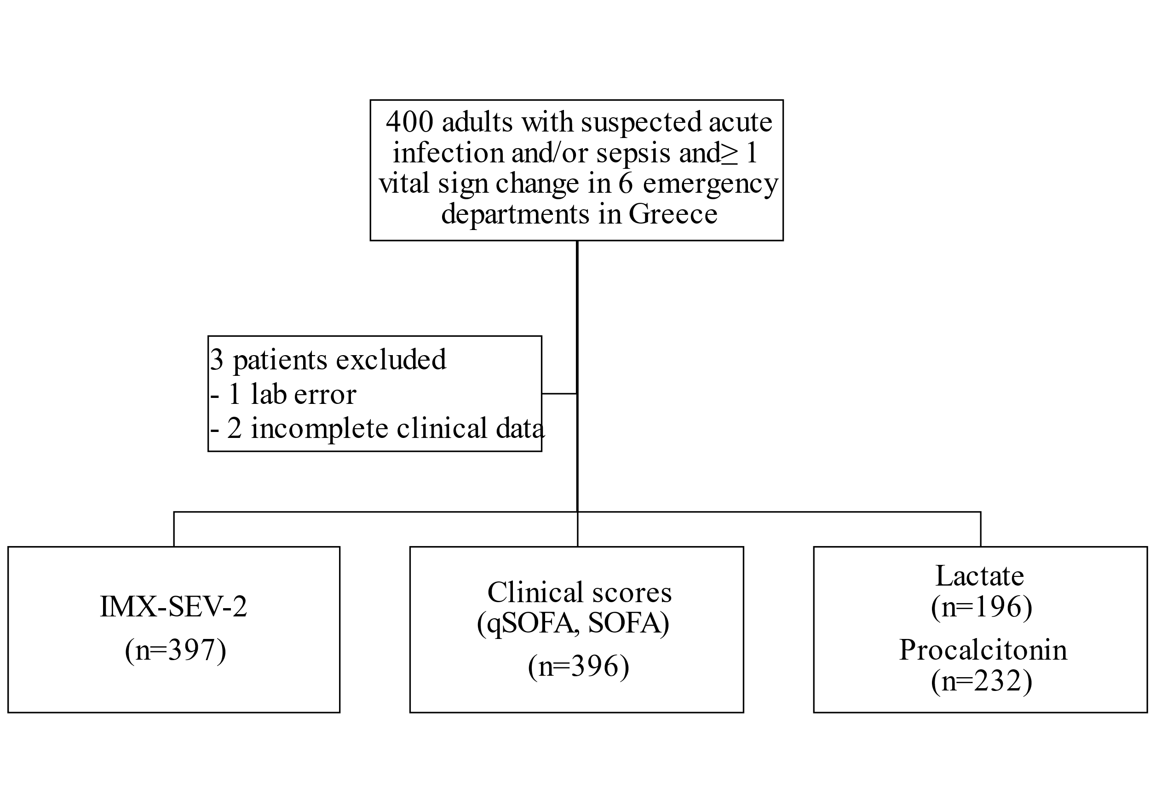
Supplementary Figure 1. Flowchart of the study
Abbreviations qSOFA: quick sequential organ failure assessment score; SOFA: sequential organ failure assessment score.

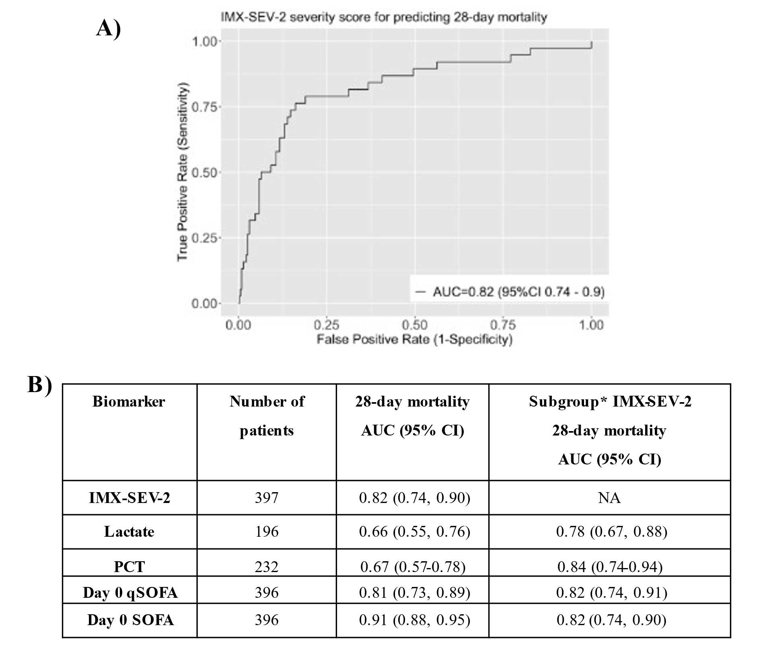
Supplementary Figure 2: Performance of IMX-SEV-2 and other biomarkers and scores for predicting 28-day mortality. (A) Receiver operating characteristic (ROC) curve of the IMX-SEV-2 severity score for classification of patients with 28-day mortality. (B) Area under the receiver operating characteristic curve (AUROC) for 28-day mortality for the IMX-SEV-2 severity score compared to other biomarkers including lactate, procalcitonin and clinical scores qSOFA and SOFA.
Abbreviations AUC: area under the receiver operating characteristic curve, CI: confidence interval; NA: not applicable; PCT: procalcitonin; qSOFA: quick sequential organ failure assessment.

Supplementary Figure 3. Overall accuracy depicted as percent patients in band, likelihood ratio, sensitivity and pecificity of outer IMX-SEV-2 interpretation bands (A) and high (> 4 mmol/L) and low (<2 mmol/L) lactate concentrations (B) to predict ICU care within 7 days.

